**Javasc ript:**

Js introduction

Js variables

Js datatypes

Js opearators

Conditional stmts and looping stmts

Input and output stmts

String operations

Array opearations

Objects

Date and math object

Dom

From handling

Es6

Callback.async await ,promises

Modules and classes along with ‘this’keyword

Js scopes

This keyword

Js browser storage apis,cookies

Advanced functions()- iife,concise func(arrow funcs),scheduling functions(settimeout and setinterval)

Fetch method and debugging

Function carrying and borrowing

Event handling

Oops concepts

Debounce

Throlling,async,defer

**Datastructures:  
ds and**  algo basics

Sorting techniques

Searching techniques

Recursion

Arrays

Stacks and queues

Map()

Hashtable

Sll(singly linked list)

Dll

Cll and cdll

Trees

Sets

Heaps

Graphs

Advanced ds- inheritance,types of inheritance –single,hierarchial,multilevel,prototypical inheritance

Abstraction,polymorphism,method overriding and method overloading(notsupported),operator overloading(js not support)

**Js supports – 3 types of inheritance, single,hierarchial and multilevel,prototypical**

**Polymorphism examples- method overriding ,method overloading,operator overloading**

Access specifiers-private,public – private variable declared by using # infront (eg: #value=0 ,#incremetn(){})

Encapsulation- to achieve it, properties make as private and objects should have set and get methods to set and get the data

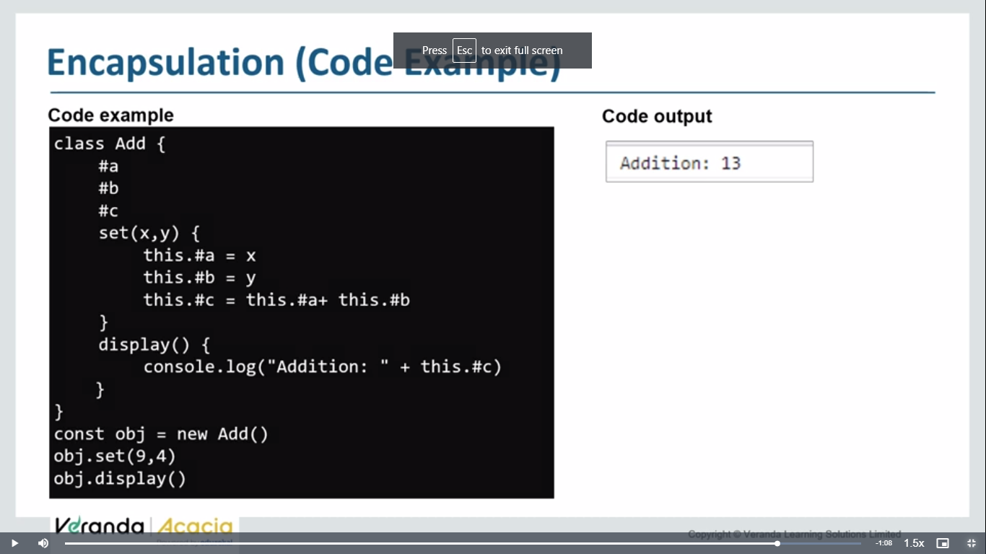

Algorithms:  
greedy,bruteforce,recursive algorithm,dynamic pgmg,randomized alg,backtrackign