Day 60

1. 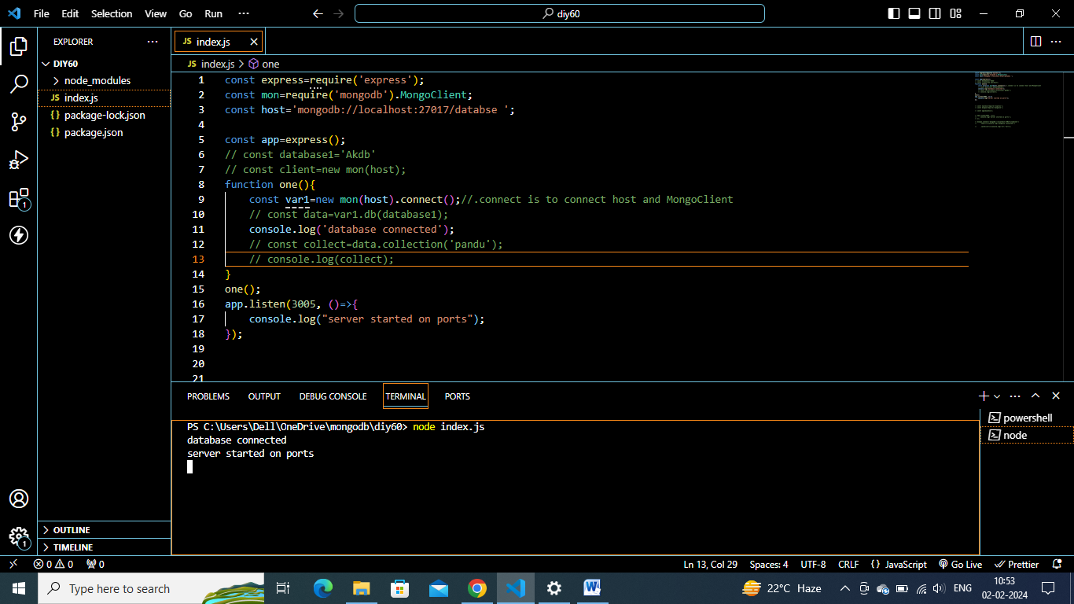

2)



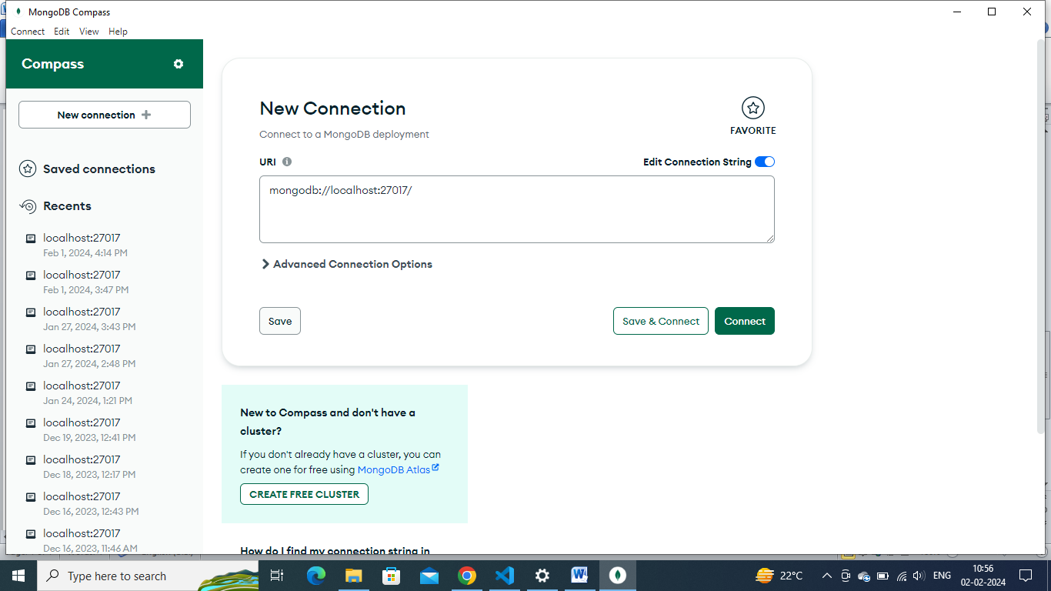

Diy 69:

1. Do npx I create-react-app appname and take screenshot

npx create-react-app my-app

cd my-app

npm start

2)Paste this code in index.js of react app or main.jsx of vite app.

Execute and take screenshot

import React from 'react';

import ReactDOM from 'react-dom/client';

import './index.css';

// import App from './App';

import reportWebVitals from './reportWebVitals';

const test1=React.createElement("h1",{},"this is test1 content");

const test2=React.createElement("h1",{},"this is test2 content");

const wrapper=React.createElement("div",{},[test1,test2]);

const root = ReactDOM.createRoot(document.getElementById('root'));

root.render(wrapper);

// If you want to start measuring performance in your app, pass a function

// to log results (for example: reportWebVitals(console.log))

// or send to an analytics endpoint. Learn more: https://bit.ly/CRA-vitals

reportWebVitals();

diy 70:

**index.js/main.jsx**

import React from 'react';

import ReactDOM from 'react-dom/client';

import './index.css';

import App from './App';

import reportWebVitals from './reportWebVitals';

const root = ReactDOM.createRoot(document.getElementById('root'));

root.render(

<App/>

);

// If you want to start measuring performance in your app, pass a function

// to log results (for example: reportWebVitals(console.log))

// or send to an analytics endpoint. Learn more: https://bit.ly/CRA-vitals

reportWebVitals();

**app.jsx**

**App.js**

import logo from './logo.svg';

import React from 'react';

import './App.css';

// function App() {

// return (

// <div>

// <h1>Hai</h1>

// <h1>It is my first Functional Component</h1>

// </div>

// );

// }

// export default App;

class App extends React.Component{

render(){

return(

<div>

<h1>Hai</h1>

<h1>This is my first Class Component</h1>

</div>

)

}

}

export default App