**119/40 Omnoi Kratumban**

**Samutsakorn 74130**

**18th February 2020**

**163 Ocean Insurance Building, 3rd Floor,**

**Suriyawong, Bang Rak, Bangkok 10500**

**Dear Ms.Chamaiporn**

**I read your advertisement in the jobthai.com of February 18th,2020,for a person to fill the position of C#.net programing.**

**I am 22 years of age,** **celibate and I got B.S.(Information Technology) Faculty of Liberal Arts and Science Kasetsart University. During I study in university. I do project to graduate.**

**My project is about everything in Restaurant ex. Food Menu(name, picture),Accounting,**

**Booking. It’s so very hard, but It makes me to full skill of C# language because my project was written by C# language 100% and use php language for collect data(database).After my project has**

**success. My project is actually used in the restaurant. I feel so proud and fun. It’s good**

**experience.**

**I will be glad to be interviewed at any time convenient to you in order to discuss the job and give you any further details that you may require.**

**Yours faithfully,**

**Narathip Rompho**

**Narathip Rompho**

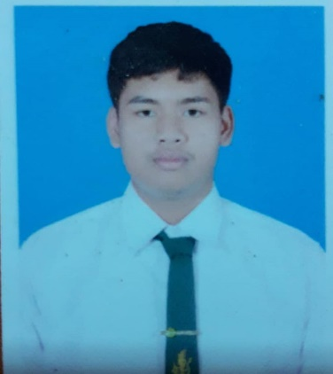

**Mr.Suradej Intagorn, Adviser**

**Faculty of Liberal Arts and Science  
Kasetsart University**

**Nakhon Pathom 73140**

**Tel : 034-300481 to 4 ext.7716**

**Email : Intagorn@gmail.com**

**References**

|  |  |
| --- | --- |
| **Oct, 2019** | **Restaurant program with C#** |
|  | **Project** |
|  |  |

**Dec,2019 Writing and create chat Blog**

**Website with wordpress**

**project**

**Working Experiences**

|  |  |
| --- | --- |
| **2018 - 2022** | **B.S.(Information Technology)** |
|  | **Kasetsart University, Faculty of Liberal Arts and Science** |
|  |  |

**Education**

**119/40 Omnoi Kratumban Samutsakorn 74130**

**Mobile Phone**

**0935861951**

**E-mail Narathip.ro@ku.th**

**Contract**

**C#.Net Programmer**

**Narathip Rompho**

**C# :   
JAVAscipt :  
HTML+SQL :**

**Skills**

**Date of Birth : March18th,2000  
Age : 20 years  
Nationality : Thai  
Sex : Male  
Marital Status : Single**

**Personal Data**