CFK Connect

Topic information:
Topic name: jdbc-employees

CFK connect: JDBC to JDBC

Source Connector
In this, we send the data i.e. present into our postgres database to kafka. Here we created the 4 clusters:
- kafka
- zookeeper
- schemaRegistry
- Connect

Steps to Perform source connector:
- First, we need to deploy postgres on cluster, so that we can connect it to our source connector using jdbc url
  - Create the configmap and apply it.
apiVersion: v1
kind: ConfigMap
metadata:
name: postgres-configmap
namespace: confluent
labels:
app: postgres
data:
POSTGRES_DB: postgresdb
POSTGRES_USER: admin
POSTGRES_PASSWORD: secret

  - Create and apply persisitent storage volume and persistent volume claim.
apiVersion: v1
kind: PersistentVolume
metadata:
name: postgres-pv-volume
namespace: confluent
labels:

type: local
app: postgres
spec:
storageClassName: manual
capacity:
storage: 5Gi
accessModes:
- ReadWriteMany
hostPath:
path: "/mnt/data"
---
apiVersion: v1
kind: PersistentVolumeClaim
metadata:
name: postgres-pv-clain
namespace: confluent
labels:
app: postgres
spec:
storageClassName: manual
accessModes:
- ReadWriteMany
resources:
requests:
storage: 5Gi

  - Create and apply PostgreSQL deployement.
apiVersion: apps/v1
kind: Deployment
metadata:
name: postgres
namespace: confluent
spec:
replicas: 1
selector:
matchLabels:
app: postgres
template:
metadata:
labels:
app: postgres
spec:
containers:
- name: postgres
image: postgres:10.1
imagePullPolicy: "IfNotPresent"
ports:
- containerPort: 5432
envFrom:
- configMapRef:
name: postgres-configmap
volumeMounts:
- mountPath: /var/lib/postgresql/data
name: postgresdb
volumes:
- name: postgresdb
persistentVolumeClaim:
claimName: postgres-pv-clain
---apiVersion: v1

  - Create and apply the PostgreSQL services.
kind: Service
metadata:
name: postgres
namespace: confluent
labels:
app: postgres
spec:
type: NodePort
ports:
- port: 5432
selector:
app: postgres

- Add the following properties in connec cluster yaml file to perform the connector.
build:
type: onDemand
onDemand:
plugins:
locationType: url
url:
- name: kafka-connect-jdbc # the url is used here as we needed to build our own connector lib to include the mysql jdbc jar
archivePath: https://raw.githubusercontent.com/confluentinc/confluent-kubernetes-examples/master/hybrid/ccloud-JDBC-mysql/confluentinc-kafka-connect-jdbc-10.2.5.zip
checksum: 9d033fabac89ec0b35a97246f7ca3a36800bcb402ccfbd76adebd4c4c9ca6e7d6a044a9162383a18f99400893581b55a87b9fe89e35276507e9a3fb6cff3fda0
keyConverterType: io.confluent.connect.avro.AvroConverter
valueConverterType: io.confluent.connect.avro.AvroConverter

Full yaml file:
apiVersion: platform.confluent.io/v1beta1
kind: Connect
metadata:
name: connect
namespace: confluent
spec:
replicas: 1
tls:
autoGeneratedCerts: true
image:
application: confluentinc/cp-server-connect:7.6.0
init: confluentinc/confluent-init-container:2.8.0
configOverrides:
server:
- config.storage.replication.factor=1
- offset.storage.replication.factor=1
- status.storage.replication.factor=1
build:
type: onDemand
onDemand:

plugins:
locationType: url
url:
- name: kafka-connect-jdbc # the url is used here as we needed to build our own connector lib to include the mysql jdbc jar
archivePath: https://raw.githubusercontent.com/confluentinc/confluent-kubernetes-examples/master/hybrid/ccloud-JDBC-mysql/confluentinc-kafka-connect-jdbc-10.2.5.zip
checksum: 9d033fabac89ec0b35a97246f7ca3a36800bcb402ccfbd76adebd4c4c9ca6e7d6a044a9162383a18f99400893581b55a87b9fe89e35276507e9a3fb6cff3fda0
# The connector certificates file paths will be showed in connect status, when creating connector CR, can refer to these paths
keyConverterType: io.confluent.connect.avro.AvroConverter
valueConverterType: io.confluent.connect.avro.AvroConverter
# connectorTLSCerts:
# - secretRef: tls-kafka
# mountedSecrets:
# - secretRef: credential
# authentication:
# type: mtls
dependencies:
kafka:
bootstrapEndpoint: kafka.confluent.svc.cluster.local:9071
authentication:
type: mtls
tls:
enabled: true
schemaRegistry:
url: https://schemaregistry.confluent.svc.cluster.local:8081
tls:
enabled: true

- Create the yaml file to perform the source connector with kind connector
apiVersion: platform.confluent.io/v1beta1
kind: Connector
metadata:
name: connector-jdbc-source
namespace: confluent
spec:
name: connector-jdbc-source
class: "io.confluent.connect.jdbc.JdbcSourceConnector"
taskMax: 2
connectClusterRef:
name: connect
configs:
topic.prefix: "jdbc-"
key.converter: "io.confluent.connect.avro.AvroConverter"
key.converter.schema.registry.url: "https://schemaregistry.confluent.svc.cluster.local:8081"
key.converter.schema.registry.ssl.truststore.location: "/mnt/sslcerts/truststore.jks"
key.converter.schema.registry.ssl.truststore.password: "${file:/mnt/sslcerts/jksPassword.txt:jksPassword}"
key.converter.schema.registry.ssl.keystore.location: "/mnt/sslcerts/keystore.jks"
key.converter.schema.registry.ssl.keystore.password: "${file:/mnt/sslcerts/jksPassword.txt:jksPassword}"
key.converter.schema.registry.ssl.key.password: "${file:/mnt/sslcerts/jksPassword.txt:jksPassword}"
value.converter: "io.confluent.connect.avro.AvroConverter"
value.converter.schema.registry.url: "https://schemaregistry.confluent.svc.cluster.local:8081"
value.converter.schema.registry.ssl.truststore.location: "/mnt/sslcerts/truststore.jks"
value.converter.schema.registry.ssl.truststore.password: "${file:/mnt/sslcerts/jksPassword.txt:jksPassword}"
value.converter.schema.registry.ssl.keystore.location: "/mnt/sslcerts/keystore.jks"
value.converter.schema.registry.ssl.keystore.password: "${file:/mnt/sslcerts/jksPassword.txt:jksPassword}"
value.converter.schema.registry.ssl.key.password: "${file:/mnt/sslcerts/jksPassword.txt:jksPassword}"
security.protocol: "SSL"
connection.url: "jdbc:postgresql://postgres:5432/postgresdb?user=zeenia&password=secret"
table.whitelist: "employees"
mode: "incrementing"
incrementing.column.name: "id"
restartPolicy:
type: OnFailure
maxRetry: 20

- Create the yaml file to create the topic
apiVersion: platform.confluent.io/v1beta1
kind: KafkaTopic
metadata:
name: jdbc-employees
namespace: confluent
spec:
replicas: 1
partitionCount: 4
configs:
cleanup.policy: "delete"

- Login and Create the database in PostgresSQL
  - Login into the PostgreSQL database.
kubectl exec -it <pod_name> -- psql -h localhost -U <user_name> -password -p 5432 <database_name>
Example:
kubectl exec -it postgres-7fbb5c685f-sdw42 -- psql -h localhost -U admin -password -p 5432 postgresdb
  - Create the table
create table <table_name>( ID SERIAL PRIMARY KEY,name VARCHAR(255), age INT);
Example:
create table employees( ID SERIAL PRIMARY KEY,name VARCHAR(255), age INT);
  - Insert the values into the table.
INSERT INTO <table_name> (name, age) VALUES ('Zeenia',21);
Example:
INSERT INTO employees (name, age) VALUES ('Zeenia',21);
INSERT INTO employees (name, age) VALUES ('Gazal',23);
INSERT INTO employees (name, age) VALUES ('Abhinav',24);
INSERT INTO employees (name, age) VALUES ('Surya',24);
  - Create the user
CREATE USER <user_name> WITH PASSWORD '<password>';
Example:
CREATE USER zeenia WITH PASSWORD 'secret';
  - Grant the privileges to the user.
GRANT ALL ON <table_name> TO <user_name>
Example:
GRANT ALL ON employees TO zeenia

- Create the secrets for external listeners.
  - Create the secret credentils
kubectl create secret generic credential \
--from-file=plain-users.json=creds-kafka-sasl-users.json \
--from-file=plain.txt=creds-kafka-sasl-users.txt
  - Generate the CA pair
openssl genrsa -out ca-key.pem 2048
openssl req -new -key ca-key.pem -x509 \
-days 1000 \
-out ca.pem \
-subj "/C=US/ST=CA/L=MountainView/O=Confluent/OU=Operator/CN=TestCA"
  - Create the secrets for tls-kafka
kubectl create secret generic tls-kafka \
--from-file=fullchain.pem=kafka-server.pem \
--from-file=cacerts.pem=cacerts.pem \
--from-file=privkey.pem=kafka-server-key.pem
  - Create the tls secret ca-pair-sslcerts. Do this if you enable the autogeneratedCerts: true
kubectl create secret tls ca-pair-sslcerts \
--cert=cacerts.pem \
--key=rootCAkey.pem
- Deploy the kafka-connect yaml file and topic yaml file.
kubectl apply -f kakfa-connect.yaml
kubectl apply -f topic.yaml

- Create Connector.
kubectl apply -f source_connector.yaml
- Login into shemaRegistry cluster and consume the data from the topic.
Kubectl exec -it schemaregistry-0 -- bash
kafka.properties file
cat <<- EOF > /opt/confluentinc/kafka.properties
bootstrap.servers=kafka:9071
security.protocol=SSL
ssl.keystore.location=/mnt/sslcerts/keystore.jks
ssl.keystore.password=mystorepassword
ssl.truststore.location=/mnt/sslcerts/truststore.jks
ssl.truststore.password=mystorepassword
ssl.key.password=mystorepassword
EOF
Consume the data:
kafka-avro-console-consumer \
--bootstrap-server kafka.confluent.svc.cluster.local:9071 \
--consumer.config /opt/confluentinc/kafka.properties \
--topic jdbc-employees \
--property schema.registry.url=https://schemaregistry.confluent.svc.cluster.local:8081 \
--property schema.registry.ssl.truststore.location=/mnt/sslcerts/truststore.jks \
--property schema.registry.ssl.truststore.password=mystorepassword \
--from-beginning
OUTPUT:
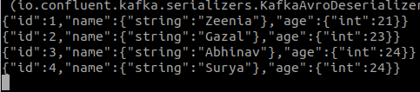

Sink Connector
In this we are going to send our data to MySQL database.
NOTE: Make sure to run the sink connector with schema.
- First, we need to deploy MySQL on cluster, so that we can connect it to our source connector using jdbc url
  - Create the kubernetes secret
kubectl apply -f mysql-secret.yaml
mysql-secret.yaml
apiVersion: v1
kind: Secret
metadata:
name: mysql-secret
namespace: confluent
type: kubernetes.io/basic-auth
stringData:
password: secret

  - Create the persistent volume and volume claim
kubectl apply -f mysql-storage.yaml
mysql-storage.yaml
apiVersion: v1
kind: PersistentVolume
metadata:
name: mysql-pv-volume
namespace: confluent
labels:
type: local
spec:
storageClassName: manual
capacity:
storage: 5Gi
accessModes:
- ReadWriteOnce
hostPath:
path: "/mnt/data"
---
apiVersion: v1
kind: PersistentVolumeClaim
metadata:

name: mysql-pv-claim
namespace: confluent
spec:
storageClassName: manual
accessModes:
- ReadWriteOnce
resources:
requests:
storage: 5Gi

  - Create MySQL deployement and service.
apiVersion: apps/v1
kind: Deployment
metadata:
name: mysql
namespace: confluent
spec:
selector:
matchLabels:
app: mysql
template:
metadata:
labels:
app: mysql
spec:
containers:
- image: mysql:5.6
name: mysql
env:
- name: MYSQL_ROOT_PASSWORD
valueFrom:
secretKeyRef:
name: mysql-secret
key: password
ports:
- containerPort: 3306
name: mysql
volumeMounts:
- name: mysql-persistent-storage
mountPath: /var/lib/mysql
volumes:
- name: mysql-persistent-storage
persistentVolumeClaim:
claimName: mysql-pv-claim
---
apiVersion: v1
kind: Service
metadata:
name: mysql
namespace: confluent
spec:
ports:
- port: 3306
selector:
app: mysql

- Create the yaml file to perform the source connector with kind connector
apiVersion: platform.confluent.io/v1beta1
kind: Connector
metadata:
name: connector-jdbc-sink
namespace: confluent
spec:
name: connector-jdbc-sink
class: "io.confluent.connect.jdbc.JdbcSinkConnector"
taskMax: 2
connectClusterRef:
name: connect
connectRest:
endpoint: https://connect.confluent.svc.cluster.local:8083
authentication:
type: mtls
tls:
secretRef: connect-generated-jks
configs:
topics: "jdbc-employees"
connector.class: "io.confluent.connect.jdbc.JdbcSinkConnector"
key.converter.schema.registry.url: "https://schemaregistry.confluent.svc.cluster.local:8081"
key.converter.schema.registry.ssl.truststore.location: "/mnt/sslcerts/truststore.jks"
key.converter.schema.registry.ssl.truststore.password: "${file:/mnt/sslcerts/jksPassword.txt:jksPassword}"
key.converter.schema.registry.ssl.keystore.location: "/mnt/sslcerts/keystore.jks"
key.converter.schema.registry.ssl.keystore.password: "${file:/mnt/sslcerts/jksPassword.txt:jksPassword}"
key.converter.schema.registry.ssl.key.password: "${file:/mnt/sslcerts/jksPassword.txt:jksPassword}"
value.converter.schema.registry.url: "https://schemaregistry.confluent.svc.cluster.local:8081"
value.converter.schema.registry.ssl.truststore.location: "/mnt/sslcerts/truststore.jks"
value.converter.schema.registry.ssl.truststore.password: "${file:/mnt/sslcerts/jksPassword.txt:jksPassword}"
value.converter.schema.registry.ssl.keystore.location: "/mnt/sslcerts/keystore.jks"
value.converter.schema.registry.ssl.keystore.password: "${file:/mnt/sslcerts/jksPassword.txt:jksPassword}"
value.converter.schema.registry.ssl.key.password: "${file:/mnt/sslcerts/jksPassword.txt:jksPassword}"
security.protocol: "SSL"
connection.url: "jdbc:mysql://mysql:3306/mysql?allowPublicKeyRetrieval=true"
connection.user: "zeenu"
connection.password: "secret"
table.name.format: "employees"
delete.enabled: "false"
auto.evolve: "true"
insert.mode: "upsert"
pk.mode: "record_value"
pk.field: "id"
auto.create: "true"
restartPolicy:
type: OnFailure
maxRetry: 20

- Login and Create the table in MySQL
  - Login into the pod
kubectl exec -it <pod_name> – bash
Example:
kubectl exec -it mysql-849ff45467-tpp8b – bash

  - Login into mysql as root user
root@mysql-849ff45467-2gbfv:/# mysql -p

  - Select the database and Create the user
use <database_name>;
CREATE USER '<user_name>'@'%' IDENTIFIED BY '<password>';
Example:
use mysqldb;
CREATE USER 'zeenu'@'%' IDENTIFIED BY 'secret';
  - Create the table
create table <table_name>(ID INTEGER, name VARCHAR(255), age INTEGER);
Example:
create table employees(ID INTEGER, name VARCHAR(255), age INTEGER);
  - Grant the privileges to the user
GRANT ALL PRIVILEGES ON *.* TO '<user_name>'@'%';
Example:
GRANT ALL PRIVILEGES ON *.* TO 'zeenu'@'%';
- Create Connector
kubectl apply -f sink_connector.yaml
- Login into MySQL pod and check if the data there in the table or not.
kubectl exec -it <mysql_pod> -- bash
Login as mysql user
mysql -p
See the content of table
SELECT * FROM employees;

OUTPUT:
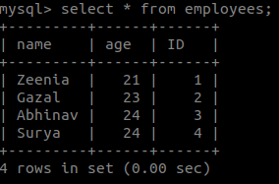

TROUBLESHOOTING

- No suitable driver found
Check the plugin you provided for kafka-jdbc-connect in the connect.yaml file.
If you provide this plugin, you’ll get the error:
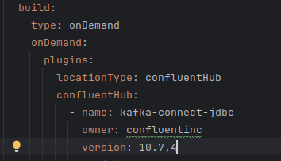
You’ll get the error, as it doesn’t download the jdbc driver. Check the correct configuration for connect.yaml file above

- If you’re getting this SSL handshake failed error while consuming the data from the topic in schemaregistry container
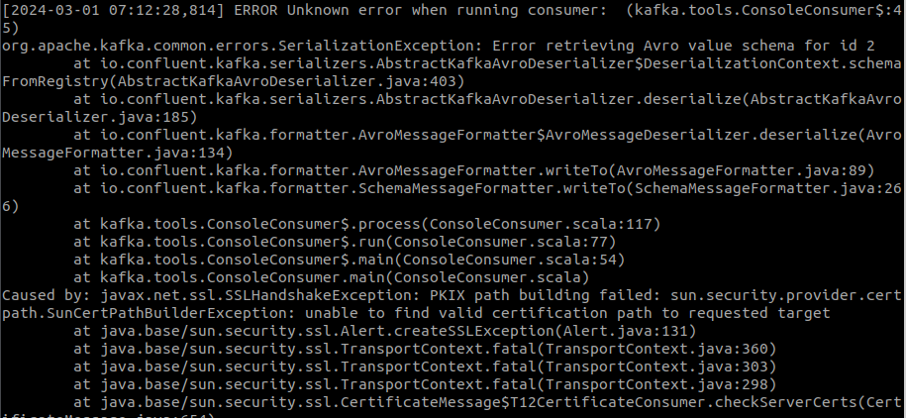
Solution: Make sure the the kafka-avro-console-consumer command you are providing is correct. You’ll get this error when you don’t provide the schema url and certification with the command using “--property” flag. Check the command mentioned above.

