* [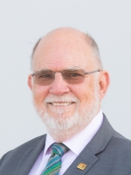](https://worldskills.org/people/id/3560/)

**[Chris Humphries](https://worldskills.org/people/id/3560/)**

**Acting President and Chair of the Board (Board member – Strategic Development)**

* [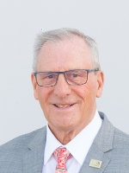](https://worldskills.org/people/id/14/)

**[Terry Cooke](https://worldskills.org/people/id/14/)**

**Board member – Treasurer**

* [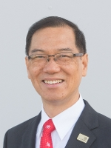](https://worldskills.org/people/id/326/)

**[Michael K K Fung](https://worldskills.org/people/id/326/)**

**Board member – Competitions**

* [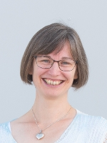](https://worldskills.org/people/id/2592/)

**[Laurence Gates](https://worldskills.org/people/id/2592/)**

**Board member – Strategic Development**

* [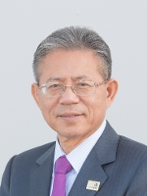](https://worldskills.org/people/id/4277/)

**[San-Quei Lin](https://worldskills.org/people/id/4277/)**

**Board member – Strategic Development**

* [](https://worldskills.org/people/id/30370/)

**[Ekaterina Loshkareva](https://worldskills.org/people/id/30370/)**

**Board member – Strategic Development**

* [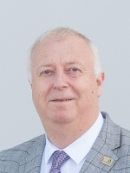](https://worldskills.org/people/id/220/)

**[Stefan Praschl](https://worldskills.org/people/id/220/)**

**Board member – Competitions**

* 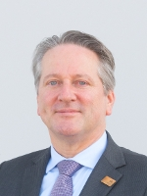

**Jos de Goey**