1. Add your game scenes to Build Settings

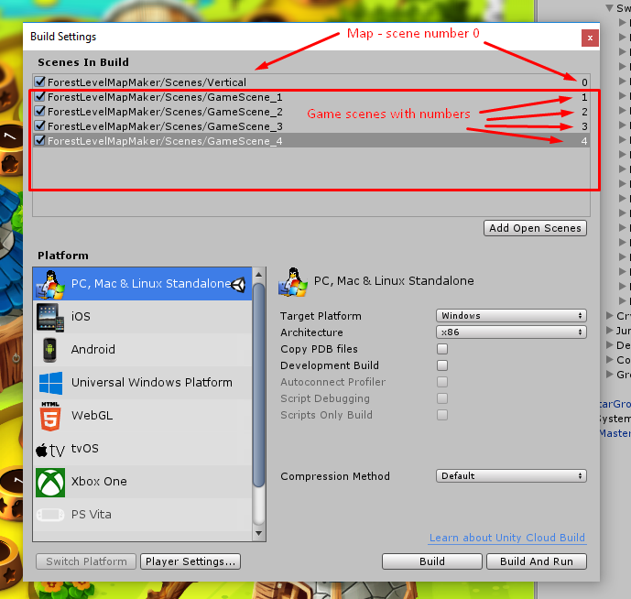

1. Drag the SceneLoader prefab in to hierarchy.

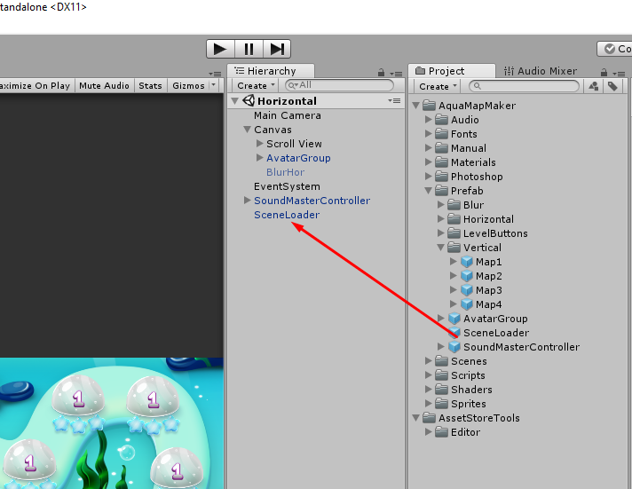

1. Open file MapController.cs (dbl click)

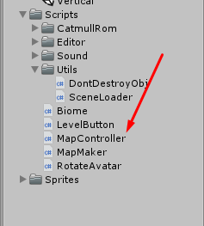

Find line 92:

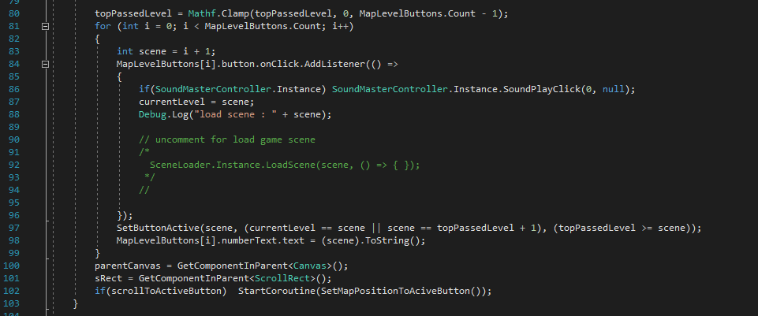

Uncomment string SceneLoader.Instance.LoadScene(scene, () => { }); (as here)

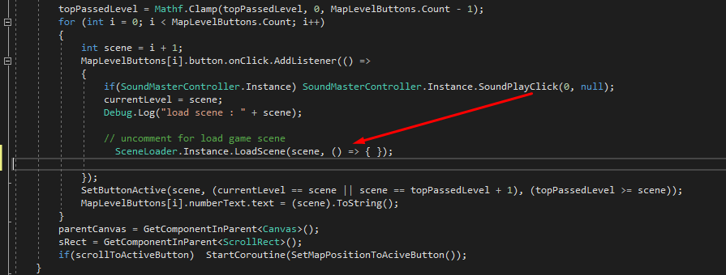

Each button has self number from 0 to levels count -1.

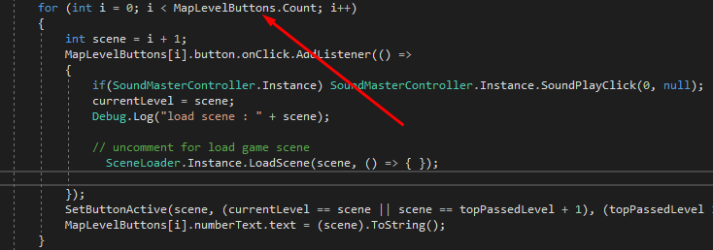

Button load scene with number

scene = i+1, (i – button number) since the numbering of game scenes starts from 1

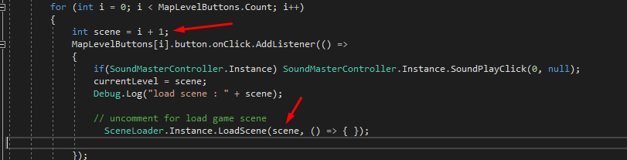

You can change enumeration if you need.

Run map scene and try.