Open the file MapController.cs.

You can see static int topPassedLevel = 30; // 30 – set for only for example.

You must set this variable directly from your code (for example MapController.topPassedLevel = 2 after passing the level 2)

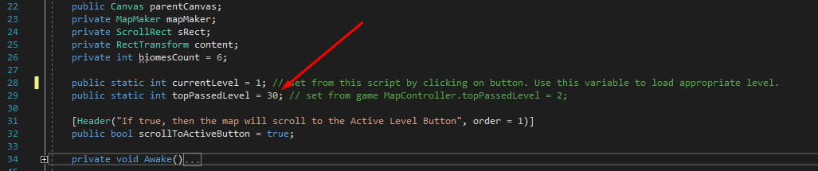

Map Buttons activation algorithm:



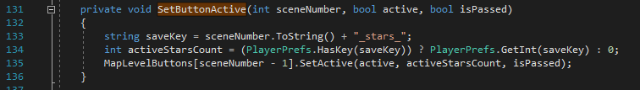

You can also save your level stars from your code using :

PlayerPrefs.SetInt(sceneNumber.ToString() + "_stars_", starsCount);