How to: add facebook coins after login (only once)

Add handler to LoginEvent (FbHolder.cs)

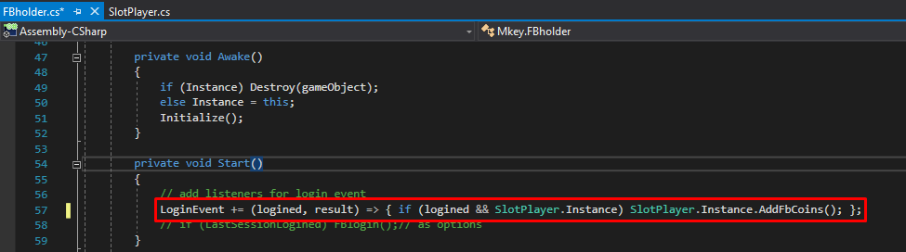

LoginEvent += (logined, result) =>

{ if (logined && SlotPlayer.Instance) SlotPlayer.Instance.AddFbCoins(); };