Facebook: 7.11.1 – from [developer site](https://developers.facebook.com/docs/unity/) - work

Facebook: 7.12.1 – from [asset store](https://assetstore.unity.com/packages/3d/characters/facebook-sdk-for-unity-beta-10989) - error

Facebook: 7.13.0 – from [developer site](https://developers.facebook.com/docs/unity/) - error

Unity: 2018.2.7f1

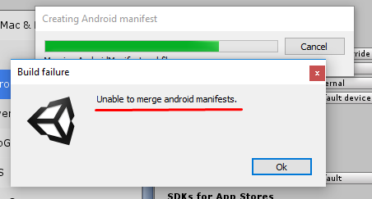

Android build error (Build System - Internal):

Error: Error while saving blame file, build will continue

Error: The prefix "tools" for attribute "tools:overrideLibrary" associated with an element type "uses-sdk" is not bound.AndroidSDKToolsException: **Unable to merge android manifests.**

Solved

|  |  |
| --- | --- |
| [Problem is usually](https://stackoverflow.com/questions/45516305/error-the-prefix-tools-for-attribute-toolsoverridelibrary-associated-with) caused by a plugin. Find AndroidManifest.xml from the plugin in your project, open it and then add xmlns:tools="http://schemas.android.com/tools" under <manifest xmlns:android="http://schemas.android.com/apk/res/android".  Save it and rebuilt again. This should solve the problem. You can see what it should like from [this](http://answers.unity3d.com/comments/1371742/view.html) post. | work |

