add a comment



**Sustainable Technology Development**

State-of-the-Art M. O. Darwich August 17, 2017

Submitted to the *Department of Computer Science* in partial fulfilment of the requirements for the course

**Design Science Research**

c Mohammad Oday Darwich, MMXVII, All rights reserved

Department of Computer Science, UNIGE

**Contents**

**Contents i**

**1 Introduction 1**

**2 Platform analyses 3**

2.1 Instructable . . . . . . . . . . . . . . . . . . . . . . . . . . . . . 3

2.1.1 Methodology . . . . . . . . . . . . . . . . . . . . . . . . 4

2.1.2 User interaction . . . . . . . . . . . . . . . . . . . . . . . 4

2.1.3 Design and process oriented documentation . . . . . . 6

|  |  |  |  |  |  |  |  |  |  |  |  |  |  |  |  |  |  |  |  |  |  |  |  |  |  |  |  |  |  |  |  |  |
| --- | --- | --- | --- | --- | --- | --- | --- | --- | --- | --- | --- | --- | --- | --- | --- | --- | --- | --- | --- | --- | --- | --- | --- | --- | --- | --- | --- | --- | --- | --- | --- | --- |
| 2.2 | Build | In Progress . . . . | | | | | | | | . | . | . | . | . | . | . | . | . | . | . | . | . | . | . | . | . | . | . | . | . | . | 6 |
|  | 2.2.1 | Design approach | | | | | | | | . | . | . | . | . | . | . | . | . | . | . | . | . | . | . | . | . | . | . | . | . | . | 7 |
|  | 2.2.2 | Features . . . . . | | | | | | | | . | . | . | . | . | . | . | . | . | . | . | . | . | . | . | . | . | . | . | . | . | . | 8 |
|  | 2.2.3 | User interaction . | | | | | | | | . | . | . | . | . | . | . | . | . | . | . | . | . | . | . | . | . | . | . | . | . | . | 11 |
|  | 2.2.4 | Summary . . . . | | | | | | | | . | . | . | . | . | . | . | . | . | . | . | . | . | . | . | . | . | . | . | . | . | . | 11 |
| 2.3 | Discussion . | | . | . | . | . | . | . | . | . | . | . | . | . | . | . | . | . | . | . | . | . | . | . | . | . | . | . | . | . | . | 12 |
| 2.4 | Future Work | | . | . | . | . | . | . | . | . | . | . | . | . | . | . | . | . | . | . | . | . | . | . | . | . | . | . | . | . | . | 12 |

**Bibliography 15**

**Introduction**

In the world of innovation, people needed tools to exchange knowledge, share experiences and to work in interdisciplinary teams to *innovate*, *design* and *implement* solutions. To follow the pace of this continuous evolutions of innovation world, the method of documentation must become more useful, learnable, available, shareable and accessible by documenting in a meaning- ful and proper ways.

The complexity of documentation has led innovators, creators and hackers to create another communities and to look for different tools in diverse related communities (e.g., blogging, makers ) as well as other areas (e.g., program- ming) to find new way of documentation process. Moreover, the authors and readers seek optimal solutions to reduce the effort needed to document, collaborate, extract knowledge and share their efforts, authors and readers agree that documentation tools become as necessary than desirable.

In this state-of-the-art, we will go through a platforms developed to support makers, creators and innovators in their projects to share their progress over time and analyse how authors and readers benefit from the online docu- mentation, what motivate them to share a project, what is the influence of sharing a work in progress with the public and discover the other for these platforms and online community.

**Platform analyses**

**2.1 Instructable**

*In this section, I share with you an analyses of how users create and share DIY projects via online platform called Instructables. I share findings of the analyses of this plat- form and the understanding of how authors and users use Instructables*

Instructables is online platform for *DIY* community that serves as ”place that lets you explore, document, and share your creations” [Instructables, 2015].

It is a website specializing in user-created and uploaded do-it-yourself projects, which other users can comment on and rate for quality [Wikipedia, 2017] [Wikipedia, 2017]. There are different categories of project such as tech- nology, crafts, food, home, workshops and living, with more than 263,258 projects and 9,888,442 monthly visit as of August 2017. Users create their project step by step and with each step they describe what they did in a text, photos or videos as displayed in the figure 2.1. The encapsulation of steps produce a typical guide that help others to re-create the project, learn from

it or build a new thing on top of it and they will have their own version of the project.

The contributions in Instructables comes from the sharing culture of projects, not only authors contribute but also readers who can view and give feedback by commenting on the project. Also, Instructables create a social community where they exchange their thoughts about a topic via forums and subforms dedicated to a special topic such as Arduino projects. Finally, prizes are given to the top shared Instructables as kind of reward for their effort of sharing their project and to keep them connected with the community.

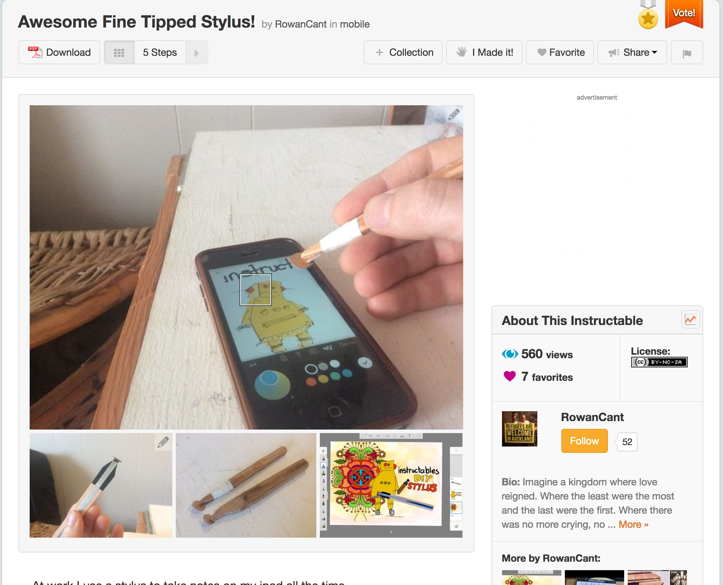

Figure 2.1: Sample Instructables project, <http://www.instructables.com/>

id/Awesome-Fine-Tipped-Stylus/

**2.1.1 Methodology**

To understand the users interactions of Instructables, an extensive study of the Instructables community has been done in the fall of 2011, this study used semi-structured interview and online surveys. The semi-structured in- terview had a framework of four themes that had been explored : (1) motiva- tion, (2) Documentation tools, (3) Writing an Instructable and (4) Feedback. A theme was covered by a set of questions that takes one hour with each interviewer. [Tseng and Resnick, 2014]. A survey of 15 multiple-choice ques- tion and open ended-questions that ask users about different aspects of their experience with replicating or building on top of a project shared by a user on the platform.

**2.1.2 User interaction**

The study has shown three strategies for documenting a project. The first was to *write after you make*, as shown in the figure 2.2 [Tseng, 2016].

A problem confronted the users with this strategy, users forgot to document

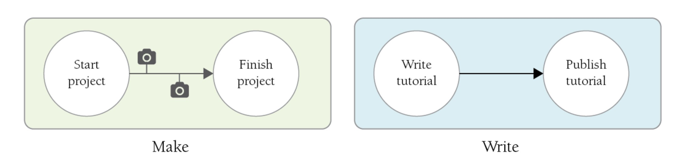

Figure 2.2: First strategy of documenting : write after you make, [Tseng, 2016]

in the midst of making. Users outperformed this problem by following the second strategy of *writing after replicating*, as displayed in the figure 2.3 [Tseng and Resnick, 2014]

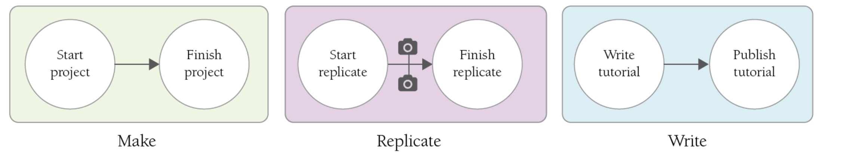

Figure 2.3: First strategy of documenting : Make, replicate then write, [Tseng, 2016]

The final strategy was to *simultaneously write and make* (figure 2.4).

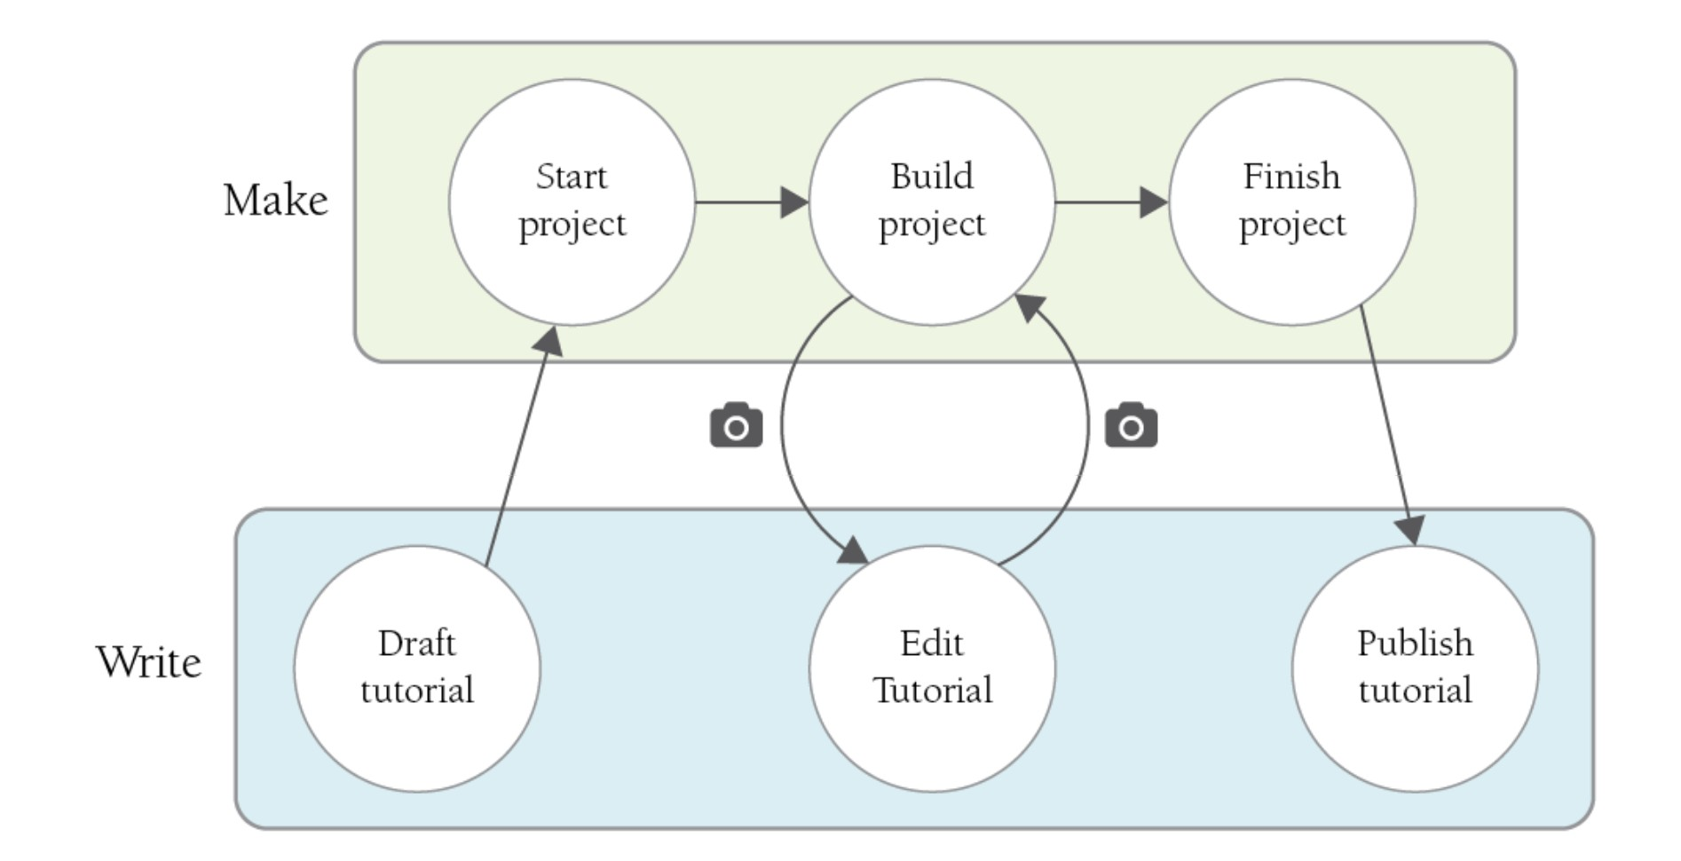

Figure 2.4: First strategy of documenting : write after you make, [Tseng, 2016]

In summary, the study showed that users need to encapsulate the collected photos and videos to show to create all the steps and a common challenge was to remember to document after each step otherwise users had to repli- cate their project merely to creating good documentation.

Finally, authors saw that documentation well worth the effort to share their work but it is time consuming process when a project get more complex, it is hard to follow up or complete the documentation. [Wakkary et al., 2015]

**2.1.3 Design and process oriented documentation**

Several approaches were suggested by to improve the online documenta- tion. Documentation techniques requires authors to simultaneously switch between making and writing, make a design process to not miss a step from not being documented or to radically recreate the project to document it in a proper way. Another challenges of documentation technique that needed to support not only the capture of digital artifacts but also physical artifacts where it is not possible to show the physical processes , With the recurring need to balance manual and automated ways of capturing, software and hardware tools need to solve open questions and be customizable for dif- ferent activities and different audiences [Kuznetsov and Paulos, 2010]. The workflow of documentation over time needed to not miss a key step in the documentation.

Documentation process seems to be more important for readers as it give them the opportunity to enable better decision making about components or materials to use [Lethbridge et al., 2003], as well as successful in encour- aging independent exploration and fostering a sense of accomplishment [Lovell and Buechley, 2010]. Also, as many users start by replicating some projects, having tools where they could be able to contribute to a project, can help more socializing and boost a collaborative work in the community .

**2.2 Build In Progress**

Build in Progress is a platform for sharing the story of your design process, and *”makers share how their DIY projects evolve over time*” [Tseng, 2016]. It focus more on the storytelling of *DIY* documented project, a snapshot of the platform displayed in the figure 2.5.

BiP was launched in 2013 and within a collaboration with many institutions and a network of schools BiP hosted over 1368 projects in categories such as Electronics, Mechanical and living. Users contributed to BiP community by sharing, providing feedback and describing their progress of each step, the encapsulation of informations lead to a story about the project as BiP

”*support a storytelling approach to documentation*” [Tseng, 2016].

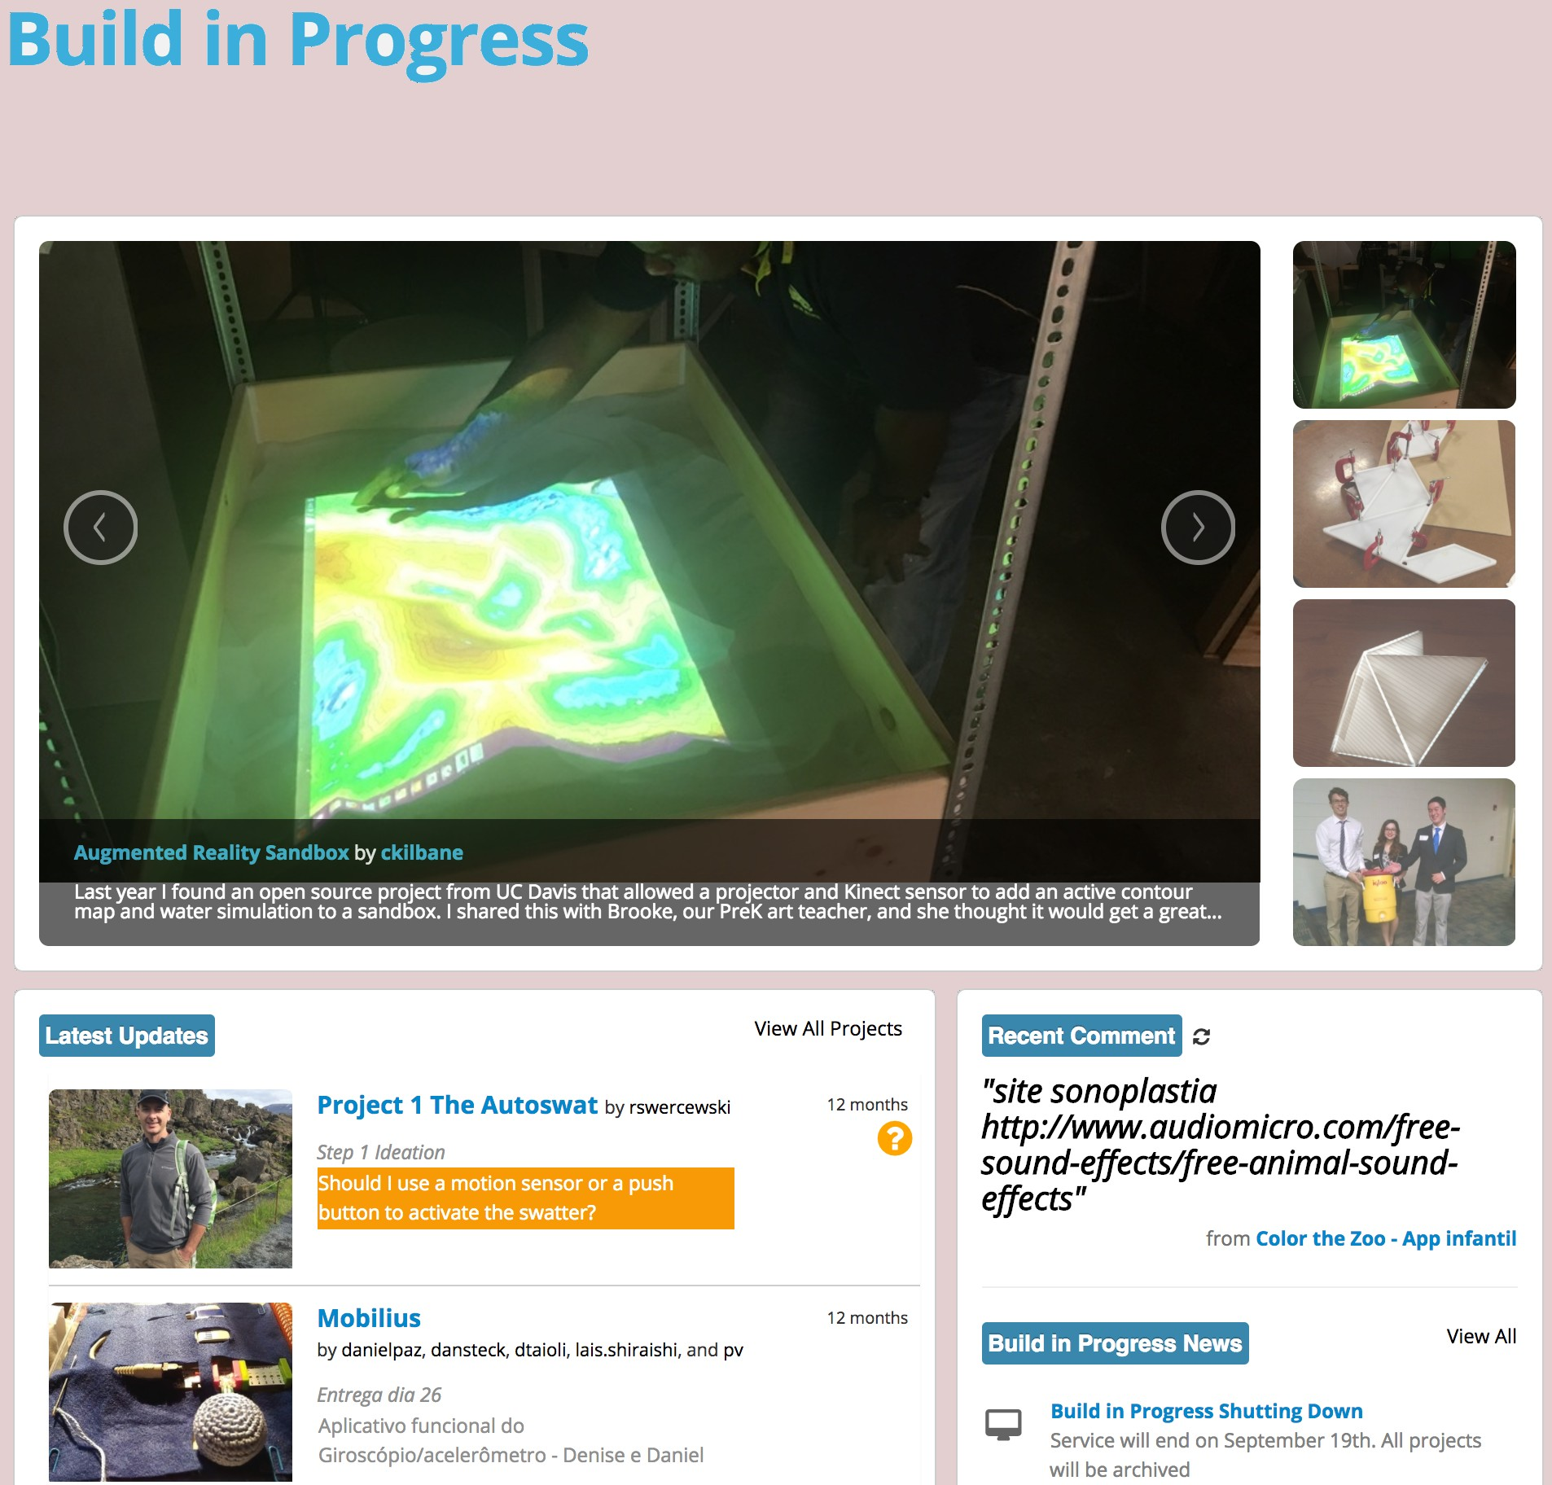

Figure 2.5: Build in progress welcome page, [BiP, 2015, http://

buildinprogress.media.mit.edu/]

**2.2.1 Design approach**

Authors shared an iterative design process in the context of sharing their personal journey by creating step-by-step instructions of their project via the online platform *BiP* and companion mobile application. Readers can contribute by suggesting to makers after publishing their steps, makers bene- fited from sharing step-by-step instructions over time by taking into account the suggestions of readers.

BiP was developed based on innovative design process, it enables users to visualize their documentation in an iterative way. Authors can continuously iterate their building process, share their techniques to help others to reach out others in the community so they can have feedback. A social design pro- cess principle was considered among the online community to engage users more, to accumulate knowledge, to learn from others and connect users with same interest as *human-related issues in the form of social ties and knowledge shar- ing were reported as keys to successful collaboration* [Kotlarsky and Oshri, 2005].

**2.2.2 Features**

BiP consists of many features in the project page and social feature. The two core features of the project page are : the *Process Map* and *Step Detail View* (2.6). In the process map, users can create a step, a label for one or more

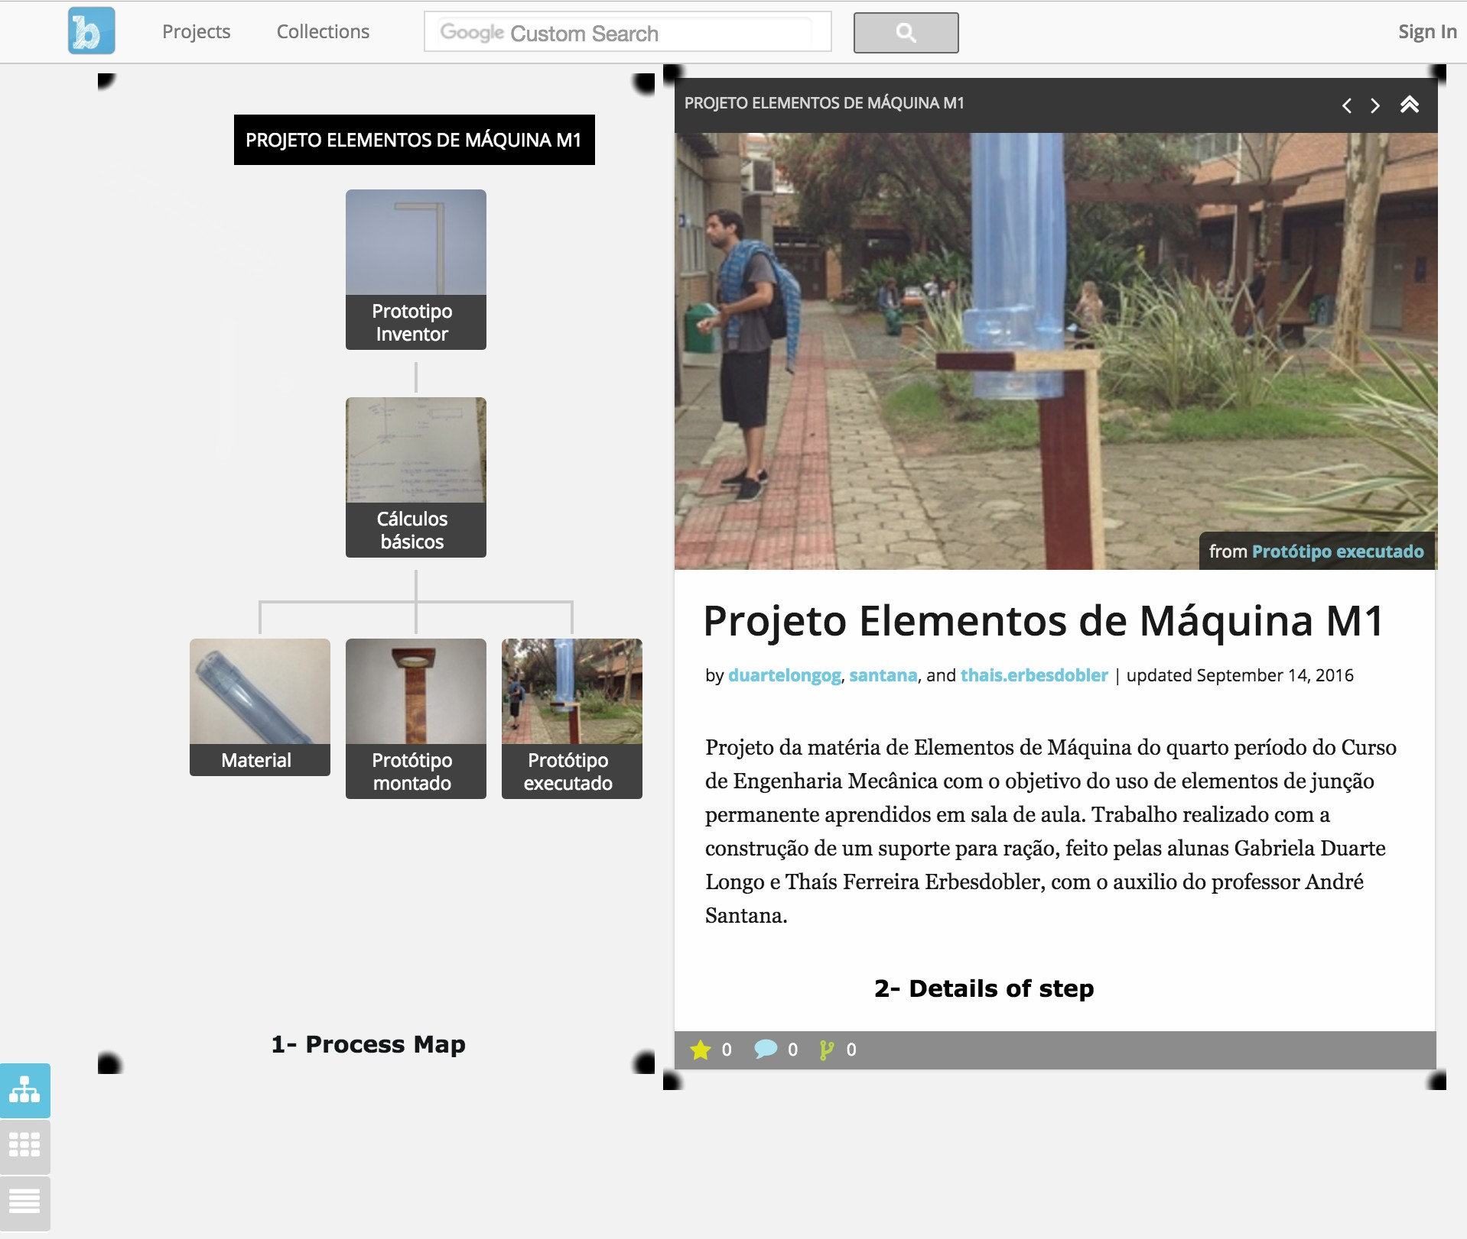

Figure 2.6: overall project view, [BiP, 2016, [http://buildinprogress.](http://buildinprogress/) media.mit.edu/projects/4599/steps]

step, drag & drop to rearrange steps. Steps are organized in a tree-map-like format with sui generis branches, label is added to a branch and it can be colored to designate a branch; for example orange labels represent that a branch is in progress.

Project are displayed in 3 different mode. The first is the default mode : tree-map, users can go through all the steps, step-by-step and discover more about it as shown in figure 2.7.

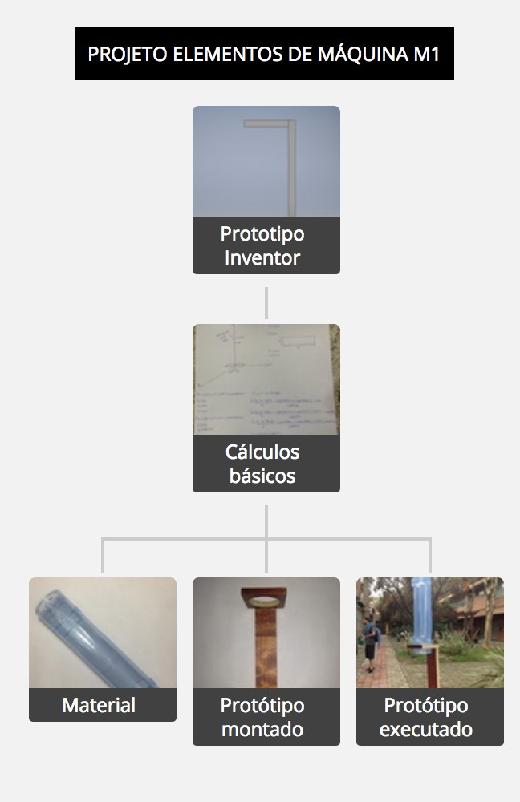

Figure 2.7: tree-map view of the project

The second is Gallery mode 2.8 and finally the blog mode : users can scroll down and an index of steps will be displayed on their left side of the page (figure 2.9).

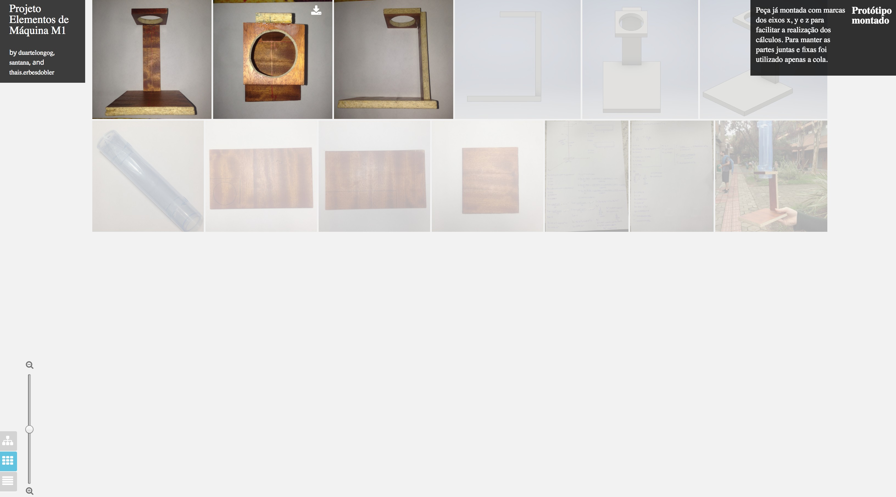

Figure 2.8: Gallery view of the project

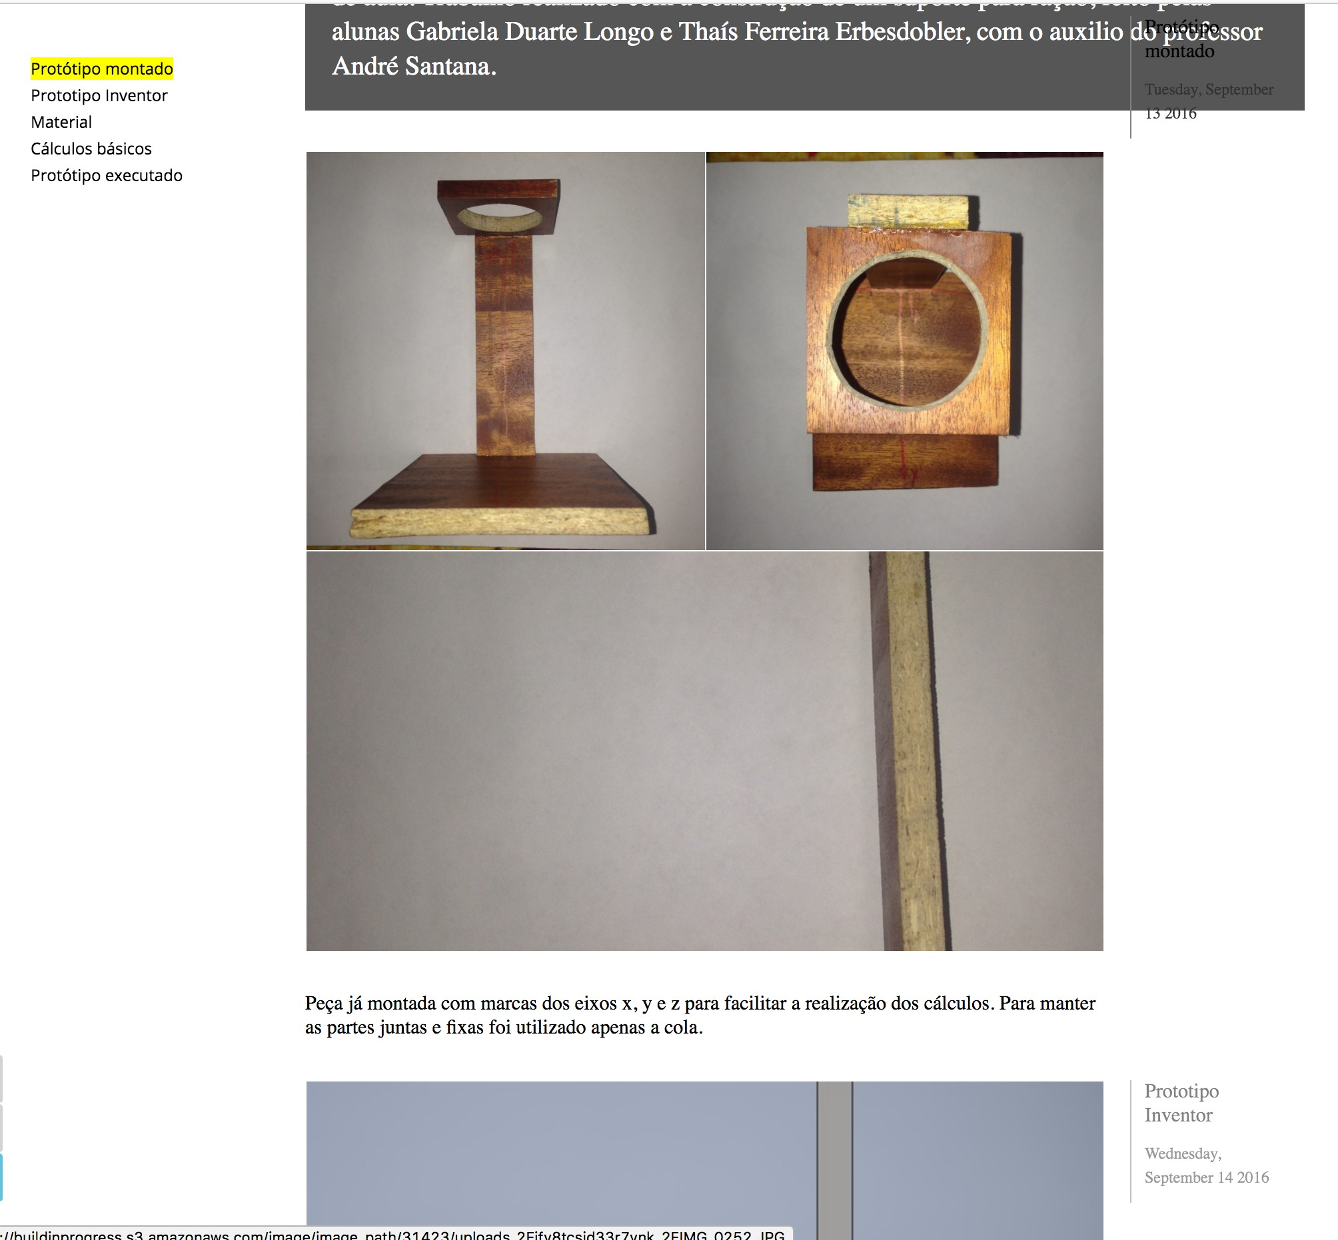

Figure 2.9: Blog like mode

In *Details of step* users can upload photos or videos, add text description, ask others a question that will appear in the homepage of the platform, upload resources or files in different formats; e.g. .PDF, .PPT, a given example is shown in the figure 2.10 .

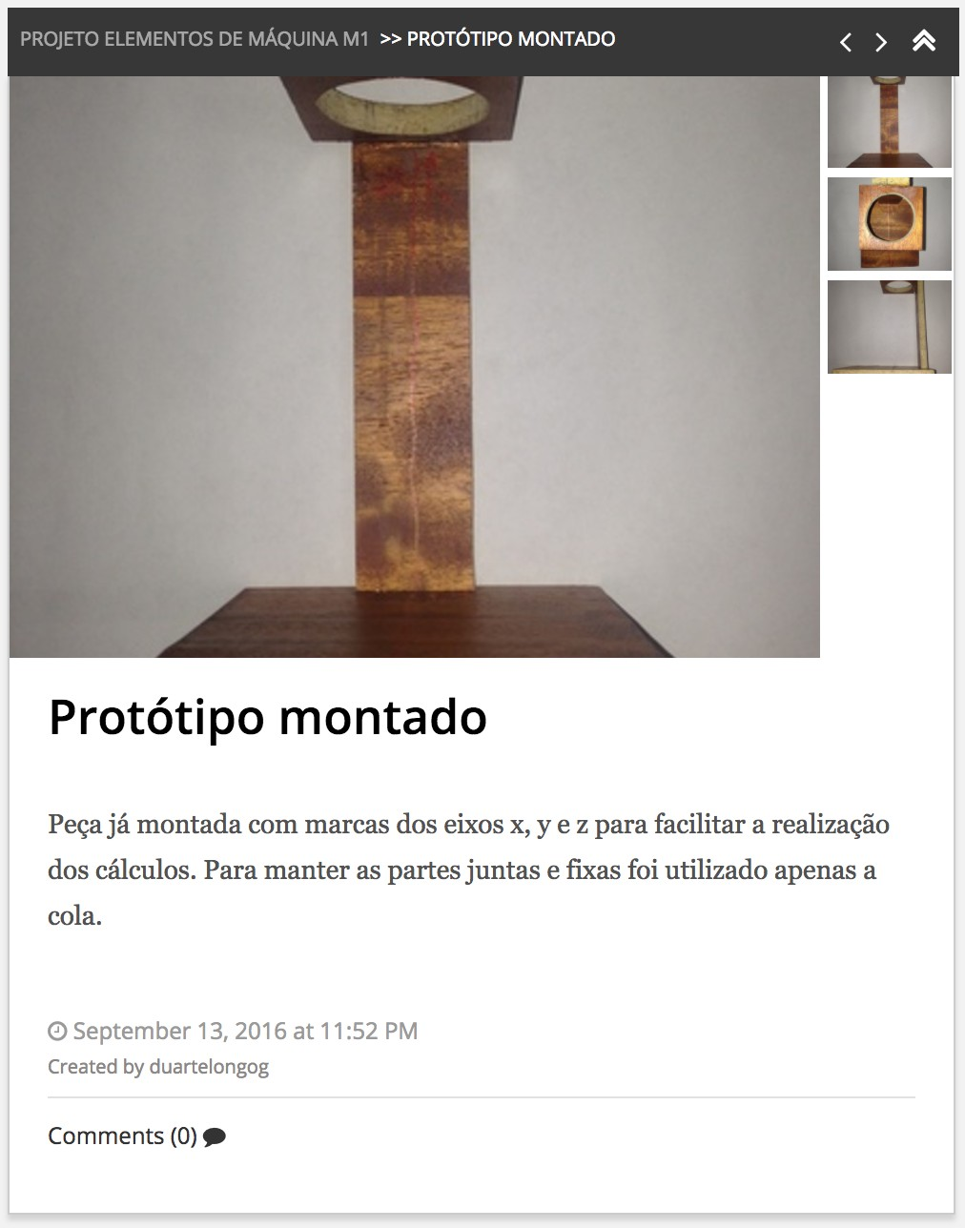

Figure 2.10: Details steps view

The online platform incorporated many features that keep the BiP commu- nity more socialized and connected. Users can follow a project, see recent activity on the homepage and they will receive notification once an author add a step or ask a question.

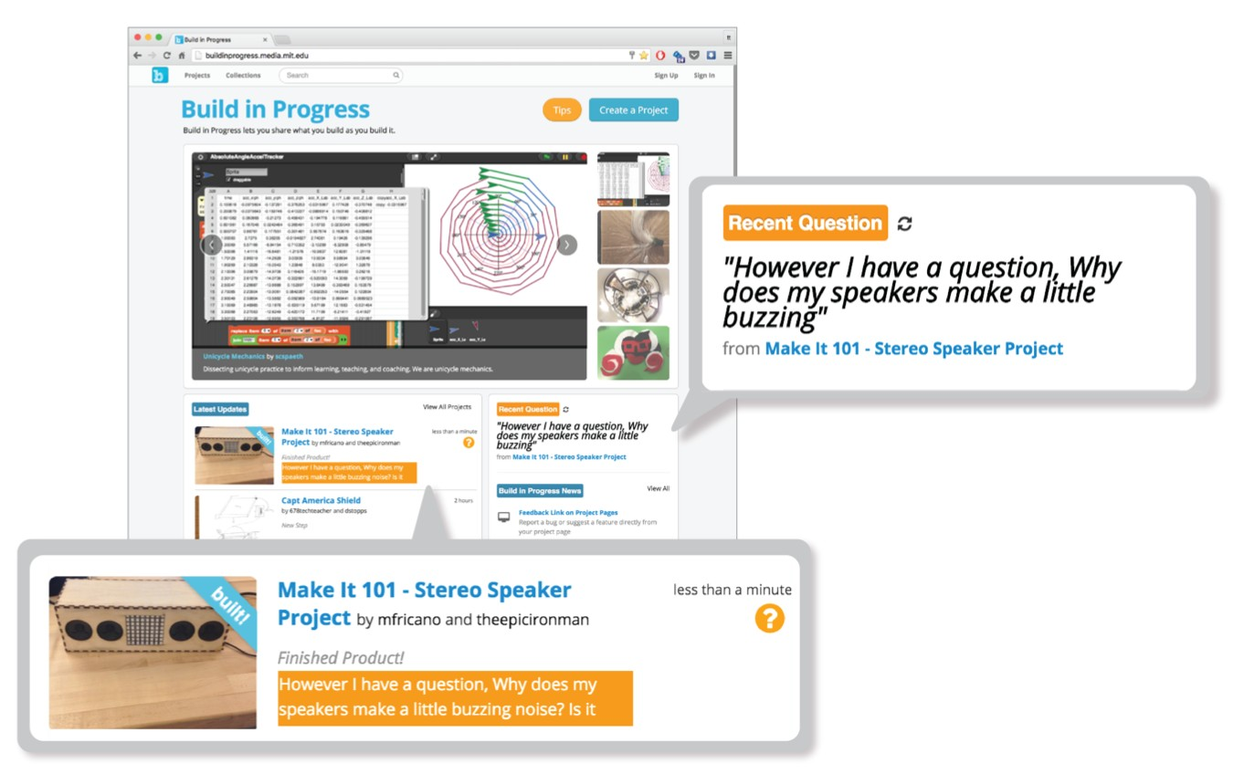

Figure 2.11: Question featured in the home page, [Tseng, 2016]

Moreover, users can leave a text on any step and they will receive a noti- fication when a comment is left. Authors can ask for feedback or help by embedding a question that will be added to the the Community Activity section of the homepage, see figure 2.11.

**Mobile application**

A mobile application created to make documentation more efficient in which users upload images and videos to their projects directly from their devices instead of taking picture from their devices then transfer it to a computer and upload it (figure 2.12.

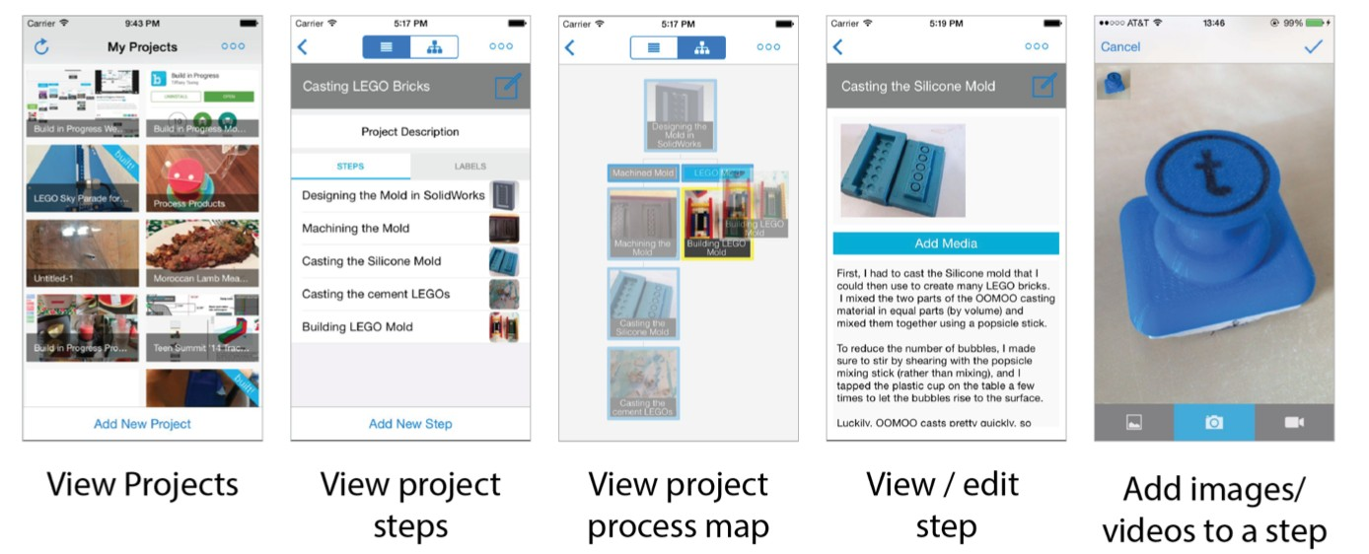

Figure 2.12: Mobile application interface, [Tseng, 2016]

**2.2.3 User interaction**

BiP has been used in after-school programs, in school and in workshop challenge by students and makers who work on their own project. Teenagers and one adult facilitator have been interviewed and a weekly survey was sent to all users to get an estimation about their weekly hours work.

The results of the interviews and surveys showed that users get motivated to share their project as it facilitate getting feedback, create and show their portfolio projects, get engaged to document and to help others. Users found that BiP support meaningful documentation practices and many strategies was identified depending on the type of project, the duration of a project and the age of makers who are using it.

**2.2.4 Summary**

The study of BuildinProgress showed that BiP support authors and readers. The documentation help makers to create a design process for their project by learning from the many iterations they did over time and BiP motivates

reflective practice on making, design process, and values and identity. Users get engaged, get feedback, get self reward and help others. It support all capturing way written and visual.

**2.3 Discussion**

BiP and Instructables didn’t bring a new fundamental way in which users can share their captured media publicly or in private. Design parameters can be adjusted to support different type of users-interactions and goals. Instructables enable users to personalize through substitution and modifica- tion of a step and any missing step mean that authors should re-create their documentation while BiP focus more on the design process where users can iterate their project by creating new branch and forget about the unsuccess- ful branches.

The mix between Capturing and text-based feature in BiP enable teenagers to document, the easy of use for creating a branch, drag and drop simplify the job for younger audience especially readers who are new to the commu- nity of *DIY*. Instructables has both features but there is no friendly structure where authors get their documentation organized and if an authors has a limited background in documentation or he doesn’t like it, he will probably abandon the documentation of a project after the first type a user find that it is not possible to re-arrage the documented steps.

Sharing a project is not enough for users, Users in Instructables found that they cannot share their thought or it is limited as the only way to express it is via a comment. BiP offers a text-based option where both authors and readers could ask a question or leave a comment, also, both can receive a notifications for a reply or any other news concerning any modification in the project.

The process of sharing the effort in progress enable users to communicate more in BiP, they helped each other, they show their effort, they get featured and receive feedback as described in section 2.2.2. Balancing the ease of use of automated documentation systems with the powerful feature to use mobile application encourage more users to use it more and enable them to be physically free so they can move around to document their project for example without having the problem of taking a photo, remember which step it is, transfer it then upload it to the platform as in Instructables.

**2.4 Future Work**

As we see, innovators need tools of documentation to support their innova- tions. I found that it is not possible find one tools that support different

goals and types of interactions especially if users are from different back- ground and different ages. But the availability of features in some tools can enable users to fulfil their need either it is showing their effort, keep tracks of their ideas, sharing their experience or exchange knowledge.

In this state-of-the-art I analysed *Instructables* the most popular online com- munity for *DIY* and the most recent *DIY* platform *BuildinProgress* but at the same time I went through many other online community *Dorkbot, Ravelry, Craftster, Etsy, hacker, hackster.io* and I found that *DIY* community share one need : A tool that enable makers, hackers and innovators to share their expe- riences in a proper and meaningful ways. Another thing I have learned from my experience of more than 13 hackathons and the analyses of *Instructables* and *BiP* that developing a new tools will not bring a new fundamental way of capturing media or writing text for documentation. Eventually, a goal would be to improve the process map used in BiP.

I can conclude that an existing tool is needed from a wide range of *DIY* community that would enable them to document in a meaningful way and make their documentation more sustainable. I believe A tool that contains all necessary feature for documentation with enhanced design process could be the new popular tool to use by *DIY* community to document their effort in meaningful way, to prove this we need to see how hackers, innovators could use this tool and if it satisfy their need or not.

**Bibliography**

[BiP, 2015] BiP (2015). Buildinprogress. [BiP, 2016] BiP (2016). Buildinprogress.

[Instructables, 2015] Instructables (2015). Instructables.

[Kotlarsky and Oshri, 2005] Kotlarsky, J. and Oshri, I. (2005). Social ties, knowledge sharing and successful collaboration in globally distributed system development projects. *European Journal of Information Systems*,

14(1):37–48.

[Kuznetsov and Paulos, 2010] Kuznetsov, S. and Paulos, E. (2010). Rise of the expert amateur: Diy projects, communities, and cultures. In *Proceed- ings of the 6th Nordic Conference on Human-Computer Interaction: Extending Boundaries*, NordiCHI ’10, pages 295–304, New York, NY, USA. ACM.

[Lethbridge et al., 2003] Lethbridge, T. C., Singer, J., and Forward, A. (2003).

How software engineers use documentation: the state of the practice.

*IEEE Software*, 20(6):35–39.

[Lovell and Buechley, 2010] Lovell, E. and Buechley, L. (2010). An e-sewing tutorial for diy learning. In *Proceedings of the 9th International Conference on Interaction Design and Children*, pages 230–233. ACM.

[Tseng, 2016] Tseng, T. (2016). *Making make-throughs: documentation as stories of design process*. PhD thesis, Massachusetts Institute of Technology.

[Tseng and Resnick, 2014] Tseng, T. and Resnick, M. (2014). Product versus process: Representing and appropriating diy projects online. In *Proceed- ings of the 2014 Conference on Designing Interactive Systems*, DIS ’14, pages

425–428, New York, NY, USA. ACM.

[Wakkary et al., 2015] Wakkary, R., Schilling, M. L., Dalton, M. A., Hauser, S., Desjardins, A., Zhang, X., and Lin, H. W. (2015). Tutorial authorship and hybrid designers: The joy (and frustration) of diy tutorials. In *Pro- ceedings of the 33rd Annual ACM Conference on Human Factors in Computing Systems*, CHI ’15, pages 609–618, New York, NY, USA. ACM.

[Wikipedia, 2017] Wikipedia (2017). Instructables — Wikipedia, the free en- cyclopedia. [Online; accessed 05-September-2017].