Examination/Quiz Application of CAU Imphal

Current Version – V-2.1 (stable)

Content
- Introduction
- Levels and Roles
- Modules
- Database
- Result
- Tools Used
- Conclusion
- References

Introduction:

The application has been designed to streamline the quiz and examination system of Central Agricultural University Imphal. Students can now register an account and start taking quiz as and when available. As of now the quiz/exam is of Multiple Choice Type questions where there will be either 2 or 4 options and out of which there will be one correct answer. Student has to carefully choose the correct answer, mark it and save it. There will be a count-down timer allocated to each quiz/examination and as soon as it expires, the quiz will be automatically closed by system.
This manual is for Administrators only.

Levels and Roles:

In this application the top most user is called Super Admin which controls all the modules and there is Local Admin, Local admin 2 and Local Admin 3 and finally the Students who will be end user of this application.
The login page is same for all. As per the role assigned to the users, the system will automatically redirect to the respective pages. The Login Page is https://www.cauimphal.online/quizapp/public/login

Student Role:
Students can create their accounts by clicking on Register button given on the page and as such after creation, the authority will approve their accounts. This approval role is given to Local Admin and Super Admin only.
After creation of their account and after getting approval from the Administrators, students can now see their dashboard where they are allowed to take examination by choosing the right paper from the dropdown list provided.
Once they select their choice, they can appear for the examination. Once they click on “start my exam”, their details are registered in the system automatically and as such a countdown timer will automatically start. As soon as this countdown timer is expired, the application will be automatically closed and hence students must choose the correct answer and save it. All the records are saved in highly secure database of CAU Imphal and is readily available as and when it is requested with proper authentication.
All the questions are multiple choice type questions and system knows the correct answer. The answer given/provided by student is compared with the correct one and as such the result can be calculated instantly. It may either be released to students right after the examination on the application or via email or later as per requirement.

Local Admin 2:
The role of Local Admin 2 is to create quiz, map quiz, create question for the quiz only. Create quiz is basically creation of a title of the exam/quiz and as soon as it is created, the quiz is mapped to the user’s Location.

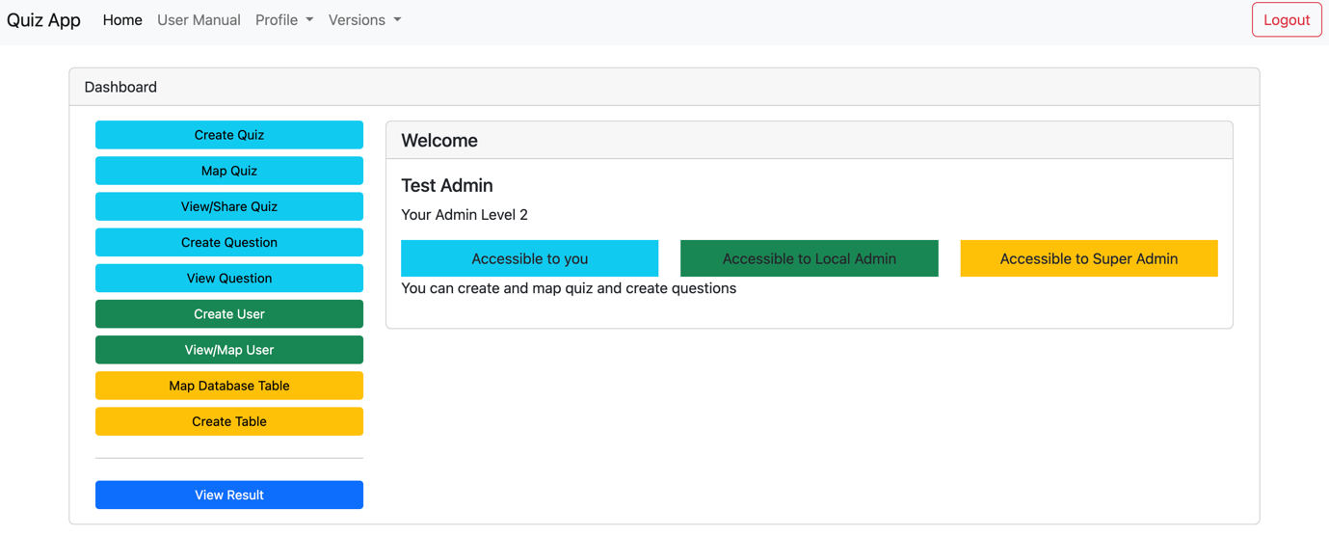

The above image shows the dashboard of an Admin Level 2. As displayed in color, user can what is accessible to him/her.
For new quiz/new topic creation, click on “Create Quiz” on the left panel and a page will appear like follows:

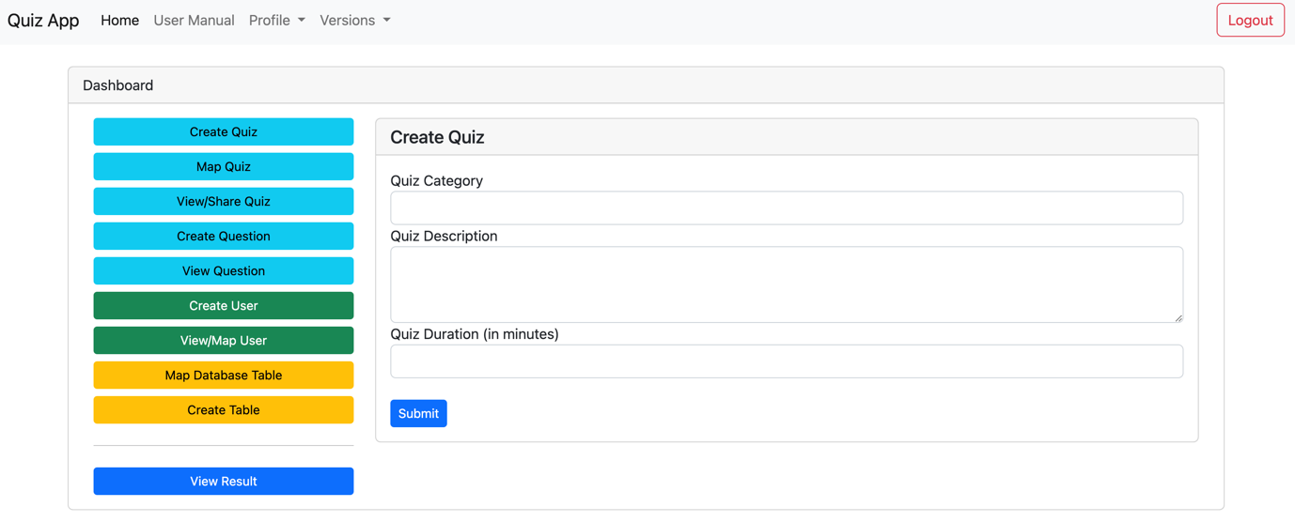

Here, a quiz title/category/subject is to be entered along with a brief description and duration of the quiz must be set here. The Admin users always have the right to modify these details in future also. While creating a new quiz, care should be taken while entering the duration as the exact countdown of the quiz will be determined from here and system will automatically close as the countdown expires at Students’ end.
Now after creation of the quiz, Admins must map the quiz by selecting the quiz which was just created with the “4 Option Type”

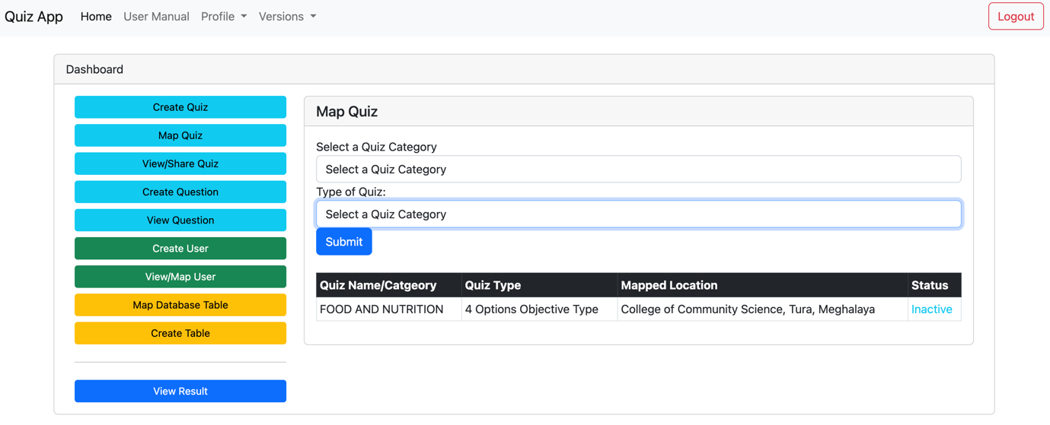

This part is especially added for future scope when we want to add more Type of Quiz like “2 Options type Quiz”, “Descriptive Answer Type” or “Mixed type” in future. But for time being only “4 Options type Quiz” is available for selection.
Here, all the other quizzes from other locations are also visible but Admin Level 2 are provided with permission to modify their Location’s only.

Further, if we go to “View/Share Quiz”, Admins can see the list of Quizzes for the present Location only. From here, Admins can edit quiz details, Delete and even share, However the share capability is provided to Local Admin and Super Admin Only and Delete option is available as long as the quiz is not mapped with. Also by clicking on the quiz topic, Admins can see the list of question added under this quiz topic.
Since the multiple-choice type questions can be of two Options type or Four Options type, Local Admin 2 can map the quiz type.
Mapped quiz can be further shared to other locations. Here, all the questions will also be shared along with the quiz duration, title etc. Once shared and published, the students of the shared quiz can also see the quiz in their dashboard dropdown list and they can take part in the quiz.

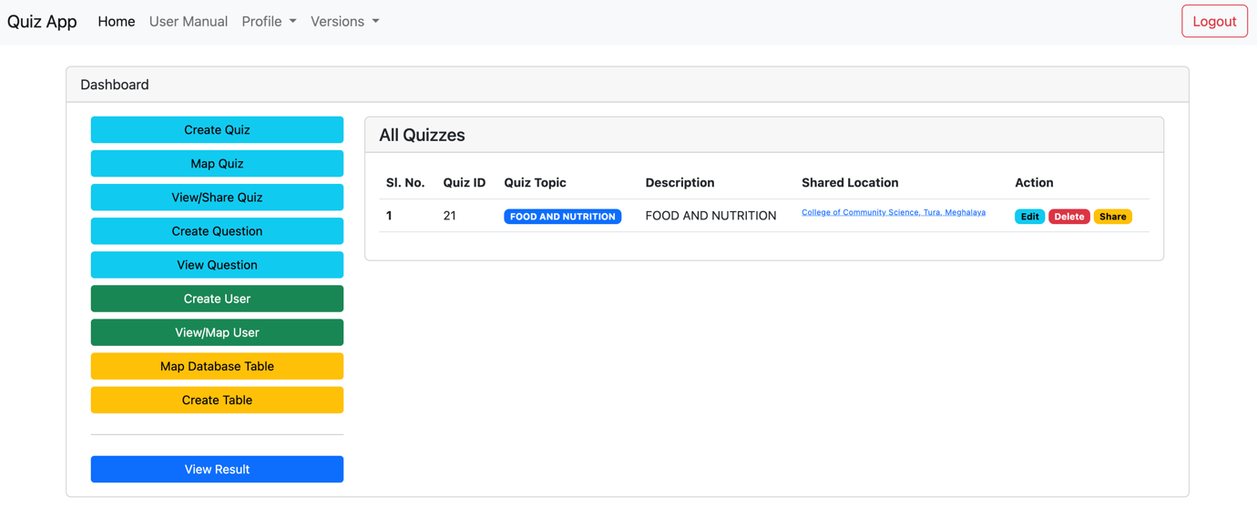

Once mapping is completed, Local Admin 2 can start creating questions for the quizzes created. Here, if there are multiple Local Admin 2s of a particular location, the quiz created by one is visible to other and same goes for Question but in the database, the creator’s credentials are marked for future reference. However, if the Local Admin 2s are of different Locations, the activities are not visible to one another [However, all are visible to Super Admin].
At the time of Question creation, the Local Admin 2 must take care of selecting the suitable quiz topic before adding each question.

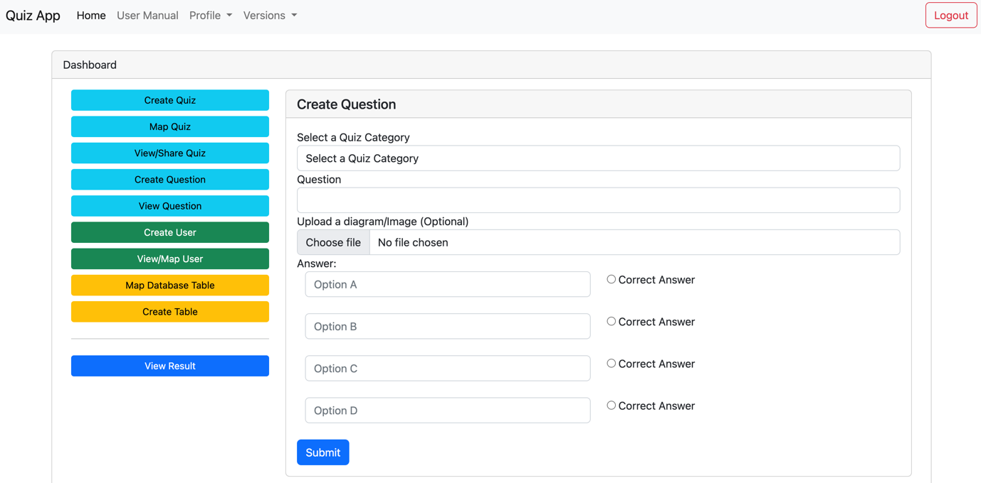
After selection the quiz category, we need to type the whole question, provide the options and mark the correct option so that the system knows the correct one for easy calculation. Further a facility has also been added that if there is symbols which cannot be saved as plain text in database, we can take a screenshot of it crop it properly and upload as question. Similarly, here also, the Admin has to mark the correct answer by choosing the correct one.
Thus Admins can add as many questions as they want.
Further, list of all the questions can be checked from the “View Question” Tab on the left panel

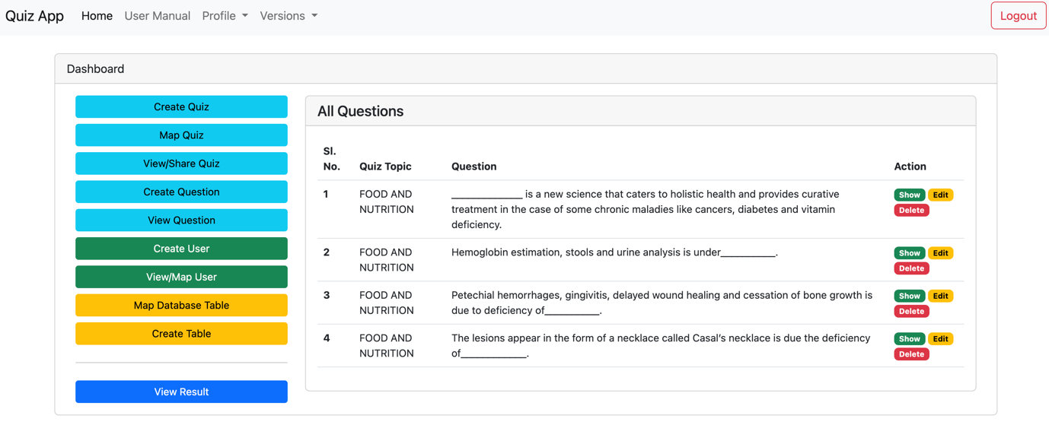

Here also, Admins can show, edit and delete questions as per requirement.

Local Admin:
Here, all the roles provided to a Local Admin 2 is also provided with Local Admin and on top of it there are few more roles here that a Local Admin has the ability to create, map new users on the portal, however, the transfer facility is provided to Super Admin only.
The Green Tabs are accessible to Local Admins and Super Admins only. Here Local Admins can create new users also from the portal.

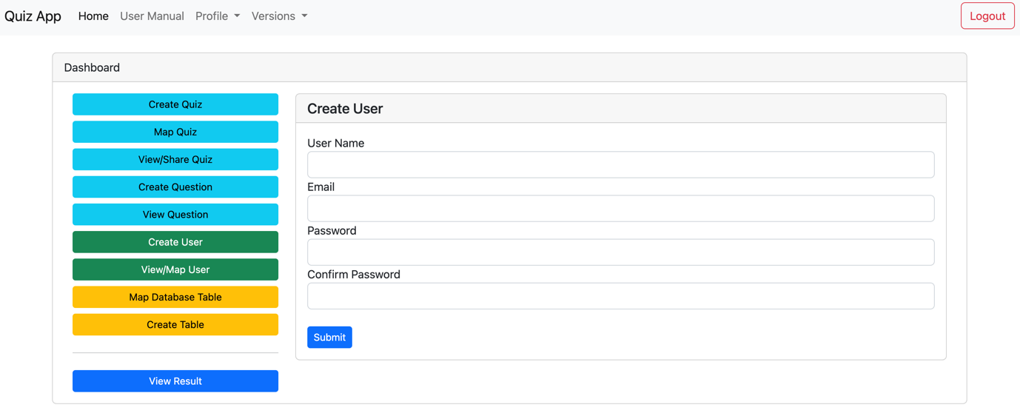

Only a basic information as asked for account creation. Accounts created are not given right to access the portal. They are to be approved by Local Admin.

Approval is done by clicking on “View/Map User”

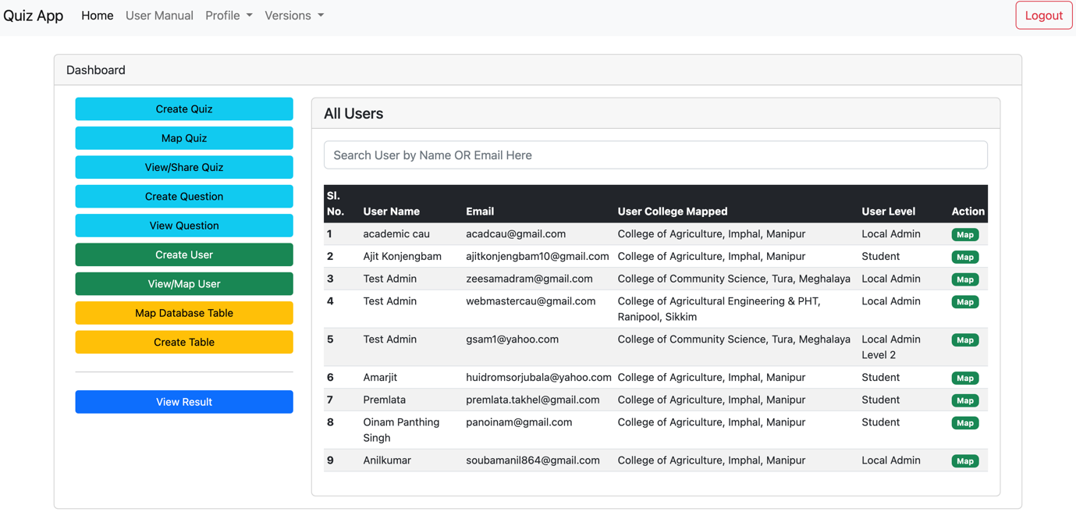

The Users’ list is available here and those unmapped users can be mapped with a new role along with a location for accessibility. Once mapped, they are considered as approved and hence the approved users can access the portal.
Also, Local Admins can take the advantage of using Search Bar where search is filtered by “Name” or “Email” for easy access.

Local Admin can also map the database table. It was initially intended for Super Admins but as there was requirement of it, facility was provided to Local Admins too. Database Table Mapping is mapping of a table for storing answers of the quiz/exam to be conducted. Once a table is mapped with the quiz/exam, the quiz/exam can be published as and when required by the examination committee/authority.

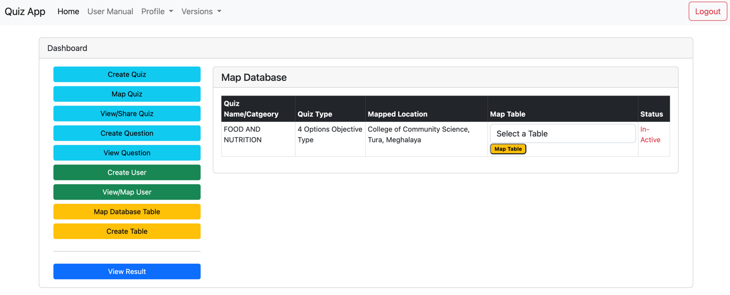

Once published, the exam/quiz status will become “Active” and as such, it will start showing up in the students’ portal. At this point of time, students can start taking the exam/quiz. The quiz can also be un-publish at any point of time by Local Admin and if unpublished, the status will be changed to In-Active and therefore, students can no longer take examination.

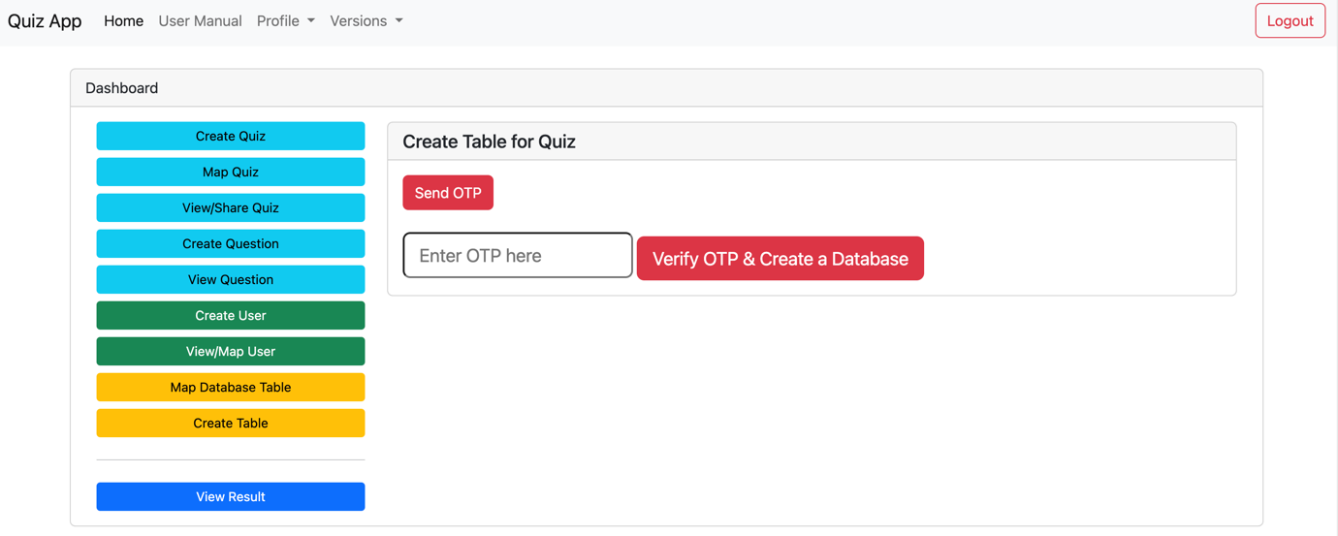

Every quiz must be mapped with a table for storing answers from Students. If all the provided tables are exhausted, we can create new tables. We have added 2-Factor Authentication as creating a table in database will lead to extra space so to avoid creation of table by mistake a 2-Factor Email Authentication system has been added where the facility has been provided to Local Admin and Super Admin Only. When clicked on Send OTP, the system will send an OTP to the registered email and the OTP must be entered, system will verify the OTP and with the correctness of the OTP, system will decide the creation of a table.
Once created, it will appear on the table list dropdown for mapping.

Version 2.1.2: Additional Module:
As per requirement, a new module “Exam Student Selector” is now added where, faculties can now select only those students who can appear in examination. Only the selected students will have access to the quiz published. Note: It is to be noted that after selection of the students, the Local Admin must publish the quiz. Further if the quiz added by faculties is not appearing in the List of “Exam Student Selector” Tab, mapping must be done. Make sure the mapping is done by going to “Map Quiz” section.
The following image shows the Page where the quizzes added by the Faculty is listed and Faculties need to choose the quiz which he/she would like to conduct and click on it to select the students who will be appearing for the examination.

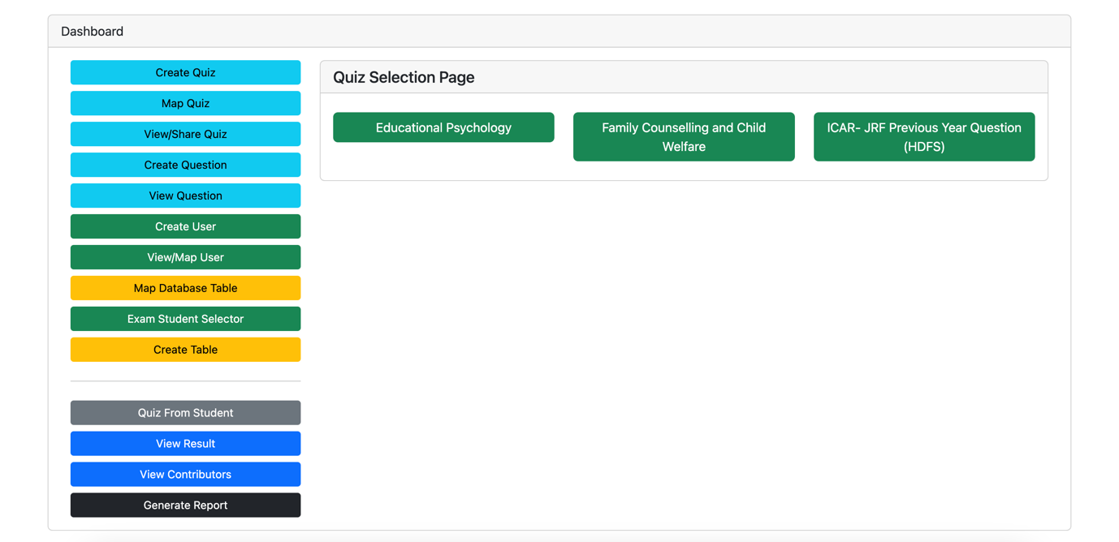

As for Instance here the following image shows the list of students which are to be selected for the Quiz “Educational Psychology” is listed and we can search from the list and choose the student from the list. Selected students will be listed in the Right-hand side and those students in the right-hand side is selected for appearing in examination/quiz and they are automatically saved in the database. They can also be removed as and when needed by the concerned faculty.

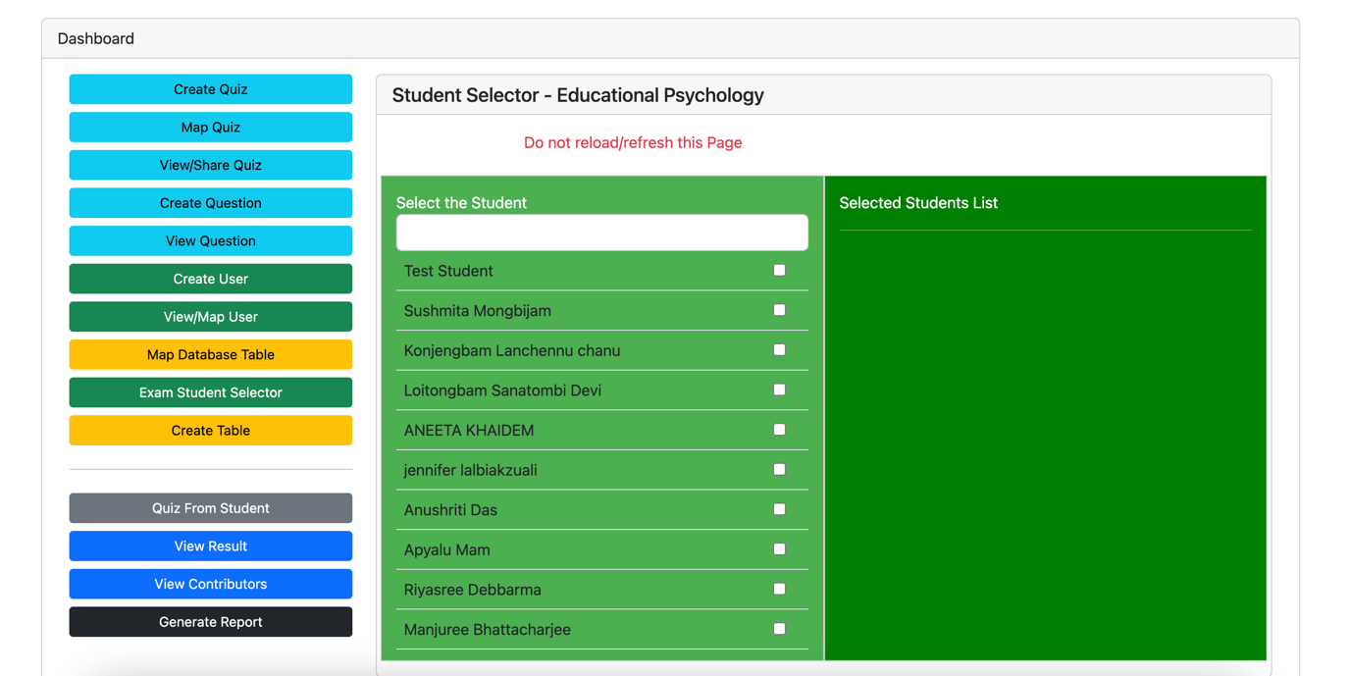

Modules:

Here, we have designed 4 modules,
- Quiz Modules – where all the topics and subjects are added
- Question Module – where all the questions related to the quizzes are added
- Student Module – as explained above in roles
- Result Module – the result module is described in the later heading “Result”

Result:

Examination/Quiz result is one of the most crucial parts in this module and we have designed a system where the result declaration is very quick and accurate.
Since the system is already aware of all the correct answers which is provided by the Local Admin 2, the examination result can be declared as soon as the exam/quiz is over or we can fix a date and time for result declaration. On the click of a button, all the results will be declared by the system on the portal and as per requirement, the same may be sent as email to the students.
The result is provided in various forms like consolidated form where all the students who took the examination are displayed along with marks secured, full mark and also percentage. Further we can even display the student-wise result which allows us to check question-wise where the errors are.

Tools Used:
The Application has been designed solely with Laravel Framework as backend, bootstrap as frontend, javascript and livewire as interactive modules and MySQL as database.
The application is highly secure one and it is virtually uncrackable with SSL protected URL and Middleware Protection.

Conclusion:
We are proud to present to you our Alpha Version of Quiz Application currently named V-1.1(alpha). The application is portable and as it has been developed using a PHP Framework, it is suitable for any Operating System Environment like Windows, Linux, MacOS and so on. Since the application is in alpha version, it is expected to have some glitches and we are ready to fix any bug/issue that comes up before we release the beta and then stable version of the application. Hope this piece of application will be helpful to you in streamlining the manual works.

References:
- Laravel Framework – version 10
- Breeze Authentication for login
- Socialite for Google and Facebook Login
- Livewire for interactive and easy to use designs
- Bootstrap 5.2 as frontend tool
- Mews\Captcha for captcha verification tool

