Examination/Quiz Application of CAU Imphal

Current Version – V-2.1 (stable)

Content
- Introduction
- Login and Register
- Dashboard
- Quiz Page
- Result

Introduction:

The application has been designed to streamline the quiz and examination system of Central Agricultural University Imphal. Students can now register an account and start taking quiz as and when available. As of now the quiz/exam is of Multiple Choice Type questions where there will be either 2 or 4 options and out of which there will be one correct answer. Student has to carefully choose the correct answer, mark it and save it. There will be a count-down timer allocated to each quiz/examination and as soon as it expires, the quiz will be automatically closed by system.

Login & Register:

The application is so designed that all the users have to be registered on the portal using and email address and a password of their choice. The user, after registration will not get full access of the portal. They are to be approved by their respective administrator. Once approved, they will get access to dashboard.
The Login email and password will be credentials for login to the portal. Users can also directly login without registering if they have their Google Account. Here, Google Oauth2 authentication has been used and as such the necessary data from google is fetched and stored in the portal for future logins.

This is the registration page where each and every candidate has to fill their full name, email, password and password confirmation. After registration, candidate has to wait for their account approval.

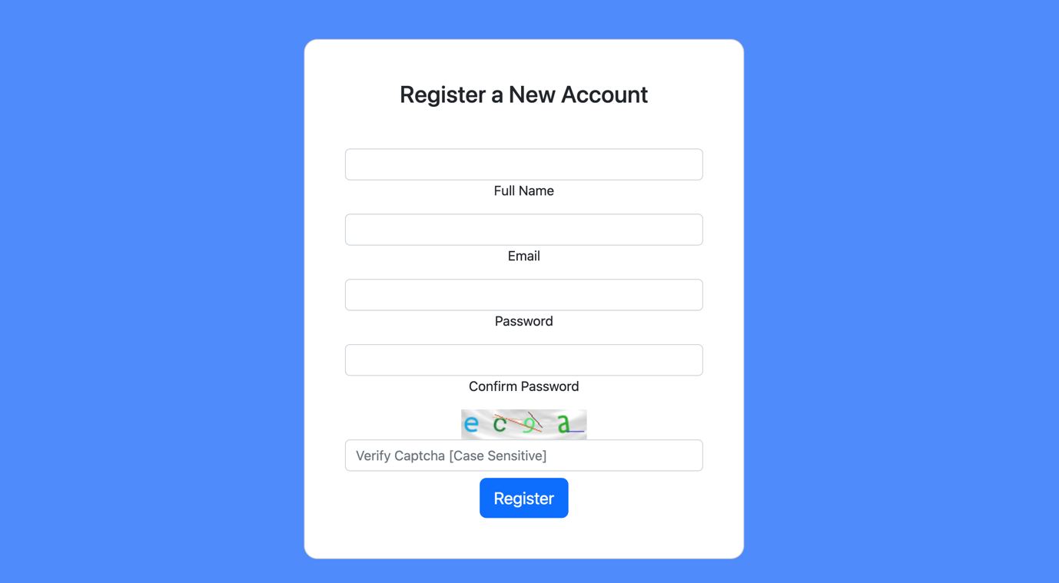

On the other hand, candidates can also register directly using their google account by clicking on “Sign in with Google”. Here, they will be redirected to a google Oauth2 page and necessary authentication is done by providing the google email and password credentials and then once verified, candidate’s credentials except the google password are stored in our database and in future, the candidates may also reset their password, change name etc. by going to Profile Page.

Following shows the Login Page of the portal and above all there is a Forgot Password Page where the User can reset their password by clicking on it. A password reset link will be sent to the email and as such a new password can be set.
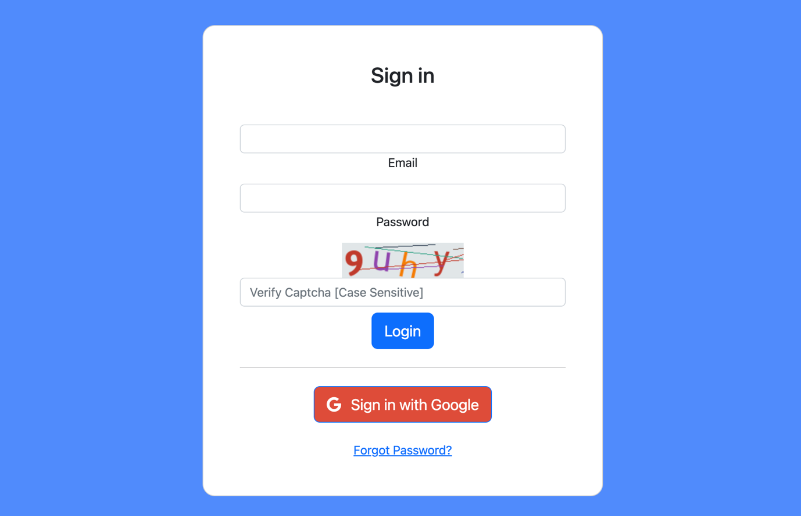

Dashboard

The following image shows the dashboard of candidate:
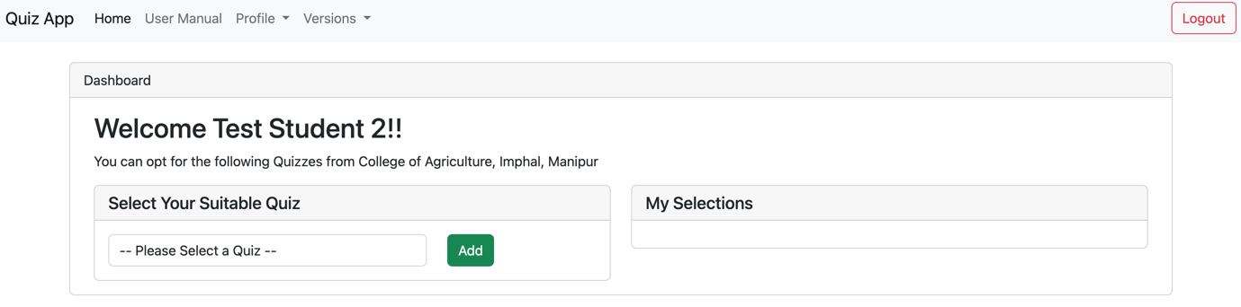

After getting approval, candidates can select their suitable quiz and all the selected quizzes will be shown in My Selections tab. Here, candidates can start quiz one by one by clicking on the Quiz Title shown in My Selections tab.
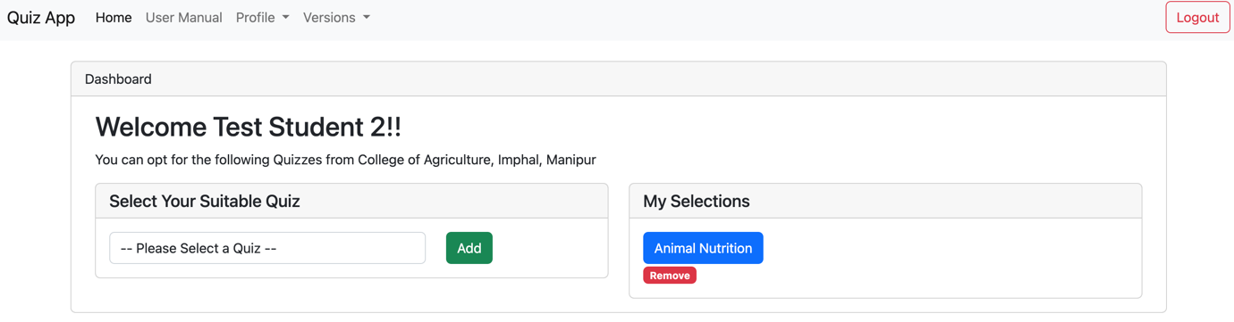

For example, the candidate has selected Animal Nutrition and here by clicking on Animal Nutrition, he/she can start the quiz. Once the quiz starts, a countdown timer will begin and as such candidates have to complete the quiz within the stipulated time or the system will automatically close the session.
Also, if the quiz title was added by mistake, candidates can remove it by clicking on the remove button provided. However, if the quiz has been started, this “remove” button will not work.

Quiz Page:
The following image shows the quiz page:

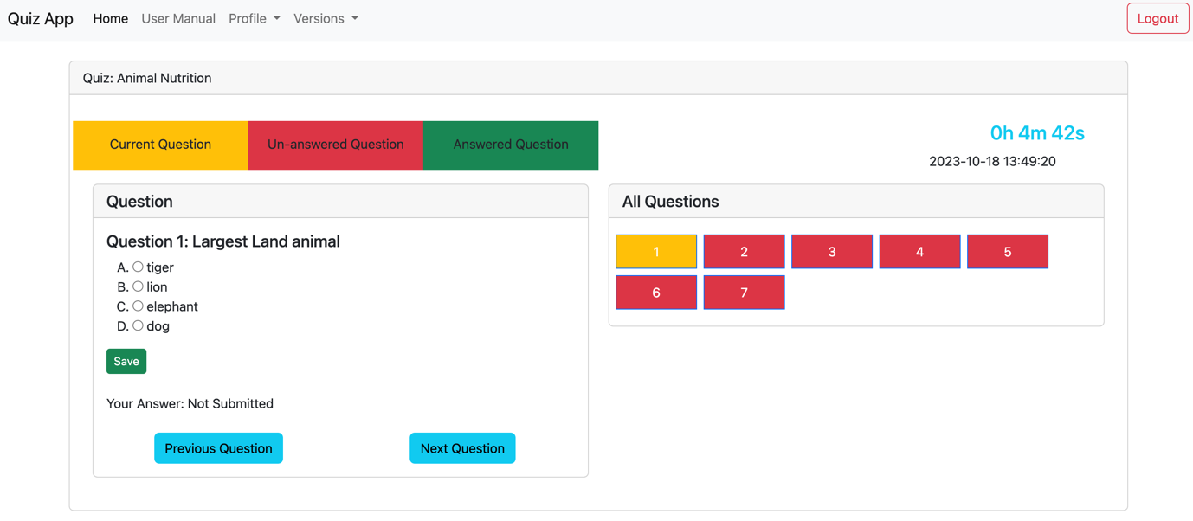

On the left panel, the current question is appearing, candidate has to choose the answer choice and the same must be marked and save. After saving the candidate can move to next question.

On the right panel, candidates can see a countdown timer and Ending date and time. Here, list of all the questions are also displayed in the portal, hence, candidates can also jump from one question to another randomly and attempt.
As per the color indication
Yellow – Current Question
Red - Un-attempted Question
Green - Answer marked

Once the countdown timer expires, a popup message will appear and candidate will be redirected to the dashboard automatically and will not be allowed to go back to the same quiz again. Candidates can take other quiz at any point of time.

Result:

Result can be obtained instantly. System will calculate the score, percentage

