Solution is developed using spring boot, Swagger, JPA and H2(in memory database).

Following are the Instructions to run the application.

**Pre-requisite**: Java and Maven should already be installed on your machine.

1. Copy the zip file to a directory <source-dir>. Let’s say /tmp.
2. Open command prompt/console.
3. Change directory to <source-dir>.



1. When you are in source directory type ls command to make sure if zip file is present.



1. Unzip the file to a directory called twitter.



1. Go to twitter directory.

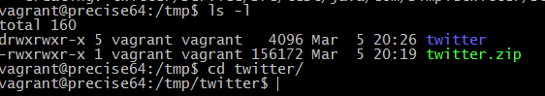

1. Type “mvn package”



1. Type “java -jar api/target/api-0.0.1-SNAPSHOT.jar”

(It will start swagger UI on port 8080. Please make sure that 8080 is not already in use.If you want to change it please change it in api/src/main/resources/application.properties)



1. Open browser and go to following URL. Swagger UI is running on port 8080.

http://<your-machine-name>:8080/swagger-ui.html and click “List Operations”.

You will see following screen.

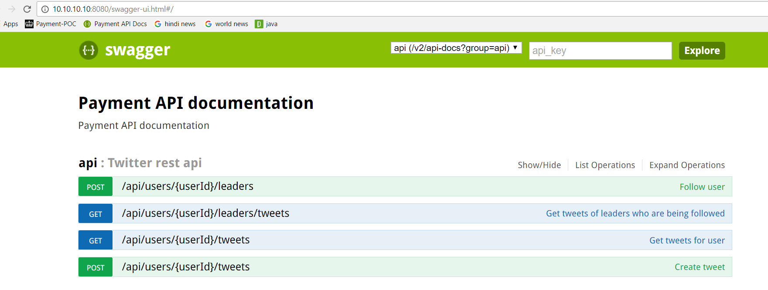

Here is the Mapping of requirement to api operation.

