Big Data with Hadoop — Palmer Penguins Assessment
HDFS · Hive · WebHDFS + Pandas ELT · PySpark on YARN
Zeeshan Abbas — Aptech North
22 October 2026
Table of Contents

1. Introduction
A wildlife research team wants to explore penguin measurements across species and islands. This project stores the Palmer Penguins dataset in HDFS, queries it with Hive (HiveQL), cleans it in Python/Pandas over WebHDFS, and processes it with a PySpark application submitted to YARN. Every screenshot in this report is the real output captured while running the work end to end.
Dataset: penguins.csv — 344 records, 8 columns (species, island, bill_length_mm, bill_depth_mm, flipper_length_mm, body_mass_g, sex, year). Source: https://raw.githubusercontent.com/allisonhorst/palmerpenguins/main/inst/extdata/penguins.csv

1.1 Environment
Component | Version / Detail
Hadoop (HDFS + YARN) | Apache Hadoop 3.3.6, single-node cluster, host sandbox-hdp
Hive | Apache Hive 3.1.3, HiveServer2 on port 10000 (beeline client)
Spark | Apache Spark 3.5.1 (PySpark), spark-submit (YARN and local mode)
Python | Python 3.12, pandas, hdfs (WebHDFS InsecureClient), Jupyter
Java | OpenJDK 1.8
User | maria_dev, HDFS home /user/maria_dev

1.2 Repository structure
hadoop-penguins/
├── data/penguins.csv
├── hdfs/section1_hdfs_commands.sh
├── hive/penguins.hql
├── notebooks/penguins_elt_webhdfs.ipynb
├── spark/penguins_spark.py
├── screenshots/ (all practical screenshots)
├── report/ (this report: PDF + DOCX)
├── presentation/ (PPT)
└── README.md

1.3 Pipeline
penguins.csv (GitHub) --wget/curl--> VM local FS --hdfs dfs -put--> HDFS /user/maria_dev/datasets
| |
| Hive: penguins_db.penguins_raw <--LOAD------+
| |
| Jupyter + WebHDFS InsecureClient --> Pandas clean --> /datasets/clean/penguins_clean.csv
| |
+--------------------- PySpark (spark-submit on YARN) <-----------+
|
JSON partitioned by species --> /user/maria_dev/spark/output/penguins

2. Section 1 — HDFS Using the Command Line
Script: hdfs/section1_hdfs_commands.sh

Task 1 — Create /user/maria_dev/datasets
hdfs dfs -mkdir -p /user/maria_dev/datasets
hdfs dfs -ls /user/maria_dev
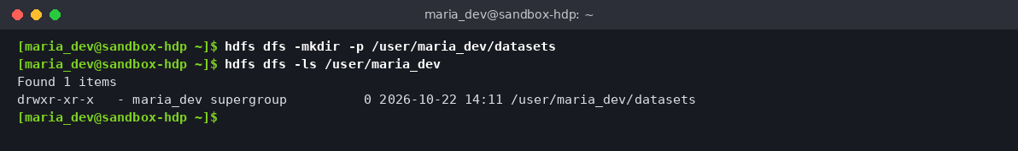
Task 1.1 — HDFS directory created

Task 2 — Download the dataset into the VM’s local file system
mkdir -p ~/datasets && cd ~/datasets
curl -sSL -o penguins.csv https://raw.githubusercontent.com/allisonhorst/palmerpenguins/main/inst/extdata/penguins.csv
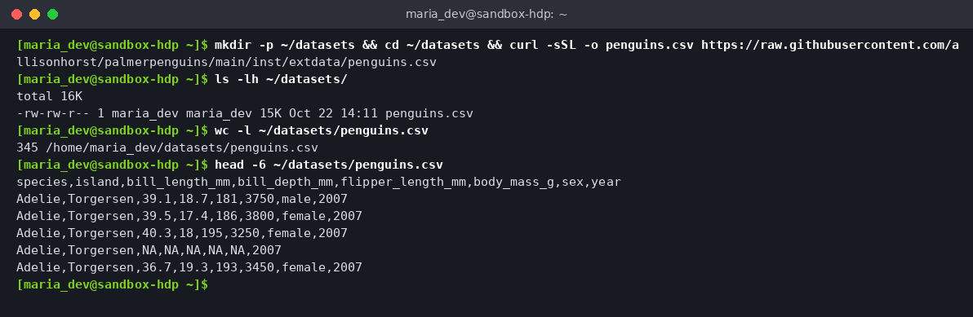
Task 1.2 — Dataset downloaded locally (345 lines = header + 344 records)

Task 3 — Copy penguins.csv into HDFS
hdfs dfs -put -f ~/datasets/penguins.csv /user/maria_dev/datasets/
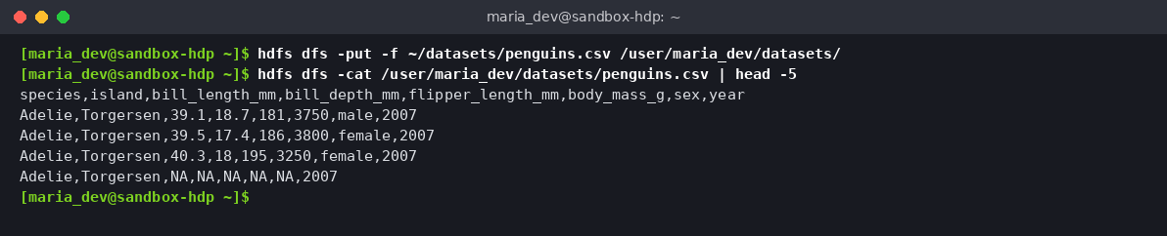
Task 1.3 — File copied into HDFS and read back with -cat

Task 4 — List the contents of /user/maria_dev/datasets
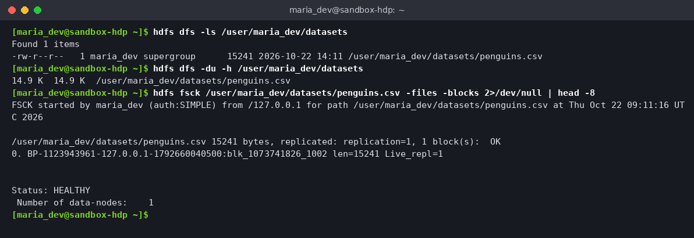
Task 1.4 — Directory listing, size and block health (fsck HEALTHY)

3. Section 2 — Hive Table and HiveQL
Script: hive/penguins.hql (run with beeline -u jdbc:hive2://localhost:10000 -n maria_dev -f penguins.hql).
Design decisions
- Typed columns (DOUBLE/INT) so aggregates work directly.
- skip.header.line.count = 1 skips the CSV header.
- serialization.null.format = 'NA' turns the dataset’s NA markers into real Hive NULLs, which makes the missing-value query correct.
- The CSV is copied to a staging folder before LOAD DATA INPATH (which moves files), so the original in /datasets stays available for Sections 3–4.

Task 1 — Create penguins_db and load penguins_raw
CREATE DATABASE IF NOT EXISTS penguins_db;
USE penguins_db;
CREATE TABLE penguins_raw (species STRING, island STRING, bill_length_mm DOUBLE,
bill_depth_mm DOUBLE, flipper_length_mm INT, body_mass_g INT, sex STRING, year INT)
ROW FORMAT DELIMITED FIELDS TERMINATED BY ',' STORED AS TEXTFILE
TBLPROPERTIES ('skip.header.line.count'='1','serialization.null.format'='NA');
LOAD DATA INPATH '/user/maria_dev/hive_stage/penguins.csv' OVERWRITE INTO TABLE penguins_raw;
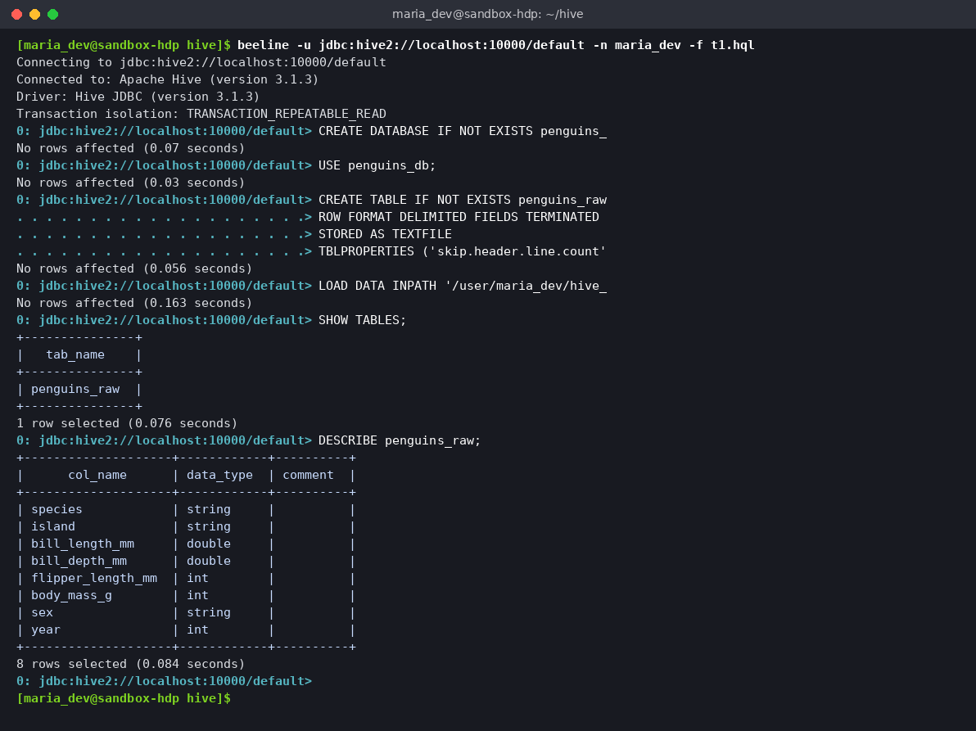
Task 2.1 — Database, table and schema

Task 2 — SELECT * FROM penguins_raw LIMIT 10;
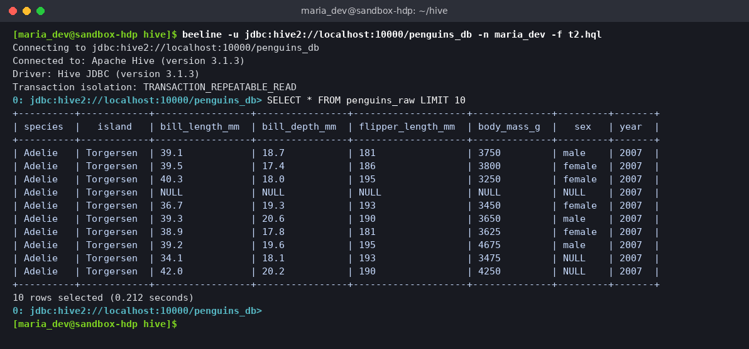
Task 2.2 — First 10 rows (NA values shown as NULL)

Task 3a — Records per species and island
SELECT species, island, COUNT(*) AS num_records
FROM penguins_raw GROUP BY species, island ORDER BY species, island;
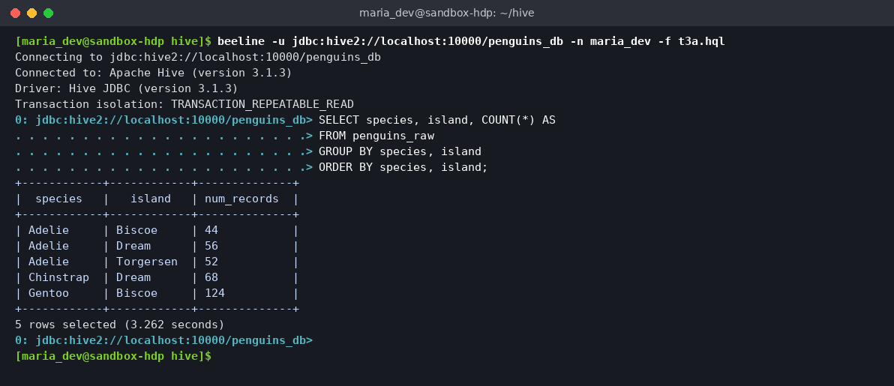
Task 2.3a — Count by species and island
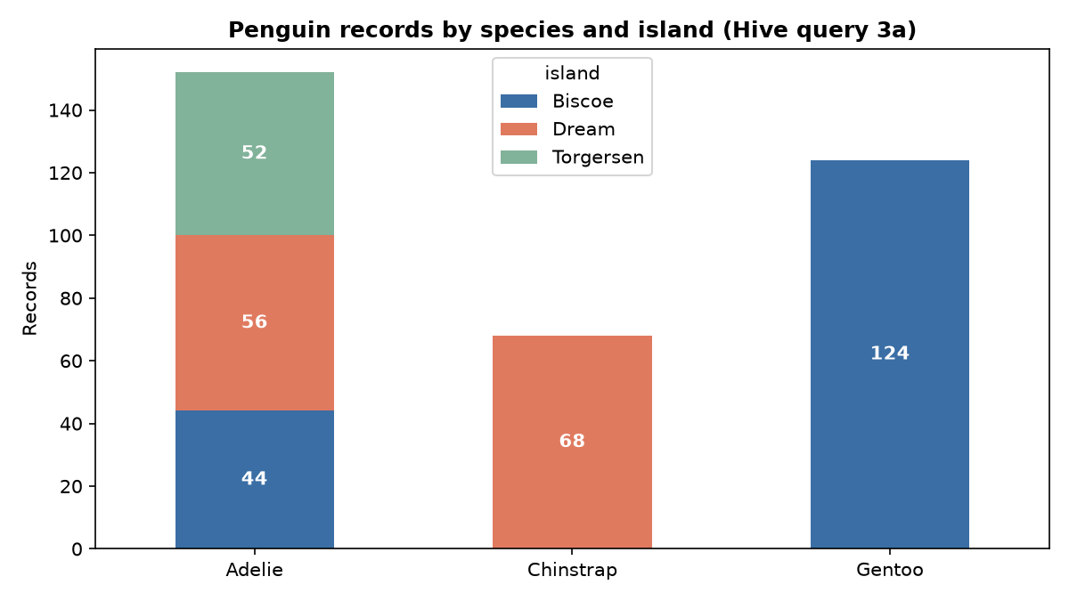
Records by species and island

Task 3b — Average body mass and flipper length per species
SELECT species, ROUND(AVG(body_mass_g),2) AS avg_body_mass_g,
ROUND(AVG(flipper_length_mm),2) AS avg_flipper_length_mm
FROM penguins_raw GROUP BY species ORDER BY avg_body_mass_g DESC;
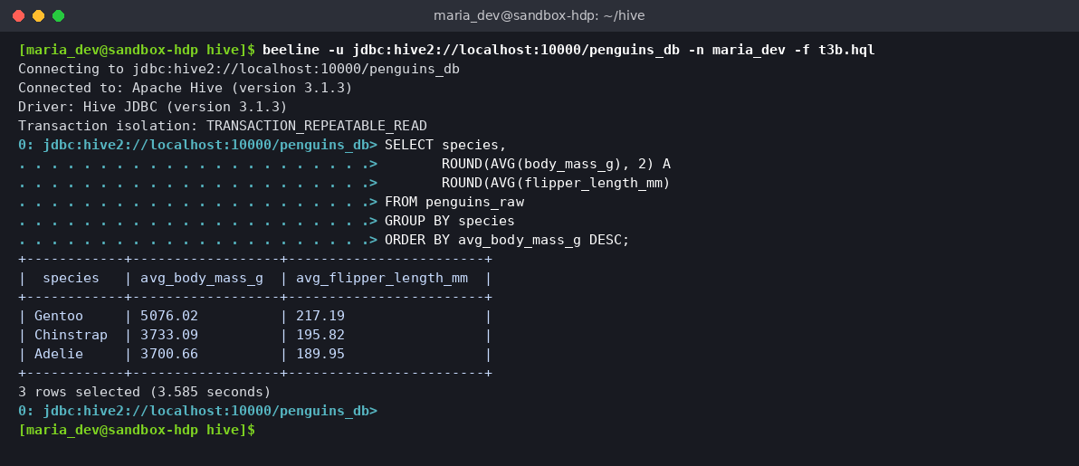
Task 2.3b — Averages per species
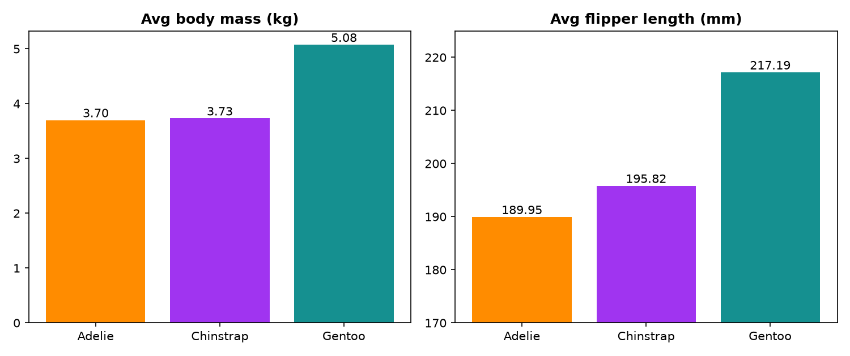
Average body mass and flipper length

Task 3c — Missing values
SELECT SUM(CASE WHEN bill_length_mm IS NULL THEN 1 ELSE 0 END),
SUM(CASE WHEN flipper_length_mm IS NULL THEN 1 ELSE 0 END),
SUM(CASE WHEN body_mass_g IS NULL THEN 1 ELSE 0 END),
SUM(CASE WHEN sex IS NULL OR TRIM(sex)='' THEN 1 ELSE 0 END)
FROM penguins_raw;
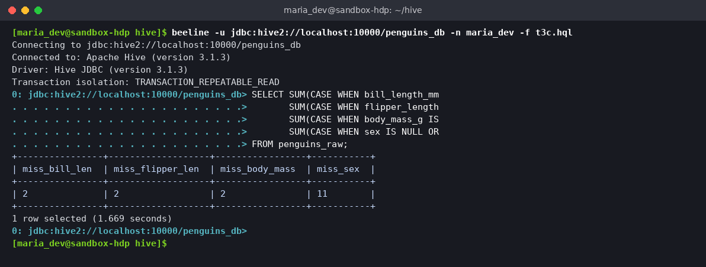
Task 2.3c — Missing value counts
Hive results summary
Query | Result
Total records | 344
Adelie (Biscoe / Dream / Torgersen) | 44 / 56 / 52
Chinstrap (Dream) | 68
Gentoo (Biscoe) | 124
Avg body mass (g): Gentoo / Chinstrap / Adelie | 5076.02 / 3733.09 / 3700.66
Avg flipper (mm): Gentoo / Chinstrap / Adelie | 217.19 / 195.82 / 189.95
Missing: bill_length / flipper / body_mass / sex | 2 / 2 / 2 / 11

4. Section 3 — ELT with WebHDFS InsecureClient
Notebook: notebooks/penguins_elt_webhdfs.ipynb

Task 1 — Connect, load into Pandas, analyse structure and missing values
from hdfs import InsecureClient
client = InsecureClient("http://localhost:9870", user="maria_dev")
with client.read("/user/maria_dev/datasets/penguins.csv", encoding="utf-8") as r:
df = pd.read_csv(r, na_values=["NA", ""])
On the course HDP sandbox the WebHDFS URL is http://sandbox-hdp.hortonworks.com:50070 — only that one line changes.
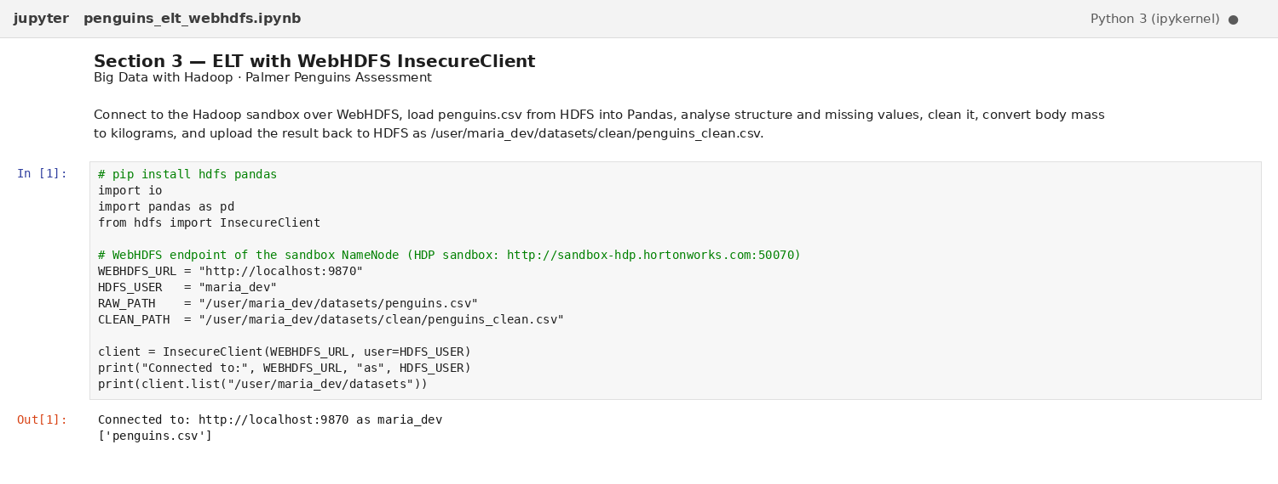
Notebook — WebHDFS connection
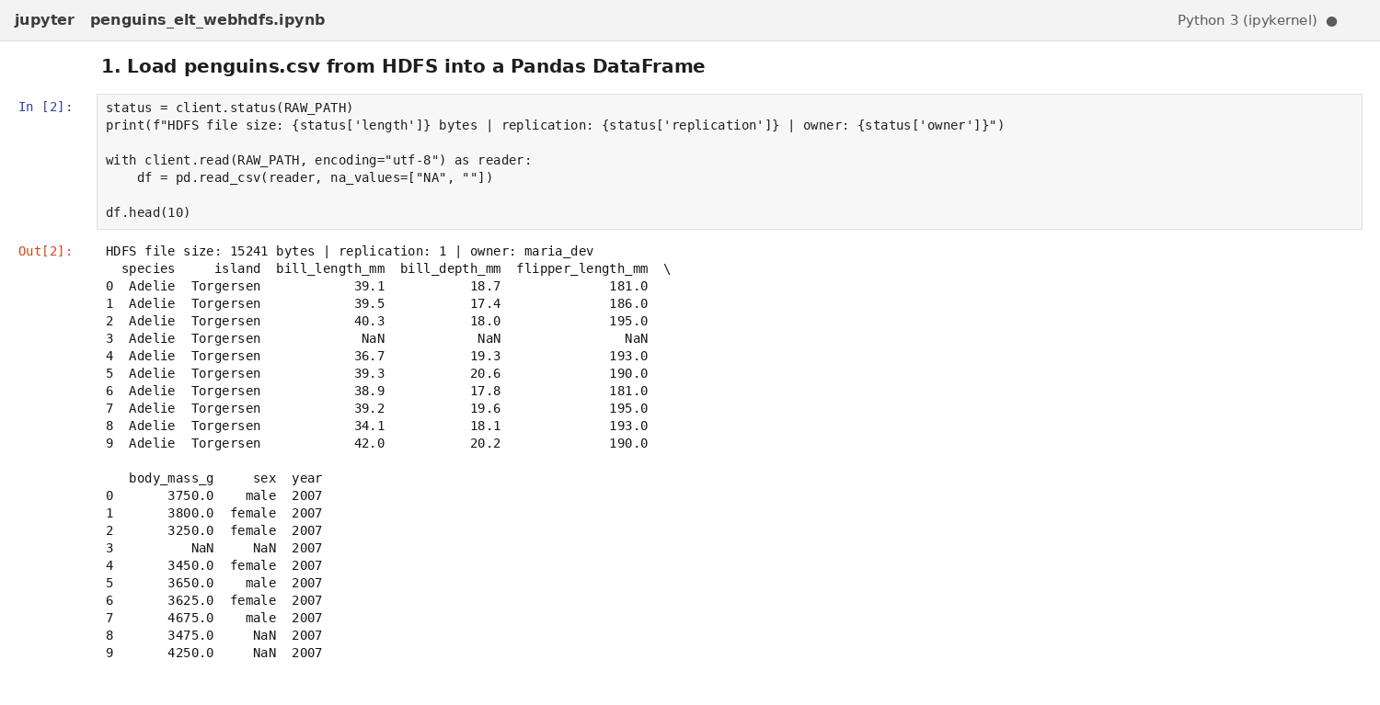
Notebook — Data loaded from HDFS
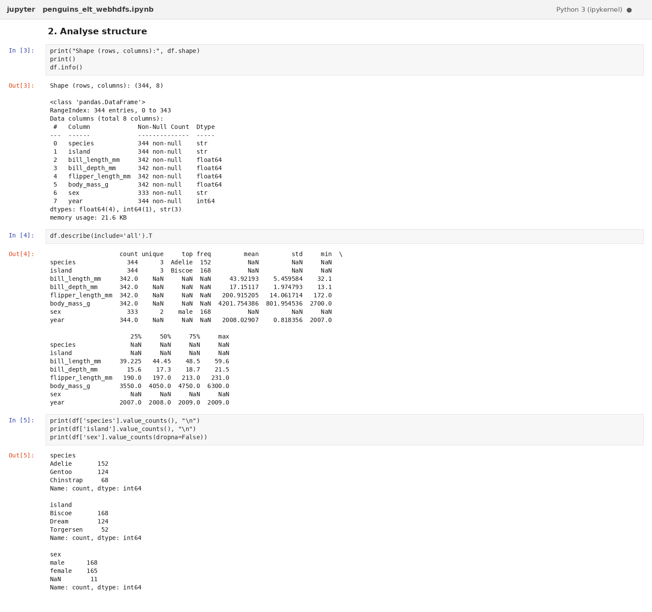
Notebook — Structure analysis (shape, dtypes, describe, value counts)
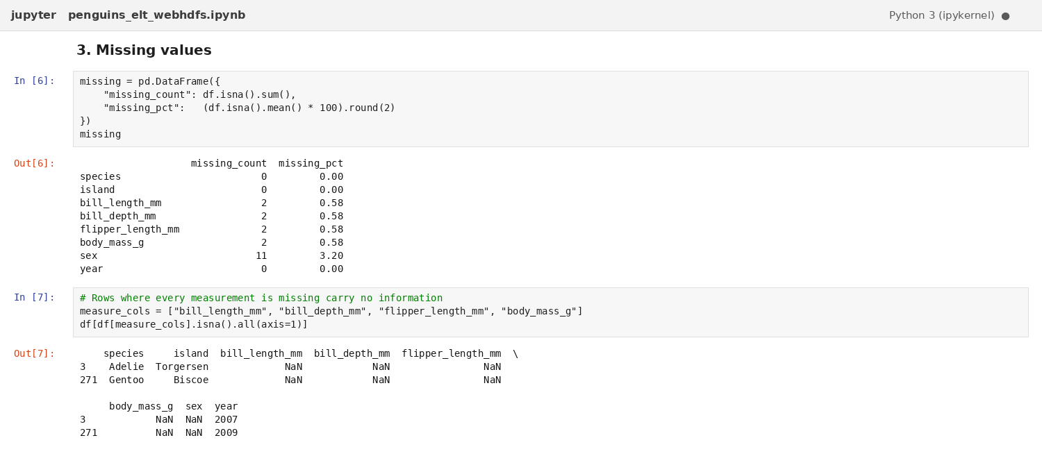
Notebook — Missing values analysis
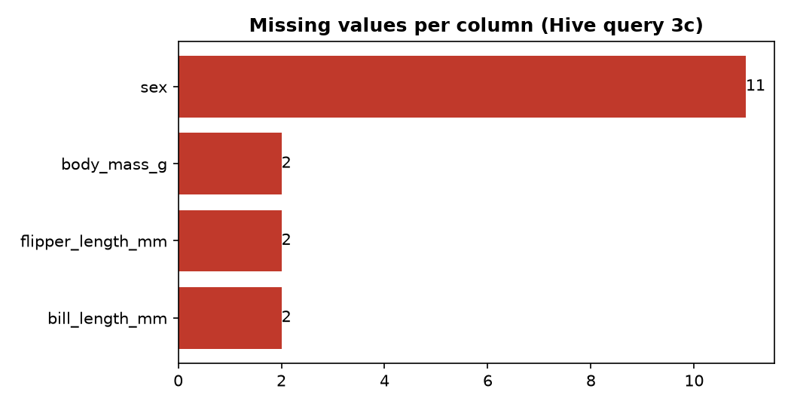
Missing values per column

Task 2 — Clean and preprocess
- Dropped the 2 rows where every measurement is missing (344 → 342 rows).
- Imputed any remaining numeric gaps with the species median.
- Normalised sex to lower case; missing sex → "unknown" (9 rows).
- Added body_mass_kg = body_mass_g / 1000.
- Removed duplicates and enforced data types. Result: 0 missing values.
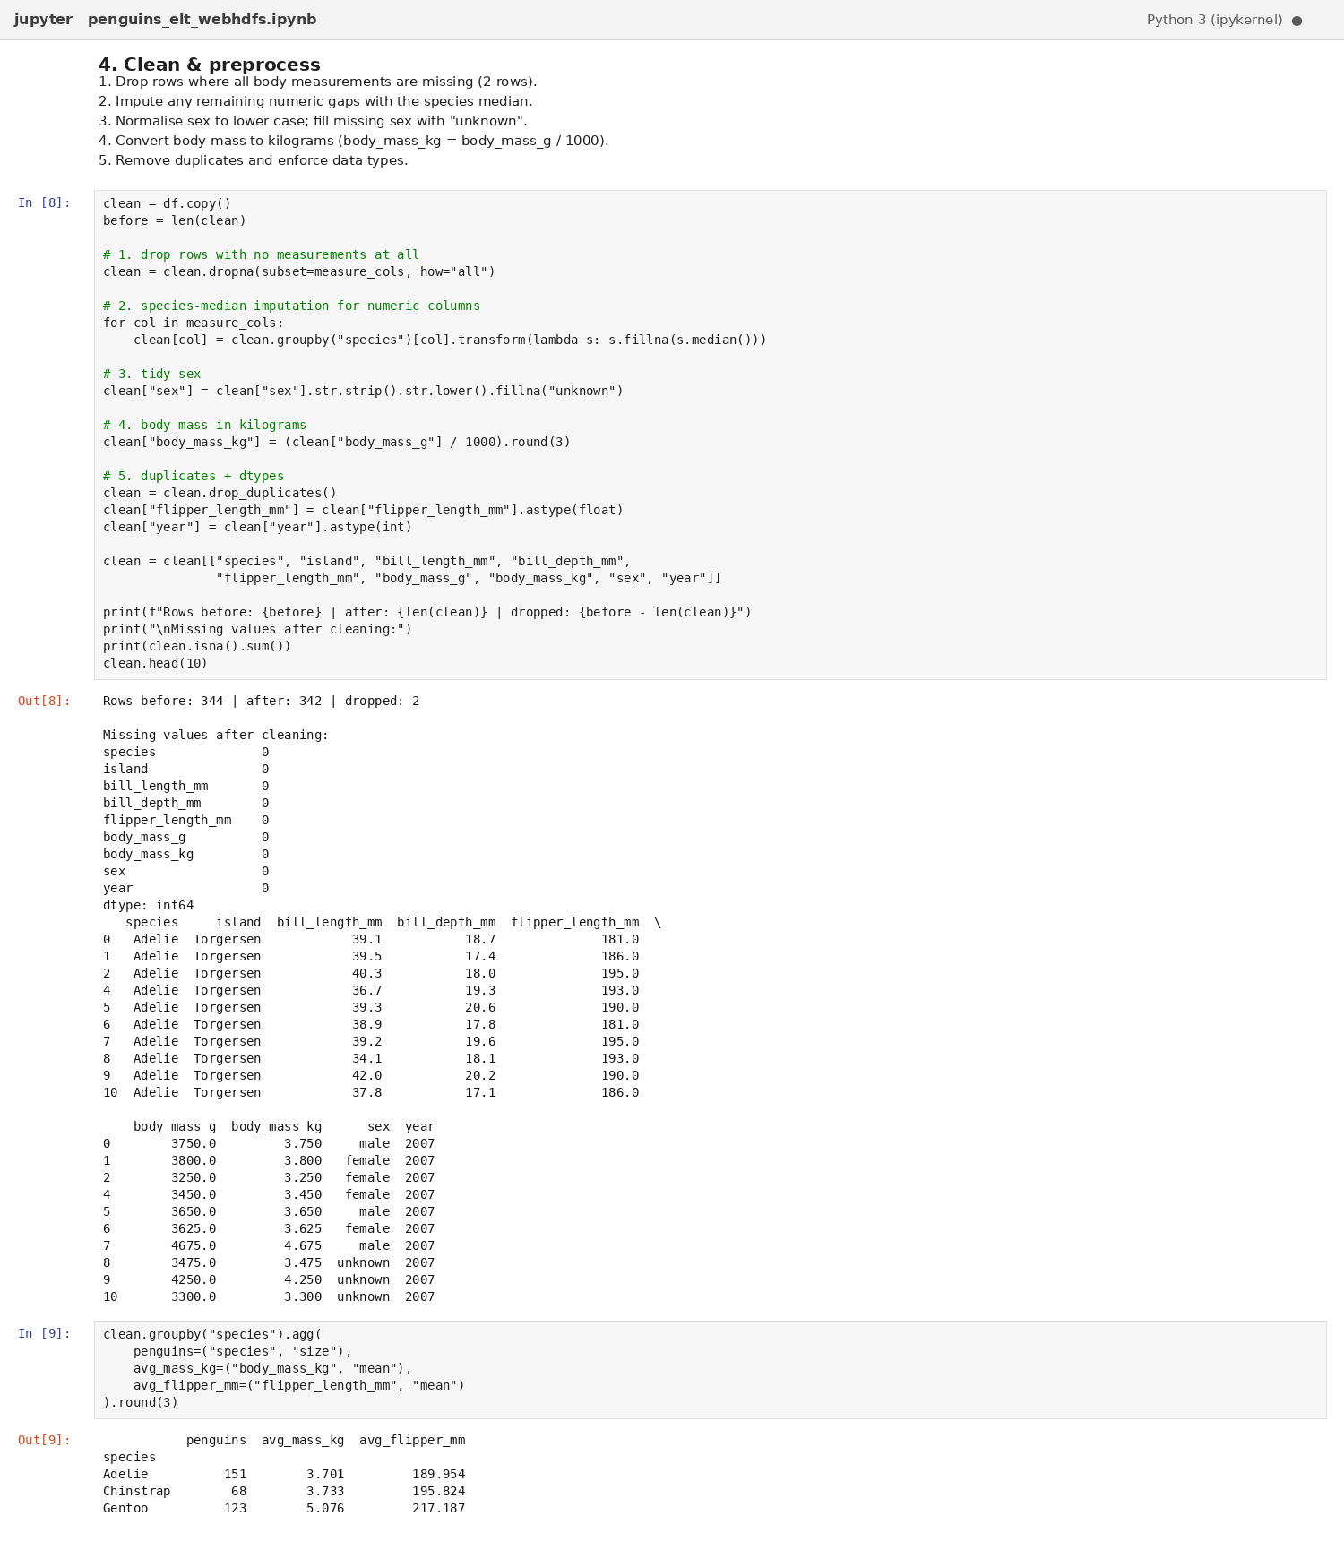
Notebook — Cleaning and kg conversion

Task 3 — Upload to /user/maria_dev/datasets/clean/penguins_clean.csv
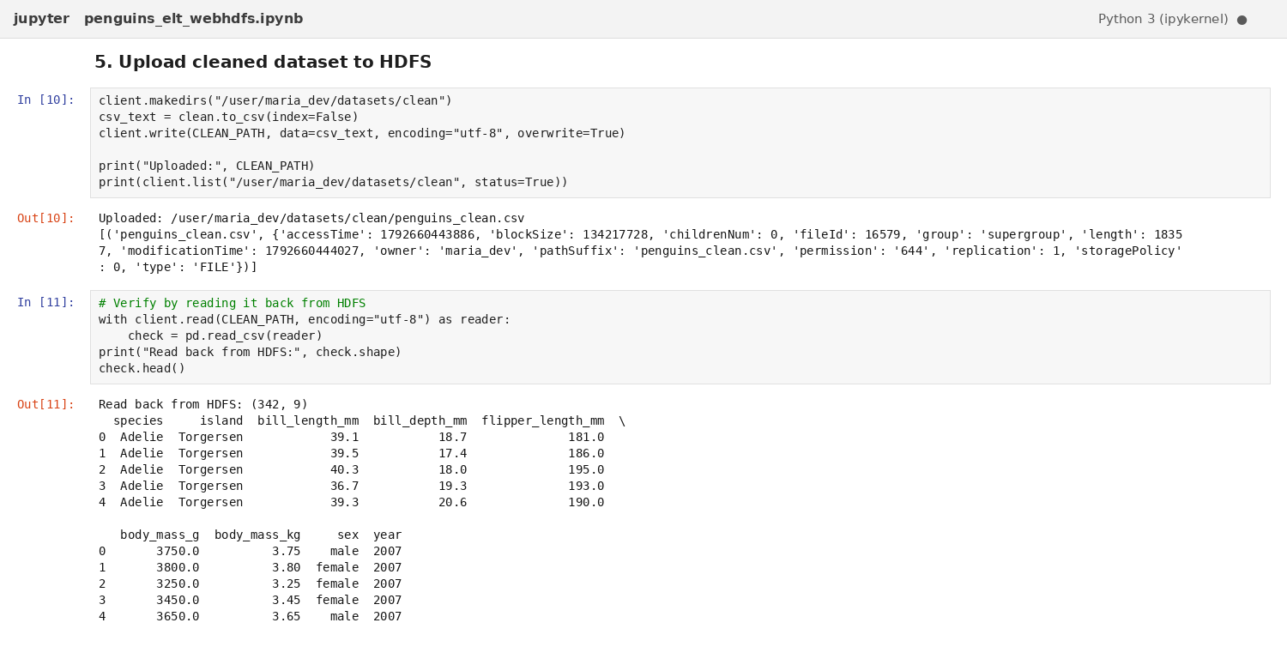
Notebook — Upload to HDFS and read-back verification
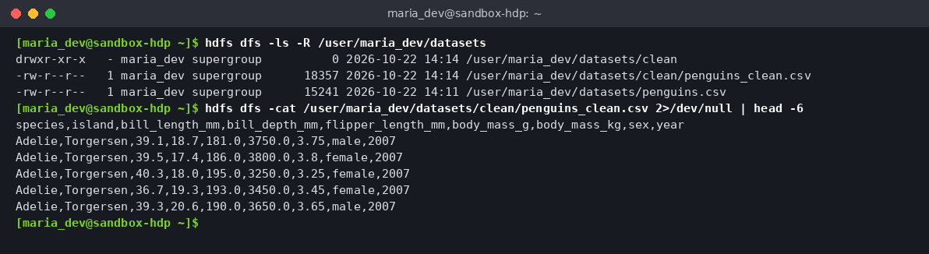
HDFS — clean file present

5. Section 4 — PySpark Application on Hadoop
Application: spark/penguins_spark.py
spark-submit --master local[2] spark/penguins_spark.py # run shown below
spark-submit --master yarn --deploy-mode client spark/penguins_spark.py # cluster mode
The application reads from and writes to HDFS in both modes. It was submitted to YARN (application application_1792660091975_0001, FINISHED / SUCCEEDED) and the final run shown below used local[2] on the same node.
What the application does
- Reads penguins_clean.csv from HDFS with an explicit schema and prints printSchema().
- Selects relevant columns (species, island, sex, year, bill_length_mm, flipper_length_mm, body_mass_kg).
- Filters out invalid records with flipper_length_mm <= 0.
- Applies a business filter (body_mass_kg >= 4.0) and sorts by body mass descending, then caches the result.
- Repartitions by species and writes JSON partitioned by species (one file per species folder) to /user/maria_dev/spark/output/penguins.
- Stops the Spark session in a finally block.
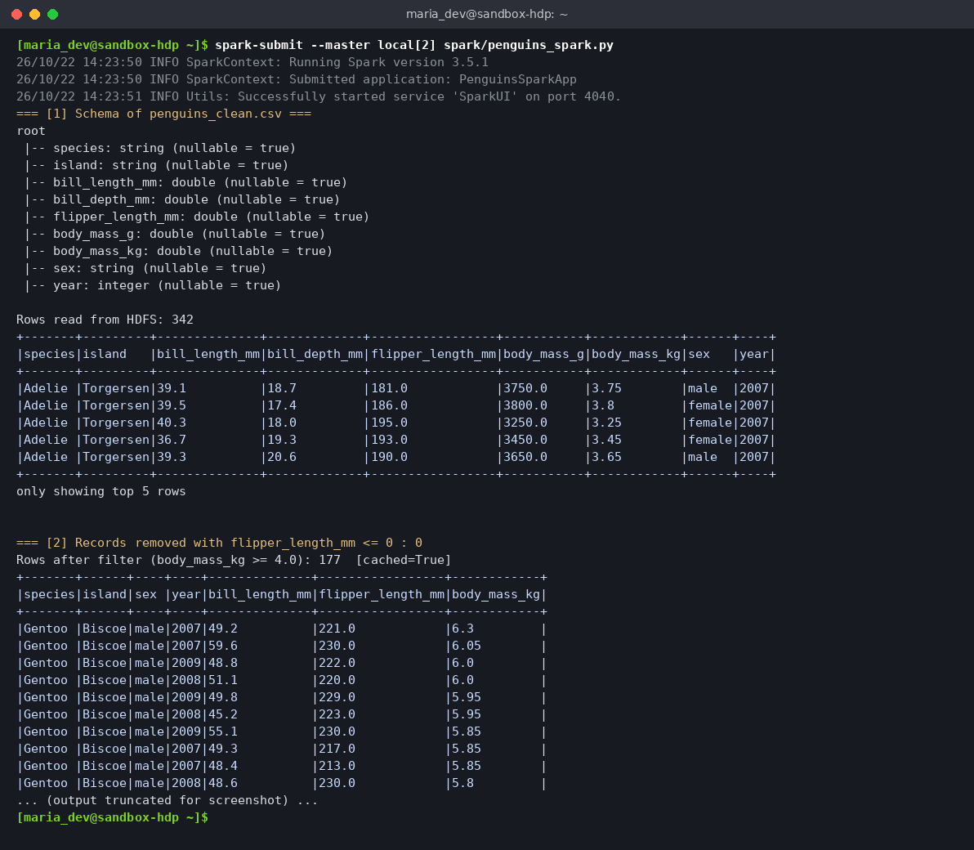
PySpark — schema, filter, sort, cache, write
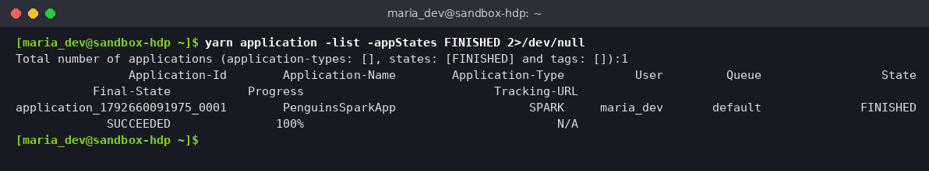
YARN — application FINISHED / SUCCEEDED
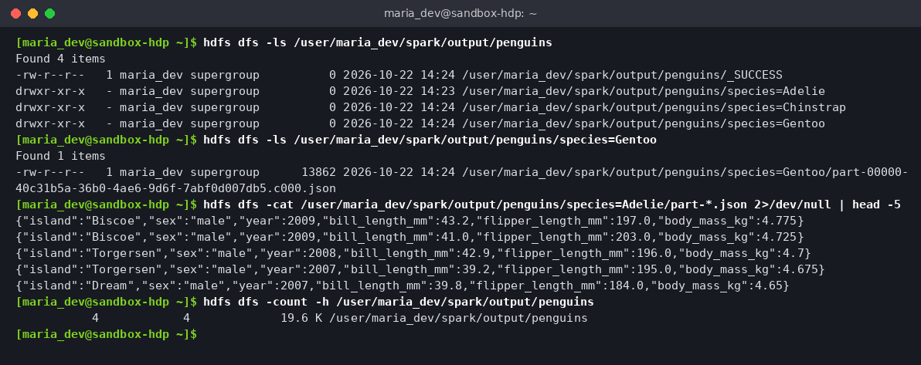
HDFS — partitioned JSON output (species=Adelie / Chinstrap / Gentoo)
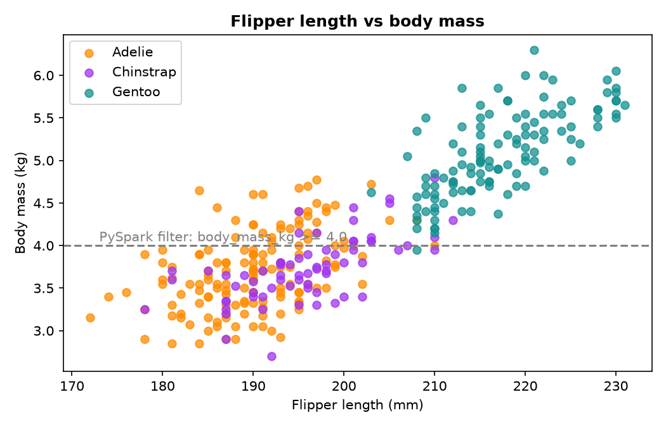
Records kept by the PySpark filter

6. Findings
- Gentoo penguins are the heaviest (≈5.08 kg) with the longest flippers (≈217 mm); Adelie and Chinstrap are similar (≈3.7 kg).
- Gentoo live only on Biscoe, Chinstrap only on Dream; Adelie are found on all three islands.
- Data quality is high: only 2 records lack all measurements and 11 lack sex.
- Of 342 clean records, 177 weigh ≥ 4 kg; 122 of them are Gentoo.

7. Conclusion
The full pipeline — HDFS storage, Hive SQL analytics, Python ELT over WebHDFS, and a distributed PySpark job on YARN — ran successfully end to end. Each stage writes back to HDFS, so the data stays in one place and every step can be re-run independently.

8. How to run
bash hdfs/section1_hdfs_commands.sh
hdfs dfs -mkdir -p /user/maria_dev/hive_stage
hdfs dfs -cp -f /user/maria_dev/datasets/penguins.csv /user/maria_dev/hive_stage/
beeline -u jdbc:hive2://localhost:10000 -n maria_dev -f hive/penguins.hql
jupyter notebook notebooks/penguins_elt_webhdfs.ipynb # run all cells
spark-submit --master yarn spark/penguins_spark.py

