Zeeshan Khan 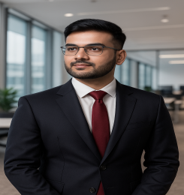
Phone: +91 6262676855
E-mail : zeeshantechsunset@gmail.com
Address : Bhopal, Madhya Pradesh

Objective
Full Stack MERN Developer with 3+ years of experience building scalable, user-centric web applications. Adept at translating complex business workflows into clean, optimized code. Passionate about delivering impactful solutions through continuous learning, teamwork, and modern development practices.

Education
BTECH 2015-19(with Grade A)
12 ^{TH} 2014-15(with Grade B)
10 ^{TH} 2012-13(with Grade A)

Technical Skills
- Web Development( Nodejs, Mongodb, Docker, Redish, Kafka, Rabitmq, Aws cloud, Kafka)
- Aws (Ec2, Aws s3, Route 53, Load Balancer, Aws lamda, API Gateway,Media Convert)
- Database (Mongodb)
- Programming language ( C (basic))

Soft Skills
- I love W3schools
- Open Source Contributions
- Product Design
- Cost Effective

Projects
  - Project Title : SUPERPROF
Platform Used : ReactJs, NextJs, NodeJs, MongoDB, AWS

  - Project Title : FISHYKART
Platform Used : ReactJs, NextJs, NodeJs, MongoDB, AWS

- Project Title : ABCCONSULTANTS
Platform Used : ReactJs, NextJs, NodeJs, MongoDB, AWS

- Project Title : DLIFEINTERIORS
Platform Used : ReactJs, NextJs, NodeJs, MongoDB, AWS

- Project Title : CLOVEDENTAL
Platform Used : ReactJs, NextJs, NodeJs, MongoDB, AWS

Experience

Company name : Techsunset (https://techsunset.com)
3 Years+
Description : Responsible for building user interfaces and apis for client and companies

Personal profile
Date Of Birth: 03 April, 1997
S/O: Abdul Sattar Khan
Nationality: Indian Gender: Male
Language known : English and Hindi

