1. User register in the lottery system

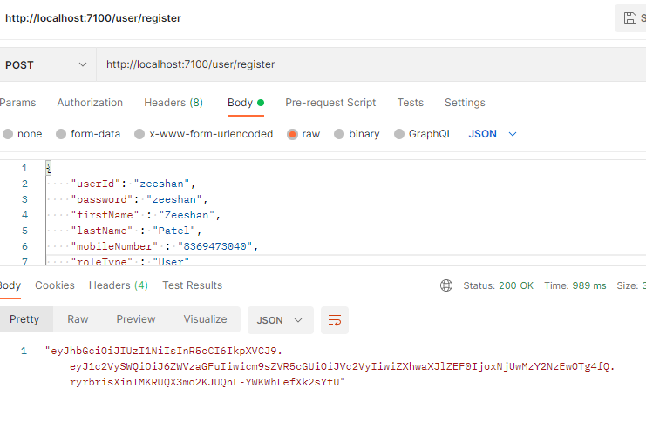

1. If same user tries to register again, system rejects the request.

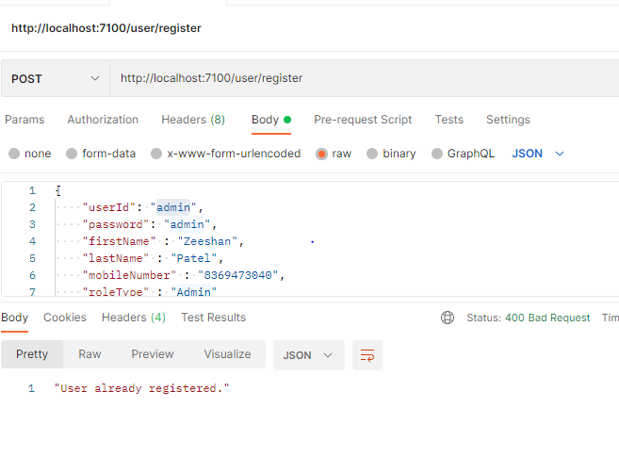

1. Admin has the access to create Lottery by loging in the system and using the token key

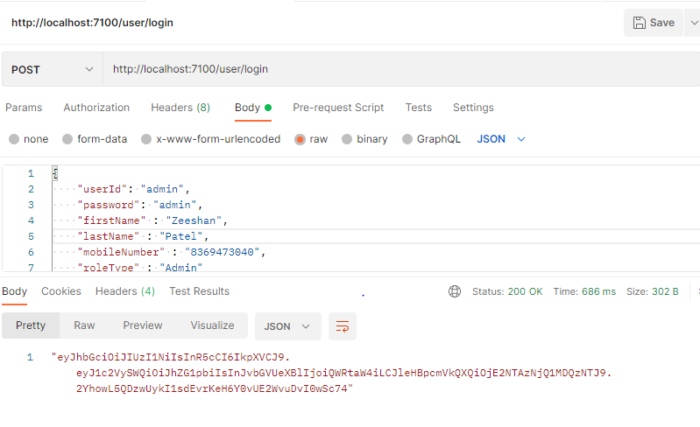

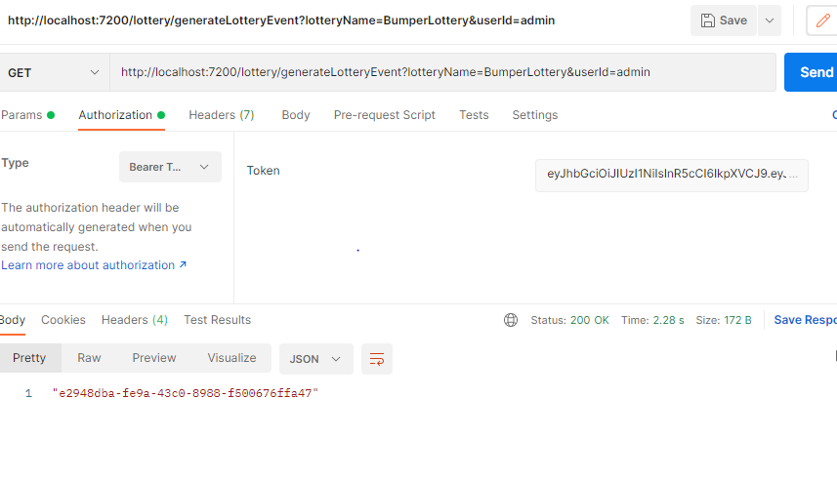

4: If admin user tries to generate lottery using the expired token it gets token expired message

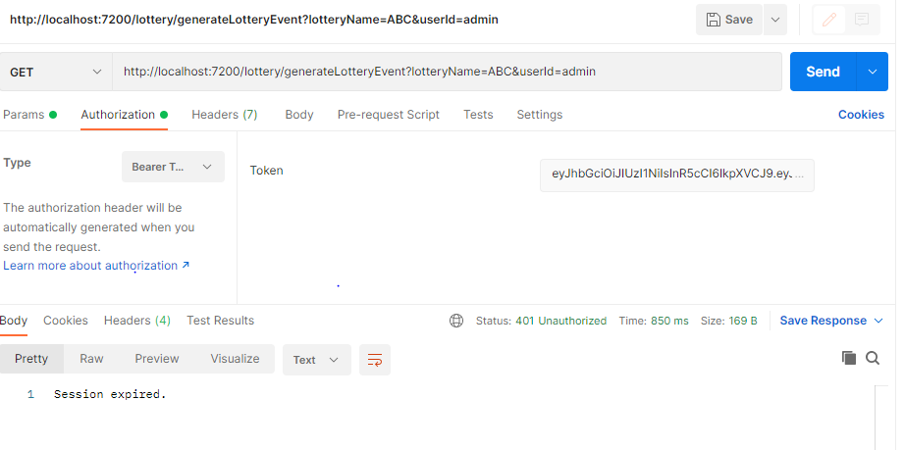

1. If admin user tries to generate Lottery using invalid token it gets Invalid token message

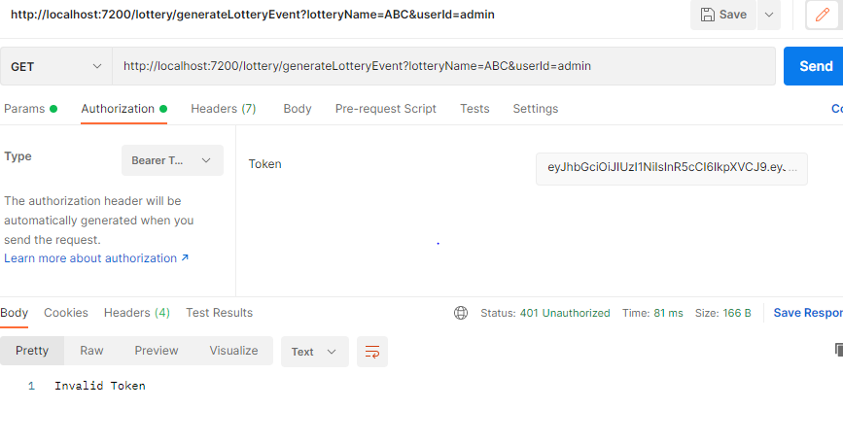

1. If admin user tries to generate Lottery with the same name, it gets error response stating Active lottery already present

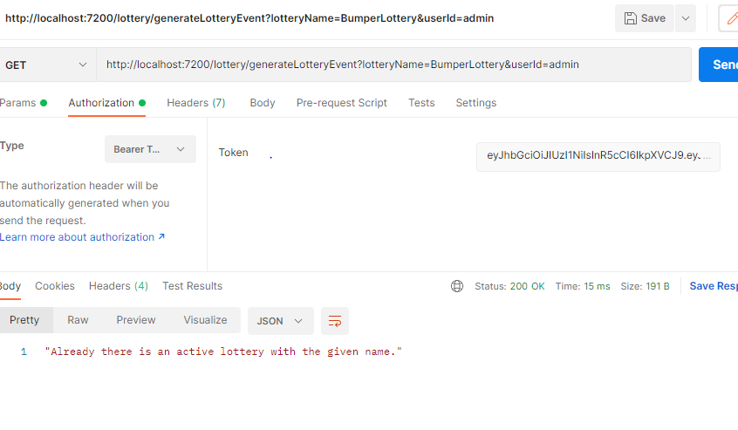

1. User can check all active lotteries

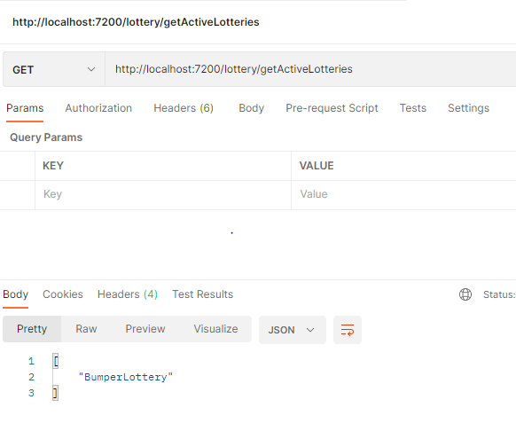

1. User tries to submit lottery for an invalid lottery gets error message

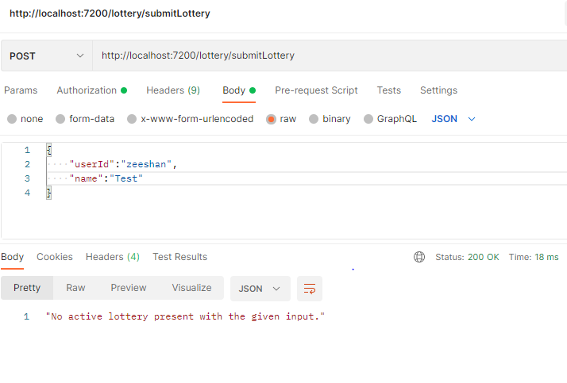

8 : User tries to submit lottery without passing the valid token gets an error message

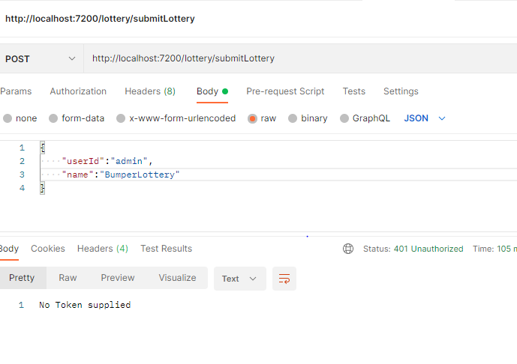

9 : User submits the lottery with the valid token and gets the ticket id in the response

