1. Open q4 .Rmd doc and select save as and give a name for the new quarter

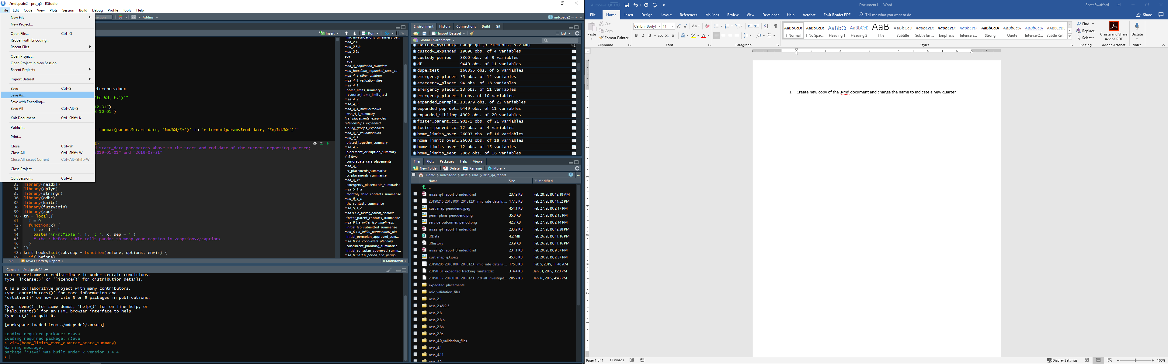

* 1. This will be used as the Q5 report
  2. Notes:
     1. Whenever you run the program or anything within it, outputs will be saved into a subdirectory of or the same location as the .Rmd document
     2. Anywhere in the code that reads and excel file into R, the excel file must be located in the directory as the .Rmd document and the name of the file must be changed in the code to match the name of the file

1. Once the new quarterly report has been created, the date parameters: end_date and start_date need to be changed since everything in the code is derived from these two dates:

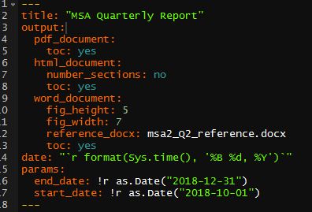

* 1. For q5, this will be:
     1. End_Date: “2019-03-31”
     2. Start_date: “2019-01-01”

1. The report is designed to connect to a database to pull all data. Depending on the needs this may be EDW or one of the historical snapshots



* 1. This is the string of code that creates a connection object for the report
     1. Until the next reporting snapshot is taken, the nDatabase should be changed to EDW and then updated once the new snapshot is taken
        1. Snapshot of EDW should be requested on the 15th of the first month following the end of a reporting quarter

1. Before, running any of the reporting chunks, the period_censor_date object needs to be updated for the actual or anticipated snapshot date.



1. The .Rmd document is divided into chunks that are intended to be run in the order they have been programmed in. They can be run separately or out of order but may rely on object created in previous steps. The first two chunks: libraries and timeframes need to be run before anything else in the report will function.

MSA provisions, programs, chunks

1. Population Overview
   1. Q4 report: Population Overview
   2. Chunks
      1. pop_overview
      2. outcomes_in_period
      3. perm_goals_pit
      4. pop_perm_goals_chart
      5. pop_by_county_chart
   3. Outputs:

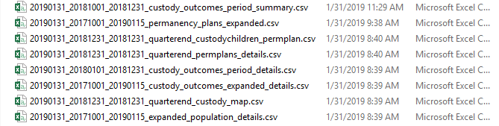

* 1. These sections of the .Rmd are intended to pull in data produce expanded validation datasets, period_detail files, and summary counts and charts for use in the quarterly report. The charts themselves are saved in the same location as the .Rmd document
  2. For the report, we report on 4 things that can be found in these files:
     1. Entries, Exits, In care counts
        1. Counts all children in care on the first day of each quarter in the msa and all children in case on the last day of each quarter, the number of children entering during each quarter and the number exiting each quarter for every quarter from msa start – current quarter
     2. Service Outcomes Chart
        1. Graph of all children who exited care in the quarter by service outcome, which is pulled from the service outcome selected in the last approved fsp.
     3. Perm Plans Chart
        1. All children in custody on the last day of the period by most recent fsp approved prior to the end of the quarter.
        2. If no plan is found, two categories are created:
           1. No Plan Documented - Less than 45 Days in Custody
           2. No Plan Documented - No current approved FSP
     4. Custody Map
        1. All children in custody on the last day of the period by county of removal.
        2. To produce the map, send the map saved as a n output and the region totals to Lea Anne Brandon

1. 2.1 - Receiving, Screening, and Investigating ANE Reports
   1. Q4 Report Summary
      1. 2.1
   2. Chunks

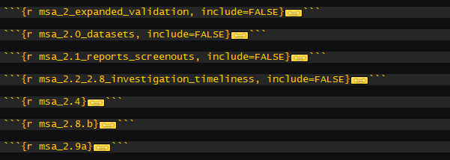

* 1. Outputs

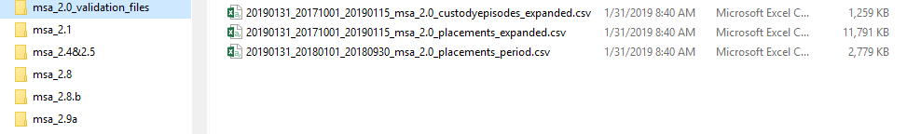

* 1. Business Rules/Etc
     1. All intakes with an intake_date between the start date of the 2nd msa and the period end date, summarized for all intakes(including mic) and mic intakes(mic intakes are defined as any intake where a custody child was attached, and SIU owned the screening(ints_siu_ane_owner = ("S","R"))
        1. All reports received – total number of reports
        2. All reports in screening – total reports with intake status of 05scr
        3. All reports screened out - total reports with intake status o f10sco
        4. All reports assigned for investigation – total reports with intake status not in 05scr or 10sco
        5. All reports assigned, and investigation completed – total reports where findings approved date is blank/null
        6. All reports assigned and still in investigation – total reports with status not in 05scr or 10sco and findings approved date is null

1. 2.2/2.8.a - MIC Investigation Timeliness
   1. Q4 Report Summary
      1. 2.2 & 2.8
   2. Chunks



* 1. Outputs

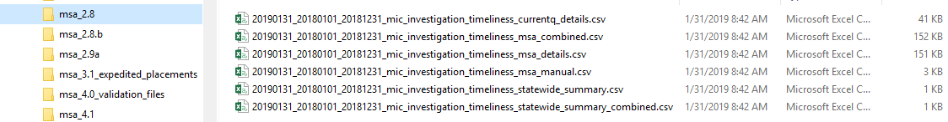

* 1. Business Rules, Etc
     1. All mic investigations with an intake date in the period with an intake status of 15sci, 20inv, 30inv, 35inv, 40inv and due for approval in the period and an indicator for whether the inv was initiated timely(first contact with vic or 2nd attempted contact in 24/72 hours), approved timely(within 30 day of intake), initiated and approved timely(both = Yes)
     2. Mic investigation defined as custody child was attached and SIU owned the inv(inti_siu_owner = ("S","R"))
     3. Reported by quarter of approval was due

1. 2.4&2.5: Substantiated Investigation Follow-up
   1. Q4 Report Summary
      1. 2.4:MIC Substantiated Investigation Follow-up - Group Home & Emergency Shelters
      2. 2.5: MIC Substantiated Investigation Follow-up - Private Child Placing Agencies
   2. Chunks



* 1. Outputs



* 1. Business Rules
     1. All mic(same definition as previously used) investigation/allegations where findings approved date falls in current period and the placement the victims was in at the intake date
     2. Filter down on from this dataset to substantiated victims where the facility type of the placement at intake meets the definition of 2.4 or 2.5,
     3. Review these allegations to see if 2.4 or 2.5 applied based on the facts of the investigation send list of those that should have been followed up on to Carrie Coggins to determine if licensure has the appropriate records
     4. Upload records to pc

1. 2.8.b
   1. Q4 Report Summary
      1. Not included
   2. Chunks



* 1. Outputs



* 1. Business Rules
     1. All children who were substantiated victims of mic(use 2.9a manual review results) and who’s placement remained the same from prior to the intake/incident(intake date > placement start, incident date>placement start date) until at least 7 days after the findings were approved(placement end >= findings approved plus 7 days)
     2. For these children, calculate time period start and end(period start + 6 days or 29 days for the months) for each of the increments:
        1. week_1 = findings_approved_date
        2. week_2 = findings_approved_date %m+% days(7),
        3. week_3 = findings_approved_date %m+% days(14),
        4. week_4 = findings_approved_date %m+% days(21),
        5. month_1 = findings_approved_date %m+% days(28),
        6. month_2 = findings_approved_date %m+% days(58),
        7. month_3 = findings_approved_date %m+% days(88))
     3. Remove any time periods where the end date occurs after placement end or the end of the reporting period
     4. Count the number of face-to-face visits between valid job codes and child with narrative location was in-home and the narrative datetime fell into one of the time periods
     5. Group by the time period and count the number of children who should have received contact during each time period and then the number that did.
     6. Note: these rules will only work if the manual review for 2.9a is conducted

1. 2.9a
   1. Q4 Report Summary
      1. MIC Rate
   2. Chunks



* 1. Outputs

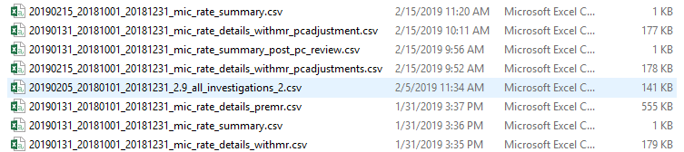

* 1. Business Rules
     1. Base population is all allegations with an intake date in the year ending on the period end date, the findings were approved before the period end date and the allegations were substantiated, the victim was a custody child, and the intake/incident date occurred at least 7 days after custody start and prior to the custody end date or the end of the period
     2. Take the results of 1 and conduct a manual review of all allegations to determine if the incident occurred while the child was in custody(mr_mic), if so was the relationship correct(mr_relatioship_correct), if the relationship was not correct what was the correct relationship(mr_correct_relationship).
     3. Count unique children where the manual review determined the allegation was mic and the correct relationship was relative foster parent, non-relative foster parent, or residential facility staff and then divide by the unique count of children in custody during the one-year period
     4. There was an additional review conducted by pc of our manual review and the results had to be incorporated into the final calculations

1. 3.1.a
   1. Q4 Report Summary
   2. Chunks
   3. Outputs
   4. Business Rules
2. 3.3
   1. Q4 Report Summary
      1. Foster Home Development
   2. Chunks
      1. Not done in R
   3. Outputs
      1. Note done in R
   4. Business Rules
      1. I just plug in numbers from the current monthly foster home development and disposition report
3. 4.1&4.13
   1. Q4 Report Summary
      1. Resource Home Limits
   2. Chunks

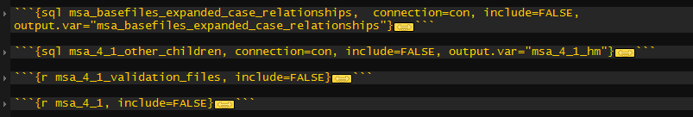

* 1. Outputs



* 1. Business Rules
     1. All MDCPS resource homes with a custody child placed on the last day of each month. The details file includes homes licensed by umbrella agencies, but they are excluded from all calculations
     2. The calculations are done by month using the following rules:
        1. Total homes – total number of foster homes with a child placed on the last day of the month
        2. >5 children – total homes where the total children in the home( custody plus non-custody) is greater than 5
        3. >3 children
        4. >2 children under 2 or therapeutic needs – total children under 2 on the last day of the month or with therapeutic needs(rate type = special needs I or II, therapeutic, etc)
        5. Number meeting standards – total homes where there were 5 or fewer children in the home, 2 or fewer children under 2 or with therapeutic needs, and the number beds the home was approved for was greater than the number of custody children placed, and there were 3 or fewer custody children placed
        6. Siblings only exception – number of homes where all custody children were members of a sibling group; exceptions were only counted after seeing if the home met the base standard
        7. 3 – 5 Custody Children with approval – number of homes where there were between 3-5 custody children and the number of beds approved exceeded the number of custody children placed and there fewer than 5 total children in the home

1. 4.2&4.14
   1. Q4 Report Summary
      1. Children with Special Needs Placed with Resources Meeting those Needs
   2. Chunks



* 1. Outputs



* 1. Business Rules
     1. All Children who were in a family-based placement(facility type)on the last day of the period including the rate type associated with the placement
     2. Family based placement in includes the following facility types:
        1. Foster Home", "Therapeutic Foster Home", "Adoptive Home (Domestic)", "Teenage Parent Foster Home", "Emergency Foster Home","Relative Foster Home", "Foster/Adopt Foster Home", "Adoption Unit Foster Home", "Respite Foster Home", "Expedited Pending Relative Res", "ICPC - Incoming"
     3. The summary file groups by rate type and facility type and counts the number of placements

1. 4.3&4.15
   1. Q4 Report Summary
      1. Children Placed in Least Restrictive Setting
   2. Chunks



* 1. Outputs

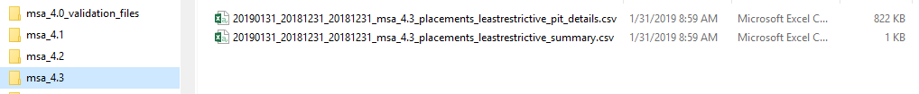

* 1. Business Rules
     1. All children in a placement on the last day of the period with groupings established in the msa provision. Facility type was used to determine the groupings
     2. Groupings used were:
        1. 0
           1. "Adoption (International)", "Adoption Unit Foster Home", "Adoptive Home (Domestic)", "Emergency Foster Home", "Foster Home", "Foster/Adopt Foster Home", "ICPC - Incoming", "ICPC - Outgoing", "Medical/Treatment Foster Home", "Respite Foster Home","Teenage Parent Foster Home", "Therapeutic Foster Home", "Maternity Home", "Child Placing Agency"
        2. 1 & 2 – Use same facility types but 1 indicates that the child placed in proximity indicator was yes 2 indicates it was no
           1. "Adoption (International)", "Adoption Unit Foster Home", "Adoptive Home (Domestic)", "Emergency Foster Home", "Foster Home", "Foster/Adopt Foster Home", "ICPC - Incoming", "ICPC - Outgoing", "Medical/Treatment Foster Home", "Respite Foster Home","Teenage Parent Foster Home", "Therapeutic Foster Home", "Maternity Home", "Child Placing Agency"
        3. 3
           1. Therapeutic Group Home", "Supervised Indep. Living", "Residential Child Caring Facil", "Medical Treatment Group Home", "Licensed Facility", "Institution", "Group Home", "Emergency Shelter", "CO NonLicensed Shelter", "Specialized Residential School"
        4. 4
           1. "Acute Care", "Chemically Dependent Group", "CO NonLicensed Det/Trng School", "Contract Facility - Non MDHS", "ICFMR", "Nursing Home", "Placement Services", "Residential Treatment"
        5. 5
           1. "Runaway"
        6. None
           1. Anything Else

1. 4.4&4.18
   1. Q4 Report Summary
      1. Children Placed Within 50-Mile Radius
   2. Chunks



* 1. Outputs

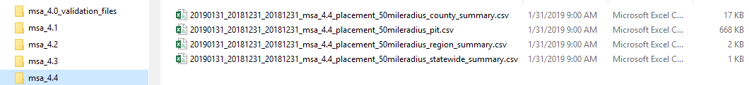

* 1. Business Rules
     1. All children in a placement on the last day of the reporting period and relying on the child placed in proximity and reason not placed in proximity indicators from macwis for the grouping and summarizing
     2. The carveout regions are reported both as part of 4.4 and separately to indicate that 4.5 is not really necessary

1. 4.5&4.19 – not reported on
   1. Q4 Report Summary
   2. Chunks
   3. Outputs
   4. Business Rules
2. 4.6
   1. Q4 Report Summary
   2. Chunks
   3. Outputs
   4. Business Rules
3. 4.9
   1. Q4 Report Summary
      1. Children Under 10 Placed in a Congregate Care Setting
   2. Chunks



* 1. Outputs

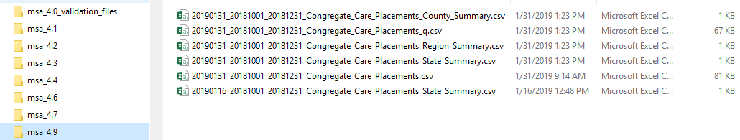

* 1. Business Rules
     1. All placements with a placement start date in the period where the child placed was under 10 at the time of placement and the placement was in one of the following facility types:
        1. 'Nursing Home',
        2. 'Chemically Dependent Group',
        3. 'Specialized Residential School',
        4. 'Contract Facility - Non MDHS',
        5. 'Group Home',
        6. 'Therapeutic Group Home',
        7. 'Licensed Facility',
        8. 'CO NonLicensed Det/Trng School',
        9. 'Residential Child Caring Facil',
        10. 'Institution',
        11. 'Emergency Shelter'
     2. Due to macwis issues summarized in the q2 and q3 reports, a placement was considered to meet the exception if either there was a rd approval date or the approval_for_congregate_care reason was “Y”
     3. Note: summary function needs to be updated to account for different rules used post macwis fix

1. 4.11
   1. Q4 Report Summary
      1. Children with More than One Emergency Shelter Placement
   2. Chunks



* 1. Outputs

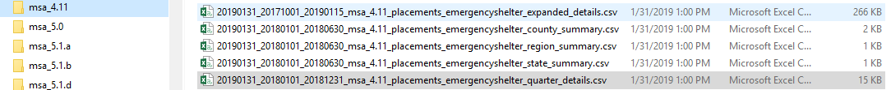

* 1. Business Rules
     1. All children placed in an emergency shelter for at least the 2nd time in their current custody episode during the period
     2. Placement meets the standard if the approved_for_emergency_placement is “Y”
     3. See q2 and Q3 report for issues related to the macwis indicator for prior quarters. In those quarters the calculation for meeting the provision used was there an rd approval date or approved_for_emergency_placement = “Y”
     4. R code

1. 5.1.a
   1. Q4 Report Summary
      1. Worker Contacts with Custody Children
   2. Chunks



* 1. Outputs

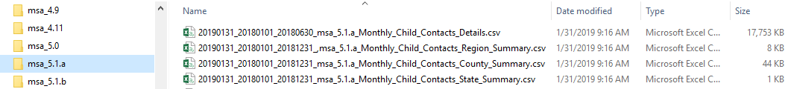

* 1. Business Rules
     1. All children in custody for the full month and the total number of contacts by a valid job code and face-to-face contact type, and the number of in-home face to face contacts for each month in the reporting period
     2. Children in an icpc outgoing placement for any time of a month are removed from the population
     3. Contacts are counted for a month if the narrative datetime is between the month start and the month end date
     4. The % used in the quarterly report is the number of children receiving at lest one in-home visit/total children receiving at lest 2 total visits in a month

1. 5.1.b
   1. Q4 Report Summary
      1. Worker Contacts with Custody Children In Trial Home Visits
   2. Chunks



* 1. Outputs

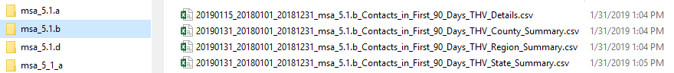

* 1. Business Rules
     1. All children in an own home placement for the entirety of the month who received at least 2 in home, face-to-face visits from a worker in a valid job code where the narrative datetime occurred within the month

1. 5.1.c&6.3.a1
   1. Q4 Report Summary
      1. Worker Contacts with Custody Parents
   2. Chunks



* 1. Outputs



* 1. Business Rules
     1. Details file includes one record per child/parent with whom the child is to be reunified combination per month the child was in custody, the parent was identified as one with whom the child is to be reunified
     2. A contact is counted for this provision if the narrative datetime is between the month start and end dates and contact method was face to face
     3. A parent is considered to be the target of reunification if the perm_reuni_id is equal the person if of a case member in the fsp
     4. Summary happens at the case level, so if a case if has 3 kids and two parents this counts as 1 in the denominator. IF all parents in the case who are reunification options received a face to face visit with a worker then both/all parents receiving contact for a month would = 1, at least one parent receiving contact would = 1 and the denominator increases by 1
        1. This avoids extra weight to large sibling groups

1. 5.1.d
   1. Q4 Report Summary
      1. Worker Contact with MDCPS Foster Parents
   2. Chunks



* 1. Outputs



* 1. Business Rules
     1. Report population is mdcps resource homes with a child placed with them for the entirety of the month
     2. Homes with children placed is identified by the facility type of custody child placements and only the following facility types are included:
        1. "ICPC - Incoming",
        2. "Foster Home",
        3. "Emergency Foster Home",
        4. "Therapeutic Foster Home",
        5. "Foster/Adopt Foster Home",
        6. "Adoption Unit Foster Home",
        7. "Adoptive Home (Domestic)",
        8. "Respite Foster Home",
        9. "Relative Foster Home",
        10. "Teenage Parent Foster Home"
     3. A resource is considered if either foster parent with a foster parent role of prim, or sec is contacted in a given month
     4. A valid contact is any in-home, face-to-face visit

1. 6.1.a
   1. Q4 Report Summary
      1. Family Service Plans Submitted and Approved within 45 days
   2. Chunks



* 1. Outputs

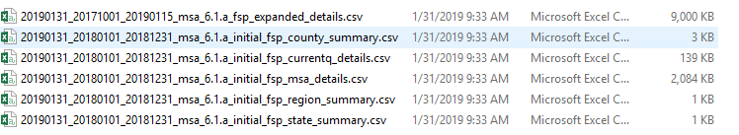

* 1. Business Rules
     1. All children who entered custody in the reporting period and the custody episode lasted at least 45 days, and the 45th day occurred before the end of the period and whether or not that had an fsp submitted and approved within 45 days of the custody start date
     2. An fsp is considered submitted timely if the submitted is within 30 days of the custody start date
     3. An fsp is considered approved timely if the approval date is within 15 days of the submitted date
     4. An fsp is considered to be submitted and approved in 45 days if the approval date is within 45 days of the custody start date

1. 6.1.d
   1. Q4 Report Summary
      1. Initial Permanency Plans Submitted and Approved within 45 days
   2. Chunks



* 1. Outputs

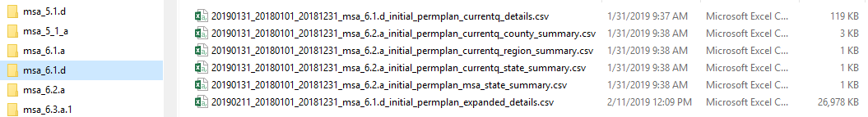

* 1. Business Rules
     1. Uses the same rules as 6.1.a except in stead of looking for the first fsp submitted and approved, it looks for the first fsp that is submitted and approved and includes a perm plan

1. 6.3.a.1
   1. Q4 Report Summary
      1. Children with a Permanency Goal of Reunification
   2. Chunks



* 1. Outputs



* 1. Business Rules
     1. Children in custody on the last day of the period whose most recent approved fsp to the end of the reporting period included a perm plan of reunification
     2. This total should match the total included in the perm plan chart

1. 6.3.a2
   1. Q4 Report Summary
      1. Worker Contacts with Custody Child Parents
   2. Chunks
      1. Same as 5.1.c
   3. Outputs
      1. Same as 5.1.c
   4. Business Rules
      1. Same as 5.1.c
2. 6.3.a.3
   1. Q4 Report Summary
      1. Services Provided in Support of Reunification
   2. Chunks



* 1. Outputs

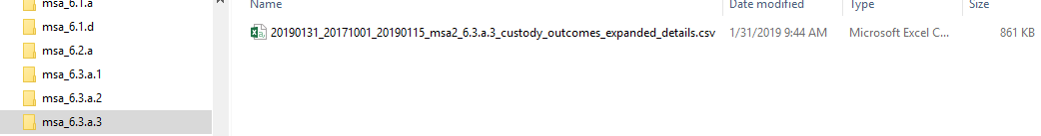

* 1. Business Rules
     1. Children who exited custody during the period with a service outcome of reunification
     2. Should be the same as children exiting to reunification in the chart

1. 6.3.a5
   1. Q4 Report Summary
      1. Trial Home Visits for Children who Reunified and had a Plan of Reunification
   2. Chunks



* 1. Outputs

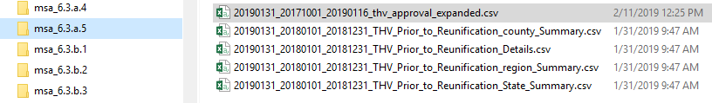

* 1. Business Rules
     1. Population is all children in custody more than 90 days who exited to reunification during the period, the most recent perm plan from the most recent approved fsp , there last placement type, and indicator for whether any in any court hearing, the thv indicator was selected

1. 6.3.b.1
   1. Q4 Report Summary
      1. Adoption Worker Assignment
   2. Chunks



* 1. Outputs

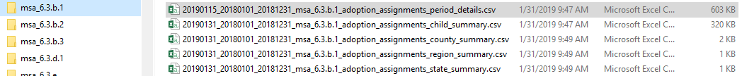

* 1. Business Rules
     1. Identify all children in custody in the period with a plan of adoption and look up when the adoption worker worker was assigned if one was assigned

1. 6.3.b.2&6.3.b.3
   1. Q4 Report Summary
   2. Chunks
   3. Outputs
   4. Business Rules
2. 6.3.d
   1. Q4 Report Summary
   2. Chunks
   3. Outputs
   4. Business Rules
3. 6.4.a
   1. Q4 Report Summary
   2. Chunks



* 1. Outputs
  2. Business Rules

1. 6.4.b
   1. Q4 Report Summary
   2. Chunks



* 1. Outputs
  2. Business Rules

1. 7.1
   1. Q4 Report Summary
   2. Chunks – all data sets for section 7 come from the same R chunk



* 1. Outputs



* 1. Business Rules
     1. Identify all children who exited custody in the proceeding 6 month period who were age 16+ at the time of exit and include the most recent approved perm plan prior to exiting custody

1. 7.2
   1. Q4 Report Summary
   2. Chunks
   3. Outputs
   4. Business Rules
      1. Identify all children in custody at the end of the period who were over the age of 14 at the end of the period
2. 7.3
   1. Q4 Report Summary
   2. Chunks
   3. Outputs
   4. Business Rules
      1. Same as 7.2 but with columns add for the different il skills modules
3. 7.5
   1. Q4 Report Summary
   2. Chunks
   3. Outputs
   4. Business Rules
      1. Youth who emancipated during the 6 month period and were age 18+ at the time of exit who received IL startup funds
4. 7.6
   1. Q4 Report Summary
   2. Chunks
   3. Outputs
   4. Business Rules
      1. Youth who emancipated during the 6 month period and were age 18+ at the time of exit who received etv stipend funds
5. 7.7.
   1. Q4 Report Summary
   2. Chunks
   3. Outputs
   4. Business Rules
      1. Nothing provided to Mario
6. 7.8
   1. Q4 Report Summary
   2. Chunks
   3. Outputs
   4. Business Rules
      1. Provide two separate reports: one for Youth who emancipated during the 6 month period and were age 18+ at the time of exit; and, one for youth who were in custody at the end of the period and age 17 or 18 at the end of the period and had a plan of APPLA.
      2. Columns are added for manual review
7. 8.1.a
   1. Q4 Report Summary
   2. Chunks
   3. Outputs
   4. Business Rules
      1. Identify children who entered custody during the period and the custody episode was at least 7 days and the 7th day fell in the period
      2. Look up whether these children received an epsdt, initial health screening, or comprehensive medical exam, and if they did was it timely
8. 8.1.b
   1. Q4 Report Summary
   2. Chunks
   3. Outputs
   4. Business Rules
      1. Identify children who entered custody during the period and the custody episode was at least 60 days and the 60th day fell in the period
      2. Look up whether these children received an epsdt, or comprehensive medical exam, and if they did was it timely
9. 8.1.c
   1. Q4 Report Summary
   2. Chunks
   3. Outputs
   4. Business Rules
      1. For children under 3, Identify children who were in custody during the period and due for one of the 11 epsdt exams set forth in the epsdt periodicity schedule
      2. Calculate the due date for each exam using custody start and date of birth and only include those exams due in the child child’s custody episode
      3. Find any epsdt exams received by each of the due dates, and count the requirement as met if there is an exam.
      4. Note: late exams are counted towards the next exam due
10. 8.1.d
    1. Q4 Report Summary
    2. Chunks
    3. Outputs
    4. Business Rules
       1. For all children in custody during the period, who were over 30 months of age and who had been in custody at year, identify any
11. 8.1.e
    1. Q4 Report Summary
    2. Chunks
    3. Outputs
    4. Business Rules