Certificate
Department of Computer Science and Engineering

This is to certify that this Practical Record contains the bona fide practical work carried out by Mr./Ms. ______________________________________________, bearing PRN. _____________________, of Batch _________, Semester ______, Section _________, during the Academic Year __________________.

Date: _____________

Name of Course Teacher: _________________________________________

Signature of Course Teacher: ______________________________________

Name of Student: ________________________ PRN: _________________
Batch: ______________ Semester: ____________ Section: ______________
Index
Practical No. | Aim | Performance Date | Submission Date | Remarks
1 | Demonstrate inline, internal, and external JavaScript; use console methods; create a webpage showing user info and a welcome message.
2 | Use var, let, const, and demonstrate basic features like template literals and destructuring; build a billing calculator with user input.
3 | Implement control structures and form validation; create a grading system based on user-entered marks.
4 | Use function types, scope, and closures; apply try-catch; build a palindrome checker.
5 | Apply array methods and object handling; create a cart total calculator with discount logic.
6 | Use string functions and regex for email validation, data extraction, and text analysis.
7 | Perform DOM traversal and updates; develop a to-do list app with add, edit, and delete features.
8 | Access and validate form fields using events; design a gym admission form with live input checks.
9 | Implement localStorage and sessionStorage to save user preferences like theme settings.
10 | Load and display JSON data using fetch() and jQuery $.getJSON(); render results dynamically in a table.
VA 11 | Use JavaScript timers (setTimeout(), setInterval()) and ES6 modules (import/export) to build a dynamic countdown or class scheduler with real-time updates and responsive layout.
VA 12 | Build an interactive real-time web app using JavaScript and jQuery with DOM, events, storage, and AJAX integration.

EXP 1

Aim
Demonstrate inline, internal, and external JavaScript; use console methods; create a webpage showing user info and a welcome message.

CODE
<!DOCTYPE html>
<html lang="en">
<head>
<meta charset="UTF-8">
<meta name="viewport" content="width=device-width, initial-scale=1.0">
<title>Symbiosis Institute of Technology - User Welcome</title>

<style>
body {
font-family: Arial, sans-serif;
background-color: #f4f6f9;
text-align: center;
padding-top: 50px;
}
.card {
background: white;
padding: 30px;
border-radius: 8px;
box-shadow: 0 4px 8px rgba(0,0,0,0.1);
display: inline-block;
}
h1 {
color: #003366;
}
button {
background-color: #003366;
color: white;
border: none;
padding: 10px 20px;
border-radius: 4px;
cursor: pointer;
font-size: 16px;
margin-top: 15px;
}
button:hover {
background-color: #002244;
}
</style>

<!-- EXTERNAL JAVASCRIPT: Linking the external script file -->
<script src="script.js" defer></script>
</head>
<body>

<div class="card">
<!-- Displaying the updated welcome message with full institute name -->
<h1 id="welcome-heading">SYMBIOSIS INSTITUTE OF TECHNOLOGY WELCOMES YOU KANGANA AGRAWAL</h1>

<p>Click the button below to trigger the pop-up alert.</p>

<!-- INLINE JAVASCRIPT: Using onclick attribute to trigger a pop-up alert -->
<button onclick="showAlert();">
Show Page Pop-up
</button>
</div>

<!-- INTERNAL JAVASCRIPT: Written inside script tags within the HTML document -->
<script>
// Internal JavaScript console logging
console.log("--- Internal JavaScript Block Executed ---");

// Function for handling the pop-up alert
function showAlert() {
console.warn("Pop-up triggered by user click.");
alert("This page shows: Welcome Kangana Agrawal to Symbiosis Institute of Technology!");
}
</script>

</body>
</html>
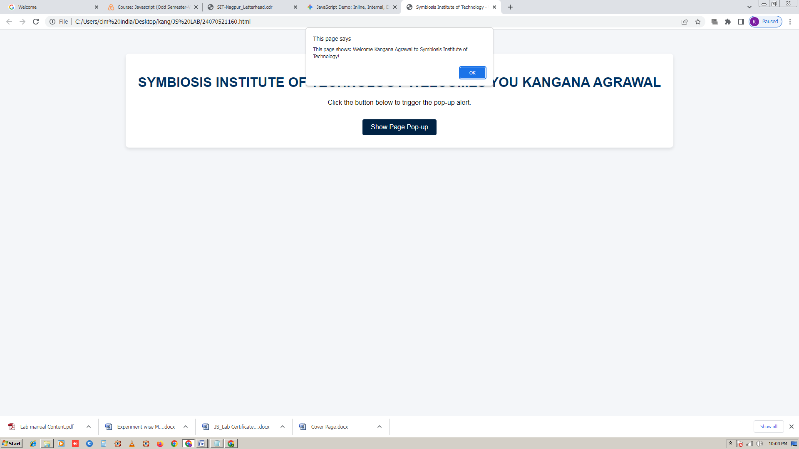

EXP 2
Aim
Use var, let, const, and demonstrate basic features like template literals and destructuring; build a billing calculator with user input

CODE

<!DOCTYPE html>
<html lang="en">
<head>
<meta charset="UTF-8">
<meta name="viewport" content="width=device-width, initial-scale=1.0">
<title>Dynamic Billing Calculator & Receipt Generator</title>
<style>
body {
font-family: 'Segoe UI', Tahoma, Geneva, Verdana, sans-serif;
background-color: #f0f2f5;
margin: 0;
padding: 20px;
}
.container {
max-width: 800px;
margin: 0 auto;
background: white;
padding: 30px;
border-radius: 12px;
box-shadow: 0 4px 15px rgba(0,0,0,0.1);
}
h2, h3 {
color: #1a73e8;
text-align: center;
}
.input-section, .receipt-section {
margin-bottom: 25px;
padding: 20px;
border: 1px solid #ddd;
border-radius: 8px;
background: #fafafa;
}
table {
width: 100%;
border-collapse: collapse;
margin-bottom: 15px;
}
th, td {
border: 1px solid #ccc;
padding: 10px;
text-align: left;
}
th {
background-color: #1a73e8;
color: white;
}
input[type="text"], input[type="number"] {
width: 90%;
padding: 6px;
border: 1px solid #ccc;
border-radius: 4px;
}
button {
background-color: #1a73e8;
color: white;
border: none;
padding: 10px 18px;
border-radius: 4px;
cursor: pointer;
font-size: 15px;
margin-right: 5px;
}
button:hover {
background-color: #1557b0;
}
.btn-danger {
background-color: #dc3545;
}
.btn-danger:hover {
background-color: #a71d2a;
}
.tax-container {
margin-top: 15px;
font-weight: bold;
}
/* Printable Receipt Box Style */
#receiptOutput {
background: #fff;
padding: 20px;
border: 2px dashed #1a73e8;
font-family: monospace;
white-space: pre-wrap;
color: #333;
}
textarea {
width: 100%;
height: 120px;
margin-top: 10px;
font-family: monospace;
padding: 10px;
border-radius: 4px;
border: 1px solid #ccc;
}
</style>
</head>
<body>

<div class="container">
<h2>Symbiosis Institute of Technology - Billing Portal</h2>

<!-- User Input Section -->
<div class="input-section">
<h3>1. Edit Bill Details</h3>
<p>Modify customer details, items, quantities, prices, and tax rates below:</p>

<label><strong>Customer Name:</strong></label><br>
<input type="text" id="customerName" value="Kangana Agrawal"><br><br>

<label><strong>Tax Percentage (%):</strong></label><br>
<input type="number" id="taxRate" value="18" style="width: 150px;"><br><br>

<h4>Line Items</h4>
<table id="itemTable">
<thead>
<tr>
<th>Item Description</th>
<th>Quantity</th>
<th>Price per Unit ($)</th>
<th>Action</th>
</tr>
</thead>
<tbody id="itemRows">
<tr>
<td><input type="text" class="item-name" value="Textbook - Advanced JS"></td>
<td><input type="number" class="item-qty" value="2" min="1"></td>
<td><input type="number" class="item-price" value="45.00" step="0.01"></td>
<td><button class="btn-danger" onclick="removeItem(this)">Remove</button></td>
</tr>
<tr>
<td><input type="text" class="item-name" value="SIT Lab Access Pass"></td>
<td><input type="number" class="item-qty" value="1" min="1"></td>
<td><input type="number" class="item-price" value="120.50" step="0.01"></td>
<td><button class="btn-danger" onclick="removeItem(this)">Remove</button></td>
</tr>
</tbody>
</table>
<button onclick="addRow()">+ Add New Item</button>
<button onclick="generateBill()" style="float: right; background-color: #28a745;">Generate Bill & Receipt</button>
<div style="clear: both;"></div>
</div>

<!-- Receipt Output Section -->
<div class="receipt-section">
<h3>2. Generated Bill Receipt & HTML Code</h3>

<h4>Visual Preview:</h4>
<div id="receiptOutput">Click "Generate Bill & Receipt" above to render output.</div>

<h4>Raw HTML Code for Receipt (Copyable):</h4>
<textarea id="htmlCodeOutput" readonly></textarea>
</div>
</div>

<script>
// Demonstrating var, let, and const as requested
const INSTITUTION_NAME = "Symbiosis Institute of Technology, Nagpur";
var developerTag = "Billing Module v1.0";

console.log(`System Initialized: ${developerTag} for ${INSTITUTION_NAME}`);

function addRow() {
let tbody = document.getElementById("itemRows");
let newRow = document.createElement("tr");
newRow.innerHTML = `
<td><input type="text" class="item-name" value="New Item"></td>
<td><input type="number" class="item-qty" value="1" min="1"></td>
<td><input type="number" class="item-price" value="10.00" step="0.01"></td>
<td><button class="btn-danger" onclick="removeItem(this)">Remove</button></td>
`;
tbody.appendChild(newRow);
}

function removeItem(button) {
let row = button.parentElement.parentElement;
if(document.querySelectorAll("#itemRows tr").length > 1) {
row.remove();
} else {
alert("At least one item is required.");
}
}

function generateBill() {
// Fetch User Inputs
let customerInput = document.getElementById("customerName").value;
let taxInput = document.getElementById("taxRate").value;

// Use 'let' and Destructuring concepts for processing item rows
let nameElements = document.querySelectorAll(".item-name");
let qtyElements = document.querySelectorAll(".item-qty");
let priceElements = document.querySelectorAll(".item-price");

let subtotal = 0;
let itemsListHTML = "";

// Loop through elements using ES6 standards
for (let i = 0; i < nameElements.length; i++) {
// Array/Variable assignment structuring
let itemName = nameElements[i].value;
let quantity = parseFloat(qtyElements[i].value) || 0;
let unitPrice = parseFloat(priceElements[i].value) || 0;
let itemTotal = quantity * unitPrice;

subtotal += itemTotal;

// Template literal usage for item rows
itemsListHTML += `
<tr>
<td>${itemName}</td>
<td style="text-align:center;">${quantity}</td>
<td style="text-align:right;">$${unitPrice.toFixed(2)}</td>
<td style="text-align:right;">$${itemTotal.toFixed(2)}</td>
</tr>`;
}

// Calculations involving tax configuration
let taxPercentage = parseFloat(taxInput) || 0;
let taxAmount = (subtotal * taxPercentage) / 100;
let grandTotal = subtotal + taxAmount;

// Object declaration to structure receipt parameters
const receiptData = {
store: INSTITUTION_NAME,
customer: customerInput,
date: new Date().toLocaleString(),
sub: subtotal.toFixed(2),
taxPct: taxPercentage,
taxVal: taxAmount.toFixed(2),
total: grandTotal.toFixed(2)
};

// Object Destructuring application
const { store, customer, date, sub, taxPct, taxVal, total } = receiptData;

// Template Literal generation for the final receipt layout HTML structure
const receiptHTMLCode = `
<div style="font-family: Arial, sans-serif; max-width: 400px; padding: 20px; border: 1px solid #ccc; background: #fff;">
<h3 style="text-align: center; margin-bottom: 5px;">${store}</h3>
<p style="text-align: center; font-size: 12px; color: #666;">Official Fee & Purchase Receipt</p>
<hr style="border: 0; border-top: 1px solid #eee;">
<p><strong>Billed To:</strong> ${customer}</p>
<p><strong>Date:</strong> ${date}</p>
<table style="width: 100%; border-collapse: collapse; font-size: 14px; margin-top: 10px;">
<thead>
<tr style="background: #f8f9fa;">
<th style="border: 1px solid #ddd; padding: 6px; text-align: left;">Item</th>
<th style="border: 1px solid #ddd; padding: 6px; text-align: center;">Qty</th>
<th style="border: 1px solid #ddd; padding: 6px; text-align: right;">Price</th>
<th style="border: 1px solid #ddd; padding: 6px; text-align: right;">Total</th>
</tr>
</thead>
<tbody>
${itemsListHTML}
</tbody>
</table>
<div style="margin-top: 15px; font-size: 14px; text-align: right;">
<p>Subtotal: $${sub}</p>
<p>Tax (${taxPct}%): $${taxVal}</p>
<h3 style="color: #1a73e8;">Grand Total: $${total}</h3>
</div>
<hr style="border: 0; border-top: 1px solid #eee;">
<p style="text-align: center; font-size: 11px; color: #888;">Thank you for your transaction!</p>
</div>`.trim();

// Render visual output and populate copyable receipt HTML text area
document.getElementById("receiptOutput").innerHTML = receiptHTMLCode;
document.getElementById("htmlCodeOutput").value = receiptHTMLCode;

console.info("Bill successfully generated and computed for: ", customer);
}
</>
</body>
</html>

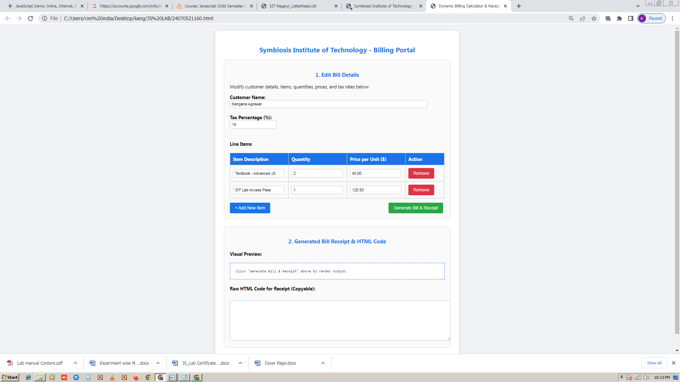

EXP 3
Aim
Implement control structures and form validation; create a grading system based on user-entered marks.

CODE

<!DOCTYPE html>
<html lang="en">
<head>
<meta charset="UTF-8">
<meta name="viewport" content="width=device-width, initial-scale=1.0">
<title>SIT Nagpur - Student Grading System</title>
<style>
body {
font-family: 'Segoe UI', Tahoma, Geneva, Verdana, sans-serif;
background-color: #f0f2f5;
margin: 0;
padding: 20px;
}
.container {
max-width: 650px;
margin: 0 auto;
background: white;
padding: 30px;
border-radius: 12px;
box-shadow: 0 4px 15px rgba(0,0,0,0.1);
}
h2, h3 {
color: #1a73e8;
text-align: center;
}
.form-group {
margin-bottom: 15px;
}
label {
display: block;
font-weight: bold;
margin-bottom: 5px;
color: #333;
}
input[type="text"], input[type="number"] {
width: 100%;
padding: 10px;
border: 1px solid #ccc;
border-radius: 6px;
box-sizing: border-box;
font-size: 15px;
}
input.error {
border-color: #dc3545;
background-color: #fff8f8;
}
.error-msg {
color: #dc3545;
font-size: 13px;
margin-top: 4px;
display: none;
}
button {
background-color: #1a73e8;
color: white;
border: none;
padding: 12px 20px;
border-radius: 6px;
cursor: pointer;
font-size: 16px;
width: 100%;
margin-top: 10px;
font-weight: bold;
}
button:hover {
background-color: #1557b0;
}
/* Result Display Styles */
.result-card {
margin-top: 25px;
padding: 20px;
border-radius: 8px;
background: #fafafa;
border: 1px solid #ddd;
display: none;
}
.result-card.success {
border-left: 6px solid #28a745;
}
.result-card.fail {
border-left: 6px solid #dc3545;
}
.result-row {
display: flex;
justify-content: space-between;
margin-bottom: 8px;
font-size: 15px;
}
</style>
</head>
<body>

<div class="container">
<h2>Symbiosis Institute of Technology, Nagpur</h2>
<h3>Student Academic Grading Portal</h3>

<form id="gradingForm" onsubmit="processGrading(event)">
<!-- Student Name -->
<div class="form-group">
<label for="studentName">Student Full Name:</label>
<input type="text" id="studentName" value="Kangana Agrawal" placeholder="Enter full name">
<div id="nameError" class="error-msg">Please enter a valid student name.</div>
</div>

<!-- Subject 1 Marks -->
<div class="form-group">
<label for="sub1">Advanced JavaScript (Max: 100):</label>
<input type="number" id="sub1" value="88" min="0" max="100">
<div id="sub1Error" class="error-msg">Marks must be between 0 and 100.</div>
</div>

<!-- Subject 2 Marks -->
<div class="form-group">
<label for="sub2">Data Structures & Algorithms (Max: 100):</label>
<input type="number" id="sub2" value="92" min="0" max="100">
<div id="sub2Error" class="error-msg">Marks must be between 0 and 100.</div>
</div>

<!-- Subject 3 Marks -->
<div class="form-group">
<label for="sub3">Software Engineering (Max: 100):</label>
<input type="number" id="sub3" value="79" min="0" max="100">
<div id="sub3Error" class="error-msg">Marks must be between 0 and 100.</div>
</div>

<button type="submit">Calculate Grade & Generate Report</button>
</form>

<!-- Result Display Container -->
<div id="resultContainer" class="result-card">
<h3>Academic Evaluation Report</h3>
<div class="result-row"><span><strong>Student:</strong></span> <span id="resName"></span></div>
<div class="result-row"><span><strong>Total Marks:</strong></span> <span id="resTotal"></span> / 300</div>
<div class="result-row"><span><strong>Percentage:</strong></span> <span id="resPercentage"></span>%</div>
<div class="result-row"><span><strong>Final Grade:</strong></span> <span id="resGrade"></span></div>
<div class="result-row"><span><strong>Status:</strong></span> <span id="resStatus"></span></div>
<div class="result-row"><span><strong>Remark:</strong></span> <span id="resRemark"></span></div>
</div>
</div>

<script>
function validateInput(inputElement, errorElement, condition) {
if (!condition) {
inputElement.classList.add("error");
errorElement.style.display = "block";
return false;
} else {
inputElement.classList.remove("error");
errorElement.style.display = "none";
return true;
}
}

function processGrading(event) {
// Prevent default form reload behavior
event.preventDefault();

// 1. Form Validation using control structures
let nameField = document.getElementById("studentName");
let sub1Field = document.getElementById("sub1");
let sub2Field = document.getElementById("sub2");
let sub3Field = document.getElementById("sub3");

let nameError = document.getElementById("nameError");
let sub1Error = document.getElementById("sub1Error");
let sub2Error = document.getElementById("sub2Error");
let sub3Error = document.getElementById("sub3Error");

// Validate student name is not empty
let isNameValid = validateInput(nameField, nameError, nameField.value.trim() !== "");

// Validate marks are numeric and between 0 and 100 using control validation checks
let m1 = parseFloat(sub1Field.value);
let m2 = parseFloat(sub2Field.value);
let m3 = parseFloat(sub3Field.value);

let isSub1Valid = validateInput(sub1Field, sub1Error, !isNaN(m1) && m1 >= 0 && m1 <= 100);
let isSub2Valid = validateInput(sub2Field, sub2Error, !isNaN(m2) && m2 >= 0 && m2 <= 100);
let isSub3Valid = validateInput(sub3Field, sub3Error, !isNaN(m3) && m3 >= 0 && m3 <= 100);

// If validation fails, halt execution
if (!isNameValid || !isSub1Valid || !isSub2Valid || !isSub3Valid) {
console.error("Form validation failed due to invalid user inputs.");
return;
}

console.info("Form validation passed successfully.");

// 2. Calculations using arithmetic and control structures
let totalMarks = m1 + m2 + m3;
let percentage = (totalMarks / 300) * 100;
let roundedPercentage = Math.round(percentage);

// 3. Control Structures (If-Else & Switch statements) for Grading
let grade = "";
let status = "";
let remark = "";
let cardClass = "result-card success";

// Checking pass/fail criteria first (If-Else ladder)
if (m1 < 40 || m2 < 40 || m3 < 40) {
grade = "F";
status = "Fail (Backlog in one or more subjects)";
remark = "Needs significant improvement and re-evaluation.";
cardClass = "result-card fail";
} else {
// Switch statement implementation based on rounded percentage intervals
// Using Math.floor to categorize ranges (e.g., 90-100 -> 9, etc.)
let scoreCategory = Math.floor(roundedPercentage / 10);

switch (scoreCategory) {
case 10:
case 9:
grade = "A+";
status = "Pass";
remark = "Outstanding academic performance!";
break;
case 8:
grade = "A";
status = "Pass";
remark = "Excellent work, keep it up.";
break;
case 7:
grade = "B+";
status = "Pass";
remark = "Very good understanding of core concepts.";
break;
case 6:
grade = "B";
status = "Pass";
remark = "Good effort, scope for refinement.";
break;
case 5:
grade = "C";
status = "Pass";
remark = "Satisfactory performance.";
break;
default:
grade = "D";
status = "Pass (Low Pass)";
remark = "Passed, but requires closer attention to studies.";
break;
}
}

// 4. Populate Result Values into the DOM
document.getElementById("resName").innerText = nameField.value.trim();
document.getElementById("resTotal").innerText = totalMarks;
document.getElementById("resPercentage").innerText = percentage.toFixed(2);

let gradeElement = document.getElementById("resGrade");
gradeElement.innerText = grade;
gradeElement.style.color = (grade === "F") ? "#dc3545" : "#28a745";

document.getElementById("resStatus").innerText = status;
document.getElementById("resRemark").innerText = remark;

let resultContainer = document.getElementById("resultContainer");
resultContainer.className = cardClass;
resultContainer.style.display = "block";

console.table({
Student: nameField.value.trim(),
Total: totalMarks,
Percentage: percentage.toFixed(2) + "%",
Grade: grade,
Status: status
});
}
</script>

</body>
</html>

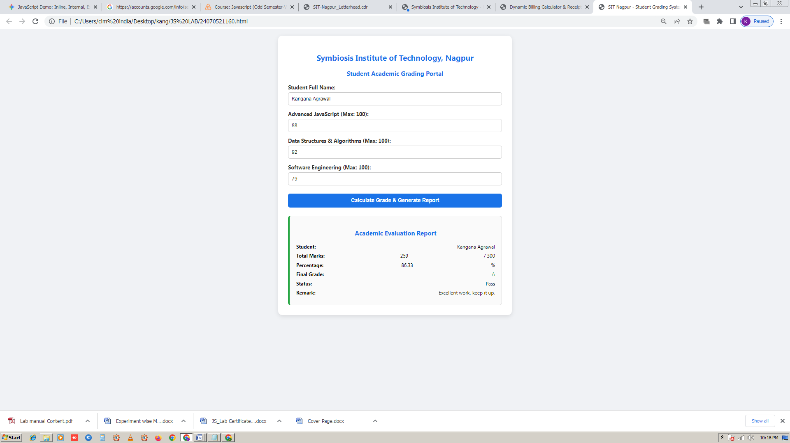

EXP 4
Aim
Use function types, scope, and closures; apply try-catch; build a palindrome checker

CODE

<!DOCTYPE html>
<html lang="en">
<head>
<meta charset="UTF-8">
<meta name="viewport" content="width=device-width, initial-scale=1.0">
<title>SIT Nagpur - Palindrome Password Analyzer</title>
<style>
body {
font-family: 'Segoe UI', Tahoma, Geneva, Verdana, sans-serif;
background-color: #f0f2f5;
margin: 0;
padding: 20px;
}
.container {
max-width: 550px;
margin: 40px auto;
background: white;
padding: 30px;
border-radius: 12px;
box-shadow: 0 4px 15px rgba(0,0,0,0.1);
}
h2, h3 {
color: #1a73e8;
text-align: center;
}
.form-group {
margin-bottom: 20px;
}
label {
display: block;
font-weight: bold;
margin-bottom: 8px;
color: #333;
}
input[type="password"], input[type="text"] {
width: 100%;
padding: 12px;
border: 1px solid #ccc;
border-radius: 6px;
box-sizing: border-box;
font-size: 16px;
}
button {
background-color: #1a73e8;
color: white;
border: none;
padding: 12px 20px;
border-radius: 6px;
cursor: pointer;
font-size: 16px;
width: 100%;
font-weight: bold;
}
button:hover {
background-color: #1557b0;
}
/* Result Panel */
.result-panel {
margin-top: 25px;
padding: 20px;
border-radius: 8px;
background: #fafafa;
border: 1px solid #ddd;
display: none;
}
.strength-weak {
border-left: 6px solid #dc3545;
background-color: #fff8f8;
}
.strength-strong {
border-left: 6px solid #28a745;
background-color: #f4fff4;
}
.metric-row {
display: flex;
justify-content: space-between;
margin-bottom: 10px;
font-size: 15px;
}
.badge {
padding: 4px 10px;
border-radius: 4px;
font-weight: bold;
color: white;
}
.bg-weak { background-color: #dc3545; }
.bg-strong { background-color: #28a745; }
.error-text {
color: #dc3545;
font-weight: bold;
text-align: center;
margin-top: 15px;
}
</style>
</head>
<body>

<div class="container">
<h2>Symbiosis Institute of Technology, Nagpur</h2>
<h3>Security Portal: Palindrome Password Checker</h3>
<p style="text-align: center; color: #666; font-size: 14px;">Rule: If password is a <strong>Palindrome</strong>, it is classified as <strong>WEAK</strong>. Otherwise, it is <strong>STRONG</strong>.</p>

<div class="form-group">
<label for="passwordInput">Enter Password to Test:</label>
<input type="text" id="passwordInput" placeholder="e.g., racecar or SecurePass123">
</div>

<button onclick="handleCheck()">Analyze Password Strength</button>

<!-- Error container -->
<div id="errorBox" class="error-text" style="display: none;"></div>

<!-- Dynamic Result Card -->
<div id="resultPanel" class="result-panel">
<h3>Analysis Report</h3>
<div class="metric-row">
<span><strong>Normalized Value:</strong></span>
<span id="resNormalized" style="font-family: monospace;"></span>
</div>
<div class="metric-row">
<span><strong>Is Palindrome?</strong></span>
<span id="resIsPalindrome"></span>
</div>
<div class="metric-row">
<span><strong>Calculated Count:</strong></span>
<span id="resCheckCount"></span>
</div>
<div class="metric-row" style="align-items: center; margin-top: 15px;">
<span><strong>Password Strength:</strong></span>
<span id="resStrengthBadge" class="badge"></span>
</div>
</div>
</div>

<script>
// --- CLOSURE & SCOPE DEMONSTRATION ---
// The createAnalyzerTracker function creates a private lexical scope
// keeping track of how many times checks have been executed without global exposure.
const createAnalyzerTracker = function() {
let executionCount = 0; // Private variable hidden inside closure scope

return {
increment: () => {
executionCount++;
return executionCount;
},
getCount: () => executionCount
};
};

// Instantiate closure tracker instance
const tracker = createAnalyzerTracker();

// --- FUNCTION TYPES & HELPER METHODS ---

// 1. Arrow Function to clean/normalize input string (removes spaces, makes lowercase for fair checking)
const normalizeString = (str) => {
if (typeof str !== 'string') throw new TypeError("Input must be a valid string.");
return str.trim().toLowerCase();
};

// 2. Function Expression to evaluate palindrome logic
const checkPalindrome = function(cleanStr) {
if (cleanStr.length === 0) {
throw new Error("Password cannot be empty.");
}
// Reverse string logic
let reversedStr = cleanStr.split('').reverse().join('');
return cleanStr === reversedStr;
};

// Main execution controller tied to the button click with try-catch implementation
function handleCheck() {
const inputField = document.getElementById("passwordInput");
const resultPanel = document.getElementById("resultPanel");
const errorBox = document.getElementById("errorBox");

// Clear previous states
errorBox.style.display = "none";
resultPanel.style.display = "none";

try {
// --- TRY BLOCK: Handling runtime checks and data manipulation safely ---
let rawInput = inputField.value;

// Trigger normalization (can throw error if invalid type)
let processedText = normalizeString(rawInput);

// Execute palindrome checking function expression
let isPalindromeResult = checkPalindrome(processedText);

// Increment closure counter safely
let currentCounts = tracker.increment();

// Determine Strength based on user requirement: Palindrome = WEAK, Else = STRONG
let strengthLabel = isPalindromeResult ? "WEAK" : "STRONG";
let badgeClass = isPalindromeResult ? "badge bg-weak" : "badge bg-strong";
let panelClass = isPalindromeResult ? "result-panel strength-weak" : "result-panel strength-strong";

// Populate DOM Elements
document.getElementById("resNormalized").innerText = processedText;
document.getElementById("resIsPalindrome").innerText = isPalindromeResult ? "Yes (Matches backwards)" : "No (Unique flow)";
document.getElementById("resCheckCount").innerText = currentCounts + " analysis run(s)";

let badge = document.getElementById("resStrengthBadge");
badge.innerText = strengthLabel;
badge.className = badgeClass;

resultPanel.className = panelClass;
resultPanel.style.display = "block";

console.info(`Checked password successfully. Result: ${strengthLabel}`);

} catch (error) {
// --- CATCH BLOCK: Handling user input errors gracefully ---
console.error("Validation error caught: ", error.message);
errorBox.innerText = "Error: " + error.message;
errorBox.style.display = "block";
} finally {
// --- FINALLY BLOCK: Executes regardless of success or failure ---
console.log("Password evaluation cycle concluded.");
}
}
</script>

</body>
</html>

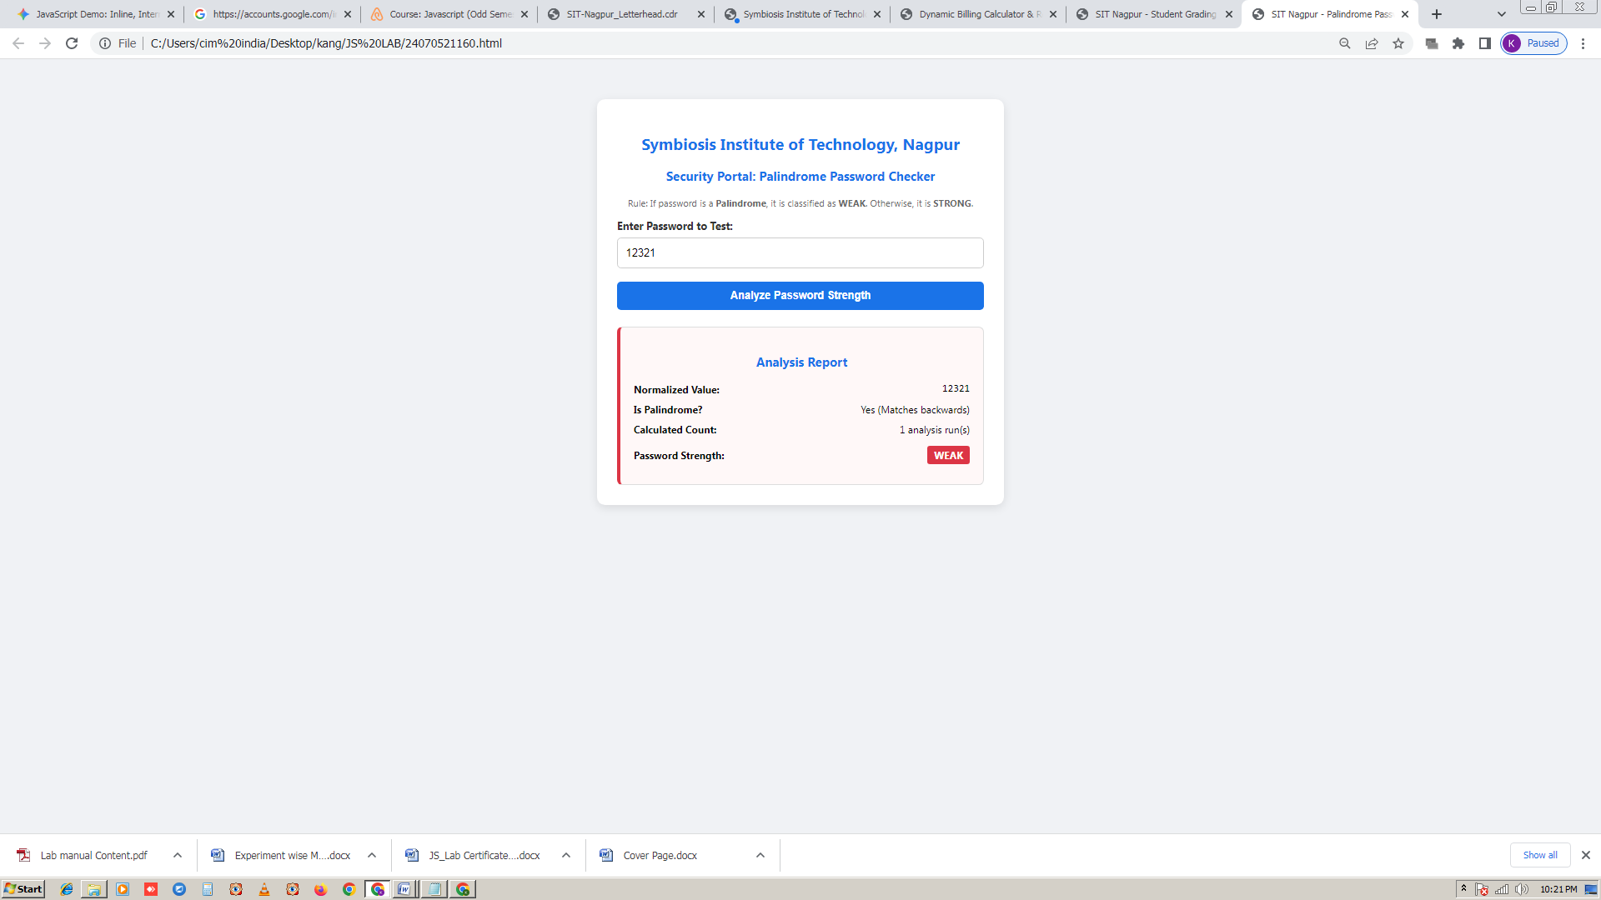

EXP 5
Aim
Apply array methods and object handling; create a cart total calculator with discount logic.

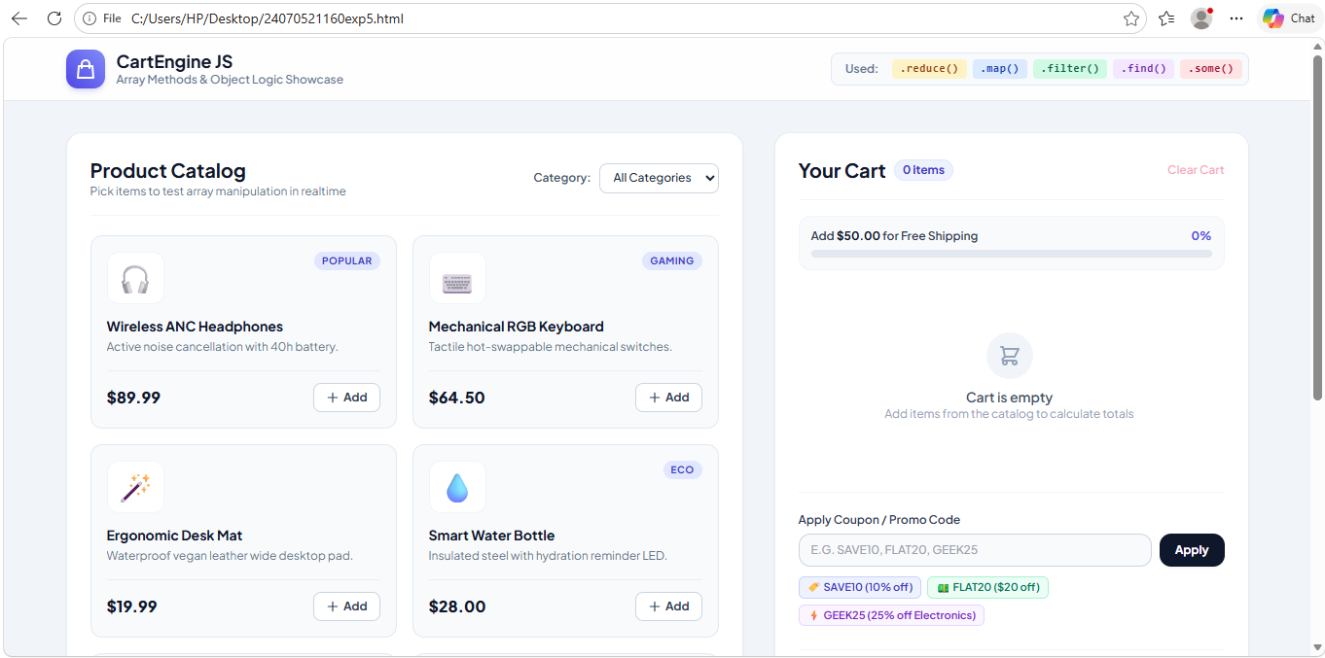

// Shopping Cart using Array and objects
// Array of Product objects

let cart = [
{name: "Book",price: 300, quantity: 2 },
{name:"Pen", price: 20, quantity: 5 },
{name:"Bag", price: 500, quantity: 1 }

];
// Calculate total using array method
let total = cart.reduce((sum,item) => {
return sum + (item.price * item.quantity);

}, 0);
// Apply 10% discount if total is more than 1000
let discount = 0;
if (total > 1000) {
discount = total * 0.10;
}
else if(total > 500 ){
discount = total * 0.05;
}
else if(total > 200){
discount = total * 0.02;
}
else{
discount = 0;}
let finalAmount = total - discount// Display result

EXP 6
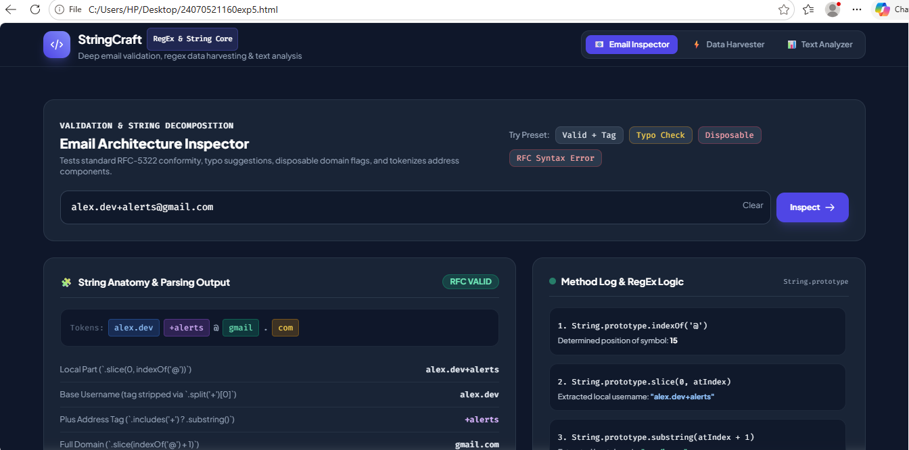

<!DOCTYPE html>
<html lang="en">
<head>
<meta charset="UTF-8">
<meta name="viewport" content="width=device-width, initial-scale=1.0">
<title>Text Analyzer & Case Swapper</title>
<style>
body {
font-family: Arial, sans-serif;
background-color: #f4f7f6;
margin: 0;
padding: 20px;
}
.container {
max-width: 600px;
margin: auto;
background: #fff;
padding: 30px;
border-radius: 8px;
box-shadow: 0 4px 10px rgba(0,0,0,0.1);
}
h2 {
margin-top: 0;
color: #333;
}
textarea {
width: 100%;
height: 120px;
padding: 10px;
border: 1px solid #ccc;
border-radius: 4px;
resize: vertical;
box-sizing: border-box;
font-size: 14px;
transition: border-color 0.2s ease, box-shadow 0.2s ease;
}
textarea:focus {
outline: none;
border-color: #007bff;
box-shadow: 0 0 0 3px rgba(0, 123, 255, 0.25);
}
.button-group {
display: flex;
gap: 10px;
margin-top: 10px;
flex-wrap: wrap;
}
button {
color: white;
padding: 10px 20px;
border: none;
border-radius: 4px;
cursor: pointer;
font-size: 16px;
transition: background-color 0.2s ease, transform 0.1s ease;
}
.btn-primary {
background-color: #007bff;
}
.btn-primary:hover {
background-color: #0056b3;
}
/* Style for the new feature button */
.btn-secondary {
background-color: #28a745;
}
.btn-secondary:hover {
background-color: #218838;
}
button:hover {
transform: translateY(-1px);
}
button:active {
transform: translateY(1px);
}
.results {
margin-top: 20px;
background: #e9ecef;
padding: 15px;
border-radius: 4px;
display: none;
opacity: 0;
}
.results.show {
display: block;
animation: fadeInUp 0.4s ease forwards;
}
.results p {
margin: 8px 0;
font-size: 15px;
}
.highlight {
font-weight: bold;
color: #007bff;
}
/* Style container for swapper text block */
.swapped-output-box {
background: #fff;
padding: 10px;
border: 1px solid #ccc;
border-radius: 4px;
margin-top: 8px;
white-space: pre-wrap;
word-break: break-all;
font-family: monospace;
}

@keyframes fadeInUp {
from {
opacity: 0;
transform: translateY(15px);
}
to {
opacity: 1;
transform: translateY(0);
}
}
</style>
</head>
<body>

<div class="container">
<h2>Text Analyzer & Data Extraction</h2>
<p>Type or paste your paragraph below:</p>

<textarea id="userInput" placeholder="Type text containing emails and words here..."></textarea>
<br>

<div class="button-group">
<button class="btn-primary" onclick="analyzeText()">Analyze Text</button>
<!-- Added Swap Case action button -->
<button class="btn-secondary" onclick="swapTextCase()">Swap Capital & Lowercase</button>
</div>

<!-- Original Analysis Container -->
<div class="results" id="outputSection">
<h3>Analysis Results</h3>
<p><strong>Text Length (Characters):</strong> <span id="charLength" class="highlight"></span></p>
<p><strong>Uppercase Count:</strong> <span id="upperCount" class="highlight"></span></p>
<p><strong>Lowercase Count:</strong> <span id="lowerCount" class="highlight"></span></p>
<p><strong>Contains "Welcome":</strong> <span id="welcomeFound" class="highlight"></span></p>
<p><strong>Extracted Valid Emails:</strong> <span id="emailList" class="highlight"></span></p>
</div>

<!-- New Swapped Case View Container -->
<div class="results" id="swapSection">
<h3>Case Swapped Text</h3>
<button style="padding: 4px 10px; font-size: 12px; background-color: #6c757d;" onclick="copySwappedText()">Copy Text</button>
<div id="swappedTextDisplay" class="swapped-output-box"></div>
</div>
</div>

<script>
function analyzeText() {
const text = document.getElementById('userInput').value;
const outputSection = document.getElementById('outputSection');
document.getElementById('swapSection').classList.remove('show'); // Hide other section

const charLength = text.length;
const upperCount = (text.match(/[A-Z]/g) || []).length;
const lowerCount = (text.match(/[a-z]/g) || []).length;
const containsWelcome = /welcome/i.test(text);

const emailRegex = /[a-zA-Z0-9._%+-]+@[a-zA-Z0-9.-]+\.[a-zA-Z]{2,}/g;
const foundEmails = text.match(emailRegex) || [];
const uniqueEmails = [...new Set(foundEmails)];

document.getElementById('charLength').innerText = charLength;
document.getElementById('upperCount').innerText = upperCount;
document.getElementById('lowerCount').innerText = lowerCount;
document.getElementById('welcomeFound').innerText = containsWelcome ? "Yes" : "No";
document.getElementById('emailList').innerText = uniqueEmails.length > 0 ? uniqueEmails.join(', ') : "None found";

outputSection.classList.remove('show');
void outputSection.offsetWidth;
outputSection.classList.add('show');
}

// Core implementation logic for casing transformation
function swapTextCase() {
const text = document.getElementById('userInput').value;
const swapSection = document.getElementById('swapSection');
document.getElementById('outputSection').classList.remove('show'); // Hide other section

// Converts character by character checking its current active case state
let swapped = "";
for (let i = 0; i < text.length; i++) {
let char = text[i];
if (char === char.toUpperCase()) {
swapped += char.toLowerCase();
} else {
swapped += char.toUpperCase();
}
}

document.getElementById('swappedTextDisplay').innerText = swapped || "No text provided to transform.";

swapSection.classList.remove('show');
void swapSection.offsetWidth;
swapSection.classList.add('show');
}

// Helper tool function to let users copy transformed outcome directly
function copySwappedText() {
const textToCopy = document.getElementById('swappedTextDisplay').innerText;
navigator.clipboard.writeText(textToCopy);
alert("Swapped text copied to clipboard!");
}
</script>

</body>

</html>

EXP 7
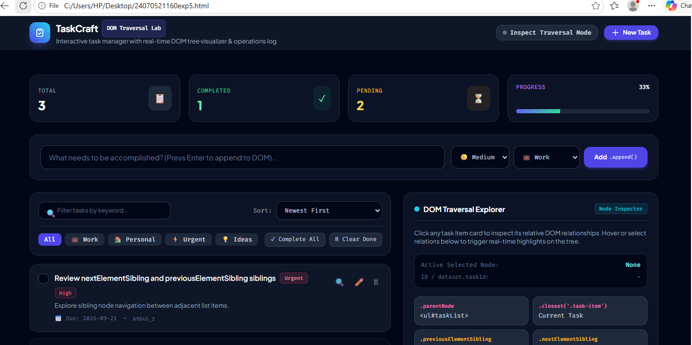

<!DOCTYPE html>
<html>
<head>
<title>DOM Traversal and Updates</title>

<style>
body {
font-family: Arial, sans-serif;
background-color: #f2f2f2;
text-align: center;
padding: 40px;
}

.container {
width: 500px;
margin: auto;
background: white;
padding: 25px;
border-radius: 10px;
box-shadow: 0 0 10px gray;
}

.student-info {
margin-bottom: 20px;
color: #333;
}

input[type="text"] {
width: 60%;
padding: 10px;
border: 1px solid #aaa;
border-radius: 5px;
}

.editInput {
flex: 1;
padding: 8px;
border: 1px solid #aaa;
border-radius: 5px;
}

button {
padding: 8px 12px;
margin: 5px;
border: none;
border-radius: 5px;
cursor: pointer;
}

.add {
background-color: green;
color: white;
}

.edit {
background-color: orange;
color: white;
}

.save {
background-color: blue;
color: white;
}

.delete {
background-color: red;
color: white;
}

li {
list-style: none;
background-color: #eee;
margin: 10px 0;
padding: 10px;
border-radius: 5px;

display: flex;
align-items: center;
gap: 5px;
}

.task {
flex: 1;
text-align: left;
}

.completed {
text-decoration: line-through;
color: gray;
}
</style>
</head>

<body>

<div class="container">

<h2>My To-Do List</h2>

<div class="student-info">
<p><strong>Name:</strong> Ayush Katekhaye</p>
<p><strong>PRN:</strong> 24070521161</p>
</div>

<input type="text" id="taskInput" placeholder="Enter a task">

<button class="add" onclick="addTask()">Add Task</button>

<ul id="taskList"></ul>

</div>

<script>

function addTask() {

let input = document.getElementById("taskInput");
let task = input.value.trim();

if (task === "") {
alert("Please enter a task!");
return;
}

// Create list item
let li = document.createElement("li");

// CHECKBOX FIRST
let checkbox = document.createElement("input");
checkbox.type = "checkbox";

// Create task text
let taskText = document.createElement("span");
taskText.textContent = task;
taskText.className = "task";

// Create Edit button
let editButton = document.createElement("button");
editButton.textContent = "Edit";
editButton.className = "edit";

// Create Delete button
let deleteButton = document.createElement("button");
deleteButton.textContent = "Delete";
deleteButton.className = "delete";

// CHECKBOX FUNCTION
checkbox.onclick = function () {

let parent = this.parentElement;

let text = parent.querySelector(".task");

text.classList.toggle("completed");
};

// EDIT FUNCTION
editButton.onclick = function () {

// DOM Traversal
let parent = this.parentElement;

// Find current task
let text = parent.querySelector(".task");

// Create input box
let editInput = document.createElement("input");

editInput.type = "text";
editInput.value = text.textContent;
editInput.className = "editInput";

// Create Save button
let saveButton = document.createElement("button");

saveButton.textContent = "Save";
saveButton.className = "save";

// Replace task text with input box
parent.replaceChild(editInput, text);

// Replace Edit button with Save button
parent.replaceChild(saveButton, editButton);

// SAVE FUNCTION
saveButton.onclick = function () {

let newTask = editInput.value.trim();

if (newTask === "") {
alert("Task cannot be empty!");
return;
}

// Create new task text
let newText = document.createElement("span");

newText.textContent = newTask;
newText.className = "task";

// Replace input with updated text
parent.replaceChild(newText, editInput);

// Replace Save button with Edit button
parent.replaceChild(editButton, saveButton);
};
};

// DELETE FUNCTION
deleteButton.onclick = function () {

// DOM Traversal
let parent = this.parentElement;

// Remove task
parent.remove();
};

// Add elements in order
// CHECKBOX FIRST
li.appendChild(checkbox);
li.appendChild(taskText);
li.appendChild(editButton);
li.appendChild(deleteButton);

// Add task to list
document.getElementById("taskList").appendChild(li);

// Clear input
input.value = "";
}

</script>

</body>
</html>

EXP 8
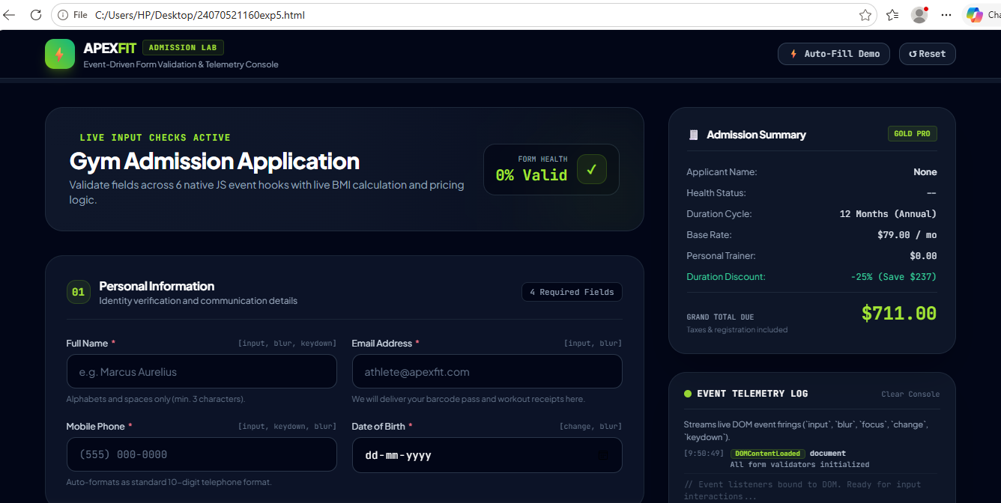

<!DOCTYPE html>
<html lang="en">
<head>
<meta charset="UTF-8">
<meta name="viewport" content="width=device-width, initial-scale=1.0">

<title>IronFit Gym Admission Form</title>

<style>

* {
box-sizing: border-box;
margin: 0;
padding: 0;
font-family: Arial, sans-serif;
}

body {
min-height: 100vh;
background: linear-gradient(135deg, #111111, #242424);
padding: 30px 15px;
color: white;
}

.container {
max-width: 850px;
margin: auto;
background: #1b1b1b;
border-radius: 20px;
overflow: hidden;
box-shadow: 0 15px 40px rgba(0,0,0,0.5);
}

/* HEADER */

header {
text-align: center;
padding: 35px 20px;
background: linear-gradient(135deg, #ff512f, #dd2476);
}

.logo {
font-size: 30px;
font-weight: bold;
margin-bottom: 10px;
}

header h1 {
font-size: 34px;
margin-bottom: 8px;
}

header p {
font-size: 15px;
}

.student-info {
margin-top: 18px;
background: rgba(0,0,0,0.25);
padding: 12px;
border-radius: 10px;
display: inline-block;
}

.student-info p {
margin: 4px;
}

/* FORM */

.form-container {
padding: 35px;
}

.section-title {
font-size: 22px;
margin-bottom: 20px;
border-left: 5px solid #ff512f;
padding-left: 12px;
}

.form-group {
margin-bottom: 22px;
}

label {
display: block;
margin-bottom: 8px;
font-weight: bold;
}

input,
select {
width: 100%;
padding: 14px;
border: 2px solid #444;
border-radius: 10px;
background: #292929;
color: white;
font-size: 15px;
outline: none;
transition: 0.3s;
}

input:focus,
select:focus {
border-color: #ff512f;
}

/* VALIDATION COLORS */

input.correct,
select.correct {
border-color: #00c853;
background: rgba(0, 200, 83, 0.08);
}

input.wrong,
select.wrong {
border-color: #ff1744;
background: rgba(255, 23, 68, 0.08);
}

.message {
display: block;
margin-top: 6px;
font-size: 13px;
font-weight: bold;
}

.success {
color: #00e676;
}

.error {
color: #ff5252;
}

/* TWO COLUMN */

.row {
display: grid;
grid-template-columns: 1fr 1fr;
gap: 20px;
}

/* MEMBERSHIP */

.membership-section {
margin-top: 35px;
}

.plans {
display: grid;
grid-template-columns: repeat(3, 1fr);
gap: 15px;
}

.plan {
border: 2px solid #444;
border-radius: 15px;
padding: 20px;
text-align: center;
cursor: pointer;
transition: 0.3s;
position: relative;
background: #242424;
}

.plan:hover {
transform: translateY(-5px);
border-color: #ff512f;
}

.plan.selected {
border-color: #00c853;
background: rgba(0, 200, 83, 0.08);
}

.plan input {
width: auto;
margin-bottom: 10px;
accent-color: #00c853;
}

.plan h3 {
margin: 8px 0;
}

.price {
color: #ff7043;
font-size: 22px;
font-weight: bold;
}

.popular {
position: absolute;
top: -12px;
right: 10px;
background: #ff512f;
padding: 5px 10px;
border-radius: 15px;
font-size: 11px;
font-weight: bold;
}

/* BENEFITS */

.benefits {
display: grid;
grid-template-columns: repeat(5, 1fr);
gap: 10px;
margin-top: 30px;
}

.benefit {
text-align: center;
background: #252525;
padding: 15px 5px;
border-radius: 10px;
font-size: 13px;
}

.benefit span {
display: block;
font-size: 25px;
margin-bottom: 6px;
}

/* FINAL STATUS */

#formStatus {
margin-top: 25px;
padding: 15px;
border-radius: 10px;
text-align: center;
font-weight: bold;
display: none;
}

#formStatus.successBox {
display: block;
background: rgba(0, 200, 83, 0.15);
border: 2px solid #00c853;
color: #00e676;
}

#formStatus.errorBox {
display: block;
background: rgba(255, 23, 68, 0.15);
border: 2px solid #ff1744;
color: #ff5252;
}

/* BUTTON */

.submit-btn {
width: 100%;
margin-top: 25px;
padding: 16px;
border: none;
border-radius: 12px;
background: linear-gradient(135deg, #ff512f, #dd2476);
color: white;
font-size: 18px;
font-weight: bold;
cursor: pointer;
transition: 0.3s;
}

.submit-btn:hover {
transform: scale(1.02);
box-shadow: 0 8px 20px rgba(255,81,47,0.3);
}

/* RESPONSIVE */

@media(max-width: 700px) {

.row {
grid-template-columns: 1fr;
gap: 0;
}

.plans {
grid-template-columns: 1fr;
}

.benefits {
grid-template-columns: repeat(2, 1fr);
}

header h1 {
font-size: 27px;
}

.form-container {
padding: 25px 20px;
}
}

</style>
</head>

<body>

<div class="container">

<!-- HEADER -->

<header>

<div class="logo">
💪 IRONFIT GYM
</div>

<h1>GYM ADMISSION FORM</h1>

<p>
Transform Your Body • Build Your Strength • Become Better
</p>

<div class="student-info">
<p><strong>Created By:</strong> Ayush Katekhaye</p>
<p><strong>Roll No:</strong> 24070521161</p>
</div>

</header>

<!-- FORM -->

<div class="form-container">

<h2 class="section-title">
👤 Personal Information
</h2>

<!-- NAME -->

<div class="form-group">

<label for="name">
Full Name
</label>

<input
type="text"
id="name"
placeholder="Enter your full name"
oninput="validateName()"
>

<span id="nameMessage" class="message"></span>

</div>

<!-- EMAIL + MOBILE -->

<div class="row">

<div class="form-group">

<label for="email">
Email Address
</label>

<input
type="text"
id="email"
placeholder="example@gmail.com"
oninput="validateEmail()"
>

<span id="emailMessage" class="message"></span>

</div>

<div class="form-group">

<label for="mobile">
Mobile Number
</label>

<input
type="text"
id="mobile"
placeholder="10 digit mobile number"
maxlength="10"
oninput="validateMobile()"
>

<span id="mobileMessage" class="message"></span>

</div>

</div>

<!-- AGE + GENDER -->

<div class="row">

<div class="form-group">

<label for="age">
Age
</label>

<input
type="number"
id="age"
min="18"
max="80"
placeholder="18 - 80"
oninput="validateAge()"
>

<span id="ageMessage" class="message"></span>

</div>

<div class="form-group">

<label for="gender">
Gender
</label>

<select id="gender" onchange="validateGender()">

<option value="">
Select Gender
</option>

<option value="Male">
Male
</option>

<option value="Female">
Female
</option>

<option value="Other">
Other
</option>

</select>

<span id="genderMessage" class="message"></span>

</div>

</div>

<!-- MEMBERSHIP -->

<div class="membership-section">

<h2 class="section-title">
🏋️ Choose Membership Plan
</h2>

<div class="plans">

<!-- MONTHLY -->

<div class="plan" id="monthlyPlan">

<input
type="radio"
name="membership"
value="Monthly"
onclick="selectPlan('monthlyPlan')"
>

<h3>Monthly</h3>

<div class="price">
₹999
</div>

<p>per month</p>

</div>

<!-- QUARTERLY -->

<div class="plan" id="quarterlyPlan">

<div class="popular">
MOST POPULAR
</div>

<input
type="radio"
name="membership"
value="Quarterly"
onclick="selectPlan('quarterlyPlan')"
>

<h3>Quarterly</h3>

<div class="price">
₹2,499
</div>

<p>3 months</p>

</div>

<!-- YEARLY -->

<div class="plan" id="yearlyPlan">

<input
type="radio"
name="membership"
value="Yearly"
onclick="selectPlan('yearlyPlan')"
>

<h3>Yearly</h3>

<div class="price">
₹7,999
</div>

<p>per year</p>

</div>

</div>

<span id="membershipMessage" class="message"></span>

</div>

<!-- BENEFITS -->

<div class="benefits">

<div class="benefit">
<span>🏋️</span>
Modern Equipment
</div>

<div class="benefit">
<span>👨‍🏫</span>
Certified Trainers
</div>

<div class="benefit">
<span>🏃</span>
Cardio Zone
</div>

<div class="benefit">
<span>📶</span>
Free Wi-Fi
</div>

<div class="benefit">
<span>🔐</span>
Locker Facility
</div>

</div>

<!-- FINAL STATUS -->

<div id="formStatus"></div>

<!-- SUBMIT -->

<button
class="submit-btn"
onclick="submitForm()"
>
JOIN IRONFIT GYM 💪
</button>

</div>

</div>

<script>

/* NAME VALIDATION */

function validateName() {

let input = document.getElementById("name");
let message = document.getElementById("nameMessage");

let name = input.value.trim();

if (name === "") {

input.classList.remove("correct", "wrong");
message.innerHTML = "";

return false;
}

if (/^[A-Za-z ]+$/.test(name) && name.length >= 3) {

input.classList.remove("wrong");
input.classList.add("correct");

message.innerHTML = "✓ Name is correct";
message.className = "message success";

return true;

} else {

input.classList.remove("correct");
input.classList.add("wrong");

message.innerHTML =
"✗ Enter a valid name using letters only";

message.className = "message error";

return false;
}
}

/* EMAIL VALIDATION */

function validateEmail() {

let input = document.getElementById("email");
let message = document.getElementById("emailMessage");

let email = input.value.trim();

let emailPattern =
/^[^\s@]+@[^\s@]+\.[^\s@]+$/;

if (email === "") {

input.classList.remove("correct", "wrong");
message.innerHTML = "";

return false;
}

if (emailPattern.test(email)) {

input.classList.remove("wrong");
input.classList.add("correct");

message.innerHTML = "✓ Email is correct";
message.className = "message success";

return true;

} else {

input.classList.remove("correct");
input.classList.add("wrong");

message.innerHTML =
"✗ Enter a valid email address";

message.className = "message error";

return false;
}
}

/* MOBILE VALIDATION */

function validateMobile() {

let input = document.getElementById("mobile");
let message = document.getElementById("mobileMessage");

let mobile = input.value.trim();

let mobilePattern =
/^[6-9][0-9]{9}$/;

if (mobile === "") {

input.classList.remove("correct", "wrong");
message.innerHTML = "";

return false;
}

if (mobilePattern.test(mobile)) {

input.classList.remove("wrong");
input.classList.add("correct");

message.innerHTML =
"✓ Mobile number is correct";

message.className = "message success";

return true;

} else {

input.classList.remove("correct");
input.classList.add("wrong");

message.innerHTML =
"✗ Enter a valid 10-digit mobile number";

message.className = "message error";

return false;
}
}

/* AGE VALIDATION */

function validateAge() {

let input = document.getElementById("age");
let message = document.getElementById("ageMessage");

let age = Number(input.value);

if (input.value === "") {

input.classList.remove("correct", "wrong");
message.innerHTML = "";

return false;
}

if (age >= 18 && age <= 80) {

input.classList.remove("wrong");
input.classList.add("correct");

message.innerHTML =
"✓ Age is valid (18–80)";

message.className = "message success";

return true;

} else {

input.classList.remove("correct");
input.classList.add("wrong");

message.innerHTML =
"✗ Age must be between 18 and 80";

message.className = "message error";

return false;
}
}

/* GENDER VALIDATION */

function validateGender() {

let input = document.getElementById("gender");
let message = document.getElementById("genderMessage");

if (input.value !== "") {

input.classList.remove("wrong");
input.classList.add("correct");

message.innerHTML =
"✓ Gender selected";

message.className = "message success";

return true;

} else {

input.classList.remove("correct");
input.classList.add("wrong");

message.innerHTML =
"✗ Please select your gender";

message.className = "message error";

return false;
}
}

/* MEMBERSHIP */

function selectPlan(planId) {

document.querySelectorAll(".plan")
.forEach(function(plan) {

plan.classList.remove("selected");

});

document
.getElementById(planId)
.classList.add("selected");

let message =
document.getElementById("membershipMessage");

message.innerHTML =
"✓ Membership plan selected";

message.className =
"message success";
}

/* CHECK MEMBERSHIP */

function validateMembership() {

let selected =
document.querySelector(
'input[name="membership"]:checked'
);

let message =
document.getElementById("membershipMessage");

if (selected) {

message.innerHTML =
"✓ Membership plan selected";

message.className =
"message success";

return true;

} else {

message.innerHTML =
"✗ Please select a membership plan";

message.className =
"message error";

return false;
}
}

/* FINAL FORM VALIDATION */

function checkAllFields() {

let nameValid = validateName();
let emailValid = validateEmail();
let mobileValid = validateMobile();
let ageValid = validateAge();
let genderValid = validateGender();
let membershipValid = validateMembership();

let status =
document.getElementById("formStatus");

if (
nameValid &&
emailValid &&
mobileValid &&
ageValid &&
genderValid &&
membershipValid
) {

status.innerHTML =
"✓ All information is correct! You can submit the form.";

status.className =
"successBox";

return true;

} else {

status.innerHTML =
"✗ Please correct the highlighted information.";

status.className =
"errorBox";

return false;
}
}

/* SUBMIT */

function submitForm() {

if (checkAllFields()) {

alert(
"🎉 Admission Successful!\n\n" +
"Welcome to IronFit Gym, " +
document.getElementById("name").value + "!"
);

} else {

alert(
"❌ Please correct all red fields before submitting."
);
}
}

/* CHECK FORM WHEN USER CLICKS ANY FIELD */

document
.querySelectorAll("input, select")
.forEach(function(element) {

element.addEventListener("blur", function() {

checkAllFields();

});

});

</script>

</body>
</html>

EXP 9
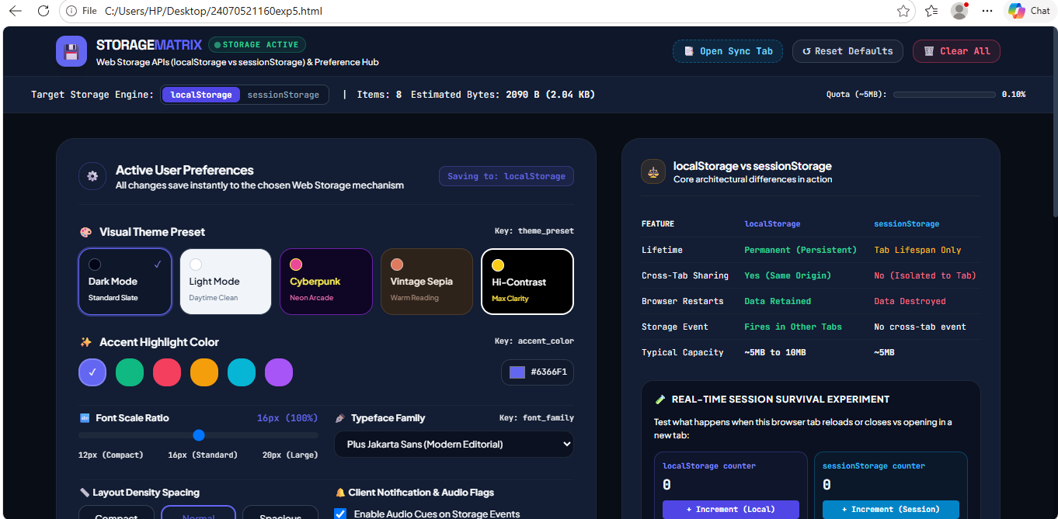

<!DOCTYPE html>
<html lang="en">

<head>
<meta charset="UTF-8">

<meta name="viewport"
content="width=device-width, initial-scale=1.0">

<title>Theme Settings - Ayush Katekhaye</title>

<style>

/* ==============================
RESET
============================== */

* {
margin: 0;
padding: 0;
box-sizing: border-box;
}

/* ==============================
BODY
============================== */

body {
min-height: 100vh;

display: flex;
justify-content: center;
align-items: center;

font-family: Arial, sans-serif;

background: #e8edf3;

color: #222;

transition:
background 0.4s ease,
color 0.4s ease;
}

/* ==============================
DARK MODE
============================== */

body.dark {
background: #1c1c1c;
color: white;
}

/* ==============================
MAIN CONTAINER
============================== */

.container {
width: 430px;

padding: 35px;

background: white;

border-radius: 12px;

text-align: center;

box-shadow:
0 8px 25px rgba(0, 0, 0, 0.20);

transition: 0.4s;
}

body.dark .container {
background: #2b2b2b;

box-shadow:
0 8px 25px rgba(0, 0, 0, 0.5);
}

/* ==============================
HEADING
============================== */

h1 {
font-size: 28px;

margin-bottom: 15px;
}

.subtitle {
color: #666;

margin-bottom: 15px;
}

body.dark .subtitle {
color: #ccc;
}

/* ==============================
STUDENT INFORMATION
============================== */

.student-info {
background: #f2f2f2;

padding: 12px;

margin-bottom: 25px;

border-radius: 7px;

text-align: left;

font-size: 14px;

line-height: 1.7;
}

body.dark .student-info {
background: #414141;
}

.student-info strong {
color: #5555cc;
}

body.dark .student-info strong {
color: #aaaaff;
}

/* ==============================
SELECT BOX
============================== */

select {
width: 170px;

padding: 10px;

margin-bottom: 20px;

border: 1px solid #888;

border-radius: 6px;

font-size: 15px;

cursor: pointer;

background: white;
}

body.dark select {
background: #444;

color: white;

border-color: #777;
}

/* ==============================
BUTTON AREA
============================== */

.buttons {
display: flex;

justify-content: center;

gap: 8px;

flex-wrap: wrap;
}

/* ==============================
BUTTON
============================== */

button {
padding: 10px 14px;

border: none;

border-radius: 6px;

background: #e1e1e1;

color: #222;

cursor: pointer;

font-size: 13px;

transition: 0.2s;
}

button:hover {
background: #d0d0d0;

transform: translateY(-2px);
}

body.dark button {
background: #555;

color: white;
}

body.dark button:hover {
background: #666;
}

/* ==============================
STATUS
============================== */

.status {
margin-top: 25px;

padding: 12px;

border-radius: 6px;

background: #eef7ee;

color: #247024;

font-size: 14px;

min-height: 40px;
}

body.dark .status {
background: #243d24;

color: #9bea9b;
}

/* ==============================
STORAGE INFORMATION
============================== */

.storage {
margin-top: 20px;

padding-top: 18px;

border-top: 1px solid #ddd;

text-align: left;
}

body.dark .storage {
border-color: #555;
}

.storage h3 {
text-align: center;

margin-bottom: 12px;
}

.storage p {
margin: 8px 0;

font-size: 14px;
}

.value {
font-weight: bold;

color: #5555cc;
}

body.dark .value {
color: #aaaaff;
}

/* ==============================
FOOTER
============================== */

.footer {
margin-top: 20px;

font-size: 12px;

color: #777;
}

body.dark .footer {
color: #aaa;
}

/* ==============================
MOBILE
============================== */

@media (max-width: 500px) {

.container {
width: 90%;

padding: 25px;
}

}

</style>

</head>

<body>

<!-- =================================
MAIN CONTAINER
================================== -->

<div class="container">

<!-- TITLE -->

<h1>Theme Settings</h1>

<p class="subtitle">
Select your preferred theme
</p>

<!-- =================================
STUDENT INFORMATION
================================== -->

<div class="student-info">

<p>
<strong>Name:</strong>
Ayush Katekhaye
</p>

<p>
<strong>PRN:</strong>
24070521161
</p>

</div>

<!-- =================================
THEME SELECTION
================================== -->

<select id="themeSelect">

<option value="light">
☀️ Light
</option>

<option value="dark">
🌙 Dark
</option>

</select>

<!-- =================================
BUTTONS
================================== -->

<div class="buttons">

<button onclick="saveLocal()">

💾 Save using Local Storage

</button>

<button onclick="saveSession()">

🕐 Save using Session Storage

</button>

<button onclick="clearPreferences()">

🗑️ Clear Preferences

</button>

</div>

<!-- =================================
STATUS MESSAGE
================================== -->

<div
class="status"
id="status">

Select a theme and save your preference.

</div>

<!-- =================================
STORAGE INFORMATION
================================== -->

<div class="storage">

<h3>
Storage Information
</h3>

<p>

Local Storage:

<span
class="value"
id="localData">

Empty

</span>

</p>

<p>

Session Storage:

<span
class="value"
id="sessionData">

Empty

</span>

</p>

<p>

Current Theme:

<span
class="value"
id="currentTheme">

Light ☀️

</span>

</p>

</div>

<!-- =================================
FOOTER
================================== -->

<div class="footer">

JavaScript Practical

<br>

Local Storage & Session Storage

</div>

</div>

<!-- =====================================
JAVASCRIPT
====================================== -->

<script>

/* ==============================
GET HTML ELEMENTS
============================== */

const themeSelect =
document.getElementById("themeSelect");

const status =
document.getElementById("status");

const localData =
document.getElementById("localData");

const sessionData =
document.getElementById("sessionData");

const currentTheme =
document.getElementById("currentTheme");

/* ==============================
APPLY THEME
============================== */

function applyTheme(theme) {

if (theme === "dark") {

document.body.classList.add("dark");

themeSelect.value = "dark";

currentTheme.innerText =
"Dark 🌙";

}

else {

document.body.classList.remove("dark");

themeSelect.value = "light";

currentTheme.innerText =
"Light ☀️";

}

}

/* ==============================
THEME CHANGE EVENT
============================== */

themeSelect.addEventListener(
"change",
function () {

const theme =
themeSelect.value;

applyTheme(theme);

status.innerText =
"Theme selected. Click a storage button to save it.";

}
);

/* ==============================
SAVE USING LOCAL STORAGE
============================== */

function saveLocal() {

const theme =
themeSelect.value;

localStorage.setItem(
"theme",
theme
);

applyTheme(theme);

updateStorage();

status.innerText =
"Theme saved using Local Storage ✓";

}

/* ==============================
SAVE USING SESSION STORAGE
============================== */

function saveSession() {

const theme =
themeSelect.value;

sessionStorage.setItem(
"theme",
theme
);

applyTheme(theme);

updateStorage();

status.innerText =
"Theme saved using Session Storage ✓";

}

/* ==============================
CLEAR PREFERENCES
============================== */

function clearPreferences() {

localStorage.removeItem("theme");

sessionStorage.removeItem("theme");

applyTheme("light");

updateStorage();

status.innerText =
"Theme preferences cleared ✓";

}

/* ==============================
UPDATE STORAGE INFORMATION
============================== */

function updateStorage() {

const localTheme =
localStorage.getItem("theme");

const sessionTheme =
sessionStorage.getItem("theme");

if (localTheme) {

localData.innerText =
localTheme;

}

else {

localData.innerText =
"Empty";

}

if (sessionTheme) {

sessionData.innerText =
sessionTheme;

}

else {

sessionData.innerText =
"Empty";

}

}

/* ==============================
LOAD SAVED THEME
============================== */

window.onload = function () {

/*
Check Local Storage first
*/

let savedTheme =
localStorage.getItem("theme");

/*
If Local Storage is empty,
check Session Storage
*/

if (!savedTheme) {

savedTheme =
sessionStorage.getItem("theme");

}

/*
Apply saved theme
*/

if (savedTheme) {

applyTheme(savedTheme);

status.innerText =
"Saved theme loaded successfully ✓";

}

else {

applyTheme("light");

}

updateStorage();

};

</script>

</body>

</html>

EXP 10
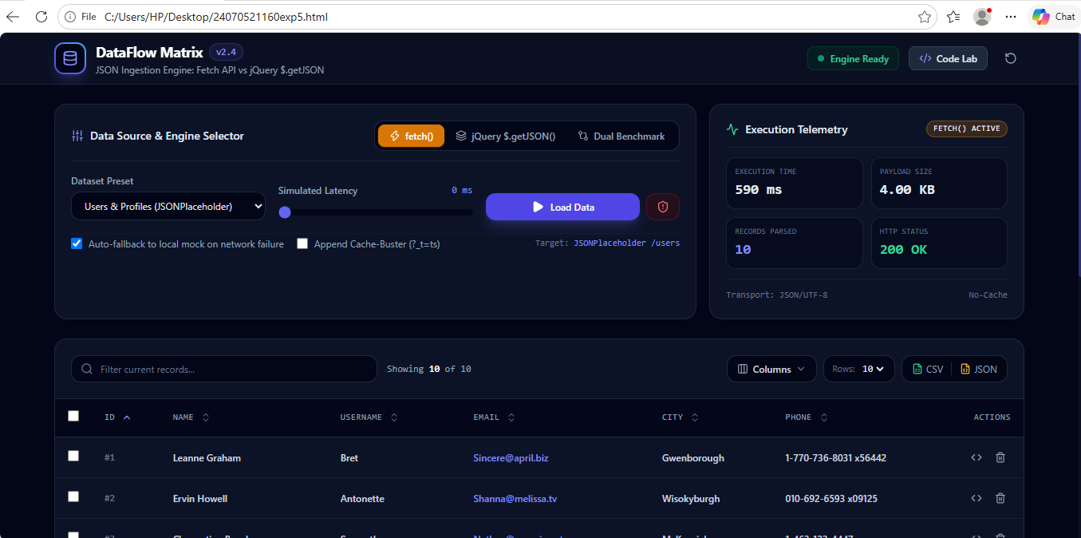

<!DOCTYPE html>
<html lang="en">

<head>
<meta charset="UTF-8">
<meta name="viewport" content="width=device-width, initial-scale=1.0">

<title>Student Information</title>

<!-- jQuery Library -->
<script src="https://code.jquery.com/jquery-3.7.1.min.js"></script>

<style>
body {
font-family: Arial, sans-serif;
background: #eef2f7;
margin: 0;
padding: 0;
}

.container {
width: 80%;
max-width: 700px;
margin: 60px auto;
background: white;
padding: 30px;
border-radius: 15px;
text-align: center;
box-shadow: 0 5px 20px rgba(0, 0, 0, 0.15);
}

h1 {
color: #2c3e50;
}

.buttons {
margin: 25px 0;
}

button {
padding: 12px 22px;
margin: 8px;
border: none;
border-radius: 7px;
color: white;
font-size: 16px;
cursor: pointer;
}

#fetchBtn {
background: #27ae60;
}

#getBtn {
background: #8e44ad;
}

button:hover {
opacity: 0.8;
}

#output {
margin-top: 25px;
}

.student-card {
text-align: left;
background: #f7f9fb;
padding: 20px;
border-radius: 10px;
border-left: 5px solid #3498db;
}

.student-card h2 {
text-align: center;
color: #2c3e50;
}

.student-card p {
font-size: 17px;
margin: 12px 0;
}

.method {
color: #8e44ad;
font-weight: bold;
}
</style>
</head>

<body>

<div class="container">

<h1>🎓 Student Information</h1>

<p>Load student information from JSON file</p>

<div class="buttons">

<!-- Fetch Button -->
<button id="fetchBtn">
Load Using fetch()
</button>

<!-- jQuery GET Button -->
<button id="getBtn">
Load Using $.get()
</button>

</div>

<div id="output">
<p>Click a button to load student information.</p>
</div>

</div>

<script>

// ============================================
// 1. LOAD DATA USING FETCH()
// ============================================

$("#fetchBtn").click(function () {

fetch("student.json")

.then(response => {

if (!response.ok) {
throw new Error("JSON file not found");
}

return response.json();
})

.then(data => {

$("#output").html(`

<div class="student-card">

<h2>Student Details</h2>

<p>
<b>Name:</b> ${data.name}
</p>

<p>
<b>PRN:</b> ${data.prn}
</p>

<p>
<b>Course:</b> ${data.course}
</p>

<p>
<b>Year:</b> ${data.year}
</p>

<p>
<b>College:</b> ${data.college}
</p>

<p>
<b>Email:</b> ${data.email}
</p>

<p>
<b>Loaded Using:</b>
<span class="method">fetch()</span>
</p>

</div>

`);

})

.catch(error => {

$("#output").html(`
<p>❌ Error loading student data.</p>
<p>Check whether student.json is in the correct folder.</p>
`);

console.log(error);

});

});

// ============================================
// 2. LOAD DATA USING $.get()
// ============================================

$("#getBtn").click(function () {

$.get("student.json", function (data) {

$("#output").html(`

<div class="student-card">

<h2>Student Details</h2>

<p>
<b>Name:</b> ${data.name}
</p>

<p>
<b>PRN:</b> ${data.prn}
</p>

<p>
<b>Course:</b> ${data.course}
</p>

<p>
<b>Year:</b> ${data.year}
</p>

<p>
<b>College:</b> ${data.college}
</p>

<p>
<b>Email:</b> ${data.email}
</p>

<p>
<b>Loaded Using:</b>
<span class="method">$.get()</span>
</p>

</div>

`);

})

.fail(function () {

$("#output").html(`
<p>❌ Error loading student data.</p>
<p>Check whether student.json is in the correct folder.</p>
`);

});

});

</script>

</body>

</html>

