UNIVERSITY OF EDUCATION


Lab Assignment | 1 | Mid |  | Final
Course Title & Code | SNA
Submitted By: | Khawaja Zeeshan Ijaz
Registration No: | Mtf25004960
Semester/Class/ Section: | 5th Semester/BSIT
Submitted To: | Sir Allah Dita
Due Date | Online |  | Hard copy
 | 15/10/2025
Student’s Signature: | 

UNIVERSITY OF EDUCATION
DIVISION OF SCIENCE AND TECHNOLOGY

LAB ASSIGNMENT NO 1
- How to build a Virtual Disk File with the VHD File Extension and store the data on this Virtual Disk?
Create a Virtual Hard Disk (VHD or VHDX) using the Disk Management utility in Windows
- Open Disk Management:
-- Press the Windows key + X and select Disk Management from the menu.Alternatively, type (diskmgmt.msc) in the Run dialog (Windows key + R) and press Enter.
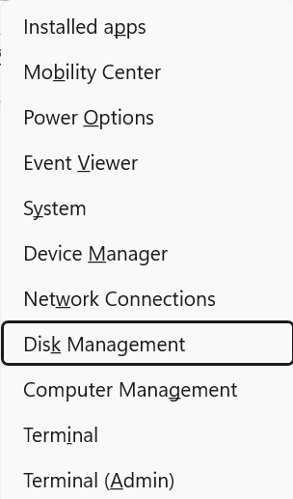
- Start the Creation Process:
--In the Disk Management window, go to the Action menu and select Create VHD
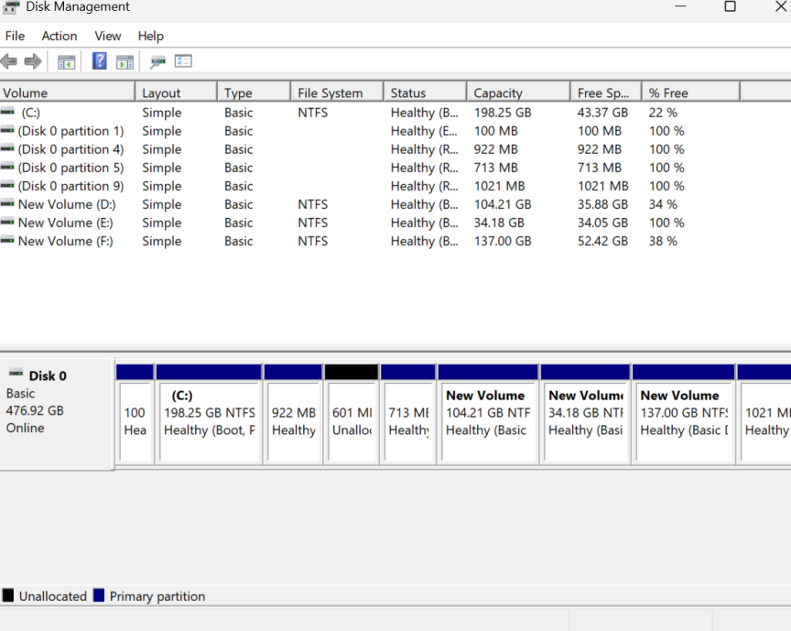

- Specify Location and Size:
Location: To save the .vhd or .vhdx file on your physical hard drive, click the Browse option, and select the desired location. Enter the appropriate file name (for example, MyVirtualDisk.vhdx).
Virtual hard disk size: Specify the size that you require your virtual disk to be. This size must be in MB, GB, or TB.
Virtual hard disk format: Select either VHD (standard virtual hard disk format) or VHDX (better for larger disks and offers more resilience which is preferred).
Virtual hard disk type: Select Completely expanding (grows as you provide more data, to the maximum size you set) or the Fixed size (all space is set right away which forms a small speed gain).
- Create the VHD:
Click OK. The system will create and automatically attach the new virtual disk, which will appear as a new disk in the Disk Management window, marked as "Unknown" and "Not Initialized."

- Initialize and Format the Virtual Disk:
- Initialize the Disk: Right-click on the new disk (the left area with the disk number) and select Initialize Disk. Choose GPT or MBR and click OK
- Create a Volume: Right-click on the Un allocated space and select New Simple Volume.
- Follow the New Simple Volume Wizard
- Specify the volume size.
- Assign a drive letter.
- Format the volume (File system: NTFS; check Perform a quick format; assign a Volume label).
- Click Finish.

- Store Data on the Virtual Disk:
- · Once formatted, the VHD will appear as a new drive in File Explorer with the assigned drive letter.

- You can now open this new drive and copy, move, or save files and folders to it. The data is now stored inside the single VHD file you created.
·

