⬡
FlowCraft
Embedded Workflow Engine for Any Website
n8n-style visual builder • 50+ integrations • AI Agents • Website mein embed karo
✓ Complete PRD + Architecture Diagrams + Flowcharts + Implementation Guide
★ AI KO DO AUR SEEDHA CODE BANWAO — Har section mein ready prompts hain

SECTION 1 — ARCHITECTURE DIAGRAMS

1.1 System Architecture — Complete Overview
Yeh diagram FlowCraft ka poora system dikhata hai — Website layer se lekar External Services tak.
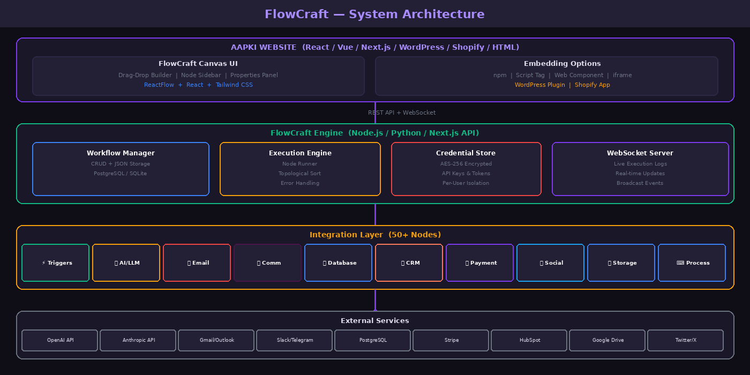
Figure 1: FlowCraft System Architecture — Website → Canvas UI → Engine → Integrations → External Services

1.2 Workflow Execution Flow
Jab koi trigger fire hota hai to workflow is process se guzarta hai — trigger se response tak.
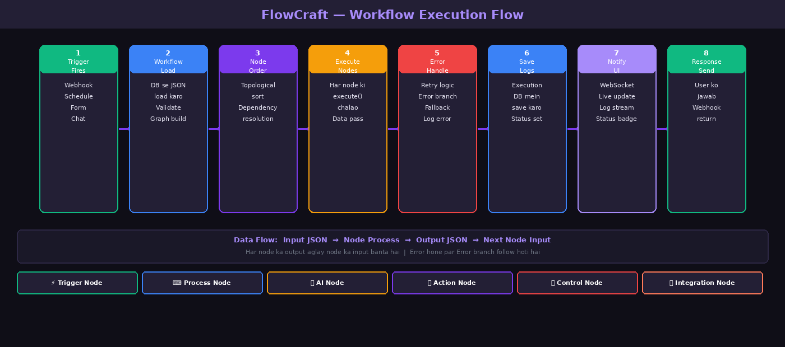
Figure 2: Workflow Execution Flow — 8 steps from Trigger to Response

1.3 Complete Integration Map — 50+ Nodes
Tamam available integrations categories ke mutabiq — yeh sab nodes FlowCraft mein built-in hain.
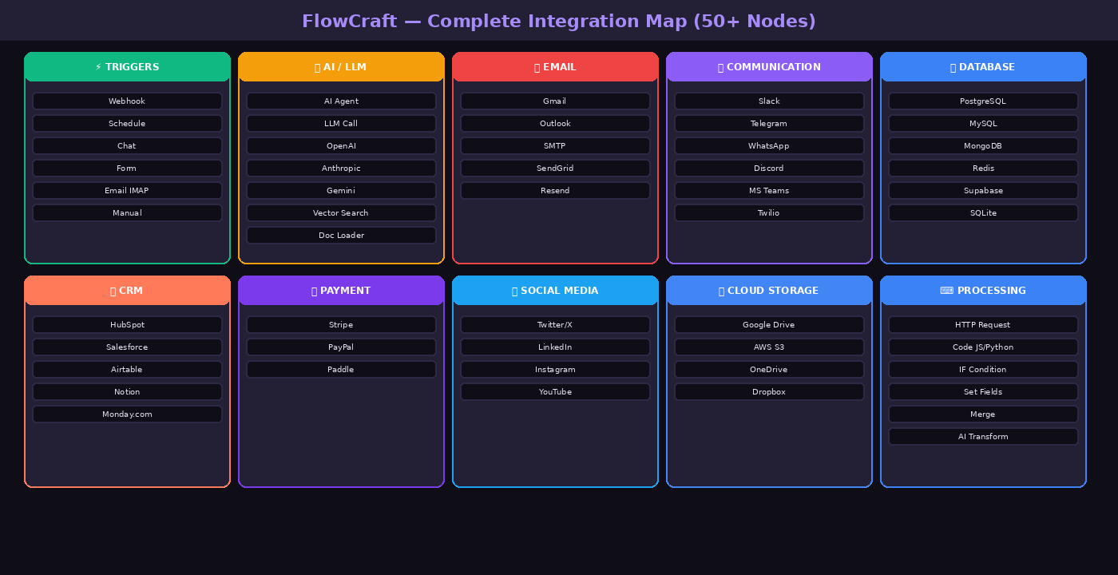
Figure 3: FlowCraft Integration Map — 10 categories, 50+ nodes

SECTION 2 — PRODUCT VISION

2.1 Product Kya Hai?
FlowCraft ek embeddable workflow automation engine hai — bilkul n8n ki tarah — lekin yeh aap ki apni website ka hissa ban jata hai.
n8n = Alag application jise alag server chahiye | FlowCraft = Aap ki website ka built-in feature
Feature | n8n (Original) | FlowCraft (Aap ka Product)
Installation | Alag server deploy karo | npm install / script tag — bas
Login | Alag n8n account | Aap ki website ka existing auth
Hosting | Aap ka server ya n8n.cloud | Aap ki website ke saath
Customization | Limited branding | 100% aap ka design, aap ke nodes
Users | Technical users mostly | Koi bhi — non-technical bhi
Business Logic | Generic nodes | Aap ke business ke custom nodes
Integration | Webhook se connect karo | Direct DB, auth, APIs access

SECTION 3 — EMBEDDING GUIDE (Kisi Bhi Website Mein)

3.1 React / Next.js
npm install @flowcraft/react @flowcraft/engine

import { FlowCraftCanvas } from '@flowcraft/react';

<FlowCraftCanvas
apiUrl='/api/flowcraft'
userId={session.user.id}
theme='dark'
customNodes={myNodes}
onSave={(wf) => console.log('Saved:', wf)}
/>

3.2 Vanilla HTML
<link rel='stylesheet' href='https://cdn.flowcraft.dev/latest/style.css' />
<div id='workflow-builder'></div>
<script src='https://cdn.flowcraft.dev/latest/flowcraft.js'></script>
<script>
FlowCraft.init({
container: '#workflow-builder',
apiUrl: 'https://your-backend.com/api/flowcraft',
userId: currentUser.id,
height: '80vh'
});
</script>

3.3 WordPress Plugin
[flowcraft] ← shortcode page mein dalo, bas!

3.4 Vue.js
<FlowCraftCanvas :api-url='apiUrl' :user-id='userId' />

SECTION 4 — BUILT-IN NODES (50+)

4.1 Trigger Nodes
Node | Description | Key Config
Webhook Trigger | HTTP request receive karo | Path, Method, Auth
Schedule | Waqt par chalao | Cron, Timezone
Chat Trigger | Chat widget se message | Public access, Greeting
Form Trigger | Form submit hone par | Fields, Response
Email Trigger (IMAP) | Email aane par | Host, Folder, SSL
Manual | Button click se test karo | —

4.2 AI / LLM Nodes
Node | Provider | Key Options
AI Agent | Any LLM | Model, Memory, Tools, System Prompt, Max Iterations
LLM Call | Any LLM | Model, Prompt, Temperature, Max Tokens
OpenAI | OpenAI | Chat, Images (DALL-E), Audio (Whisper), Embeddings
Anthropic | Anthropic | claude-sonnet-4-6, claude-opus-4-6, claude-haiku-4-5
Google Gemini | Google | gemini-2.0-flash, gemini-1.5-pro, gemini-2.5-pro
Vector Search | Pinecone/Qdrant/etc | Store, Query, Top K
Doc Loader (RAG) | Any | Source, Chunk Size, Overlap

4.3 Communication Nodes
Node | Operations
Slack | Send Message, Send Block, Upload File, Add Reaction, Create Channel
Telegram | Send Message, Photo, Document, Poll, Edit Message
WhatsApp | Send Text, Template, Media, Buttons, List
Discord | Send Message, Embed, Add Role, Create Channel
MS Teams | Send Message, Adaptive Card, Create Team
Twilio | Send SMS, Make Call, Verify OTP

4.4 Database Nodes
Database | Operations
PostgreSQL | SELECT, INSERT, UPDATE, DELETE, UPSERT, Execute Query
MySQL | SELECT, INSERT, UPDATE, DELETE, Execute Query
MongoDB | Find, FindOne, Insert, Update, Delete, Aggregate
Redis | Get, Set, Delete, Expire, List Push, Hash, Pub/Sub
Supabase | DB CRUD, RPC, Storage Upload, Auth
SQLite | SELECT, INSERT, UPDATE, DELETE, Execute

4.5 CRM Nodes
CRM | Key Operations
HubSpot | Create/Update Contact, Create Deal, Create Ticket, Add Note, Search
Salesforce | Create/Update/Get Record, Search, Run SOQL, Any Object
Airtable | List/Create/Update/Delete Records, Search
Notion | Create/Update Page, Query DB, Search, Append Blocks
Monday.com | Create/Update/Delete Item, Move to Group

4.6 Payment Nodes
Service | Operations
Stripe | Create Payment Intent, Confirm, Customer, Subscription, Invoice, Refund, Checkout Session
PayPal | Create/Capture Order, Refund, Subscription, Get Transaction
Paddle | Get/Cancel/Update Subscription, Create Pay Link

4.7 Social Media Nodes
Platform | Operations
Twitter/X | Post Tweet, Reply, Like, Retweet, Search, Get User, Delete
LinkedIn | Create Post, Company Post, Get Profile, Share Article
Instagram | Get Media, Profile, Insights, Reply to Comment
YouTube | Get Videos, Search, Get Comments, Upload Video

4.8 Cloud Storage Nodes
Service | Operations
Google Drive | Upload, Download, List, Move, Copy, Delete, Share, Create Folder, Search
AWS S3 | Upload, Download, Delete, List, Presigned URL, Copy, Create Bucket
OneDrive | Upload, Download, List, Move, Delete, Share Link
Dropbox | Upload, Download, List, Move, Copy, Delete, Get Link

SECTION 5 — BACKEND ENGINE SPEC

5.1 Database Schema
CREATE TABLE workflows (
id UUID PRIMARY KEY DEFAULT gen_random_uuid(),
user_id VARCHAR(255) NOT NULL,
name VARCHAR(255) NOT NULL,
json_data JSONB NOT NULL,
active BOOLEAN DEFAULT false,
created_at TIMESTAMP DEFAULT NOW()
);

CREATE TABLE executions (
id UUID PRIMARY KEY,
workflow_id UUID REFERENCES workflows(id),
status VARCHAR(50), -- running, success, error
started_at TIMESTAMP,
finished_at TIMESTAMP,
data JSONB,
error_message TEXT
);

CREATE TABLE credentials (
id UUID PRIMARY KEY,
user_id VARCHAR(255),
name VARCHAR(255),
data_encrypted TEXT -- AES-256 encrypted
);

5.2 REST API Endpoints
Method | Endpoint | Description
GET | /api/workflows | User ke workflows list
POST | /api/workflows | Naya workflow create
PUT | /api/workflows/:id | Workflow update
DELETE | /api/workflows/:id | Workflow delete
POST | /api/workflows/:id/execute | Manually execute
GET | /api/nodes | Available nodes list
POST | /api/webhooks/:path | Webhook receive
GET | /api/executions/:id/logs | Live logs (SSE)
POST | /api/credentials | Credential save

SECTION 6 — SECURITY
Area | Implementation
Credentials Encryption | AES-256-GCM — keys kabhi plain text mein nahi
API Authentication | JWT tokens — har request verify
User Isolation | Row-Level Security — user sirf apna data dekhe
Webhook Security | HMAC signatures verify karo
Code Execution | Sandboxed VM (vm2 ya isolated-vm) — no eval()
Rate Limiting | Per-user execution limits
Input Validation | Zod schemas — har input validate
CORS | Allowed origins whitelist
★ Code Node mein user ka code SANDBOX mein chalao — direct Node.js eval KABHI MAT KARO

SECTION 7 — IMPLEMENTATION ROADMAP
Phase | Duration | Deliverables
Phase 1: MVP | 4-6 weeks | Canvas UI + 10 nodes + Webhook + Schedule + PostgreSQL
Phase 2: AI | 3-4 weeks | AI Agent + LLM nodes + Memory + Tools
Phase 3: Integrations | 4-6 weeks | Email, Slack, DB nodes + Credential manager
Phase 4: Embed | 2-3 weeks | npm package + Script tag + WordPress plugin
Phase 5: Custom Nodes | 2-3 weeks | Custom node SDK + CLI + Documentation
Phase 6: Enterprise | 4-6 weeks | Multi-tenant + RBAC + Audit logs + Analytics

SECTION 8 — AI KO DENE KE READY PROMPTS

PROMPT 1 — Complete MVP:
Is spec ke mutabiq FlowCraft ka complete MVP banao. Stack: React + ReactFlow (frontend), Node.js + Express + PostgreSQL (backend). Pehle project structure, phir Canvas component, phir Execution Engine. TypeScript mein. Har file ka code dena.

PROMPT 2 — Canvas UI Only:
FlowCraft React frontend banao. ReactFlow use karo. Components: WorkflowCanvas, NodeSidebar (categories ke saath), NodePropertiesPanel, Toolbar. 50+ nodes with icons. Dark theme. Tailwind CSS. AI node category included.

PROMPT 3 — Backend Engine:
FlowCraft Node.js execution engine banao. TypeScript + Fastify + PostgreSQL + BullMQ. Features: Workflow CRUD API, Execution engine, WebSocket live updates, Webhook handler, Credential encryption. DB schema bhi dena.

PROMPT 4 — npm Package:
FlowCraft npm package banao: @flowcraft/react aur @flowcraft/engine. React component props: apiUrl, userId, theme, customNodes. Engine: class-based API. TypeScript types. README with examples.

PROMPT 5 — WordPress Plugin:
FlowCraft WordPress plugin banao. PHP + WP REST API. Features: shortcode [flowcraft], admin settings page, user meta mein workflows save, current user ID auto pass. Gutenberg block bhi banao.

PROMPT 6 — Custom Node SDK:
FlowCraft custom node SDK banao. TypeScript interface: NodeDefinition. CLI: npx flowcraft create-node MyNodeName. Auto-generate boilerplate. Validation utilities. Example: Stripe custom node.

⬡ DOCUMENT COMPLETE ⬡
FlowCraft — Complete PRD with Architecture Diagrams

