**Report: MNIST Digit Image Generation Using Neural Networks**

**Introduction**

This report outlines the implementation and evaluation of a neural network model for generating handwritten digit images from the MNIST dataset. The model is trained using gradient descent, aiming to produce realistic digit images corresponding to each class label (0-9).

**Design Decisions**

1. Data Preprocessing: The MNIST dataset is loaded from a CSV file, shuffled, and split into development and training sets. Pixel values are normalized to the range [0, 1].

1. Model Architecture: The neural network consists of an input layer, a hidden layer with ReLU activation, and an output layer with softmax activation. Random initialization is used for network parameters.
2. Training Strategy: Stochastic gradient descent is employed for training. The model parameters are updated iteratively using backpropagation to minimize cross-entropy loss. Hyperparameters such as learning rate and batch size are tuned for optimal performance.

**Training Details**

1. Initialization: Random initialization of weights and biases for the neural network.
2. Forward Propagation: Compute activations of hidden and output layers using matrix multiplication and activation functions.
3. Backward Propagation: Compute gradients of the loss function with respect to model parameters using the chain rule.
4. Parameter Update: Update model parameters using computed gradients and a specified learning rate.
5. Iterations: The training loop iterates over the training data for a specified number of epochs, with periodic evaluation of model performance.

**Evaluation Metrics**

1. Accuracy: The accuracy of the model is calculated based on predictions made on the training data during training iterations.

**Results**

Images generated by the model are visualized below:

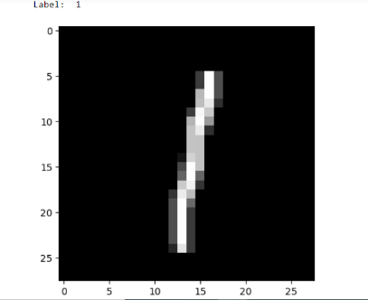

The generated images exhibit varying degrees of resemblance to handwritten digits, demonstrating the model's ability to produce digit representations. While some imperfections may be present, the overall quality of generated images is promising.