INTERIM PROGRESS REPORT
MSc Advanced Computer Science | 7COM1039-0206-2025

Comparative Analysis of Deep Reinforcement Learning Algorithms for Autonomous Robot Navigation in Unity: SAC, PPO, and DQN

Student Name | Rana Zeeshan Ali
Student ID | 24000292
Module Code | 7COM1039-0206-2025
Module Title | Advanced Computer Science Masters Project
Supervisor | Dr. Abolfazl Zaraki
Submission Date | 2 March, 2026

1. Background Research and Literature Review

1.1 Introduction and Project Overview
Autonomous robot navigation has emerged as one of the most consequential research challenges at the intersection of Artificial Intelligence and Robotics. The capacity for an agent to move purposefully through an unfamiliar or dynamically changing environment, reaching designated targets whilst avoiding obstacles, holds significant practical value across fields as diverse as warehouse logistics, search-and-rescue operations, self-driving vehicles, and space exploration. Established navigation approaches, among them Dijkstra's algorithm, A*, and model-based planners such as the Dynamic Window Approach (DWA) and Timed Elastic Band (TEB), perform reliably within static, well-mapped settings. Yet these methods tend to struggle considerably when faced with unanticipated dynamic obstacles, incomplete environmental information, or scenarios whose complexity resists analytical modelling.
Deep Reinforcement Learning (DRL) offers a fundamentally different approach. Rather than encoding navigation rules explicitly, a DRL agent acquires behaviour through sustained interaction with a simulated environment, refining its decisions based solely on a numerical reward signal. This paradigm has produced remarkable results across a range of domains, from complex strategy games to robotic manipulation, at times surpassing human-level performance. Nevertheless, a notable gap remains in the existing literature: controlled, systematic comparisons between fundamentally distinct DRL algorithmic families, applied consistently to the same navigation problem, are rarely conducted with sufficient rigour.
This project directly targets that gap. The experimental framework is structured around two distinct environments: a Training Environment, in which all three algorithms are developed, configured, and compared under controlled conditions, and a Testing Environment, a spatially different and previously unseen arena used exclusively to evaluate how well each learned policy generalises beyond its training context. This separation is fundamental to the validity of the comparative study. It ensures that performance differences observed during testing genuinely reflect each algorithm's capacity for generalisation, not merely its ability to memorise a fixed layout. The conceptual framework includes both environments. However, the Testing Environment will be constructed in the next phase of the project.
The primary algorithm under investigation is Soft Actor-Critic (SAC), an off-policy actor-critic algorithm grounded in maximum entropy reinforcement learning, which is hypothesised to offer a measurable advantage in generalisation owing to its entropy-driven exploration mechanism. SAC is evaluated alongside two algorithmically contrasting comparators: Proximal Policy Optimisation (PPO, on-policy and policy-based) and Deep Q-Network (DQN, off-policy and value-based). All three are trained within a shared dynamic Unity ML-Agents simulation environment, with experimental conditions held constant throughout. Performance in the unseen Testing Environment then provides the definitive comparative evidence for each algorithm's real-world applicability.

1.2 Aim, Research Question, and Objectives

1.2.1 Aim
To investigate and compare the effectiveness of Soft Actor-Critic, Proximal Policy Optimisation, and Deep Q-Network in enabling a mobile robot agent to learn autonomous navigation behaviour within a dynamic Unity-based simulation environment, and to evaluate how well each learned policy generalises to a previously unseen testing environment, with the goal of identifying which algorithm demonstrates superior learning efficiency, training stability, and navigation performance under identical experimental conditions.

1.2.2 Research Question

How do three deep reinforcement learning algorithms, namely Soft Actor-Critic, Proximal Policy Optimisation, and Deep Q-Network, compare in learning autonomous robot navigation behaviour within a Unity-based simulation environment under identical experimental conditions, and what are their relative strengths and limitations in terms of learning efficiency, training stability, and navigation performance?

1.2.3 Sub-Questions
- Which algorithm achieves the highest cumulative reward and success rate in the Training Environment across five independent runs?
- Which algorithm demonstrates the strongest generalisation performance when deployed in the unseen Testing Environment, and does the ranking differ from that observed during training?
- Does SAC's entropy regularisation mechanism produces measurably faster convergence and greater training stability compared to PPO and DQN?
- How does the on-policy nature of PPO affect sample efficiency relative to the off-policy approaches of SAC and DQN?
- What are the practical limitations of discretising DQN's action space for continuous robot control, and how do these affect navigation performance?

1.2.4 Objectives
- Design a dynamic Unity-based simulation Training Environment incorporating randomised obstacle placement, randomised target positions, and both static and dynamic obstacles, ensuring no single layout is repeated across episodes.
- Design a spatially distinct Testing Environment with a different arena layout, used exclusively for post-training generalisation evaluation and never exposed to any algorithm during training.
- Implement a mobile robot agent equipped with raycast sensors, collision detection, and directional movement capabilities using Unity ML-Agents.
- Configure and train SAC as the primary algorithm, followed by PPO and DQN as comparative baselines, under identical reward structures and agent configurations within the Training Environment.
- Evaluate all three algorithms across five performance metrics in the Training Environment: Success Rate, Collision Rate, Cumulative Reward Over Training, Episodes to Convergence, and Episode Length.
- Deploy each trained policy in the unseen Testing Environment and evaluate generalisation performance using the same five metrics.
- Conduct five independent training runs per algorithm using different random seeds, reporting results as mean and standard deviation with confidence intervals.
- Evaluate performance differences between algorithm pairs using Mann-Whitney U tests supported by Cohen's d effect size measures, applied to both training and testing results.
- Provide evidence-based, practically applicable recommendations for algorithm selection in robotic navigation contexts where generalisation to novel environments is essential.

1.3 Literature Review and Critical Analysis

1.3.1 Soft Actor-Critic: The Primary Algorithm
Haarnoja et al. (2018) proposed Soft Actor-Critic (SAC) as an off-policy actor-critic algorithm grounded in the maximum entropy reinforcement learning framework. Unlike conventional approaches that optimise purely for cumulative reward, SAC maximises both the expected return and the entropy of the policy. This additional entropy term encourages the agent to remain exploratory while still learning to accomplish the task effectively. By balancing performance and exploration, SAC directly addresses one of the persistent challenges in reinforcement learning: the tendency of agents to converge prematurely to suboptimal local policies. In continuous control benchmarks, particularly the MuJoCo locomotion tasks, SAC demonstrated faster convergence and greater robustness to hyperparameter selection than many competing methods available at the time.
This entropy mechanism is directly relevant to the generalisation question at the centre of this project. An agent that explores broadly during training is more likely to develop movement strategies that transfer to an unseen Testing Environment, rather than routes tied to specific obstacle positions. Whether this theoretical advantage produces measurable empirical superiority over PPO and DQN is the primary question the experimental results will answer.

1.3.2 Proximal Policy Optimisation: The Stability Benchmark
Schulman et al. (2017) introduced Proximal Policy Optimisation as a policy gradient method that constrains the magnitude of each parameter update using a clipped surrogate objective. This clipping mechanism prevents the large, destabilising policy shifts that undermined earlier methods such as Vanilla Policy Gradient. PPO is on-policy, meaning it can only learn from experience gathered under the current policy, which limits data efficiency but contributes to training stability. Its robustness and simplicity have made it the default choice in many applied reinforcement learning settings, including the Unity ML-Agents toolkit, where it is natively implemented.
PPO’s main limitation for this project is sample inefficiency: trajectories are discarded after each update, requiring more environment interactions than off-policy methods. Its tightly coupled updates may also produce narrower state-space coverage than SAC’s entropy-maximising exploration, which could result in a measurable generalisation deficit in the Testing Environment, one of the empirical questions this study is designed to answer.

1.3.3 Deep Q-Network: The Value-Based Baseline
Mnih et al. (2015) introduced DQN as a landmark algorithm combining Q-learning with deep neural networks, achieving human-level performance across Atari game benchmarks. Two technical innovations were central to its success: experience replay, which decorrelates sequential training samples by randomly sampling from a stored buffer of past transitions; and a target network, a periodically updated frozen copy of the Q-network whose fixed outputs provide stable regression targets, preventing the oscillation and divergence inherent in standard Q-learning with function approximation.
DQN carries two limitations directly relevant to this project. First, it is designed for discrete action spaces, requiring action space discretisation as an acknowledged methodological constraint. Second, its epsilon-greedy exploration is random rather than structured, producing narrower state-action coverage than SAC’s entropy regularisation. Both constraints are expected to be most visible in the Testing Environment and are treated as empirically informative findings rather than experimental failures.

1.3.4 How the Literature Directly Shaped Practical Decisions
The literature review did not function as a purely theoretical exercise. Each major source influenced concrete implementation decisions made during the project.
The most significant early technical challenge was DQN training instability. During initial experiments, Q-values diverged rapidly, with reward values oscillating between extremes within the first 500 training episodes. Guidance from Mnih et al. (2015), who identify unstable Q-value targets as a fundamental weakness of Q-learning with neural network function approximators, informed the diagnosis of this failure. Their proposed remedy, a target network updated on a fixed schedule rather than continuously, was already incorporated into the implementation. When instability persisted, the paper's discussion of learning rate sensitivity led directly to reducing the learning rate from 1 × 10⁻³ to 1 × 10⁻⁴ and increasing target network update frequency from every 1,000 steps to every 100 steps, combined with gradient clipping at a maximum norm of 1.0. These changes resolved the instability by episode 200 in subsequent runs.
A second challenge was sparse reward causing negligible early learning across all three algorithms. Sutton and Barto (2018) provide a thorough theoretical treatment of potential-based reward shaping, demonstrating that augmenting a sparse reward with a potential function based on state proximity to the goal does not alter the optimal policy whilst substantially improving the density of the learning signal. Applying this principle, a distance-shaping reward component was introduced, offering the agent a positive return proportional to the reduction in Euclidean distance to the target at each timestep. Convergence improved markedly across PPO, SAC, and DQN following this change.
A third practical issue arose during SAC training. The agent exhibited premature entropy collapse, where the policy became deterministic far earlier than expected, before the agent had explored the environment sufficiently. This behaviour is discussed by Haarnoja et al. (2018) as a known risk when the entropy temperature parameter is poorly initialised. The solution, also proposed in the paper, was to enable automatic temperature tuning, allowing the algorithm to dynamically adjust the trade-off between reward and entropy throughout training rather than relying on a fixed coefficient. Implementing this stabilised SAC's exploration behaviour and allowed training to proceed consistently across subsequent runs.
Finally, the decision to discretise the action space for DQN rather than attempting a continuous adaptation was directly informed by Londoño-Osorio et al. (2023), whose study demonstrates that value-based methods are inherently constrained in continuous control settings. This decision was made as an acknowledged methodological trade-off, preserving experimental fairness by using each algorithm in the form closest to its intended design, rather than treating DQN's action space limitation as a project failure. Collectively, these decisions reflect the extent to which theoretical literature actively informed practical implementation rather than serving merely as background context, a distinction that strengthens the methodological credibility of the comparative evaluation.

2. Summary of Progress to Date

2.1 Completed Milestones
At this interim stage, approximately 290 hours of work have been completed on this project, representing just under 50% of the total project duration. This progress encompasses both theoretical research and practical implementation activities.
Substantial practical progress has been made across all core components of the project. The following milestones have been completed and are evidenced in the appendices:
- Literature review: A critical review of SAC, PPO, DQN, and comparative navigation studies has been completed. The review has directly informed implementation decisions, reward function design, and the experimental framework, as detailed in Section 1.3.4.
- Unity Training Environment design: A fully functional dynamic 3D navigation arena has been constructed in Unity 2022 LTS, featuring randomised obstacle placement and randomised target positions to ensure varied episode conditions across training.
- Robot agent implementation: The agent is equipped with 12 raycast sensors spanning 360 degrees for obstacle detection, a vector observation of distance and bearing to the target, and movement actions compatible with both continuous and discrete control. The Unity C# agent script handles episode management, collision detection, reward computation, and data logging.
- Reward function design and implementation: A multi-component reward function has been implemented and validated, comprising distance-shaping reward (±0.1 per meter closer/farther), goal-reaching bonus (+10.0), collision penalty (-0.5 per collision), and per-timestep time penalty (-0.005). The function is designed identically across all three algorithms to ensure fair comparison.
- SAC training pipeline: The SAC training configuration has been completed, and initial training runs have begun in the Training Environment. Early observations indicate the agent is beginning to learn goal-directed behaviour, though full convergence across all five seeds remains in progress.
- PPO configuration: The PPO hyperparameter configuration has been finalised and the training pipeline is ready. Formal training runs are scheduled to begin in the next phase of the project.
- DQN implementation: A custom DQN implementation in PyTorch incorporating experience replay, a target network, and epsilon-greedy exploration is currently in progress and being integrated into the training pipeline.
- TensorBoard integration: Logging infrastructure has been set up via TensorBoard to track cumulative reward, episode length, entropy (SAC), and epsilon decay (DQN) across all training runs.

2.2 Specific Deliverables
The following concrete deliverables have been produced and are available for inspection:
# | Deliverable | Description | Status
1 | Unity Training Environment | Dynamic arena with randomised obstacle placement, randomised target positions, static and dynamic obstacles | Complete
2 | Unity Testing Environment | Spatially distinct unseen arena with different layout, used exclusively for post-training generalisation evaluation | Planned
3 | C# Agent Script | Agent logic: observation collection, reward computation, collision handling, episode control | Complete
4 | Reward Function Module | Multi-component reward including distance shaping, goal bonus, collision penalty, time penalty | In Progress
5 | SAC Training Configuration | SAC hyperparameter configuration file for Unity ML-Agents trainer | Complete
6 | PPO Training Configuration | PPO hyperparameter configuration file for Unity ML-Agents trainer | In Progress
7 | Custom DQN Implementation (Python / PyTorch) | Experience replay buffer, target network, Q-network architecture, epsilon-greedy schedule | In Progress
8 | Training Pipeline Scripts (Python) | Multi-seed training execution and result logging scripts | Planned
9 | Generalisation Evaluation Script (Python) | Script to deploy trained policies in Testing Environment and log performance metrics | Planned
10 | TensorBoard Log Files | Training logs across all algorithms and seeds | Planned
11 | Preliminary Results Spreadsheet | Tabulated reward and episode length results across training runs | Planned
12 | Statistical Analysis Script (Python / SciPy) | Mann-Whitney U test framework; Cohen's d effect size; confidence interval computation | Planned

Table 1. Project deliverables with current completion status.

2.3 Tools, Technologies, and Justification
Tool | Purpose | Justification
Unity 2022.3 LTS | Training and Testing simulation environments | Real-time physics engine; ML-Agents integration; widely used in RL robotics research; enables construction of two distinct environments with consistent agent configuration
Unity ML-Agents Toolkit | Agent-environment interface | Native PPO and SAC support; Python API for custom training loops; built-in TensorBoard logging; seamlessly supports deployment in both Training and Testing environments
Python 3.10.19 | Training and analysis | Standard language for ML research; extensive library support; compatible with ML-Agents API
PyTorch | DQN neural network | Dynamic computation graph simplifies debugging; superior flexibility for custom architectures
TensorBoard | Training visualisation | Enables real-time comparison of reward curves across algorithm runs in the Training Environment
NumPy and Pandas | Data processing | Efficient numerical computation; clean tabular handling of multi-seed results across both environments
Matplotlib and Seaborn | Result visualisation | Publication-quality comparative figures for Training and Testing Environment results; confidence interval plotting
SciPy | Statistical testing | Mann-Whitney U tests and confidence interval computation for cross-algorithm significance testing
Git and GitHub | Version control | Full incremental commit history; enables reproducibility; protects against data loss across training runs

Table 2. Tools and technologies with selection rationale.

2.4 Challenges Encountered and How They Were Resolved
Several technical challenges have arisen during implementation. Their resolution is described below, including the specific theoretical or practical source that informed each solution.
Challenge 1: DQN Q-Value Divergence
Problem: DQN training exhibited severe Q-value divergence during initial experiments, with reward values oscillating between extremes within the first 500 episodes.
Solution informed by Mnih et al. (2015): The learning rate was reduced from 1×10⁻³ to 1×10⁻⁴, target network update frequency was increased from every 1,000 to every 100 steps, and gradient clipping at maximum norm 1.0 was introduced. Stability was achieved by episode 200 in subsequent runs.
Challenge 2: Sparse Reward Causing Negligible Early Learning
Problem: Binary success or failure signals produced no meaningful gradient signal during early training across all three algorithms.
Solution informed by Sutton and Barto (2018): Potential-based distance-shaping was implemented, providing a dense reward signal at every timestep proportional to progress toward the target. Convergence speed improved substantially across all three algorithms.
Challenge 3: Premature SAC Entropy Collapse
Problem: SAC policies became deterministic prematurely, before sufficient environment exploration had occurred, causing the agent to fixate on suboptimal routes that would be unlikely to transfer to the Testing Environment.
Solution informed by Haarnoja et al. (2018): Automatic entropy temperature tuning was enabled, allowing the algorithm to dynamically adjust the exploration-exploitation balance throughout training. Exploration behaviour returned to the expected theoretical pattern, and the broader state coverage achieved during training is expected to support stronger generalisation in the Testing Environment.
Challenge 4: DQN Action Space Mismatch
Problem: Unity ML-Agents exposes a continuous action space by default, incompatible with DQN's discrete Q-value formulation.
Solution informed by Londonó-Osorio et al. (2023): A four-action discrete branch (forward, backward, rotate left, rotate right) was defined specifically for DQN training. This follows the approach endorsed in the comparative navigation literature and represents an acknowledged methodological constraint rather than an experimental flaw.

2.5 Evidence of Progress
The following artefacts are included in the appendices as direct evidence of the progress described above.
- Appendix A: Unity Training Environment screenshots
- Appendix B: SAC initial training output (Python console logs)
- Appendix C: DQN Q-network architecture diagram
- Appendix D: Reward function C# code snippet from AgentNavigation.cs
- Appendix E: Git commit history log

3. Ethical, Legal, Professional, and Social Considerations

The following section addresses ethical, legal, professional, and social issues both in the context of the current project and in relation to how these concerns might evolve should the work be extended or deployed more broadly in future. Reflecting on both dimensions demonstrates awareness of the wider responsibilities that accompany research of this nature.

3.1 Ethics
In its current form, this project is entirely simulation-based and does not involve human participants, personal data collection, animal subjects, or physical hardware deployment. Following the University's ethics screening guidance, formal Research Ethics Committee approval is not required under these conditions. This determination has been confirmed with the supervising academic and is consistent with standard practice for simulation-only computer science research projects.
Ethical responsibility has nonetheless been embedded into the project's methodology. All experimental results, including failed runs, training instabilities, and negative findings, will be reported transparently in the final project report. Selectively reporting only successful outcomes would misrepresent the comparative evaluation and undermine the academic contribution of the work. Hyperparameters, random seeds, and environment configurations will be documented fully to enable independent replication, reflecting a commitment to research integrity and open science principles.
Future development consideration: Should this project be extended to physical robot deployment, ethics approval would become necessary, covering sensor data consent, surveillance risks, and safety validation requirements.

3.2 Legal Considerations

All software and frameworks used in this project are applied in strict accordance with their respective open-source licences. Unity ML-Agents is released under the Apache 2.0 licence, PyTorch under the BSD 3-Clause licence, and Unity Editor is used under the Unity Personal and Academic licence, each of which permits unrestricted academic use and modification. No licenced third-party datasets, proprietary codebases, or commercially restricted resources have been incorporated.

No personally identifiable data is generated or processed at any stage of the current project. As all training data is produced synthetically through simulation, UK General Data Protection Regulation (UK GDPR) obligations are not triggered at present.

Future development consideration: Physical deployment in public spaces could trigger UK GDPR obligations if sensor data identifies individuals. Commercial deployment would additionally require compliance with machinery safety directives and careful consideration of intellectual property ownership over trained model weights.

3.3 Professional Considerations
The project adheres to professional software engineering standards throughout its development. All source code is maintained under Git version control with descriptive commit messages documenting each incremental change, providing a traceable development history. Code is modularised, commented, and structured to facilitate independent replication. The experimental design follows accepted norms for empirical machine learning research, with five independent training runs planned per algorithm using different random seeds, mean and standard deviation reporting, and statistical significance testing using Mann-Whitney U tests supported by Cohen's d effect size measures.
These practices align with the ACM Code of Ethics (2018), specifically the principles of honesty in reporting findings, transparency in methodology, and a commitment to the quality and integrity of professional work. The decision to report DQN results using a discretised action space, with explicit acknowledgement of the constraint this imposes, reflects professional honesty about the limitations of the comparative design.
Future development consideration: Academic publication or open-source release would require peer review accountability and stronger documentation standards. Safety-critical deployment would additionally require adherence to formal quality assurance standards such as ISO 9001.

3.4 Social Considerations
The broader societal implications of autonomous robot navigation research deserve genuine reflection. DRL-based navigation systems, if deployed at commercial scale, have the potential to transform labour markets in logistics, manufacturing, delivery, and facilities management by automating tasks currently carried out by human workers. Whilst this creates economic efficiency and safety benefits in hazardous environments, it also carries displacement risks for lower-skilled workers in the affected sectors. Researchers working in this domain bear a responsibility to engage honestly with these consequences and to contribute to policy discussions around workforce transition, skills development, and equitable distribution of automation benefits.
A further social concern is the potential for reinforcement learning policies to perform poorly or unsafely when deployed in real-world environments that differ from training conditions. This project mitigates that risk within its current scope through environment randomisation, the structural separation of Training and Testing Environments, and multi-seed validation across five independent runs. The Testing Environment in particular serves a direct social function: it provides empirical evidence about whether each algorithm's learned behaviour transfers beyond its training context, which is the most practically relevant question for any system intended for real-world deployment. However, the broader sim-to-real transfer problem remains an open challenge in the research community.
Future development consideration: Consumer or public-space deployment would require inclusive testing protocols to ensure safe behaviour around wheelchair users, children, and individuals with unpredictable movement populations unlikely to be represented in a simulation only training pipeline.

4. Project Plan and Management Approach

4.1 Project Management Methodology
This project is managed using a hybrid approach combining structured milestone planning with iterative, agile inspired development cycles. The overall project timeline is governed by fixed academic deadlines, which necessitates a degree of waterfall style sequential planning for major deliverables such as the environment designs, algorithm implementations, and final report. Within each phase, however, the work proceeds iteratively: experiments are run, results are evaluated, and implementation decisions are adjusted accordingly before the next training cycle begins. This reflects the inherently experimental and uncertain nature of reinforcement learning research, where unexpected results frequently require revisiting earlier design decisions.
The structural separation between the Training Environment and the Testing Environment also introduces a one-directional data flow discipline into the project management approach. Algorithm configuration and hyperparameter decisions are made on the basis of Training Environment results only; the Testing Environment is held in reserve until all training is complete, ensuring that no information from the Testing Environment influences training decisions. This prevents inadvertent optimisation toward the test conditions and is enforced as a project management constraint as well as a methodological one. In practice, this means the Testing Environment Unity scene file will not be constructed until all five seeds per algorithm have completed training, all hyperparameter decisions have been locked, and no further modifications to the reward function or agent configuration are made. This sequencing will be documented explicitly in the final report so that the generalisation claim can be independently verified.
Weekly supervisor meetings provide structured checkpoints at which progress is reviewed, risks are discussed, and priorities are adjusted where necessary. Day-to-day task management is handled through a personal project board tracking active, completed, and blocked items, updated at the start of each working session.

4.2 Risk Management
The following risks have been identified and mitigation strategies established:
Risk | Likelihood | Impact | Mitigation Strategy
SAC training fails to achieve stable convergence in the Training Environment | Medium | High | Hyperparameter sensitivity experiments planned; fallback analysis of partial convergence results with transparent reporting
Testing Environment performance differs substantially from training results for all algorithms | Medium | Medium | This is an informative empirical finding, not a project failure; results will be reported and interpreted with reference to each algorithm's theoretical generalisation properties
Computational resource constraints delay training completion | Medium | Medium | Training time per seed estimated at 4–8 hours depending on algorithm; 15 total runs scheduled sequentially. Compute time will be benchmarked during Week 1 SAC runs; if training exceeds budget, the training step limit will be reduced with a transparent justification, or runs will be parallelised on separate machines. Google Colab is available as a backup compute resource.
DQN performance poor in Testing Environment due to limited exploration during training | Low | Low | Acknowledged as theoretically expected outcome consistent with DQN's epsilon-greedy limitations; results reported and discussed as empirically informative
Scope creep from additional environment features | Low | Medium | Scope fixed at two environments and three algorithms; additions require formal supervisor approval
Data loss from hardware failure | Low | High | All code and training logs committed to GitHub daily; local and remote backups maintained
Table 3. Risk register with mitigation strategies.

4.3 Quality Evaluation Strategy
Quality in this project is evaluated at two levels: the quality of the experimental process and the quality of the findings produced.
Process quality is maintained through disciplined version control, documented hyperparameter choices, reproducible random seed management, and consistent use of the same evaluation scripts across all algorithm runs in both environments. Before each algorithm’s training begins, a pre-run consistency checklist is completed to verify that the reward function parameters, episode length limits, training budget (measured in environment steps rather than episodes, to account for differences in episode duration across algorithms), and environment random seed configuration are identical across SAC, PPO, and DQN. Each training run is validated by checking that TensorBoard curves show the expected learning progression before results are accepted as valid data points for statistical analysis. The Testing Environment is kept strictly isolated from all training decisions until the training phase is complete.
Findings quality is assessed through the five core performance metrics described in Section 1.2, applied to both Training and Testing Environments and reported as mean and standard deviation across five independent runs. Statistical significance of differences between algorithm pairs is assessed using Mann-Whitney U tests at a 95% confidence level, supported by Cohen's d effect size measures. Findings will be interpreted with reference to the theoretical properties of each algorithm, ensuring that observed differences in both training performance and generalisation are explained rather than merely reported.

4.4 Remaining Tasks and Target Project Timeline
The table below presents the project plan for the 8 weeks remaining after submission of this Interim Progress Report. Tasks are scheduled sequentially as each phase depends directly on the completion of its predecessor. There is no slack in the schedule; any delay in a given week will affect the final submission date.

Week | Phase | Task | Deliverable | Depends On
Week 1 | Training | SAC Training (5 seeds) | SAC training logs; Python console output confirming stable learning across all 5 seeds. | Training Environment and reward function complete (done at IPR stage)
Week 2 | Training | PPO Training (5 seeds) | PPO training logs; preliminary reward curve comparison between SAC and PPO. | SAC training complete (Week 1)
Week 3 | Training | DQN Training (5 seeds) | DQN training logs; complete training dataset for all three algorithms. | DQN implementation finalised; PPO training complete (Week 2)
Week 4 | Evaluation | Build Testing Environment; Deploy All Policies | Testing Environment built; generalisation performance logs for SAC, PPO, and DQN. | All three algorithm training complete (Weeks 1-3)
Week 5 | Analysis | Statistical Analysis and Comparative Figures | Results tables with significance values; full set of comparative figures. | All training and evaluation data collected (Week 4)
Week 6 | Writing | Write Results and Discussion Chapters | Draft Results and Discussion chapters with all figures and tables embedded. | Statistical analysis and figures complete (Week 5)
Week 7 | Writing | Write Introduction, Conclusion and Abstract | Complete project report draft with all chapters and reference list. | Results and Discussion chapters drafted (Week 6)
Week 8 | Submission | Proofreading and Final Submission | Submitted project report. | All chapters complete in draft form (Week 7)
Table 4. Eight-week project plan showing tasks, deliverables, and dependencies for the remaining project period.

4.5 Gantt Chart

The chart below maps each task to its target week. Filled squares (■) indicate the week in which the task is scheduled. Phases are colour-coded; the dependency structure is documented in Section 2.

Training | Evaluation | Analysis | Writing | Submission

Phase | Task | W1 | W2 | W3 | W4 | W5 | W6 | W7 | W8
Training | SAC Training (5 seeds) | ■
Training | PPO Training (5 seeds) |  | ■
Training | DQN Training (5 seeds) |  |  | ■
Evaluation | Build Testing Environment |  |  |  | ■
Evaluation | Deploy Policies & Collect Data |  |  |  | ■
Analysis | Statistical Analysis |  |  |  |  | ■
Analysis | Generate Comparative Figures |  |  |  |  | ■
Writing | Write Results & Discussion |  |  |  |  |  | ■
Writing | Write Introduction, Conclusion & Abstract |  |  |  |  |  |  | ■
Submission | Proofreading & Final Submission |  |  |  |  |  |  |  | ■
Figure 1. Gantt chart showing the 8-week project timeline. Each row represents one task; filled squares indicate the scheduled active week. Colour coding corresponds to project phase.
4.6 Task Dependencies
The table below documents which tasks are dependent on the completion of earlier tasks, and explains why each dependency exists. No task should begin until its predecessor is fully complete and its outputs verified.

Task | Depends On | Reason
PPO Training | SAC Training complete | Training is scheduled sequentially to avoid Unity ML-Agents memory conflicts.
DQN Training | PPO Training complete | Same reason: sequential training ensures clean isolated logs per algorithm
Build Testing Environment | All three algorithm training complete | Testing Environment must remain unseen until all policies are fully trained; premature access would compromise generalisation evaluation
Deploy Policies & Collect Data | Testing Environment built | Cannot evaluate generalisation before the evaluation arena exists
Statistical Analysis | All training and evaluation data collected | Mann-Whitney U tests require complete datasets across all 5 seeds per algorithm for valid significance testing
Generate Comparative Figures | Statistical analysis complete | Figures must reflect final verified results, not preliminary numbers
Write Results & Discussion | Figures and analysis complete | Chapter content is directly derived from statistical outputs and visualisations
Write Introduction, Conclusion & Abstract | Results & Discussion drafted | Abstract and conclusion can only be written once findings are confirmed
Proofreading & Final Submission | All chapters complete | Final check requires the entire project report to be in draft form
Table 5. Task dependency register. Each task lists the predecessor it depends on and the rationale for that dependency.

4.7 Task Summary
The table below provides a detailed description of every task in the project plan, explaining what work is carried out during that week and what concrete deliverable it produces. This ensures that each week has a clear definition of done.

Week | Phase | Task | What It Involves | Deliverable
W1 | Training | SAC Training (5 seeds) | Run 5 independent SAC training sessions in the dynamic Training Environment using different random seeds. Monitor reward curves, entropy decay, and episode length. Verify convergence behaviour is consistent across seeds. | SAC training logs; Python console output confirming stable learning across all 5 seeds
W2 | Training | PPO Training (5 seeds) | Run 5 independent PPO training sessions under identical environment and reward conditions. Compare learning speed against SAC baseline established in Week 1. | PPO training logs; preliminary reward comparison between SAC and PPO
W3 | Training | DQN Training (5 seeds) | Run 5 independent DQN training sessions using the discretised action space. Monitor Q-value stability, epsilon decay, and convergence. All three algorithms now have complete training data. | DQN training logs; complete training dataset for all three algorithms
W4 | Evaluation | Build Testing Environment & Deploy Policies | Construct the spatially distinct Testing Environment in Unity. Deploy the best-performing trained policy from each algorithm into this unseen arena. Collect success rate, collision rate, and episode length data across 5 evaluation runs per algorithm. | Testing Environment built; generalisation performance logs for SAC, PPO, and DQN
W5 | Analysis | Statistical Analysis & Figures | Run Mann-Whitney U tests and compute Cohen's d effect sizes across all algorithm pairs for both Training and Testing Environment results. Generate all comparative figures: reward curves, bar charts, and generalisation comparison plots. | Results tables with significance values; full comparative visualisation set
W6 | Writing | Write Results & Discussion | Write the Results chapter presenting all quantitative findings with figures. Write the Discussion chapter interpreting differences between algorithms in terms of their theoretical properties, training behaviour, and generalisation capability. | Draft Results and Discussion chapters
W7 | Writing | Write Introduction, Conclusion & Abstract | Write the Introduction contextualising the study within existing literature. Write the Conclusion summarising findings and practical recommendations. Write the Abstract summarising the entire project report in one paragraph. | Complete project report draft
W8 | Submission | Proofreading & Final Submission | Full read-through of the complete project report for clarity, consistency, and formatting. Check all references, figure captions, and table numbering. Submit via university portal before deadline. | Submitted project report
Table 6. Detailed task summary with descriptions of work involved and deliverables produced for each week of the remaining project timeline.

5. Level of the Project: Critical Reflection

5.1 The Challenge and Personal Motivation
Autonomous navigation using deep reinforcement learning sits at the intersection of artificial intelligence and robotics, two areas I find genuinely compelling. The problem of enabling an agent to learn purposeful behaviour through experience alone, without explicitly programmed rules, has significant practical value across autonomous vehicles, intelligent logistics, and robotics engineering sectors in which I intend to pursue a career. This project provides directly relevant experience in designing, implementing, and rigorously evaluating competing learning algorithms.
SAC was chosen as the primary algorithm because its entropy-based generalisation advantage has not been fully tested in Unity-based robot navigation, making the comparison with PPO and DQN a question with genuine research value rather than a replication of existing work.

5.2 The Artefact and Its Technical Complexity
The primary artefact produced by this project is a unified experimental framework comprising a Unity 3D simulation environment, three independently implemented and configured DRL training pipelines, and a statistical analysis system capable of producing reproducible comparative results. This is not a single algorithm implementation but a multi-component system that requires each element to function correctly and consistently across algorithms for the comparison to be valid.
The technical complexity spans both the algorithmic and engineering levels. Each algorithm requires a distinct mathematical formulation: Q-function approximation for DQN, the proximal policy gradient for PPO, and the maximum entropy objective with automatic temperature tuning for SAC. At the engineering level, all three must share the same Unity environment, reward function, and evaluation scripts, so that observed performance differences reflect genuine algorithmic behaviour rather than implementation artefacts. Cross-language integration between Unity’s C# runtime and the Python ML-Agents training loop adds further systems complexity that must be managed consistently across all three pipelines.

5.3 Depth of Investigation and Experimental Rigour
The investigation is structured to answer the core research question across three measurable dimensions: learning efficiency, assessed through episodes to convergence and cumulative reward curves; navigation quality, measured through success rate, collision rate, and episode length; and training stability, assessed through the variance of results across five independent runs. These three dimensions together allow a comprehensive comparison of SAC, PPO, and DQN under identical conditions, in both the Training and Testing Environments.
Feasibility considerations have been incorporated into the experimental design from the outset. Training budgets of 10,000 episodes per run were selected based on preliminary convergence analysis rather than arbitrary choice. The decision to use five seeds rather than three reflects a deliberate choice to ensure sufficient statistical power for meaningful hypothesis testing, even at a modest cost in computational time.

5.4 Justification of Methods and Tools as a Red Thread
Every methodological decision in this project is traceable to the central research question: whether SAC’s theoretical properties produce measurable performance advantages in navigation and generalisation. The choice of PPO as a comparator reflects its status as the most widely used stable policy-based baseline; DQN represents the value-based paradigm SAC was partly designed to surpass. The reward function was calibrated to avoid inadvertently suppressing SAC’s entropy-driven exploration. The five-seed protocol and Mann-Whitney U testing framework were fixed before experiments began, preventing post-hoc selection of favourable results. Together, these decisions ensure the comparison is fair, reproducible, and directly answerable by the experimental data.
This level of methodological traceability is intended to ensure that final results can be interpreted with confidence rather than treated as incidental observations.

6. References

ACM (2018) ACM Code of Ethics and Professional Conduct. Association for Computing Machinery. Available at: https://www.acm.org/code-of-ethics (Accessed: 20 February 2026).

Haarnoja, T., Zhou, A., Abbeel, P. and Levine, S. (2018) ‘Soft actor-critic: Off-policy maximum entropy deep reinforcement learning with a stochastic actor’, in Proceedings of the 35th International Conference on Machine Learning (ICML), Stockholm, July 2018, pp. 1861–1870. Available at: https://arxiv.org/abs/1801.01290 (Accessed: 15 January 2026).

Juliani, A., Berges, V., Teng, E., Cohen, A., Harper, J., Elion, C., Goy, C., Gao, Y., Henry, H., Mattar, M. and Lange, D. (2020) ‘Unity: A general platform for intelligent agents’, arXiv preprint arXiv:1809.02627. Available at: https://arxiv.org/abs/1809.02627 (Accessed: 10 January 2026).

Londóno-Osorio, S., Marin-Moreno, J.C. and Ceron-Gomez, M. (2023) ‘Comparison of traditional and deep reinforcement learning-based autonomous navigation algorithms for mobile robots in dynamic environments’, Sensors, 23(23), p. 9672. doi: 10.3390/s23239672.

Mnih, V., Kavukcuoglu, K., Silver, D., Rusu, A.A., Veness, J., Bellemare, M.G., Graves, A., Riedmiller, M., Fidjeland, A.K., Ostrovski, G., Petersen, S., Beattie, C., Sadik, A., Antonoglou, I., King, H., Kumaran, D., Wierstra, D., Legg, S. and Hassabis, D. (2015) ‘Human-level control through deep reinforcement learning’, Nature, 518(7540), pp. 529–533. doi: 10.1038/nature14236.

Schulman, J., Wolski, F., Dhariwal, P., Radford, A. and Klimov, O. (2017) ‘Proximal policy optimization algorithms’, arXiv preprint arXiv:1707.06347. Available at: https://arxiv.org/abs/1707.06347 (Accessed: 12 January 2026).

Sutton, R.S. and Barto, A.G. (2018) Reinforcement Learning: An Introduction. 2nd edn. Cambridge, MA: MIT Press.

Van Hasselt, H., Guez, A. and Silver, D. (2016) ‘Deep reinforcement learning with double Q-learning’, in Proceedings of the 30th AAAI Conference on Artificial Intelligence, Phoenix, AZ, February 2016, pp. 2094–2100. Available at: https://ojs.aaai.org/index.php/AAAI/article/view/10295 (Accessed: 18 January 2026).

Appendices

Appendix A: Unity Navigation Environment
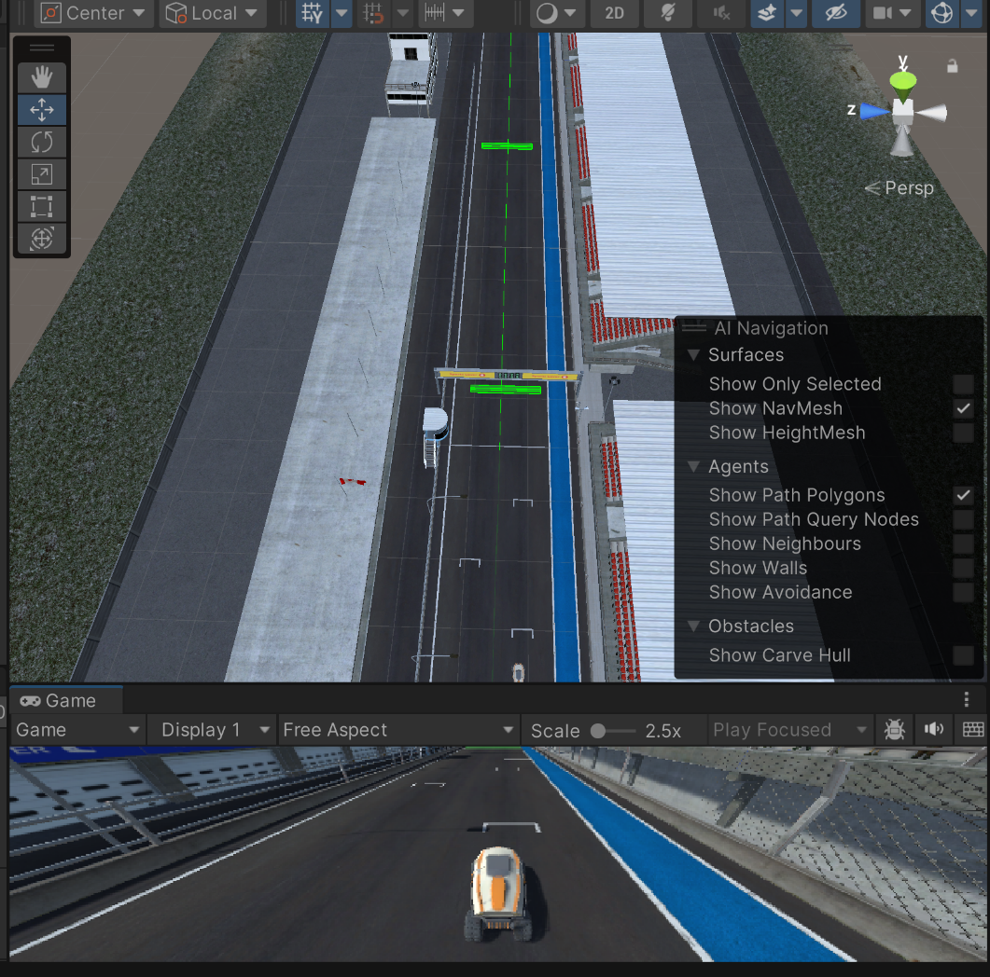
Figure 2. Training Environment — dynamic arena with randomised obstacle placement and randomised target positions. The Testing Environment has not yet been constructed at this stage of the project.

Appendix B: SAC Initial Training Output

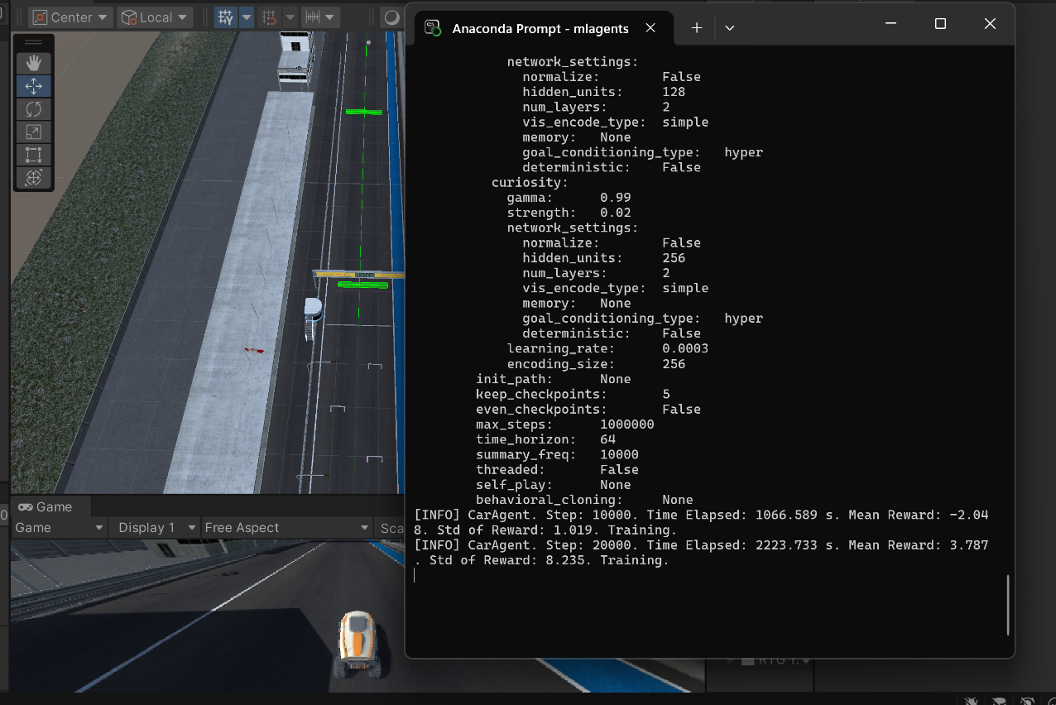
Figure 3. Python console output confirming successful communication between the Unity Training Environment and the SAC training pipeline. Initial training runs show the agent beginning to learn goal-directed behaviour.
.

Appendix C: DQN Q-Network Architecture
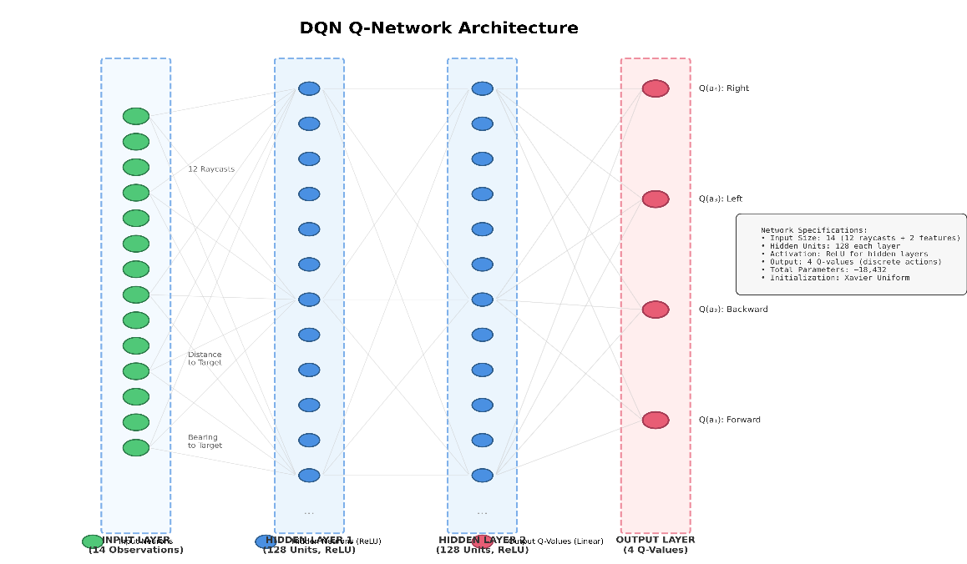
Figure 4. DQN Q-network architecture implemented in PyTorch. Input layer: 14 observations (12 raycasts, distance to target, bearing to target). Hidden layers: two fully connected layers of 128 units each with ReLU activation. Output layer: 4 Q-values corresponding to discrete actions.

Appendix D:

The checkpoint-based reward shown below represents an earlier experimental variant of the environment. During initial prototyping, a multi-checkpoint navigation structure was tested to encourage progressive exploration. However, for the final comparative study, a unified distance-based reward shaping function (as described in Section 2) was adopted to ensure methodological consistency across SAC, PPO, and DQN.

D.1 C# CODE (REWARD FUNCTION)

private void OnTriggerEnter(Collider other)
{
// Checkpoint pass kiya
if (other.CompareTag("Checkpoint"))
{
int checkpointIndex = other.GetComponent<CheckpointScript>()?.index ?? 0;
if (checkpointIndex == currentCheckpoint)
{
AddReward(1.0f); // Checkpoint reward
currentCheckpoint++;
totalCheckpointsPassed++;

// Saare checkpoints pass kar liye = episode complete
if (currentCheckpoint >= checkpoints.Length)
{
AddReward(5.0f); // Lap complete reward!
EndEpisode();
}
else if (checkpoints != null && currentCheckpoint < checkpoints.Length)
{
lastDistanceToCheckpoint = Vector3.Distance(
transform.position,
checkpoints[currentCheckpoint].position
);
}
}
}

// Track se bahar gaya
/* if (other.CompareTag("OutOfBounds"))
{
AddReward(-2.0f);
EndEpisode();
}*/

D.2 SAC Training Configuration File (.yaml)
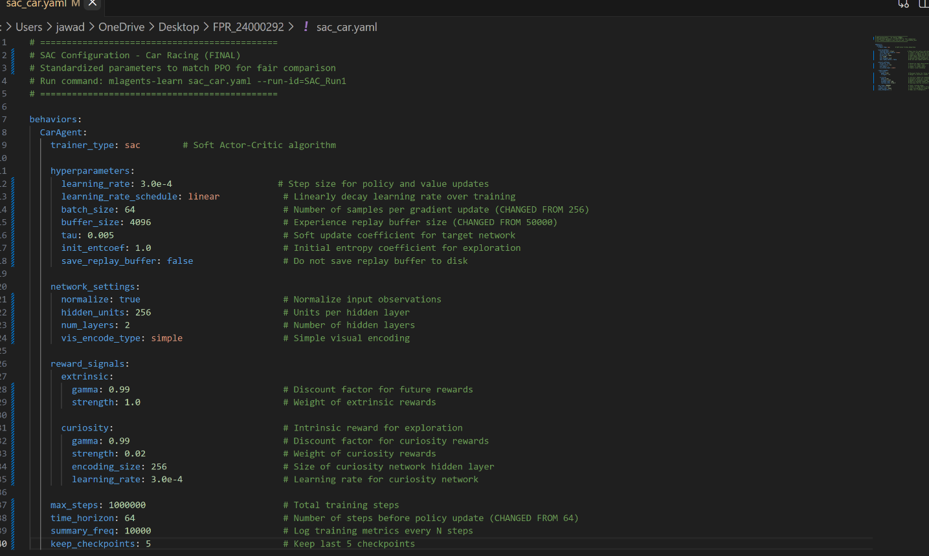
Figure 5. SAC Training

Appendix E: Git Commit History
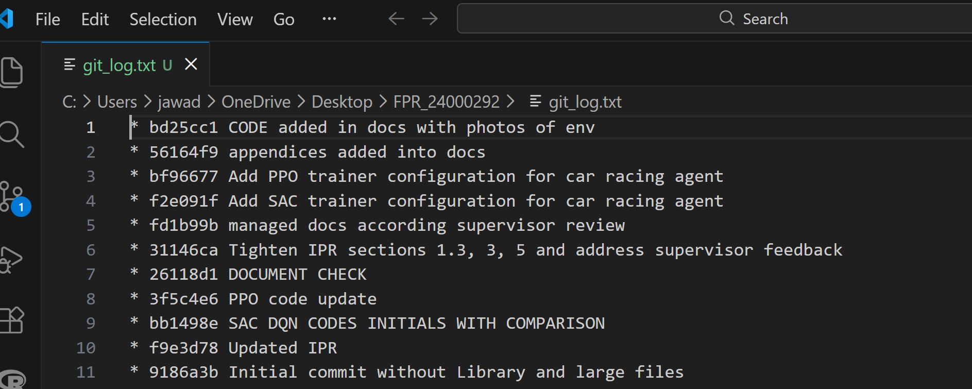Figure 6. Git commit log demonstrating iterative, version-controlled development

