**Describe Data Science and the skill sets needed to be a data scientist**

**(Assignment -1 …Spring -2022)**

**(April 19, 2022)**

**BY**

**Name: Zeeshan Ali**

**Roll No: 43**

#### Course Code (Course title): SENG419

**BS Computer Science/IT: BSCS-A**

**Submitted To**

**Name: Muhammad Kamran**

**Department: CS/IT**



**Minhaj University Lahore**

**Table of Content**

**Data Science:**

Data science is a combination of multiple discipline use statistical mathematics machine learning and extract knowledge from data. In other words we can say Data science is about a data gathering, analysis or decision making.

**Skills needed to be data scientist:**

### Math and Statistics

### Any good Data Scientist is going to have a strong foundation built on both math and statistics. Any business, especially those that are data-driven, will expect a Data Scientist to understand the different approaches to statistics

### Analytics and Modeling

### Data is only as good as the people performing the analytics and modeling on it, so a skilled Data Scientist is expected to have high proficiency in this area.

### Machine Learning Methods

### While having expert level knowledge in this area isn’t always necessary, a level of familiarity will be expected.

### Programming

### To move from the theoretical into creating practical applications, a Data Scientist needs strong programming skills. Most businesses will expect you to know both [Python](https://www.udacity.com/courses/programming-for-data-science-nanodegree--nd104) and R, as well as other [programming](https://www.udacity.com/course/intro-to-programming-nanodegree--nd000) languages.

### Data Visualization

### [Data visualization](https://www.udacity.com/blog/2020/06/data-visualization-jobs-what-to-expect-in-2020.html) is a key component of being a Data Scientist as you need to be able to effectively communicate key messaging and get buy in for proposed solutions.

### Intellectual Curiosity

### At the heart of the data science role is a deep curiosity to solve problems and find solutions — especially ones that require some out of the box thinking.

### Communication

### Data doesn’t communicate without someone manipulating it to be able to do so, which means an effective Data Scientist needs to have strong communication skills.

### Business Acumen

### For a Data Scientist to effectively use data in a way that’s meaningful to their employer, there’s a level of business acumen that’s required.

1. Determine the position of the first cell in the first column E2
2. Determine the position of the first cell in the second column F2
3. Put the equation in the next column “Total”.
4. We will multiply data contained in column E with data in Column F (=E2*F2)
5. The Result will appear in column C
6. Drag the first cell in column C downward, so the equation will be applied on all cells

|  |  |  |  |  |  |  |
| --- | --- | --- | --- | --- | --- | --- |
| **Order Date** | **Region** | **Rep** | **Item** | **Units** | **Unit Cost** | **Total** |
| 01/06/2020 | East | Jones | Pencil | 95 | 1.99 | **189.05** |
| 1/23/2020 | Central | Kivell | Binder | 50 | 19.99 | **999.5** |
| 02/09/2020 | Central | Jardine | Pencil | 36 | 4.99 | **179.64** |
| 2/26/2020 | Central | Gill | Pen | 27 | 19.99 | **539.73** |
| 3/15/2020 | West | Sorvino | Pencil | 56 | 2.99 | **167.44** |
| 04/01/2020 | East | Jones | Binder | 60 | 4.99 | **299.4** |
| 4/18/2020 | Central | Andrews | Pencil | 75 | 1.99 | **149.25** |
| 05/05/2020 | Central | Jardine | Pencil | 90 | 4.99 | **449.1** |
| 5/22/2020 | West | Thompson | Pencil | 32 | 1.99 | **63.68** |
| 06/08/2020 | East | Jones | Binder | 60 | 8.99 | **539.4** |
| 6/25/2020 | Central | Morgan | Pencil | 90 | 4.99 | **449.1** |
| 07/12/2020 | East | Howard | Binder | 29 | 1.99 | **57.71** |
| 7/29/2020 | East | Parent | Binder | 81 | 19.99 | **1619.19** |
| 8/15/2020 | East | Jones | Pencil | 35 | 4.99 | **174.65** |
| 09/01/2020 | Central | Smith | Desk | 2 | 125 | **250** |
|  |  |  |  | **818** | **229.86** | **6126.84** |

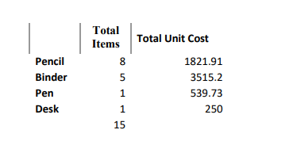

References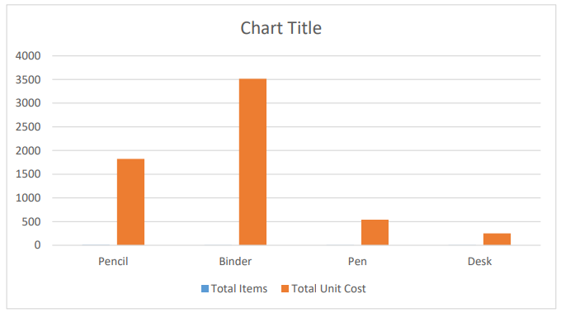: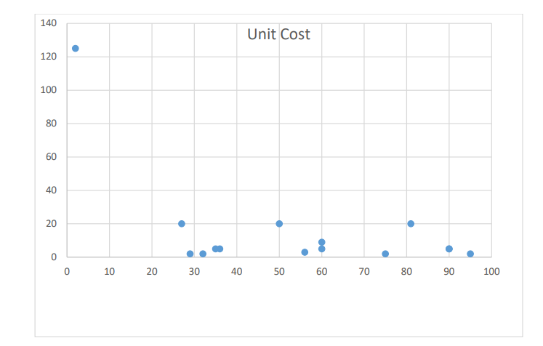

[***https://www.udacity.com/blog/2020/11/skills-to-launch-data-science-career.html***](https://www.udacity.com/blog/2020/11/skills-to-launch-data-science-career.html)