3D Modeling & Simulations in Bioinformatics (CS06F)
ASSIGNMENT: 01
METROPOLIS MONTI CARLO SIMULATION
OF
2D Hyperbolic-Polar model of Proteins
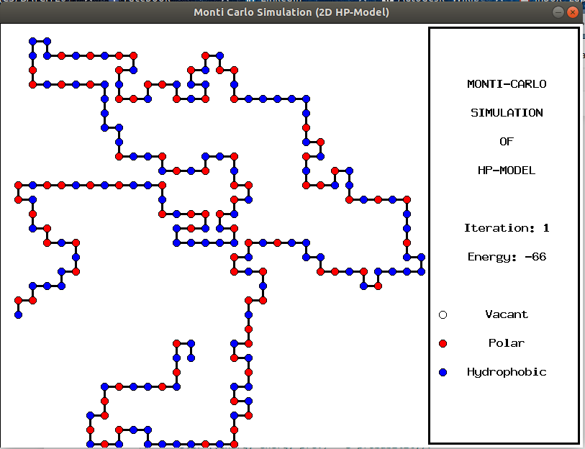
Name: ZEESHAN ALI, Roll No: I14-1623
Instructor: PROF. HAMMAD NAVEED
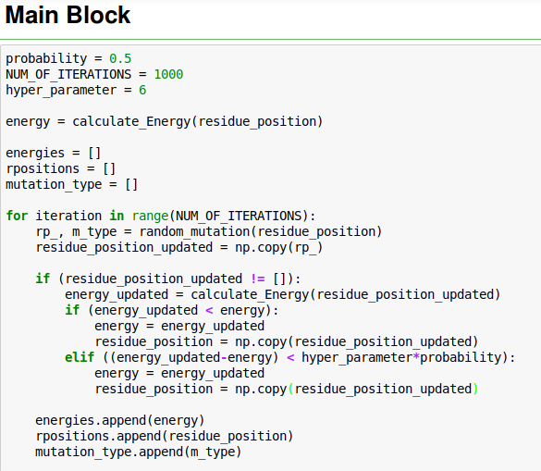

Results of the algorithm on different protein sequences
(Observed that the performance was better for longer sequences)

S# | Length | Sequence | Energy
01 | 20 | HPHPPHHPHPPHPHHPPHPH | -4
02 | 24 | PPHPPHHPPPPHHPPPPHHPPPPHH | -2
03 | 25 | PPHPPHHPPPPHHPPPPHHPPPPHH | -2
04 | 36 | PPPHHPPHHPPPPPHHHHHHHPPHHPPPPHHPPHPP | -5
05 | 48 | PPHPPHHPPHHPPPPPHHHHHHHHHHPPPPPPPPHHPPHHHPPHHHHH | -16
06 | 51 | HHPHPHPHPHHHHPHPPPHPPPHPPPPHPPPHPPPHPHPHHHHHPHPHPHH | -16
07 | 60 | PPHHHPHHHHHHHHPPPHHHHHHHHHHPHPPPHHHHHHHHHHHHPPPPHHHHHHPHHPHP | -31
08 | 64 | HHHHHHHHHHHHPHPHPPHHPPHHPPHPPHHPPHHPPHPPHHPPHHPPHPHPHHHHHHHHHHHH | -40
09 | 85 | HHHHPPPPHHHHHHHHHHHHPPPPPPHHHHHHHHHHHHPPPHHHHHHHHHHHHPPPHHHHHHHHHHHHPPPHPPHHPPHHPPHPH | -59
10 | 100 | PPPHHPPHHHHPPHHHPHHPHHPHHHHPPPPPPPPHHHHHHPPHHHHHHPPPPPPPPPHPHHPHHHHHHHHHHHPPHHHPHHPHPPHPHHHPPPPPPHHH | -33
11 | 100 | PPPPPPHPHHPPPPPHHHPHHHHHPHHPPPPHHPPHHPHHHHHPHHHHHHHHHHPHHPHHHHHHHPPPPPPPPPPPHHHHHHHPPHPHHHPPPPPPHPHH

- STRING_01 = "HP"*2+"P"+"H"*2+"P"+"H"+"P"*2+"H"+"P"+"H"*2+"P"*2+"HPH"
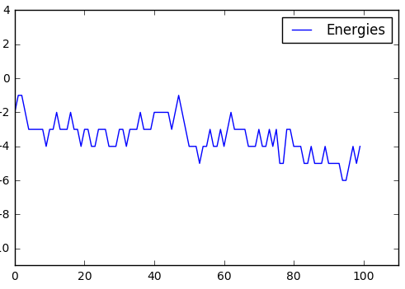

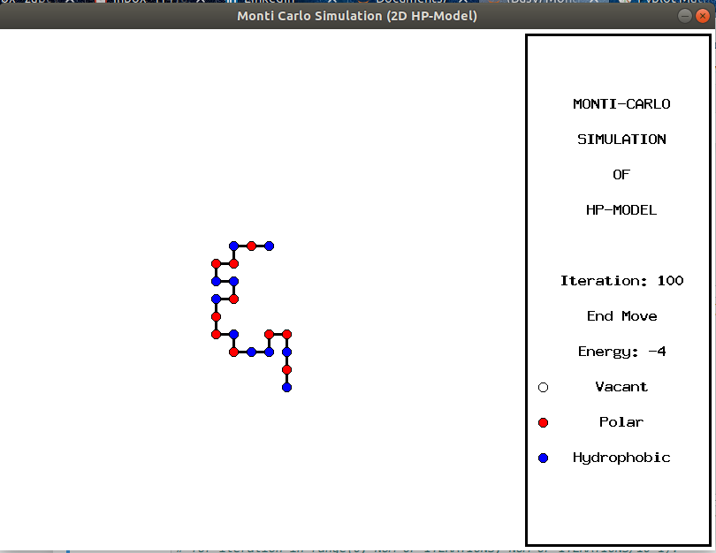

- STRING_02 = "H"*2+("P"*2+"H")*7+"H"
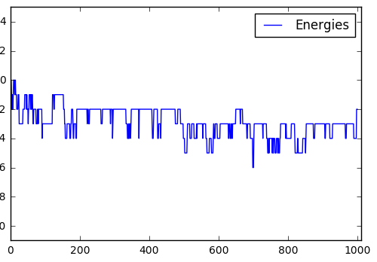
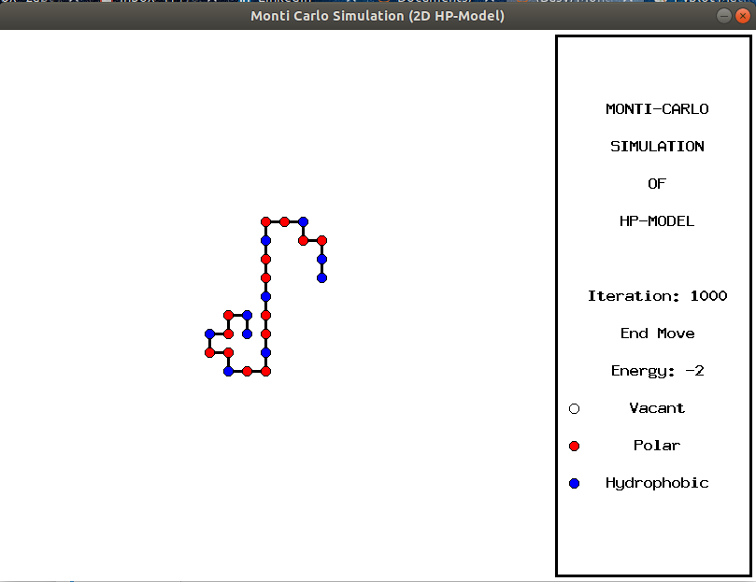
- STRING_03 = "P"*2+"H"+"P"*2+("H"*2+"P"*4)*3+"H"*2
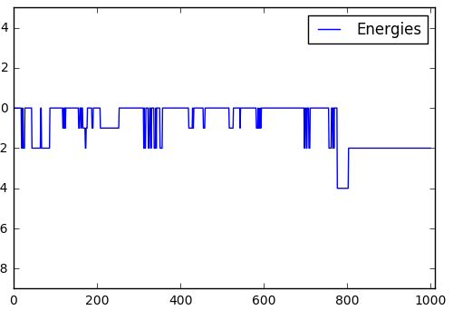
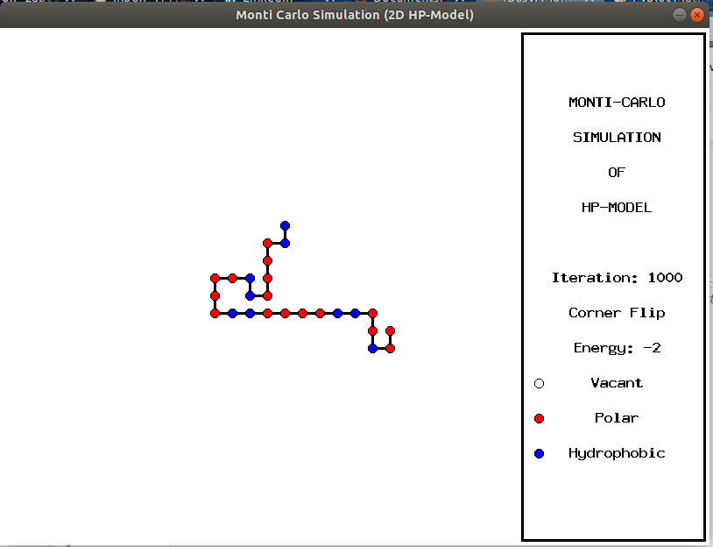
- STRING_04 = "PPPHH"+"P"*2+"H"*2+"P"*5+"H"*7+"P"*2+"H"*2+"P"*4+"HHPPHPP”
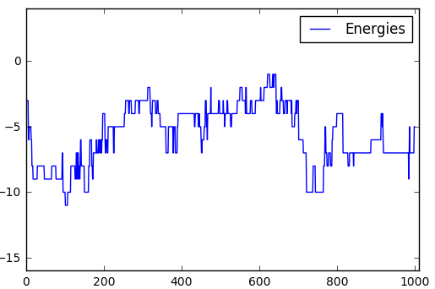
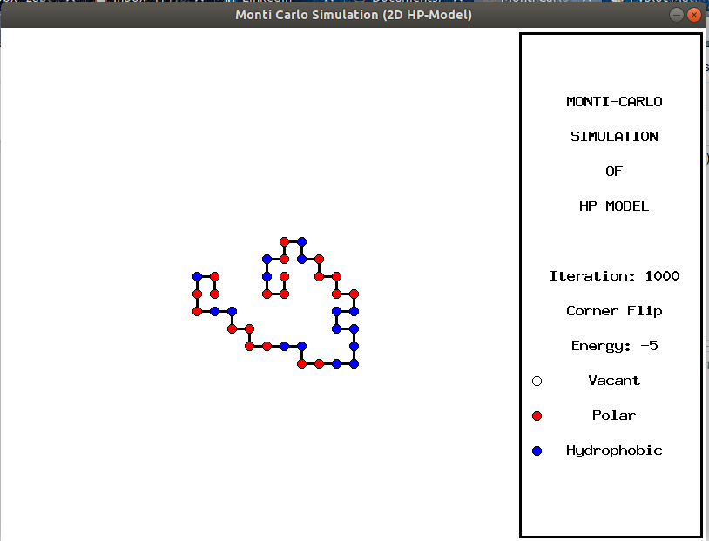
- STRING_05 = "P"*2+"H"+("P"*2+"H"*2)*2+"P"*5+"H"*10+"P"*6+("P"*2+"H"*2)*2+"H"+"P"*2+"H"*5
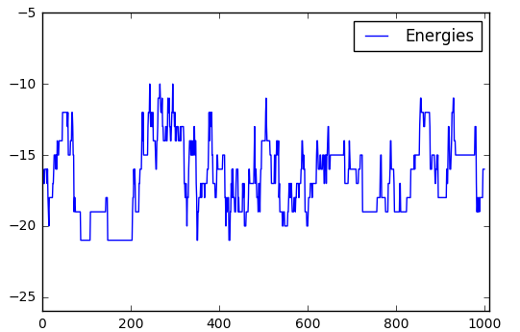
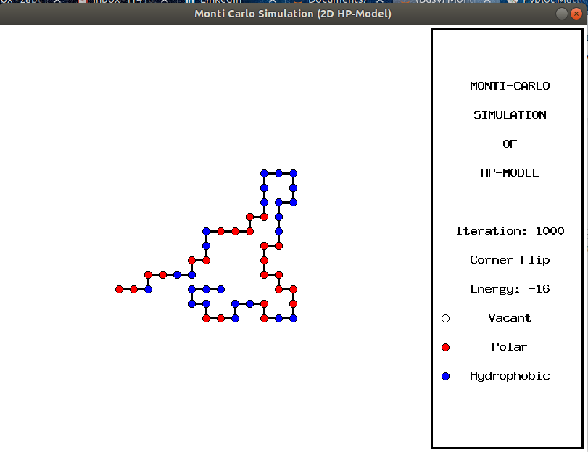

- STRING_06 = "H"*2+"PH"*3+"P"+"H"*4+"PH"+("P"*3+"H")*2+"P"*4+"H"+("P"*3+"H")*2+"PHP"+"H"*4+"HP"*3+"H"*2
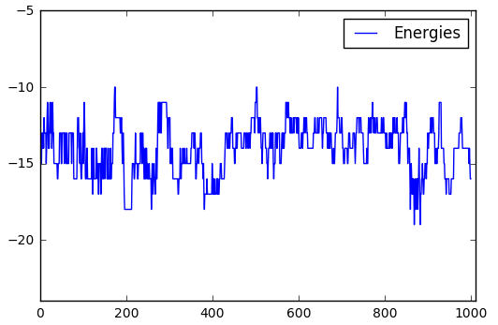
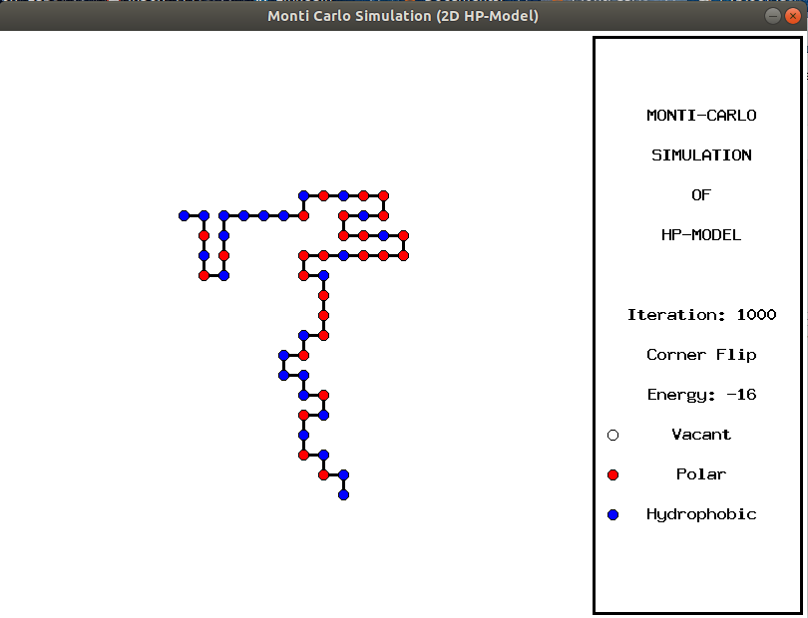
- STRING_07 = "PPHHHPHHHHHHHHPPPHHHHHHHHHHPHPPPHHHHHHHHHHHHPPPPHHHHHHPHHPHP"
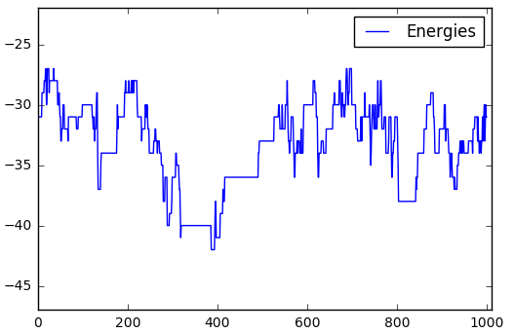
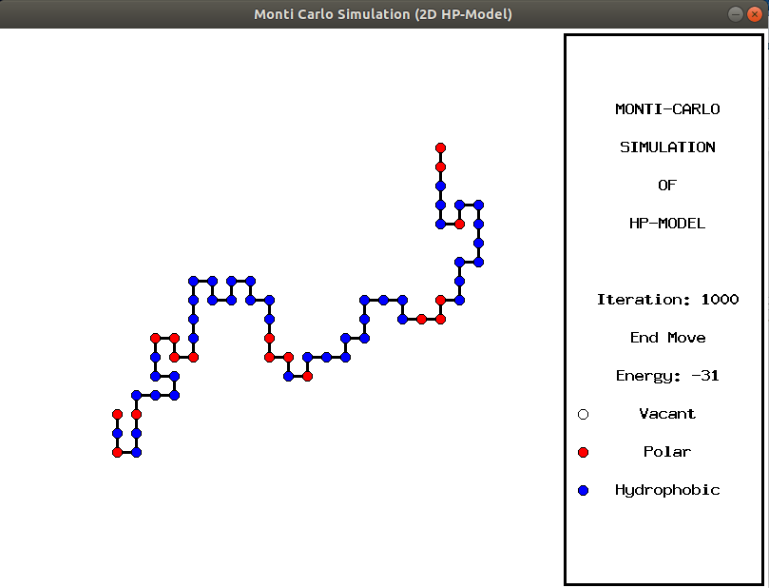
- STRING_08 = "H"*12+"PH"*2+"PPHH"*2+"PPHPPHHPPHHPPHPPHHPPHHPPHPHP"+"H"*12
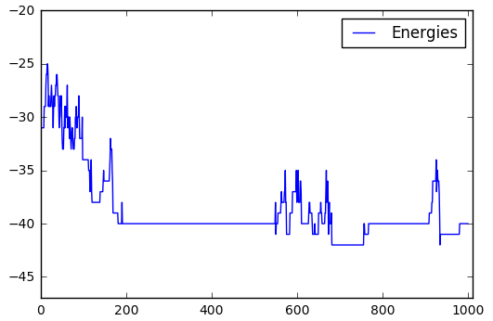
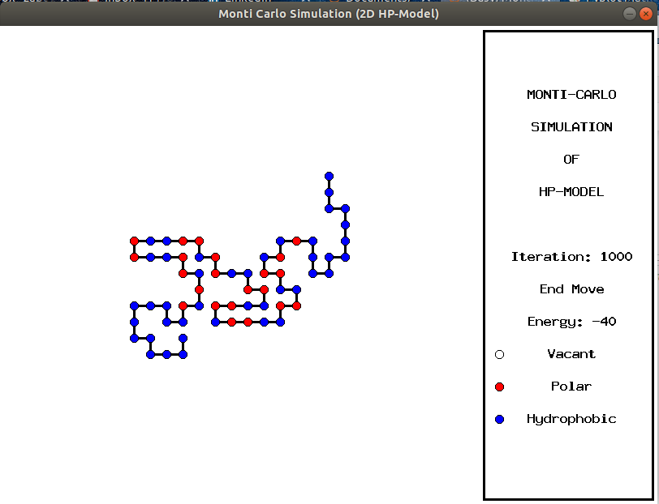
- STRING_09 = "HHHHPPPPHHHHHHHHHHHHPPPPPP"+("H"*12+"P"*3)*3+ "HPPHHPPHHPPHPH"
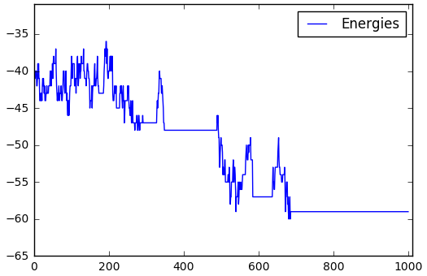
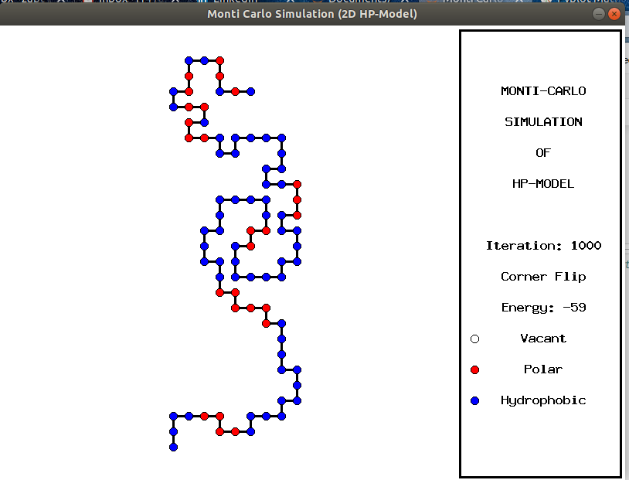
- STRING_10 = "PPPHHPPHHHHPPHHHPHHPHHPHHHHPPPPPPPPHHHHHHPPHHHHHHPPPPPPPPPHPHHPHHHHHHHHHHHPPHHHPHHPHPPHPHHHPPPPPPHHH"
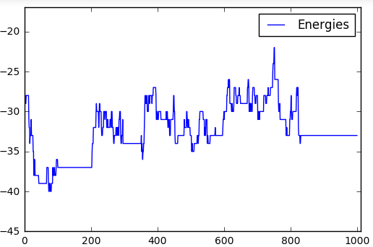
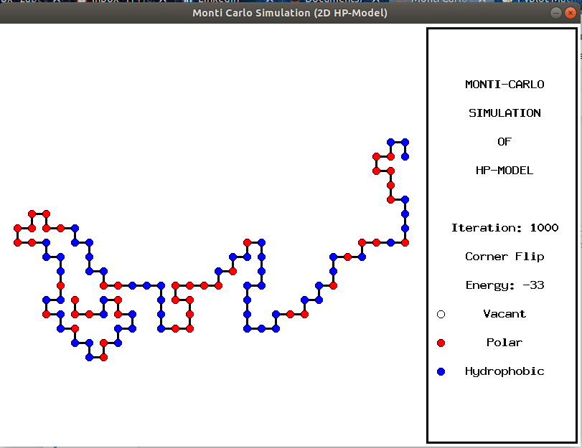
- STRING_11 = "PPPPPPHPHHPPPPPHHHPHHHHHPHHPPPPHHPPHHPHHHHHPHHHHHHHHHHPHHPHHHHHHHPPPPPPPPPPPHHHHHHHPPHPHHHPPPPPPHPHH"
