

Object Oriented Programming

Assignment #1

Name: Zeeshan Haider Khan

Roll no. FA18-BSE-103

Section: 3B

Submitted to: Raja Rashid Mehmood

Description

In this game I have created multiple classes to take the OOP concepts. First Class is of Base Game named Game, second class is enum class of Snake, Third class is enum class of Ladders and fourth class of Player. Within each enum class I have declared two data type of integers for in Snake head and tail and for Ladder top and bottom. Within these enum classes there are Object Instances already declared to make multiple ladders and snakes and these enum classes contains methods which returns head and tail in Snake class and top and bottom in Ladder class. The fourth class which is named Player contains two datas one for counter which is initialized as 1 and second is for player name of type String. Within this class there are two constructors one default and other argument constructor. There are multiple methods in this class for checking if game is end for a player or not, other methods include a static method for generating random numbers and two other methods for adding number to players counter and set method to set the counter to specific number for in case of head and tail.

The first class which is named Game contains two datas one for number of players of type integer and other data for players array of size of previously defined data where we store score of players. This method is coded as for as many players we want to play with. Method in this class includes Default Constructor which sets number of players of to 2 and other constructor of argument which take as much player as we want. The other methods in this class includes isHead to check if the number generated is head of a snake using defined enumerated objects in Snake class and isBottom to check if the number generated is bottom of a ladder using defined enumerated objects in Ladder class. The other methods includes gameEnd which checks if game is end for any of the players in the array of players score using the isEnd method defined in Player class. There are remaining two methods one for gameLoop where all the methods are used to run the game the main work where exists and last method which createPlayers() which creates players and sets names in players array.

Class Diagram

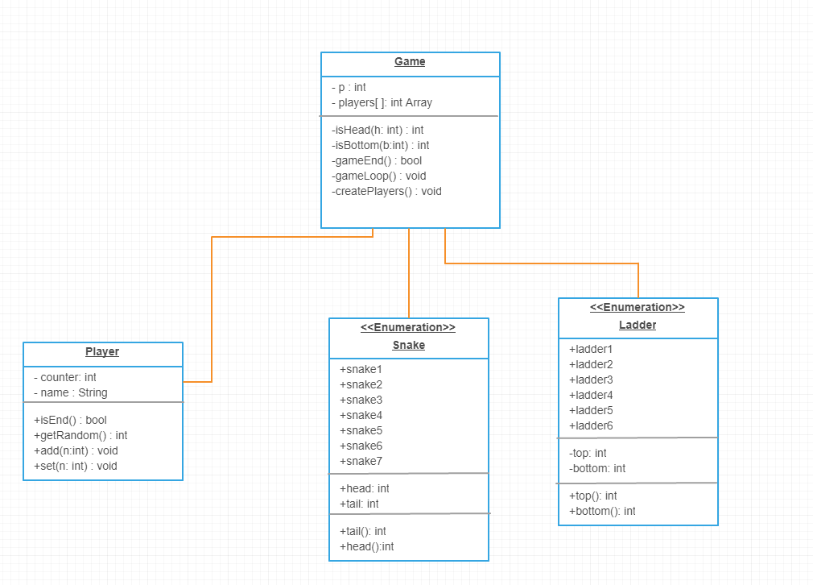

CODE

import java.util.Scanner;

public class Game{

int p; //number of players

Player[] players;// array of players

//arguments

public Game(int players){

p=players;

gameLoop();

}

//default

public Game(){

p=2;

gameLoop();}

//if head return tail

private int isHead(int h){

for(Snake s : Snake.values()){

if(s.head()==h) return s.tail();

}

return 0;

}

//if bottom return top

private int isBottom(int b){

for(Ladder l : Ladder.values()){

if(l.bottom()==b) return l.top();

}

return 0;

}

//returns true when game is end prints winner name

private boolean gameEnd(){

for(int i=0;i<p;i++){

if(players[i].isEnd()){

System.out.println(players[i].name+" is the winner");

return true;

}

}

return false;

}

//main loop where all the work and methods are used

private void gameLoop(){

createPlayers();

while(!gameEnd()){

for(int i=0;i<p;i++){

int toAdd=Player.genRandom();

System.out.println(players[i].name+" turn:-"+ toAdd);

players[i].add(toAdd);

if(isHead(players[i].counter) != 0) {

players[i].counter = isHead(players[i].counter); //returns tail

System.out.println("Ohhhhh!!!");

}

else if(isBottom(players[i].counter) !=0 ){

players[i].counter = isBottom(players[i].counter); //returns top

System.out.println("Yayyyy!!!!!");

}

System.out.println(players[i].name+" new pos "+players[i].counter);

}

}

}

//creates players

private void createPlayers(){

players=new Player[p]; // creates new players

Scanner kb = new Scanner(System.in);

for(int i=0;i<p;i++){

System.out.print("Enter Player "+(i+1)+" Name: ");

players[i] = new Player();

players[i].name = kb.next();

}

}

}

import java.util.Random;

public class Player{

public int counter=1;

public String name;

public Player(){

name="XYZ";

}

public Player(String n){

name=n;

}

public boolean isEnd(){

return counter>100;

}

public static int genRandom(){

Random generator = new Random();

return generator.nextInt(6)+1;

}

public void add(int n){

counter+=n;

}

public void set(int n){

counter =n;

}

}

public enum Ladder

{ //all ladders in the games

ladder1(51,3),

ladder2(27,6),

ladder3(70,20),

ladder4(55,36),

ladder5(95,63),

ladder6(98,68);

private int top;

private int bottom;

Ladder(int t,int b){

top=t;bottom=b;

}

public int top(){

return this.top;

}

public int bottom(){

return this.bottom;

}

}

public enum Snake

{

//all snakes in the game

snake1(34,1),

snake2(25,5),

snake3(47,19),

snake4(62,52),

snake5(87,57),

snake6(91,61),

snake7(99,78);

public int head;

public int tail;

Snake(int h,int t){

head=h;

t=tail;

}

public int tail(){

return this.tail;

}

public int head(){

return this.head;

}

}