**Name :** Israr-Ul-Haq

**Student Id**: BSCSF17-06

**Task no.:** #2

**Topic** : Installing mongoDB

**Instructor :** Sir Abdullah

**Date :** March 27, 2020



**There was the following steps to complete this task**

**Step 1:**

I have downloaded it from mongodb officail site

<https://www.mongodb.com/>.

**Step 2 :**

Then i installed it into my custom location which is (C:\mongodb)

**Step 3 :**

Then i opened the cmd as a administartor

**Step 4 :**

Then i installed it through cmd by this command after went to the main directory where was my mongodb.

C:\Mongodb\bin>mongod --directoryperdb --dbpath c:\mongodb\data\db --logpath c:\mongodb\log\mongo.log –install .

Then i start it through this command “net start MongoDB”

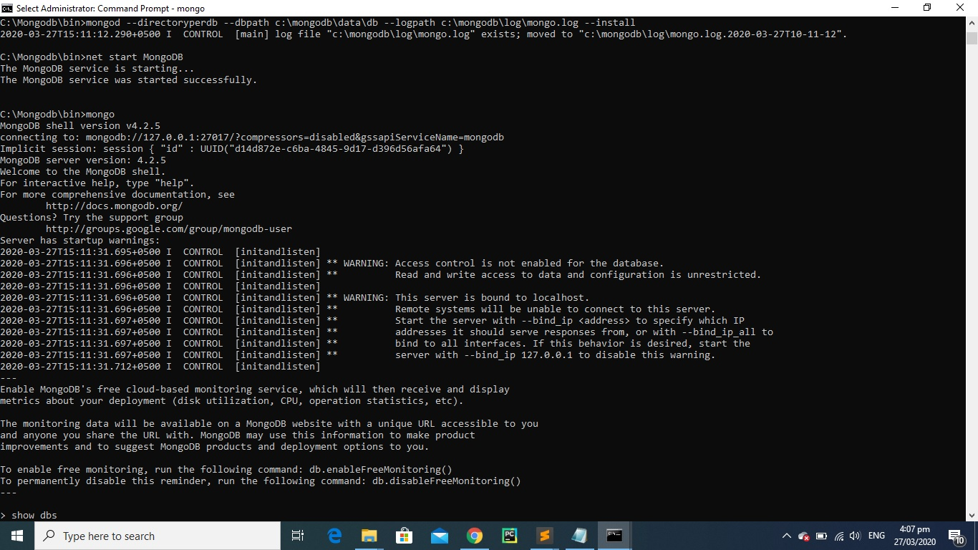

**Step 5 :**

Then i also switched into my own database named Bigdatabd.

**That’s it for Now . Thank You ☺**