1. Now let’s add rotation animation

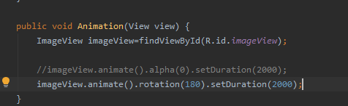A screenshot of a red car

Description generated with high confidenceA picture containing text, screenshot

Description generated with very high confidence

1. Now let’s translate the image on axis

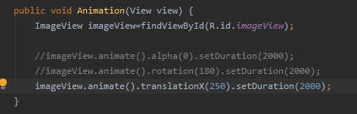

A screenshot of a red car

Description generated with high confidence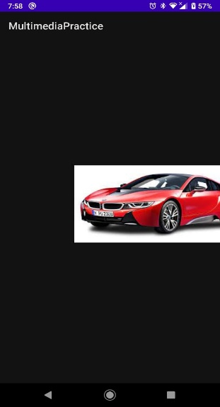

1. Now let’s rotate and fade at same time