1. Now add item in menu xml

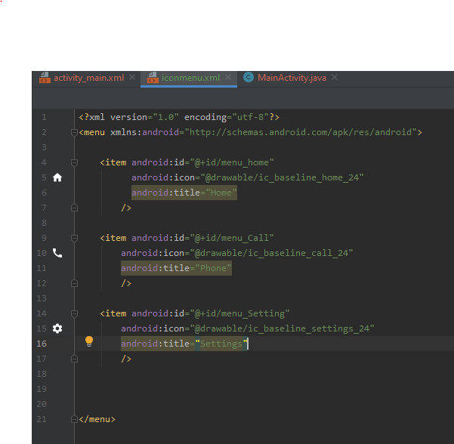

1. Now add a header xml file in layout

Graphical user interface, application

Description generated with very high confidence

1. Now we design the layout using linear layout

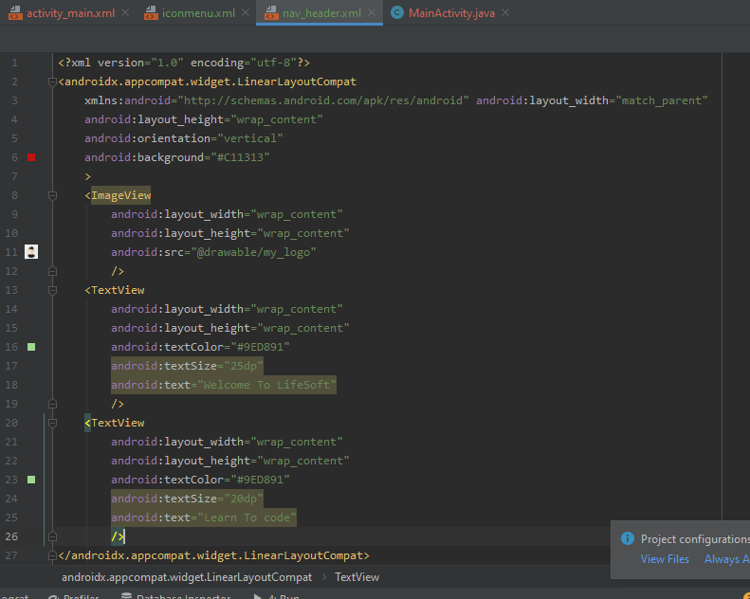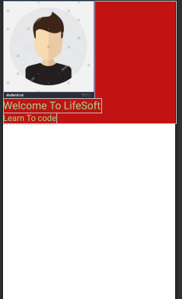

1. Now we add navigation View in the main activity

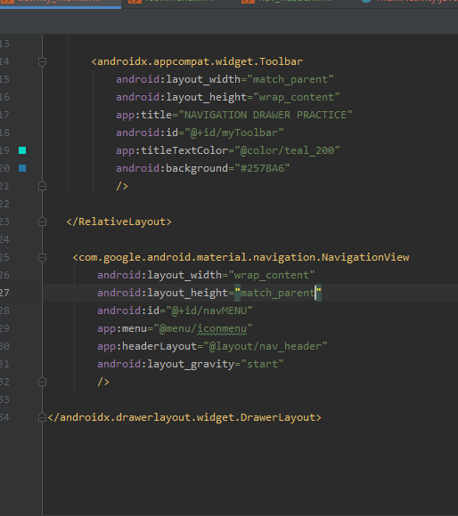

1. Now we add code in main to handle the navigation drawer functionality

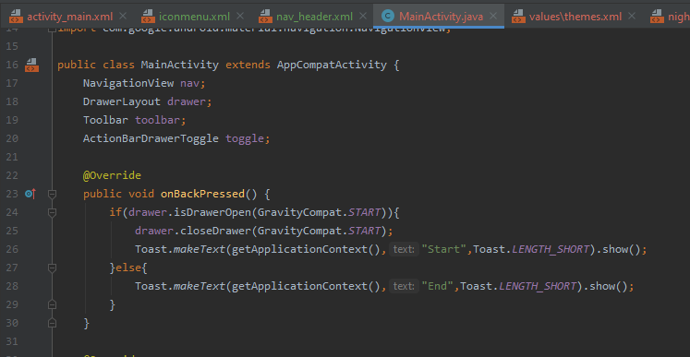Text

Description generated with very high confidence

1. Now we check the output of navigation drawer on android device

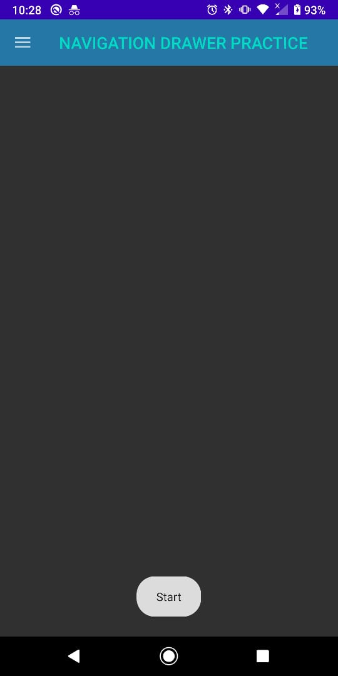

Text

Description generated with high confidenceText

Description generated with high confidence