**ADAPTERS**

1)Adapters convert data from a data source in UI Components eg. ListView, GridView etc

2)Let Us make a code for a listView.

Text

Description generated with very high confidence

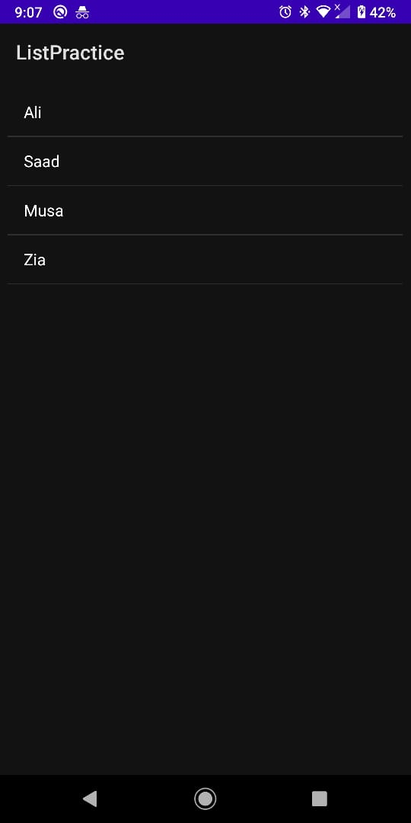

3)Now we do this procedure for ArrayList

Text

Description generated with very high confidenceText

Description generated with high confidence

4)Now we add record taking input from user

Text

Description generated with very high confidence