1. Now we add video activity as launcher activity and add videoView in it
2. 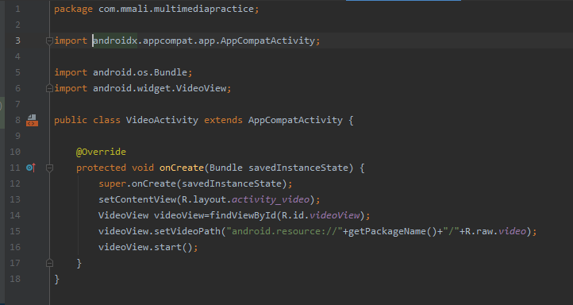

Graphical user interface, application

Description generated with very high confidence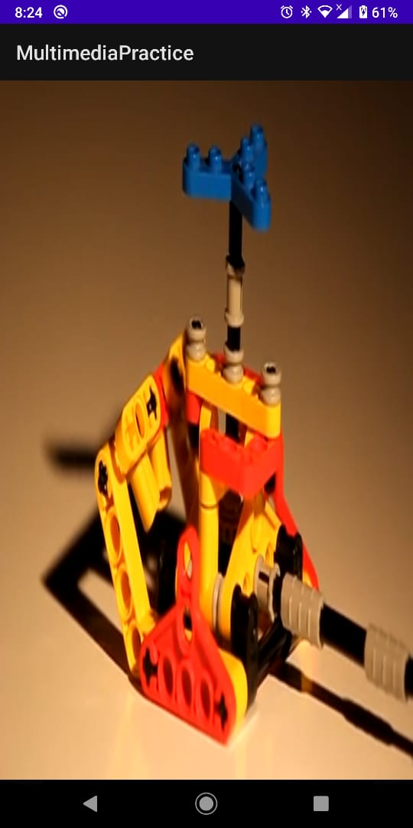

1. Now we add media controller to it.

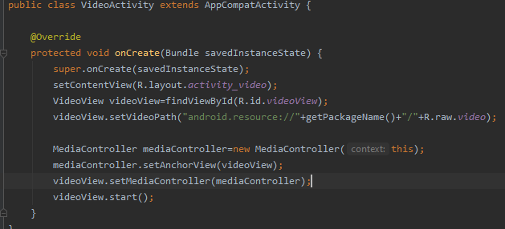A picture containing text

Description generated with very high confidence

1. Now we add an audio activity and make it as launcher activity

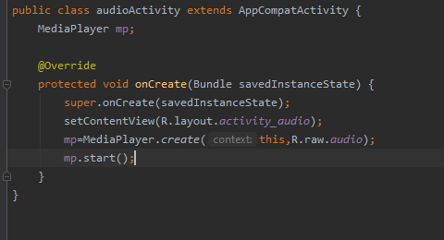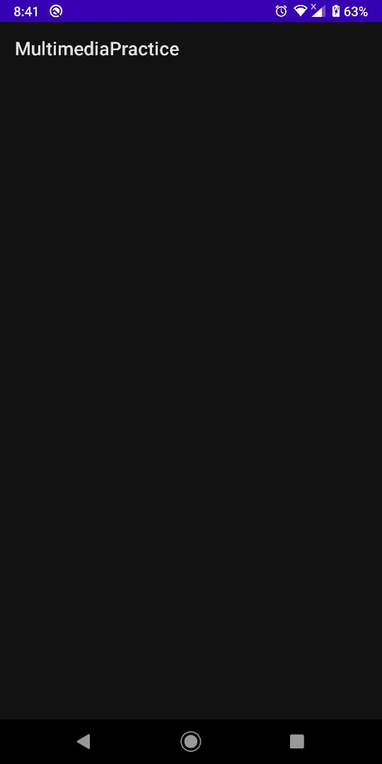

1. Now we add some controller buttons to play and pause the sound

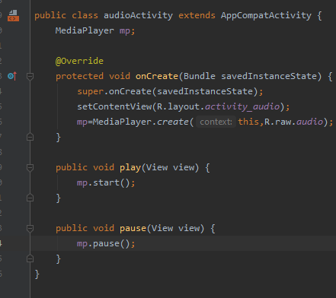Graphical user interface, application, Teams

Description generated with very high confidence

1. Sound will be played on clicking play button and stopped when click on stop button