**SKILLS HUB**

**Design Document**

**Version 1.0**



**Group Id :**

**Supervisor Name :** Musaddiq Hussain

**Revision History**

|  |  |  |  |
| --- | --- | --- | --- |
| **Date (dd/mm/yyyy)** | **Version** | **Description** | **Author** |
| **9/9/2023** | **1.0** |  | Rubina Batool |
|  |  |  |  |
|  |  |  |  |
|  |  |  |  |

**Table of Contents**

1. Introduction of Design Document
2. Entity Relationship Diagram (ERD)
3. Sequence Diagrams
4. Architecture Design Diagram
5. Class Diagram
6. Database Design
7. Interface Design
8. Test Cases

1. Introduction of Design Document

The Design Document maps the requirements into architecture-independent of how these requirements will be accomplished. The architecture defines the components, their interfaces, and behaviors. In the Design Phase, we transform the requirements gathered during the Analysis Phase into a Design Document that accurately describes the design of the system.

The purpose of the Design Phase is to transform the requirements into complete and detailed system design specifications once the design is approved the Design Document will serve as input to the Development Phase. Tools and techniques used in this phase are listed below:

* ER Diagram
* Sequence Diagram
* Architecture Design Diagram
* Class Diagram
* Database Design
* Interface Design
* Test Cases

1. 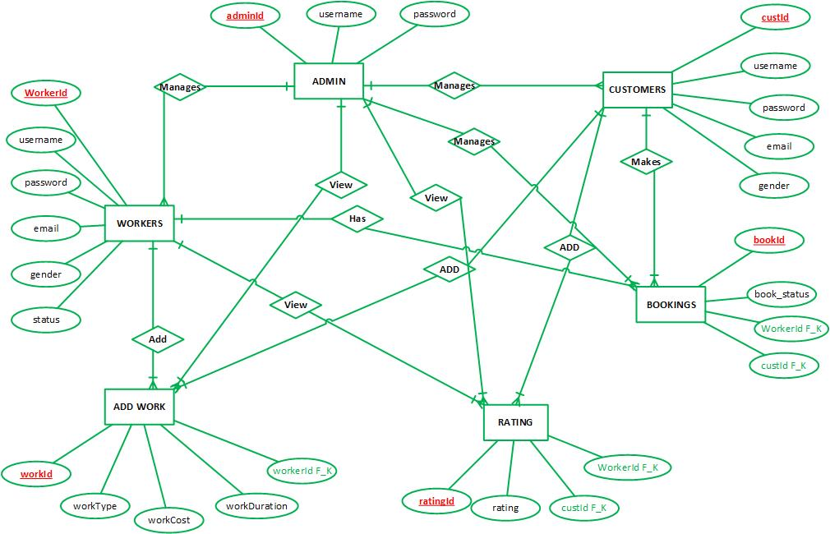Entity Relationship Diagram (ERD)
2. Sequence Diagrams

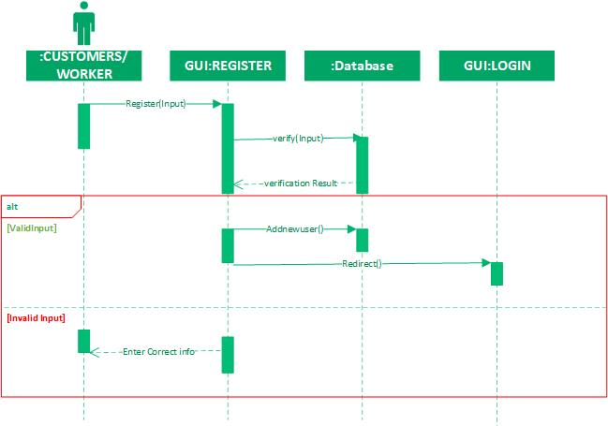Registration:

Login Panel:

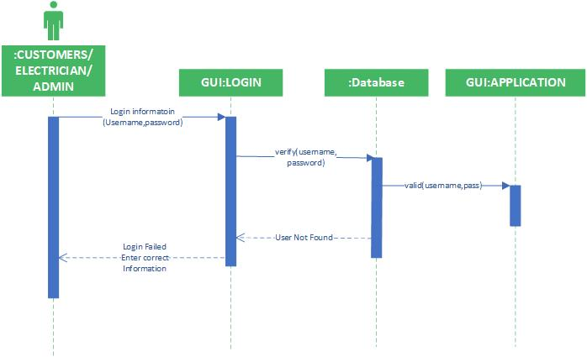

Add Service:

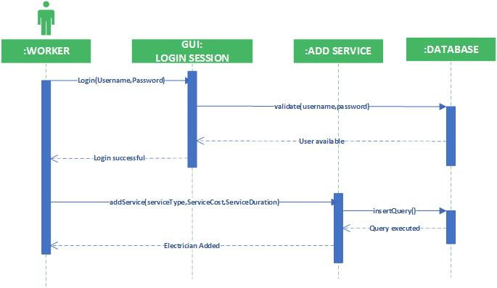

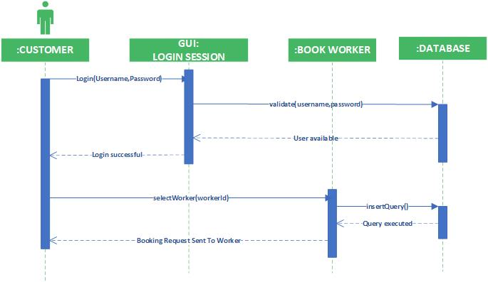Book Worker

Manage Customers

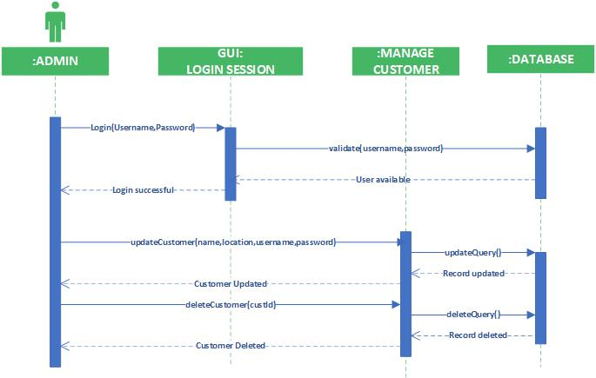

Manage Service:-

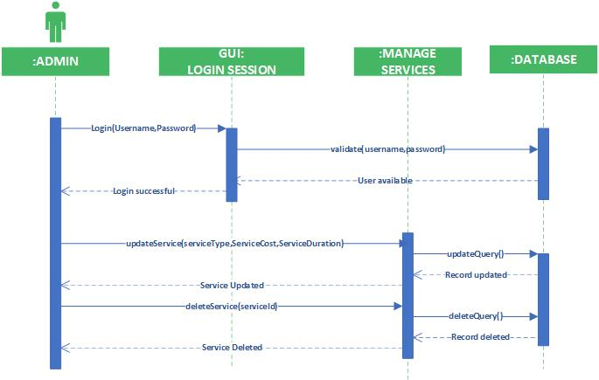

Manage Workers:-

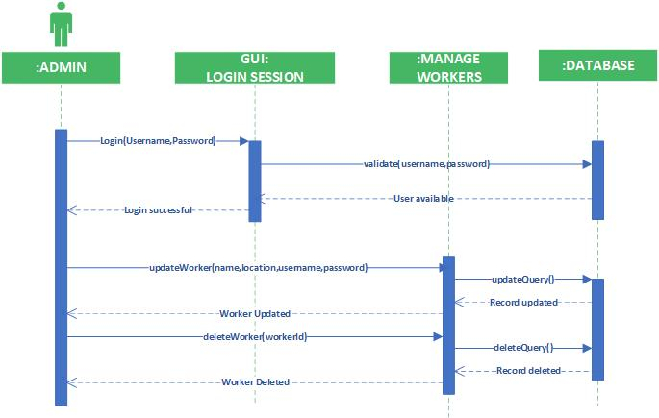

Search Worker:-

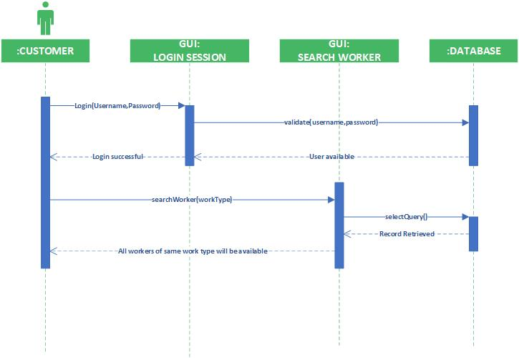

Add Profile:-

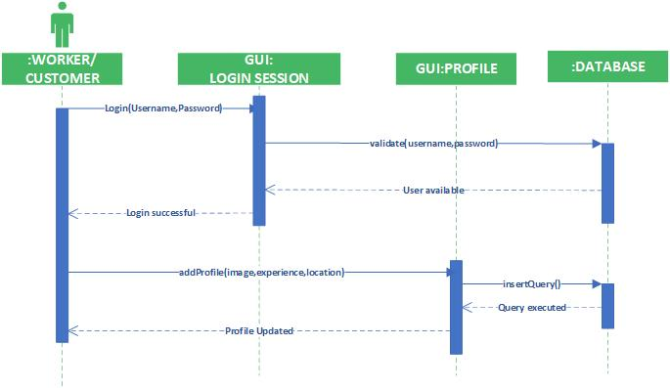

View Ratings:-

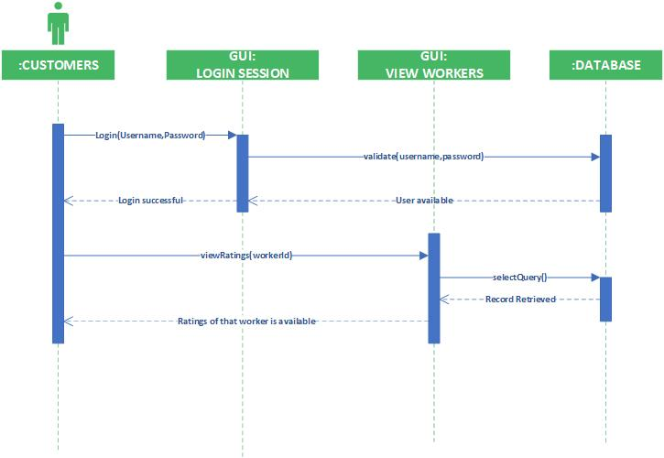

LOGOUT:-

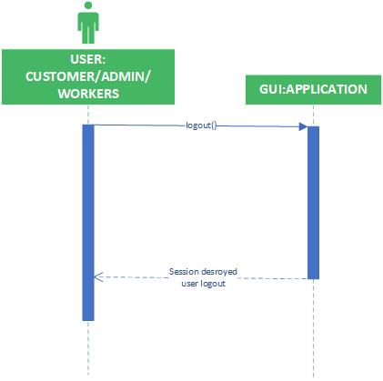

1. 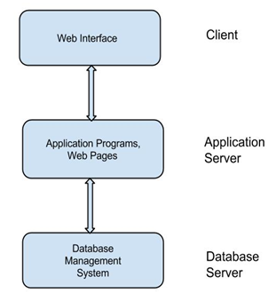Architecture Design Diagram
2. Class Diagram

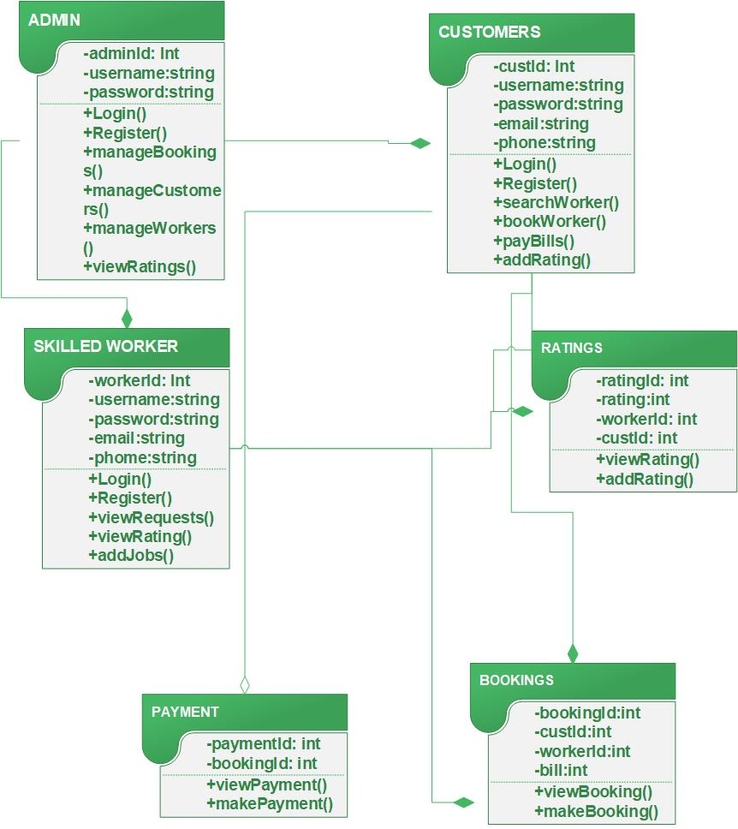

1. Database Design

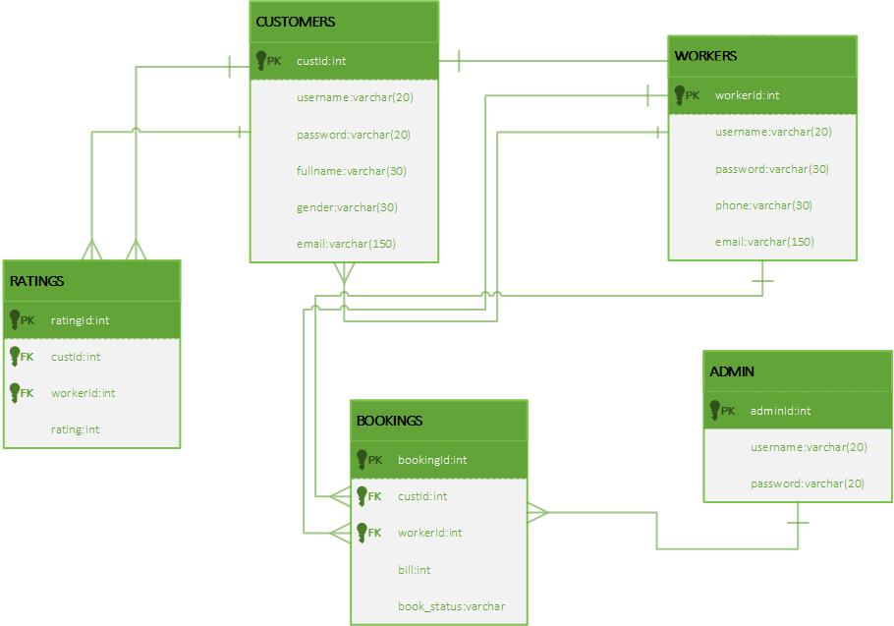

1. Interface Design



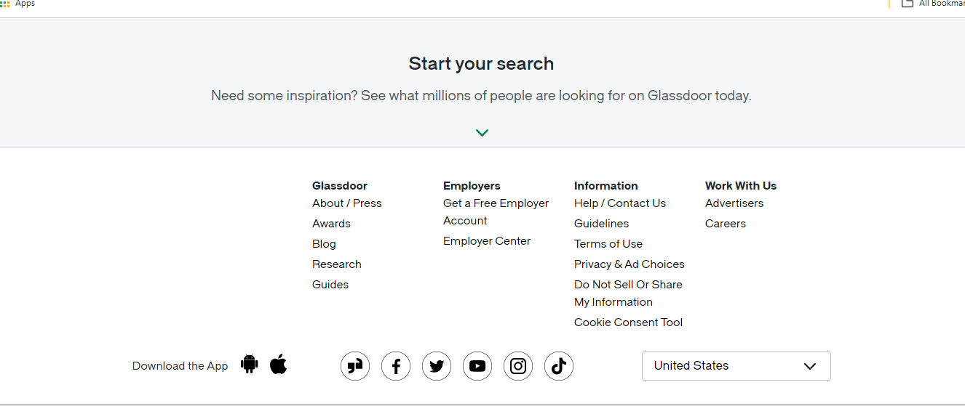

1. Test Cases
2. **Test case 01 Title= Register**

|  |  |
| --- | --- |
| **Pre-condition** | Application interface must be available. |
| **Action** | 1. Open application interface of create account 2. Fill the form of registration 3. Click on “Register” button to get registered |
| **Expected Results** | User successfully created in database. |
| **Results** | Pass |
| **Tested By** | Rubina Batool |

1. **Test case 02 Title= Login**

|  |  |
| --- | --- |
| **Pre-condition** | Admin/Skilled/Customer user must be created first, Application interface must be available |
| **Action** | 1. Open application interface of login 2. Enter user name and password 3. Click on “Login” button |
| **Expected Results** | User successfully login and able to further work |
| **Results** | Pass |
| **Tested By** | Rubina Batool |

1. **Test case 03 Title=** SEARCH WORKER

|  |  |
| --- | --- |
| **Pre-condition** | Users must be registered and Application interface must be available |
| **Action** | 1. Open application interface and fill the criteria of search workers. 2. Click on the “SEARCH” button |
| **Expected Results** | All workers that fall on the search criteria will be displayed on the website |
| **Results** | Pass |
| **Tested By** | Rubina Batool |

1. **Test case 04 Title= UPDATE PROFILE**

|  |  |
| --- | --- |
| Pre-condition | User of the system must be registered with our website and logged in. |
| Action | 1. Login as Users/Skilled Worker 2. Fill update profile form 3. Click on “Update Profile” button |
| Expected Results | Profile successfully updated and |
| Results | Pass |
| Tested By | Rubina Batool |

**Test case 05 Title= ADD RATING:**

|  |  |
| --- | --- |
| **Pre-condition** | The Users must be registered and logged in to the system. |
| **Action** | 1. Open application interface and login by providing valid username and password 2. Add Star rating thorough star selection 3. Click on the add rating button of desired worker.. |
| **Expected Results** | Rating has been added to the system. |
| **Results** | Pass |
| **Tested By** | Rubina Batool |

**Test case 06 Title= ADD SERVICE**

|  |  |
| --- | --- |
| Pre-condition | Skilled Worker of the system must be registered with our website and logged in. |
| Action | 1. Login as Skilled Worker 2. Fill add services form 3. Click on “Add Services” button |
| Expected Results | Services successfully added and available on our website for users. |
| Results | Pass |
| Author | Rubina Batool |

**Test case 7 Title= VIEW RATING**

|  |  |
| --- | --- |
| **Pre-condition** | 1. Admin/Customer must be logged in 2. Database should be available on the computer. |
| **Action** | 1. Open application interface. 2. Select skilled worker 3. Click on view rating Button |
| **Expected Results** | Details of ratings posted by customer is available. |
| **Results** | Pass |
| **Tested By** | Rubina Batool |

**Test case 8 Title= MANAGE USERS:**

|  |  |
| --- | --- |
| Pre-condition | Application interface must be available. And system must be logged in as Admin |
| Action | 1. Open application interface of create account 2. View manage_user.php page 3. Select Particular user to manage 4. Perform your desired actions i.e eidt/delete |
| **Expected Results** | Upated information added in database |
| **Results** | Pass |
| **Tested By** | Rubina Batool |

**Test case 9 Title= MANAGE SERVICES:**

|  |  |
| --- | --- |
| Pre-condition | Application interface must be available. And system must be logged in as Skilled Worker |
| Action | 1. Open application interface of create account 2. View manage_services.php page 3. Select Particular Service to manage 4. Perform your desired actions |
| Expected Results | Upated information added in database. |
| Results | Pass |
| Tested By | Rubina Batool |

**Test case 10 Title= LOGOUT:**

|  |  |
| --- | --- |
| **Pre-condition** | Admin/Skilled Worker/Customer user must be registered and logged in to the system. |
| **Action** | 1. Open application interface and logged in. 2. Click on logout button. |
| **Expected Results** | User will be logout from application |
| **Results** | Pass |
| **Tested By** | Rubina Batool |