StructML Final Project

Aspect 3 — Node Features

Experimental design
We study how the initial node representation affects a heterogeneous HGT model along three axes: (1) downstream performance, (2) model complexity (trainable parameters), and (3) usability. We fix a single HGT backbone (hidden=64, 2 layers, 2 attention heads, dropout 0.3) and swap only the per-node input encoder between three strategies:
- ID encoding (no features). A learnable embedding per node, keyed on a stable global id. Ignores tuple content; parameter count scales with the number of nodes.
- Column-wise encoding. Each cell is encoded by its column type (numeric → standardized, categorical → ordinal+standardized, datetime → days-since-cutoff), concatenated, then a per-table linear layer maps to the hidden width.
- LLM encoding. Each tuple is stringified as “col=val, …” and embedded with a frozen sentence-transformer (all-MiniLM-L6-v2, 384-d); a per-table linear layer maps to the hidden width.
Fairness. All three variants share the identical backbone, width, depth, optimizer, loader, and preprocessed graph; x (column), gid (id), and x_llm (LLM) are built in one preprocessing pass and stored on every node, so the graph and sample are guaranteed identical. Only the input encoder differs. Datasets: rel-f1/driver-dnf (small, full graph) and rel-event/user-repeat (larger; non-target tables capped at 60k rows, the same sample used for all three strategies). Metrics: ROC AUC, AUPRC, precision, recall; two seeds (0,1).

Results
Dataset | Strategy | Test AUC | Test AUPRC | Total params | Encoder params
rel-f1/driver-dnf | ID | 0.415 | 0.786 | 5,252,731 | 4,740,032
rel-f1/driver-dnf | Column-wise | 0.531 | 0.843 | 515,771 | 3,072
rel-f1/driver-dnf | LLM | 0.500 | 0.836 | 734,459 | 221,760
rel-event/user-repeat | ID | 0.608 | 0.535 | 15,136,963 | 14,855,744
rel-event/user-repeat | Column-wise | 0.679 | 0.627 | 289,091 | 7,872
rel-event/user-repeat | LLM | 0.670 | 0.589 | 404,419 | 123,200
Table 1. Node-feature strategies (mean over seeds). Encoder params isolate the cost of the representation.

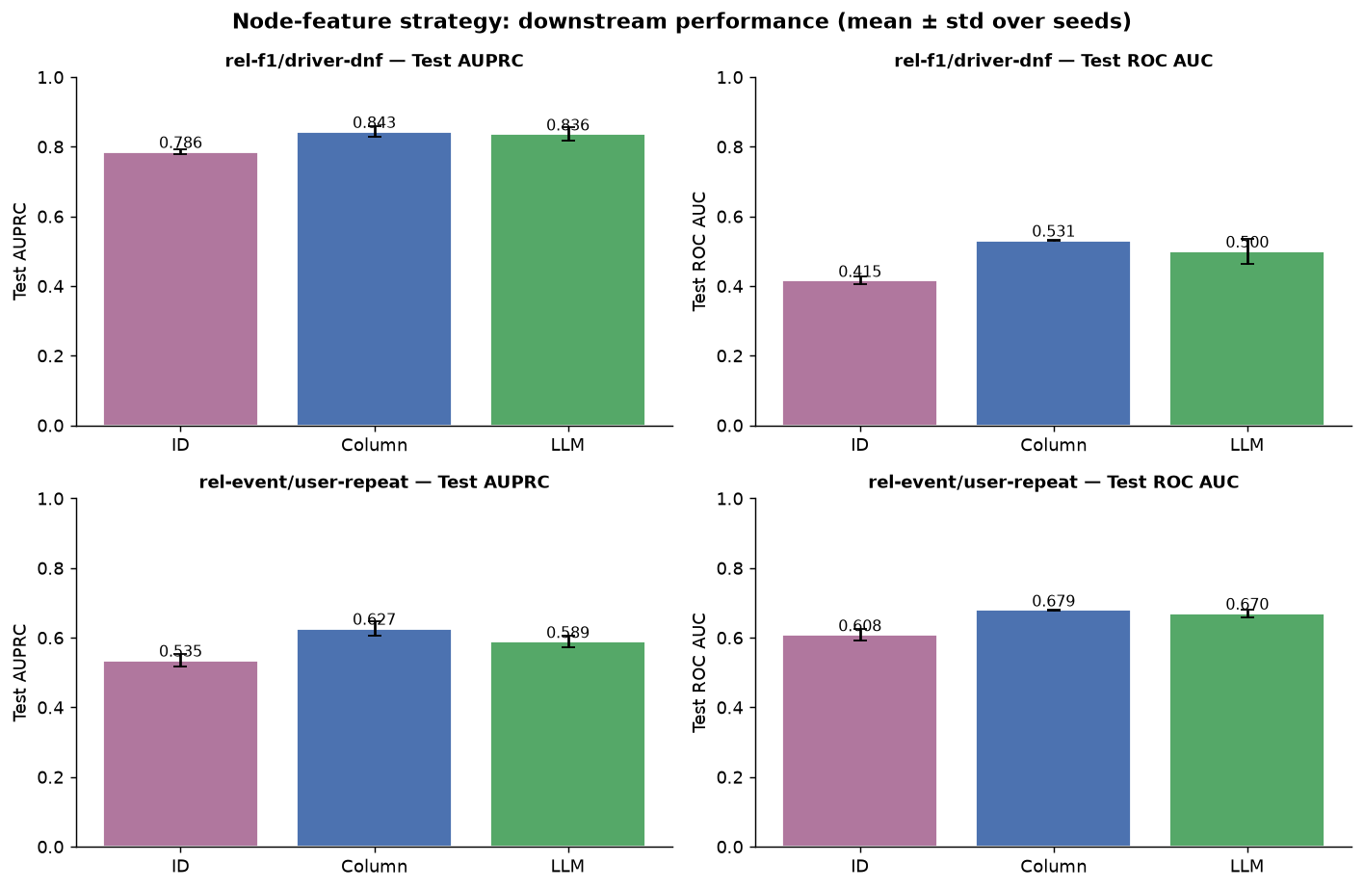
Figure 1. Downstream performance by strategy (mean ± std over seeds).
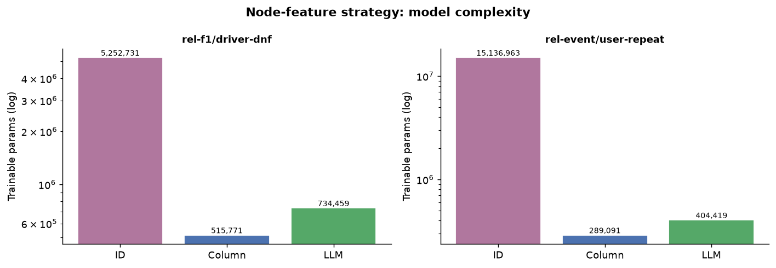
Figure 2. Model complexity (log scale). The ID embedding table dominates parameter count.

Discussion
The parameter axis behaves exactly as predicted: ID is 1-2 orders of magnitude larger than column-wise or LLM because it stores an embedding per node (its encoder holds ~4.7M params on rel-f1 and ~14.9M on rel-event), whereas the column-wise encoder is a few thousand params and the LLM encoder is a small per-table Linear(384→64).
On performance, rel-event is the reliable signal (balanced labels, ~250 test examples): column-wise and LLM clearly beat ID on ROC AUC (~0.68 vs ~0.60) and AUPRC, i.e. ID pays roughly 50× the parameters for the worst result. This matches expectation — ID embeddings are transductive, so entities appearing only at test time carry no learned signal, and the model can exploit little beyond graph structure. Column-wise is the best effort/reward point; LLM is competitive but did not beat the direct typed encoding here (the tabular content is largely numeric/categorical, which column-wise captures precisely, whereas the string embedding loses precision).
Two honest caveats for interpretation. (i) rel-f1 has only ~42 labeled val/test nodes at ~81% positive, so its metrics are noise-dominated (test AUC swings 0.24-0.54 while AUPRC mostly reflects the base rate); we therefore lead conclusions with rel-event. (ii) Precision/recall at a fixed 0.5 threshold are misleading under imbalance — the LLM variant on rel-event ranks well (AUC 0.68) yet outputs all-negative at 0.5 (precision=recall=0), a calibration artifact; AUC/AUPRC are the right headline metrics. On usability, ID is trivial to implement but not inductive; column-wise needs typed encoders fit on train but transfers; LLM is a one-line call but a heavy one-off embedding pass, and is naturally inductive.

Aspect 4 — Limitations of Deeper Models (Oversmoothing)

Experimental design
Deep message passing causes oversmoothing: node representations converge and lose their distinctiveness. We use GraphSAGE with mean aggregation (a per-type linear encoder to a uniform hidden=64 width, then L SAGEConv(mean) layers lifted to the heterogeneous graph via to_hetero, sigmoid head). We sweep depth L ∈ {1,2,4,8,16} and, for each depth, measure oversmoothing directly on the target-node representations with two similarity measures:
- MAD (mean average distance). Mean pairwise cosine distance; → 0 when representations collapse.
- Mean cosine similarity. The dual view; → 1 when oversmoothed.
As the follow-up, we compare the plain deep stack (none) against two mitigations: residual (skip) connections h ← h + SAGE(h), and DropEdge (randomly dropping a fraction of edges each training step). The uniform width across layers is what makes residual addition and the cross-depth metric comparison valid. Fairness: identical encoder/head, width, optimizer, loader and graph across all runs; only depth and mitigation change. Datasets are distinct from the other aspects: rel-f1/driver-dnf (small, shallow graph) and rel-trial/study-outcome (clinical trials; 15 node types, ~250k study nodes, ~800 balanced test labels). Metrics computed on a 1000-node sample, same cap across depths.

Results
Depth L | none cos | none AUC | resid cos | resid AUC | drop cos | drop AUC
1 | 0.29 | 0.60 | 0.28 | 0.59 | 0.27 | 0.61
2 | 0.35 | 0.58 | 0.25 | 0.57 | 0.31 | 0.59
4 | 0.59 | 0.54 | 0.30 | 0.60 | 0.62 | 0.57
8 | 0.66 | 0.55 | 1.00 | 0.50 | 0.79 | 0.51
16 | 0.99 | 0.50 | 1.00 | 0.50 | 1.00 | 0.50
Table 2. rel-trial/study-outcome: cosine similarity (oversmoothing, ↑1) and test ROC AUC by depth and mitigation.

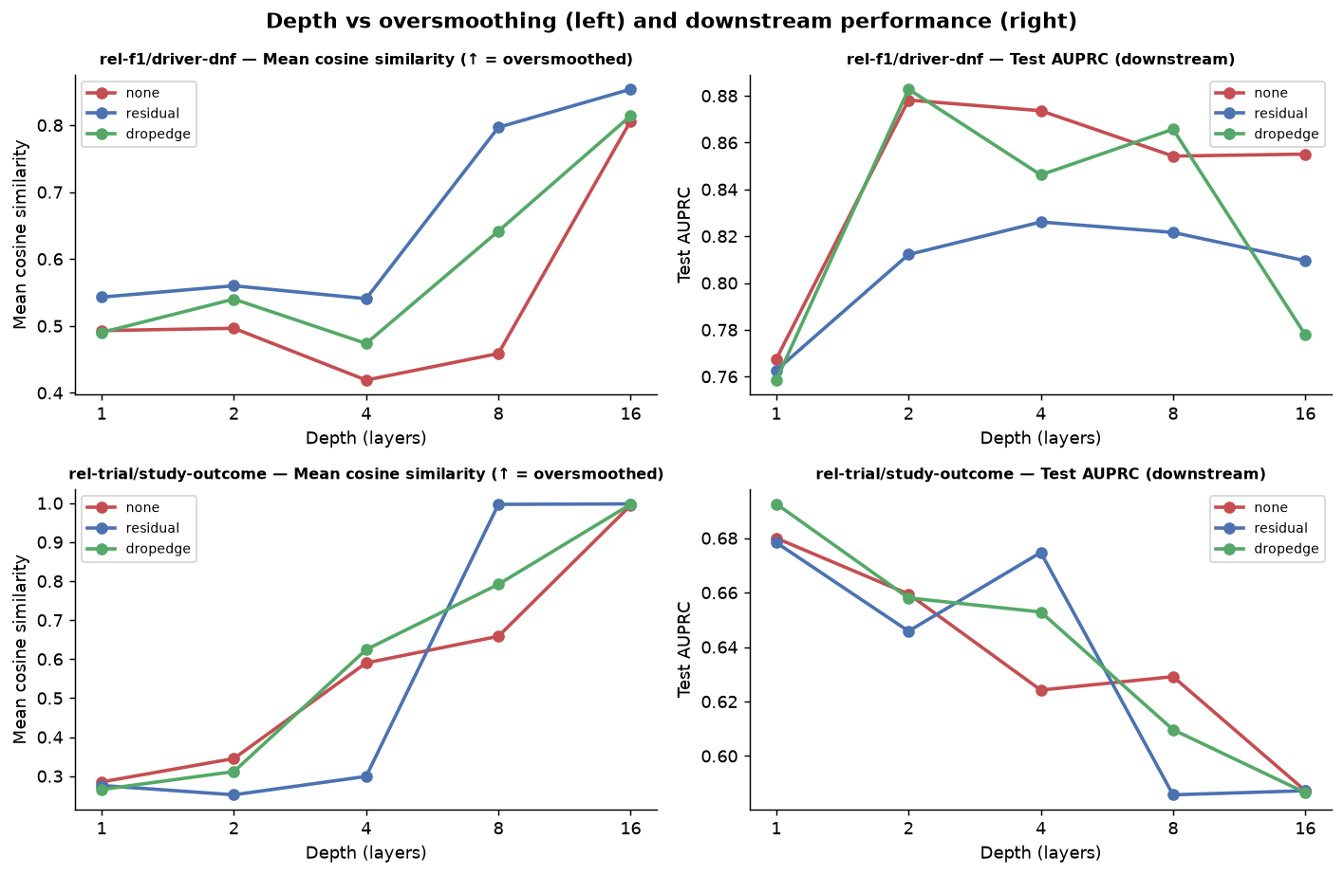
Figure 3. Oversmoothing (left, cosine similarity) and downstream AUPRC (right) versus depth.
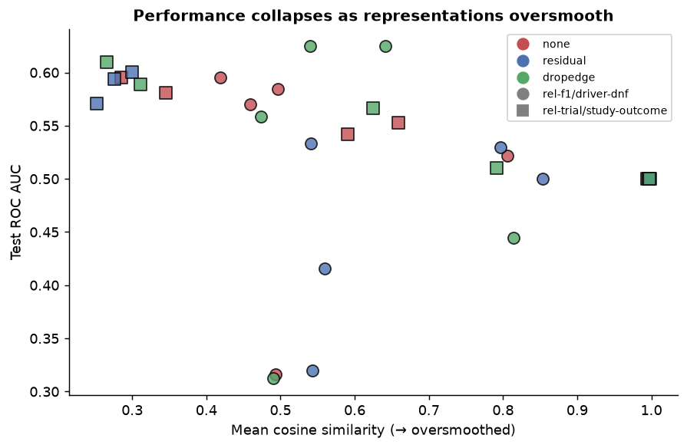
Figure 4. Downstream ROC AUC collapses toward 0.5 as representations oversmooth (cosine similarity → 1).

Discussion
Oversmoothing is clearly demonstrated. On rel-trial, as depth grows the mean cosine similarity of study representations climbs from ~0.28 (L1) to ~0.99 (L16) and downstream ROC AUC decays from ~0.60 to 0.50 (random). At L16 every variant is fully collapsed and predicts at chance, and Figure 4 shows the two are coupled — performance falls as similarity rises. Peak performance is at shallow depth (L1-L4) on both datasets.
The mitigations tell a nuanced, honest story: they delay collapse at moderate depth but do not prevent it at extreme depth. Residual is clearly best at L4 (it keeps cosine similarity at ~0.30 versus ~0.59 for the plain stack, and gives the single best AUC, ~0.60), i.e. skip connections push the oversmoothing threshold out a few layers. But at L8-L16 residual and DropEdge collapse just like the plain model — residual even collapses harder at L8 (cosine ~1.0), plausibly because the accumulating residual sum saturates under ReLU. The practical takeaway is that for these relational tasks a shallow model is preferable, and skip/DropEdge buy robustness for a handful of extra layers rather than unbounded depth. rel-f1 shows the same L16 collapse (cosine → 0.81) but with noisier downstream numbers due to its tiny evaluation set.

Aspect 5 — Foundation Models (Design Question)
We take our heterogeneous HGT model from Aspect 3 and ask what would be required to use it as a foundation model: pretrain on one dataset and apply it to another dataset with a different schema, such that pretraining improves downstream performance.

Why the current model does not transfer
Almost every parameter in our model is bound to a specific schema. The input encoders are per-table linear layers whose input dimension equals that table's column count; the HGT backbone has per-node-type and per-edge-type projection and attention matrices keyed on the literal type identities; and the ID variant stores an embedding per node. A new dataset has different tables (node types), different columns (feature dimensions), and different relations (edge types), so none of these weights are even shape-compatible, let alone semantically aligned. Transfer therefore requires making every schema-specific component schema-agnostic.

Required changes
- Schema-agnostic node encoder. Replace per-table encoders with an encoder that maps any tuple to a fixed-size vector independent of the schema. The LLM strategy from Aspect 3 already does this: stringifying a tuple as “col=val, …” and embedding it with a shared frozen text model yields a 384-d vector for any table of any dataset. This is the single most important enabler of transfer; the ID strategy is the opposite (its embeddings are dataset-specific and, as Aspect 3 showed, do not even generalize to new nodes within one dataset).
- Type-agnostic message passing. Remove the dependence on literal type identities. Options: (a) fully share weights across node/edge types (a homogeneous backbone — simplest, but discards heterogeneity); or (b) condition the per-type/per-relation parameters on a text embedding of the table/relation name via a hypernetwork, so an unseen schema derives its projections from its descriptions rather than from a fixed lookup. Option (b) keeps heterogeneity while remaining schema-agnostic.
- Schema-independent structural features. Use structural encodings (degree, local subgraph descriptors, PK–FK role) rather than id embeddings, so structural signal transfers across graphs.
- Self-supervised pretraining objective. Pretrain without downstream labels using a task-agnostic objective — e.g. PK–FK link prediction and/or masked-attribute reconstruction — so the backbone learns general relational structure. Attach a small task-specific head that is the only part (re)trained per downstream task.
- Feature-space alignment / normalization. Normalize encoder outputs (e.g. shared LayerNorm, unit-norm text embeddings) so the representation space is comparable across datasets.
In short: an LLM (schema-agnostic) node encoder + type-conditioned or shared message passing + a self-supervised pretraining objective + a light per-task fine-tuned head.

Proposed experiment to test effectiveness
Pretrain the schema-agnostic model on a source dataset A (e.g. rel-trial) with the self-supervised objective (link prediction + masked-attribute reconstruction), using no downstream labels. Transfer to a target dataset B with a different schema (e.g. rel-f1 or rel-event) and evaluate entity classification. Compare three conditions under an identical architecture and downstream head:
- From scratch. Random initialization, trained on B only (the baseline the foundation model must beat).
- Fine-tuned. Pretrained on A, then fine-tuned on B.
- Linear probe. Pretrained on A, backbone frozen, only the head trained on B (measures how transferable the representations are as-is / zero-to-few-shot).
Primary metric: ROC AUC / AUPRC on B's test set. The decisive evidence for a foundation model is a data-efficiency curve — performance versus the number of labeled examples on B — where pretraining should help most in the low-label regime. Strengthen the design by (i) pretraining on several source datasets A₁..Aₖ and measuring whether more/diverse pretraining monotonically improves transfer; (ii) an ablation removing each component (LLM encoder, type-conditioning, objective) to attribute the gain; and (iii) multiple seeds with significance testing. Controls for fairness: identical parameter budget and head across conditions, and strict separation between pretraining and evaluation data. Success criterion: pretraining yields a statistically significant improvement over the from-scratch baseline, especially at low label counts.

Note on AI assistance
AI tools assisted with implementing the experiment scaffolding (preprocessing, HGT/GraphSAGE models, training loops, plotting) and drafting this report. All results were produced by executing the code in a controlled conda environment and were validated against expectations (e.g. parameter-count checks, the oversmoothing trend, and cross-checking degenerate metrics such as the fixed-threshold precision/recall artifacts noted above). Findings and interpretations were reviewed for correctness before inclusion.

