ROBOTIC ARM PROJECT
Engineering Summary Report

Design, Build, and Testing of a 4-DOF Arduino-Controlled Servo Arm
Author:
Zeev Sklyar
Date:
June 2026
Version:
V1.0

1. Executive Summary

This report documents the design, construction, and testing of a 4-DOF (Degrees of Freedom) robotic arm, built as a personal learning project. The system uses an Arduino Uno microcontroller, four Tower Pro SG90 servo motors, four potentiometers for manual joint control, and a 3D-printed mechanical structure procured from AliExpress.
The project was undertaken with three primary learning goals: to gain hands-on experience with robotics hardware and control, to practice Git-based documentation and version control.
The arm successfully achieved full 4-axis manual control by the project's conclusion on 13 June 2026. Key challenges encountered and resolved included power supply instability (addressed with a 1000µF electrolytic capacitor), mechanical limitations of the V1 frame design, and expansion of the control code from a single-motor to a 4-motor system.

2. Project Background & Objectives

2.1 Background
This project was initiated as a self-directed learning effort to explore robotics.

2.2 Project Objectives
- Learn the fundamentals of robotic arm design, kinematics, and assembly.
- Gain practical experience with the Arduino microcontroller ecosystem.
- Practice C/C++ embedded programming for servo motor control.
- Learn Git-based project documentation (all data maintained in Git repository).
- Evaluate servo motors, power budgeting, and electronics integration.
- Assess personal interest.

3. Specifications & Constraints

Parameter | Value / Description
Degrees of Freedom | 4 (4 servo joints)
Servo Motor | Tower Pro SG90 – 9g, 90° range
Stall Current (per motor) | 800 mA @ 5V
No-load Current (per motor) | ~200 mA @ 5V
Total Power (4 motors, stall) | 15W (5V × 0.8A × 4)
Controller | Arduino Uno
Arduino Max Output Power | 2.5W – insufficient for 4 motors
External Power Supply | USB fast charger (5V, 3A, 15W)
Control Method | 4× Potentiometers → analog input → PWM servo
Mechanical Structure | 3D-printed PLA parts (AliExpress)
Payload Capacity | 47g

4. Mechanical Design

4.1 Overview
The mechanical structure of the robotic arm (V1) is based on a commercially available 3D-printed design sourced from AliExpress. An initial attempt was made to print parts using the author's personal easyThreed 3D printer; however, this was abandoned due to insufficient precision and reliability for multi-part assemblies.

4.2 Assembly Process
Assembly was performed incrementally with motor integration testing at each step:
- Each servo motor was tested standalone before integration.
- At each assembly step, the installed motor was tested for full range of motion.
- Torque adequacy was verified under load at each joint.
- Wiring integrity and controller response were confirmed before proceeding.

4.3 V1 Design Limitations Identified
- Joint bearings not separated from the motor output shaft – side loads are applied directly to the motor axis, which creates unnecessary and dangers stress on the motor axis (not best practice).
- The 9g SG90 servo torque is marginally sufficient for the arm's own weight at extended positions.
- Design is not scalable to heavier payloads without a structural redesign (V2 recommendation).

Maximum payload the robotic arm can lift:
The motor that handle the heaviest load is motor number 3 (Appendix A Basic robotic arm diagram) because it lifts the load, 2 motors and 3d printed arm skeleton.

Servo motor torque: 1.5kg/cm (4.8V)
Max robotic arm length: 20cm
Servo motor weight: 9g
Number of motors to lift: 2
3d printed arm weight: 9g

Max load weight = Servo_motor_torque/Max_robotic_arm_length – Servo_motor_weight*Number_of_motors_to_lift -3d_printed_arm_weight
Max load weight = 1.5kg*cm / 20cm - 9g*2 – 10g = 47g

5. Electrical & Hardware Architecture

5.1 System Block Diagram

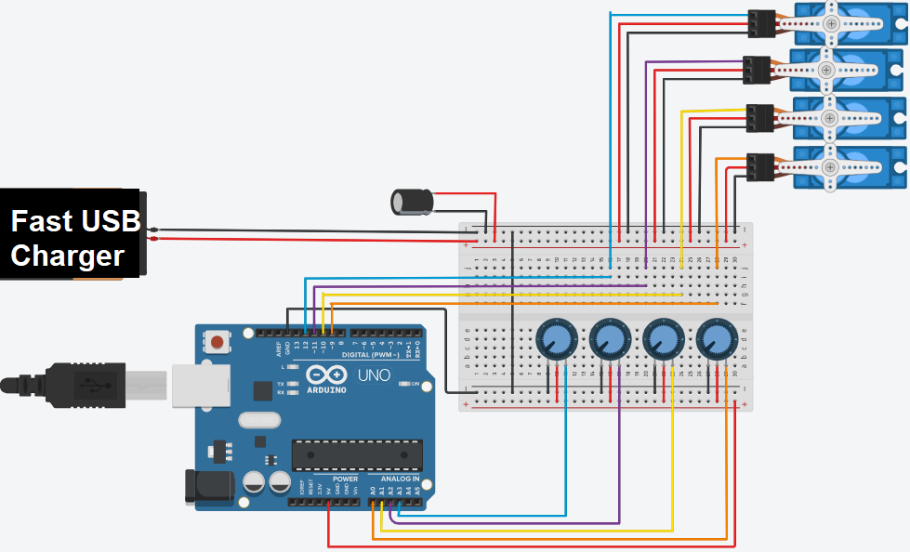

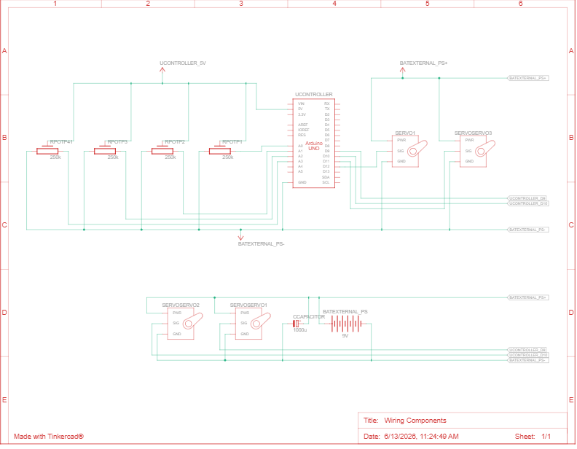

5.2 Power Budget Analysis
A critical design constraint was the power requirement for 4 simultaneous servo motors. The following analysis drove the decision to use an external power supply:
Parameter | Value | Formula
P_required (stall) | 15W | 5V × 0.8A × 4
P_Arduino (max) | 2.5W | Spec limit
P_USB charger | 15W | 5V × 3A
P_single motor (no stall) | 1W (safe for Arduino testing) | 5V × 0.2A

5.3 Capacitor Selection & Voltage Stabilization
A voltage instability problem in the external USB charger caused constant twitching of the servo motors (visible even with static potentiometers). The fix was to add a bulk decoupling capacitor at the power input:
- Minimum capacitance requirement: C_min = 200µF/A × 0.8A × 4 = 640µF
- Selected capacitor: 1000µF / 35V electrolytic (salvaged from legacy PCB)
- Voltage rating: 35V provides adequate margin above the 5V rail (best practice: ≥2× operating voltage)
- Result: Twitching eliminated when capacitor installed AND potentiometer power routed back through Arduino rail.

5.4 Final Wiring Architecture
- Servo motors (4×): Powered from external 5V/3A USB supply via breadboard with 1000µF decoupling cap
- Potentiometers (4×): Powered from Arduino 5V rail (more stable reference)
- Signal lines: Arduino digital pins 9, 10, 11, 12 → PWM servo control
- Analog inputs: Arduino A0, A1, A2, A3 → potentiometer wiper readings

6. Software & Control System

6.1 Development Environment
- Language: C/C++ (Arduino IDE)
- Library: Servo.h (Arduino standard library)
- Version control: Git (full project history maintained in repository)

6.2 Control Architecture
The control system implements direct analog-to-servo mapping: each potentiometer's analog voltage (0–5V → 0–1023 ADC counts) is mapped linearly to a servo angle (0–179°) using the Arduino map() function. The loop runs continuously with a 15ms delay, which aligns with standard servo PWM update rates.

6.3 Final Control Code
#include <Servo.h>

// Potentiometer 1
const int analogInPin1 = A0; // Potentiometer 1 input
const int analogOutPin1 = 9; // Servo 1 output
// Potentiometer 2
const int analogInPin2 = A1;
const int analogOutPin2 = 10;
// Potentiometer 3
const int analogInPin3 = A2;
const int analogOutPin3 = 11;
// Potentiometer 4
const int analogInPin4 = A3;
const int analogOutPin4 = 12;

int sensorValue1 = 0, Angle1 = 0;
int sensorValue2 = 0, Angle2 = 0;
int sensorValue3 = 0, Angle3 = 0;
int sensorValue4 = 0, Angle4 = 0;

Servo servo_9, servo_10, servo_11, servo_12;

void setup() {
Serial.begin(9600);
servo_9.attach(9, 500, 2500);
servo_10.attach(10, 500, 2500);
servo_11.attach(11, 500, 2500);
servo_12.attach(12, 500, 2500);
}

void loop() {
sensorValue1 = analogRead(analogInPin1);
Angle1 = map(sensorValue1, 0, 1023, 0, 179);
sensorValue2 = analogRead(analogInPin2);
Angle2 = map(sensorValue2, 0, 1023, 0, 179);
sensorValue3 = analogRead(analogInPin3);
Angle3 = map(sensorValue3, 0, 1023, 0, 179);
sensorValue4 = analogRead(analogInPin4);
Angle4 = map(sensorValue4, 0, 1023, 0, 179);
servo_9.write(Angle1);
servo_10.write(Angle2);
servo_11.write(Angle3);
servo_12.write(Angle4);
delay(15);
}

7. Development Timeline & Logbook Summary

Date | Activity / Milestone
Pre-16/05/26 | Single servo motor activated via potentiometer and Arduino. USB port used as power source.
16/05/26 | External 5.1V power supply built from 220V wall using USB fast charger. Voltage instability observed causing random servo behavior. Identified need for 500–1000µF electrolytic capacitor.
22/05/26 | 10 SG90 servo motors tested. 4 faulty, 6 functional. 6 valid motors selected for arm build.
24/05/26 | Robotic Arm V1 assembled using AliExpress 3D-printed parts. Integration testing at each joint. V1 design limitations identified (joint/motor axis coupling, marginal torque).
05/06/26 | Code expanded to 4-motor/4-potentiometer control. Full motion achieved. Power supply instability root-caused to USB charger. Capacitor solution implemented. Potentiometers re-routed to Arduino rail.
13/06/26 | Project V1 concluded. Motor twitching resolved. Full 4-DOF manual control operational. Lessons documented.

8. Testing & Results

8.1 Motor Acceptance Testing
10 SG90 servo motors were tested individually using the Arduino setup prior to integration. Results:
- Pass: 6 motors – full 90° range, responsive, no fault
- Fail: 4 motors – faulty (details faulty HW – motor or gears of servo motors)

8.2 Integration Testing
Each joint was tested incrementally during assembly for range of motion, torque adequacy, and controller response. All 4 joints passed integration testing before final assembly.

8.3 System-Level Testing
- Full 4-DOF motion: ✓ Achieved
- Manual potentiometer control: ✓ Achieved
- Voltage stabilization fix: ✓ Verified (twitching eliminated)
- Payload testing: – ✓ Verified

9. Issues Encountered & Lessons Learned

9.1 Issues Log
Issue | Root Cause | Resolution
Servo twitching under external power | USB fast charger voltage instability on 5V rail | 1000µF/35V capacitor at power input + potentiometers on Arduino rail
3D printing quality insufficient | Personal printer precision and reliability below requirement | Ordered pre-printed parts from AliExpress
40% motor failure rate (4/10) | Low-cost AliExpress components with variable quality | Pre-screen all motors; order spares. Consider quality suppliers for V2.
Joint loads on motor shaft | V1 frame design couples joint bearing to motor axis | Redesign V2 with separate joint bearings

9.2 Key Lessons Learned
- Arduino platform – capabilities, limitations, and GPIO power budget constraints.
- External power supply design – selection criteria, voltage instability, and decoupling capacitor sizing.
- Servo motors and potentiometers – working principles, parameters, and integration best practices.
- 3D printing limitations – consumer printers unsuitable for precision multi-part assemblies.
- C/C++ embedded programming – refreshed and applied in a practical context.
- Git version control – applied to hardware/firmware project documentation.
- Engineering discipline – importance of incremental integration testing and power budgeting at design stage.

10. Conclusions & Future Work

10.1 Conclusions
The Robotic Arm V1 project was successfully completed on 13 June 2026. All primary objectives were met: the arm achieves full 4-DOF manual control, the power supply issues were diagnosed and resolved, and the project was documented throughout in Git. The project served its learning purpose effectively, providing practical experience across mechanical assembly, electronics, embedded programming, and systems integration.

10.2 Recommended Future Work (V2)
- Mechanical redesign: separate joint bearings from motor shaft to reduce side-loading.
- Actuator upgrade: higher-torque servos (e.g., MG996R or equivalent) for greater payload capacity.
- Control upgrade: replace potentiometer manual control with kinematic trajectory planning (inverse kinematics solver on Raspberry Pi or similar).
- Feedback: add position encoders or use digital servos for closed-loop control and repeatability measurement.
- Power supply: replace USB charger with regulated bench supply or dedicated 5V/10A DC supply with proper filtering.
- Gripper / end-effector: add a 5th DOF gripper for pick-and-place demonstrations.
- Software: implement ROS2 or custom PC-based control interface.

11. References & Appendices

11.1 References
- Arduino Servo Library documentation – arduino.cc/reference/en/libraries/servo/
- Tower Pro SG90 Servo Datasheet – https://www.friendlywire.com/projects/ne555-servo-safe/SG90-datasheet.pdf
- Robotic Arm V1 AliExpress listing – https://he.aliexpress.com/item/1005006199119777.html
- Git Project Repository – GitHub - zeevsklyar6-ai/RoboticArm: RoboticArm_Arduino · GitHub

11.2 Appendices
- Appendix A: Basic robotic arm diagram

Appendix A:
