Edward Auttonberry

**Lab 6: Induction and Faraday’s Law**

1/28/2020

PHYS 262 – 001

With:

Jacob Sennett

and

Coleman Levy

**Objective**

The objective of this lab is to verify the electric potential that is induced on a solenoid placed into a magnetic field.

**Theory**

We will be testing the theory that a voltage can be introduced into a circuit with a coil only by placing that coil within the volume of influence of a changing magnetic field flux. This is relationship is expressed as follows:

$ɛ=-N\frac{dΦ}{dt}$ Eq. 6-1

Where *ɛ* is the induced voltage, *N* is the number of loops in the coil, and *dΦ/dt* is the rate of change of magnetic flux. Magnetic flux can be changed by simply introducing and mutating the location or power of a foreign magnetic object, such as a bar magnet or another solenoid with a passing charge.

**Procedure**

This experiment was broken up into two procedures. In both of these procedures, a LabPro interface kit was prepared with a voltmeter module.

**Procedure A:**

Additional materials required for Procedure A includes a bar magnet. The 200-turn solenoid was placed perpendicular to the table and hooked up to the voltmeter module. After beginning a collection period from LoggerPro for voltage over time, the north end of the bar magnet was slowly inserted then removed from the solenoid cavity. This process was repeated with a quicker periodic motion, and then again both fast and slow using the south side of the bar magnet.

**Procedure B:**

Additional materials required for Procedure B includes a larger 200-turn solenoid with a large enough inner radius to fit the small solenoid, an AC sine-wave generator, and an ammeter. The sine-wave generator was connected through the ammeter to the large solenoid and set to output 60 Hz. The small solenoid was placed in the center of the large solenoid’s cavity and connected to the voltmeter. With very high collection rates (1500 samples per second), three runs were performed. The difference between these three runs were the angle between the alignment of the two solenoids, where the orientation of the inner solenoid was adjusted slightly each time. The three angular differences were 0°, 45°, and 90°.

**Data**

**Procedure A**

Shown below are the results from the first procedure in the experiment, wherein a bar magnet was inserted into the solenoid cavity, at a fast and a slow speed starting with both the north and south poles of the magnet.

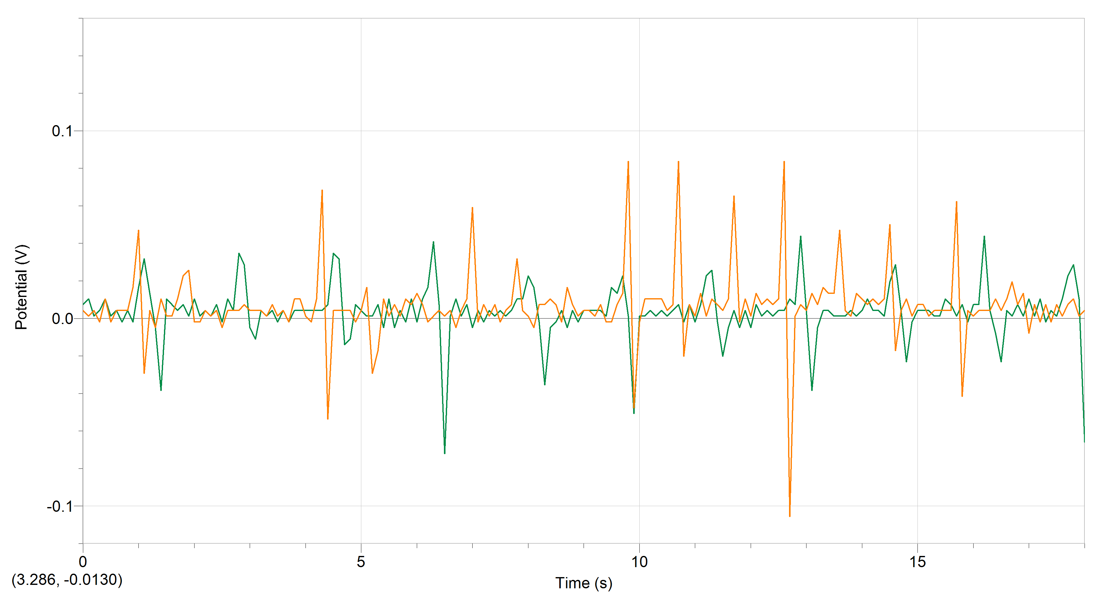

**Figure 6-1.** The voltage fluctuations observed after passing the North side of the bar magnet into the solenoid cavity at two different rates.

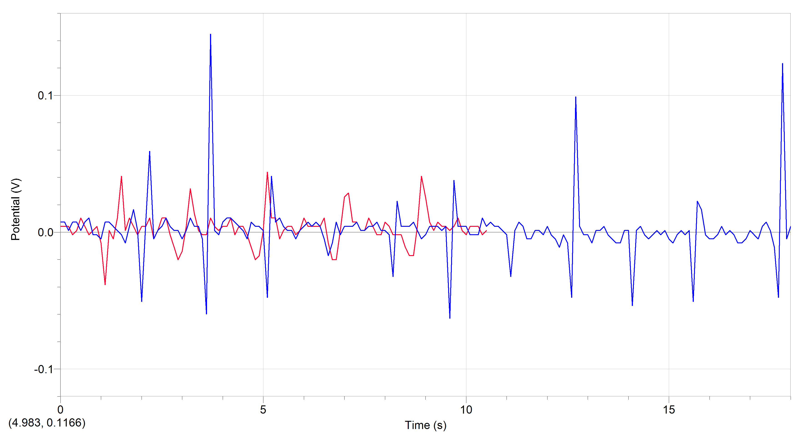

**Figure 6-2.** The voltage fluctuations observed after passing the South side of the bar magnet into the solenoid cavity at two different rates.

**Procedure B**

Shown below are the results of the second procedure of the experiment, where a sinusoidally variant AC current was introduced into a large solenoid with the smaller solenoid placed inside of its cavity at three angles.

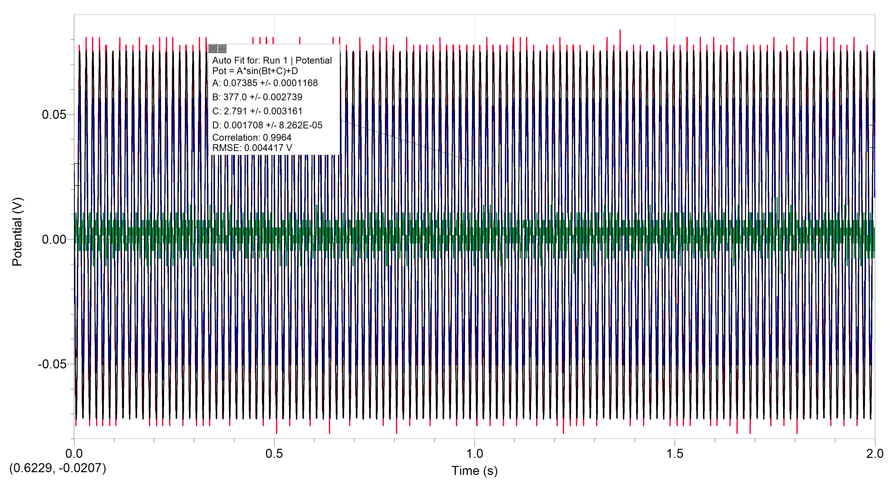

**Figure 6-3.** The voltage fluctuations observed on the small solenoid after introducing a sinusoidally varying AC current into the larger coil. Here are presented the measurements of all three runs and the estimated sine fit for the first run.

|  |  |  |  |  |  |  |
| --- | --- | --- | --- | --- | --- | --- |
| Parameters and Independent Measurements | | | | | | |
| N | Np | R [m] | f [Hz] | irms [A] | Area [m2] | ɛmeasured [V] |
| 200 | 200 | 0.105 | 60 | 0.671 | 0.000754 | 0.07385 |

**Table 6-1.** The tuned and intrinsic constant values assigned to the tools involved, and the resulting induced voltage that was observed.

**Analysis**

**Procedure A**

Figures 6-1 and 6-2 show how the measurable voltage within the small solenoid changed as the position of the bar magnet relative to the solenoid fluctuated. As the bar magnet approached and entered the solenoid cavity, the magnitude of the voltage at that point in time would change sharply in a direction dependent on the side of the bar magnet in effect. When using the north end, induced voltage would sharply increase on approach then sharply decrease, to even below the resting value ~0, on retraction. The opposite patten was observed when approaching with the south side of the magnet.

**Procedure B**

Figure 6-3 and Table 6-1 show how a passing alternating current with a magnitude fluctuating in the manner of a sine-wave period resulted in a measurable induced voltage on the small solenoid. To obtain a standard against which to compare those results, the following can be applied:

$\left|ɛ\right|=NN_{p}\left(2πf\right)\frac{μ_{0}i_{max}}{2R}$ Eq. 7-2

Using which, an expected value for induced voltage can be obtained.

|  |  |  |  |  |
| --- | --- | --- | --- | --- |
| Dependent Measurements and Derivations | | | | |
| imax [A] | ɛexperimental [V] | Percent Error | B [T] | fDerived [Hz] |
| 0.9489 | 0.064531286 | 12.62% | 377 | 60.00141355 |

**Table 6-2.** The values derived from calculations involving a combination of the values in Table 6-1 as well as quantities measured whose value is also dependent on those values.

**Conclusions**

In procedure A, the fluctuations that manifested from the interactions between the bar magnet and the solenoid formed in the way they were expected to for both sides of the bar magnet. Likewise, when looking at the results of procedure B, the induced voltage observed on the smaller solenoid matches relatively closely the expectations that were set upon that value, with only a margin difference of 12.62%. Neither of these procedures were perfect, however, but there is some blame that can be laid on interfering forces or unfortunate realities. In procedure A, the peaks and valleys of the induced voltage are much cleaner and more distinct for the runs involving a slower oscillation of the bar magnet. This is because once we started attempting to oscillate the bar magnet at faster rates, we were more often making motor errors, such as inserting the bar magnet to an inconsistent dept or missing the solenoid cavity on entry and consequently banging the bar magnet against the solenoid. In procedure B, some possible sources of the margin of error was the lack of magnetic isolation from other experiments, devices active in the room, and the Earth’s intrinsic magnetic field. Additionally, the placement of the smaller solenoid was not perfectly aligned with the primary solenoid’s magnetic field due to being “eyeballed.” Additionally, no consideration was given more any induced current passing through the banana cables between the inner solenoid and the voltmeter, which would surely generate its own small magnetic field. Through all of this the realized error margin remained fairly low, and we were mostly able to produce the figure and data artifacts as expected, ultimately in support of the tested theory.