**ENGR 121 Homework 2**

**NOTE:** Use engineering format for problems 1 and 2, and use non-engineering format discussed for problems 3 through 6. This is an individual assignment. You must complete the assignment on your own, although you may discuss the problems with other class members (but no copying of work).

1. A two-gallon (0.00757m3) tub contains water at 43℃. If you insert a fishtank heater that draws 1.3A of electric current at 12V, then how long will it take for the heater to increase the water temperature to 46℃ ? Assume no heat loss or gain through the wall of the tub or at the surface of the water. t=1.69hrs

**Given: Vol=0.00757m^3, T=43, T2=46, V=12, I=1.3A, C=4180j/kg*C, p=1000kg/m^3**

**Request: t**

**Solution: t=(p*vol*C*T)/(VI)**

**=(1000 kg/m­3 * 0.00757 m3 * 4180 * 3 C) / (12 V * 1.3 A) = 6085.11538 sec**

**= 1.690309 hrs**

1. A fishtank is 1.8 inches in diameter and contains water 2.5 inches deep. If you heat the water using a 20Ω resistor and a 12V power supply, then how long will it take to heat the water up by 3℃? t=3.03min

**Given: d=1.8*0.0254m, h=2.5*0.0254m, R=20Ω, V=12V, T=3, C=4180**

**Request: t**

**Solution: Vol=pi * r^2 * h, I=V/R**

**t=(p * pi * r^2 * h *C*T)/(VI)**

**=(1000*3.14*(1.8*0.0254)*2.5*0.0254*4180*3)/((12/20)*12)**

**=181.4766s=3.03min**

|  |
| --- |
| ***Note:*** *Include ALL units in calculations. Use consistent SI units! For example, you should use …*     * *kilograms (kg) for mass* ***First Law of Thermodynamics*** * *meters (m) for length For a system with water being heatetd by a heater:* * *volts (V) for voltage*  0 * *amps (A) for current* ∆𝐸𝐸 = 𝑄𝑄 − 𝑊𝑊 * *seconds (s) for time* 𝜌𝜌 ∙ 𝑉𝑉𝑉𝑉𝑉𝑉 ∙ 𝐶𝐶𝑝𝑝 ∙ ∆𝑇𝑇 = 𝑉𝑉 ∙ 𝐼𝐼 ∙ 𝑡𝑡     *Remember:*  Density of water (ρ) = 1000kg/m3  0.001 m3 = 0.264 gal Cpwater = 4180 J/(kg·ᵒC) |

1. Fill in the table below.

|  |  |  |  |
| --- | --- | --- | --- |
| **data type** | **# of bits** | **range** | **example of how you would use the data type** |
| boolean | 8 | True or false | True ≠ 0 and False = 0 |
| byte | 8 | 0 to 255 | An unsigned 8 bit number (28=256) |
| int | 16 | -32,768 to 32,767 | Whole number, signed (+ or -), most common data type |
| long | 32 | -2,147,483,648 to 2,147,483,647 | Frequently used data type, number with many digits, signed |
| float | 32 | -3.4028235x1038 to 3.4028235x1038 | Includes decimal point, total precision is 6 to 7 digits |
| char | 8 | One 8-bit ASCII character | Alphanumeric characters, multiple characters called strings |

1. Research the acronym ASCII. What is the purpose of the ASCII code? **The purpose is to exchange information by reading numbers to show them as characters.**

1. Write a sketch to use your thermistor to collect 200 temperature data points using a for-loop. Move your temperature sensor around to try to make the values change as data is collected. Include screenshots of your sketch and your serial monitor with your homework.
   * Things to print in the for-loop (print the things below on one line for each iteration):
     + The iteration number (the value of the counter each time through the loop). o The analog version of the temperature collected for the current iteration (this should be an integer stored in an “int” variable).
     + The temperature in ᵒC for the analog value above (this should be a floating point number stored in a “float” variable).
     + The current minimum value of temperature in ᵒC (this number will probably get smaller as the 200 data points are collected).
     + The current maximum value of temperature in ᵒC (this number will probably get larger as the 200 data points are collected).
   * Things to print after the for-loop is completed:
     + The final minimum value (that is, the absolute minimum temperature in ᵒC for the 200 data points collected).
     + The final maximum value (that is, the absolute maximum temperature in ᵒC for the 200 data points collected).
     + The average value of tem
     + perature in ᵒC with the maximum and minimum values removed from the computation (this is computed after the for-loop is completed). You can use the following equation:

199

𝑇𝑇𝑎𝑎𝑎𝑎𝑎𝑎 = 𝑇𝑇𝑖𝑖−𝑇𝑇𝑚𝑚𝑖𝑖𝑚𝑚 −𝑇𝑇𝑚𝑚𝑎𝑎𝑚𝑚 / 198

𝑖𝑖=0

or …

𝑇𝑇0 + 𝑇𝑇1 + 𝑇𝑇2 + 𝑇𝑇3+ . . . +𝑇𝑇199 −𝑇𝑇𝑚𝑚𝑖𝑖𝑚𝑚 −𝑇𝑇𝑚𝑚𝑎𝑎𝑚𝑚

𝑇𝑇𝑎𝑎𝑎𝑎𝑎𝑎 =

198

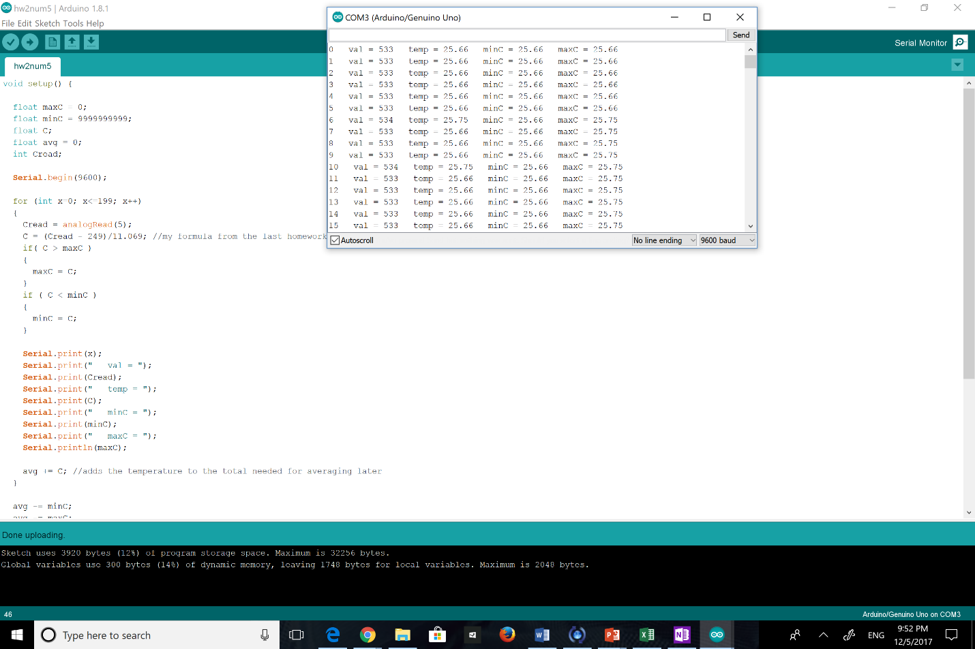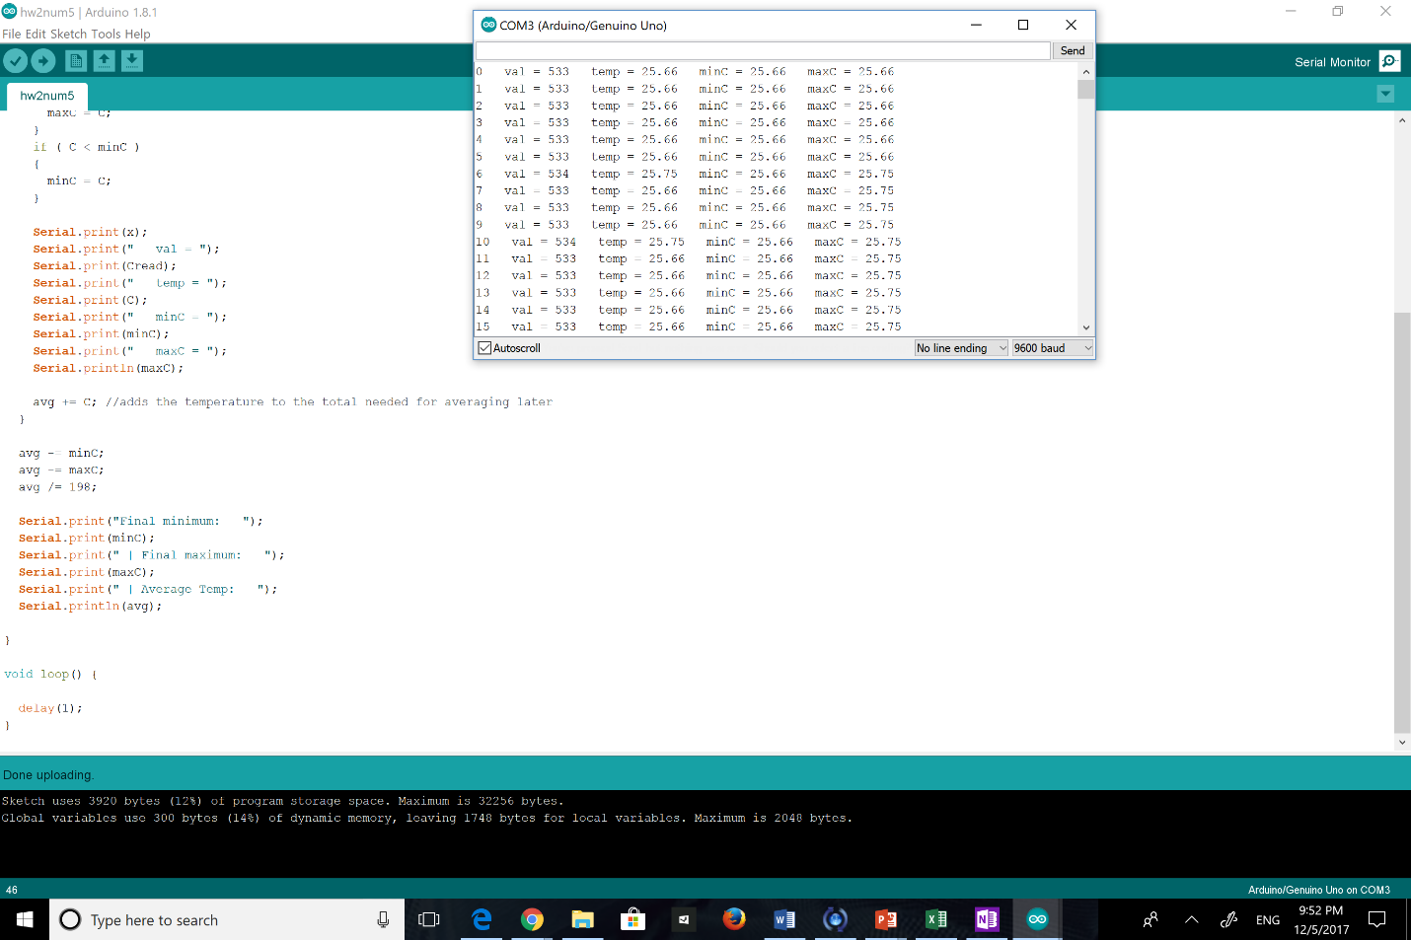

1. Using the data collected in question 5, create an Excel spreadsheet to check your values. Format the spreadsheet properly using column headings, units and other formatting elements (such as borders and shading) to improve the appearance. Print out a copy of the spreadsheet to include in your homework.

**Importing Data Tip:** Follow this procedure to help you import and organize the data from your Serial Monitor in Excel.

* 1. Copy data (Ctrl + C)

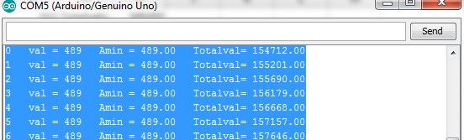

* 1. Paste the data into Excel (Ctrl + V)
  2. If the contents of each row are in one cell and not broken up into individual cells, you can split the data into different columns using Text to Columns in the Data tab

d.

Highlight the column that contains the data. Click Text to Column which will open a window.

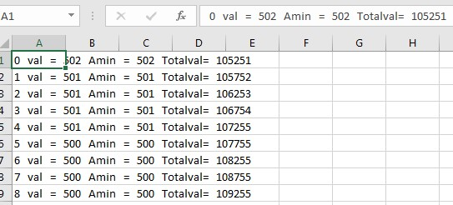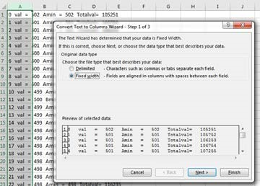

1. Check the Delimited box, then press Next.
2. Choose all Delimiter options that you would like to be used to separate data. You may also want to set some of your own by checking other and typing in a character (e.g., =).

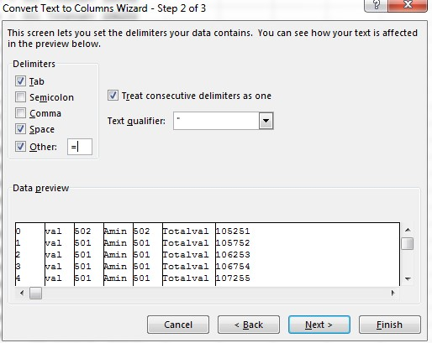

1. Click Next for a preview, if the data is separated in your desired manner, click Finish.

**Printing Tip:** If the data spans multiple pages, you can scale the document when you print.

**Print**→**Settings**→**Fit All Rows on One Page** (click on the “No Scaling” drop-down menu to see the “All Rows on One Page” option).