**ENGR 121 Homework 4**

**NOTE:** Use engineering format for problems 1 through 3, and use non-engineering format for problems 4-5. This is an individual assignment.

1. A 20-ohm resistor is used to heat the water in a container with a 2-inch internal diameter. If a 12VDC voltage adapter powers the heater and the water in your fishtank is 3 inches deep, then what change in temperature will the system experience if the heater runs for 2.5 minutes? ∆𝑇𝑇 = 1.67℃

**Given: R=20, d=2*0.0254m, V=12, h=3*0.0254m, t=2.5*60s, C=4180, p=1000**

**Request: T**

**Solution: T=VIt/ p*vol*C**

**=(12*12/20*2.5*60)/(3.14*((2*0.0254)/2)^2*3*0.0254*1000*4180)**

**=1.67C**

1. A cup that contains 5 ounces of water absorbs 1080J of energy from a heater. If the initial temperature of the

water was 20°C, what is the final temperature of the water? 𝑇𝑇2 = 21.8℃

**Given: Ti=20, vol=0.00014787m^3, C=4180, E=1080**

**Request: Tf**

**Solution: p*vol*C*(Tf-Ti)=E**

**Tf=(E/(p*vol*C))+Ti**

**=(1080/(1000*0.00014787*4180))+20**

**=21.8C**

1. The temperature of a 4-kg sample of an unknown material increases by 20°C when it absorbs 4,500J of energy.

What is the specific heat of the material?𝐶𝐶𝑝𝑝 = 56.25 𝑘𝑘𝑘𝑘∙℃𝐽𝐽

**Given: m=4kg, T=20,, E=4500**

**Request:C**

**Solution: C=E/kgc**

**=4500/(4*20)**

**=56.25 j/kgc**

1. Build a thermistor circuit, a transistor and red LED circuit, and a transistor and green LED circuit. You will use the output of the thermistor circuit to make the green LED blink when the temperature is above the setpoint and the red LED to blink when the temperature is below the setpoint.

* 1. Draw a flowchart using the appropriate flowchart symbols shown below to outline a sketch that performs the following functions:
     + Uses room temperature (the analog version) as the setpoint
     + Prints the setpoint only once; please print the analog value and the degrees Celsius value
     + Continuously reads analog values of temperature from the thermistor circuit
     + Prints the analog values on the serial monitor
     + Converts the analog values to values in degrees Celsius
     + Prints the values in degrees Celsius
     + Checks to see if the analog value is above the setpoint value
     + Checks to see the analog value if below the setpoint value
     + If the analog value is above the setpoint, the transistor causes the green LED to blink in a pattern of your choosing; please print a notification that the temperature is above the setpoint
     + If the analog value is below the setpoint, the transistor causes the red LED to blink in a pattern of your choosing; please print a notification that the temperature is below the setpoint

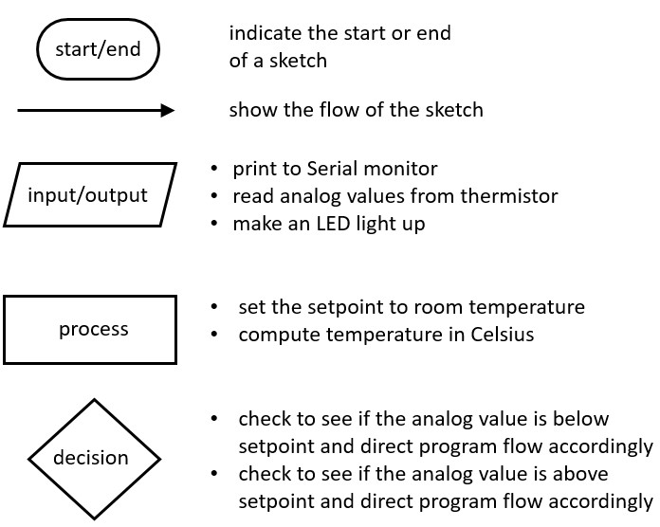

* 1. Write a sketch that performs the functions above. Include a screen shot of your sketch and your serial monitor output with your homework. Please bring your system to class ready to show your instructor.

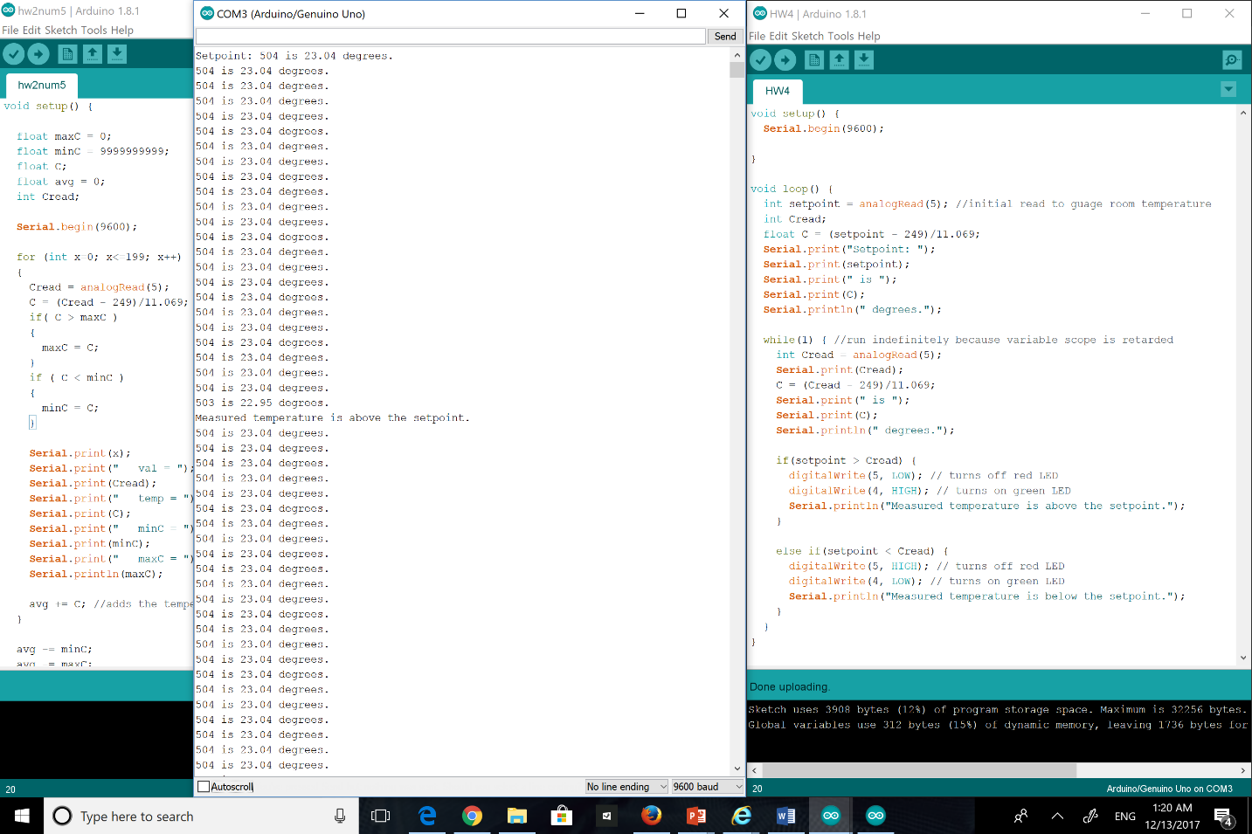

1. Create SolidWorks drawings and hand sketches of the fishtank reservoir parts; example hand sketches are provided below for the fishtank reservoir and for a barbed fitting. Turn in two screen shots of your SolidWorks drawing(s), one at an intermediate stage (unassembled) and one of the final reservoir (fully assembled). You may want to draw the pipe segment and the cap as one part, and then draw the barbed fitting as a second part. Turn in your hand sketch along with your SolidWorks.

Tip: Look at the ENGR 120 downloads page for a presentation in class 13 on how to a draw barbed fitting.

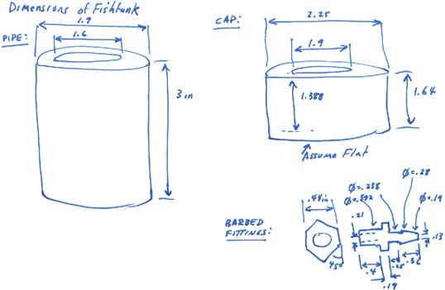

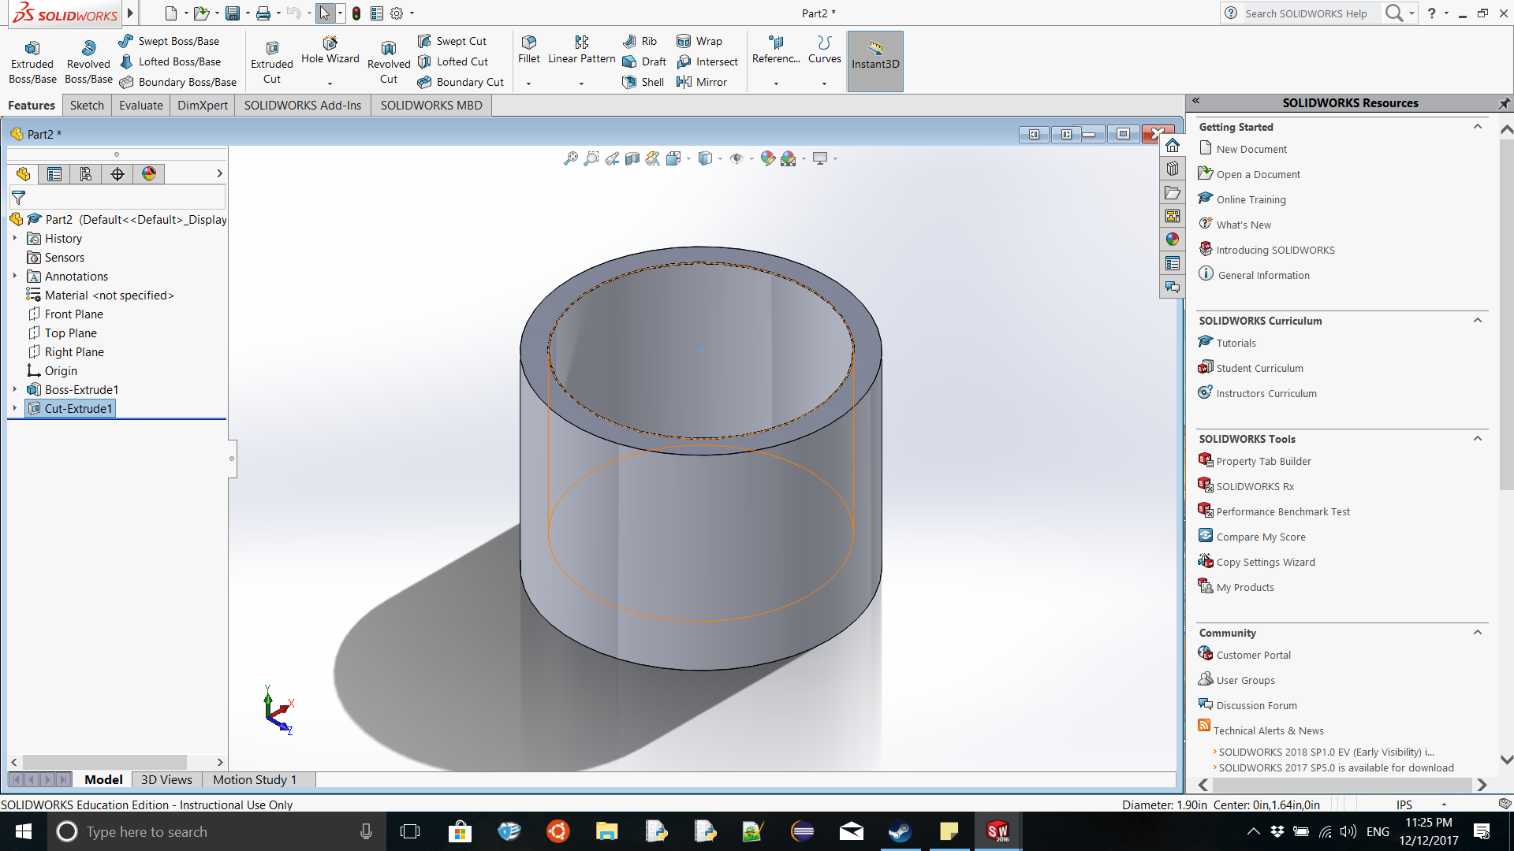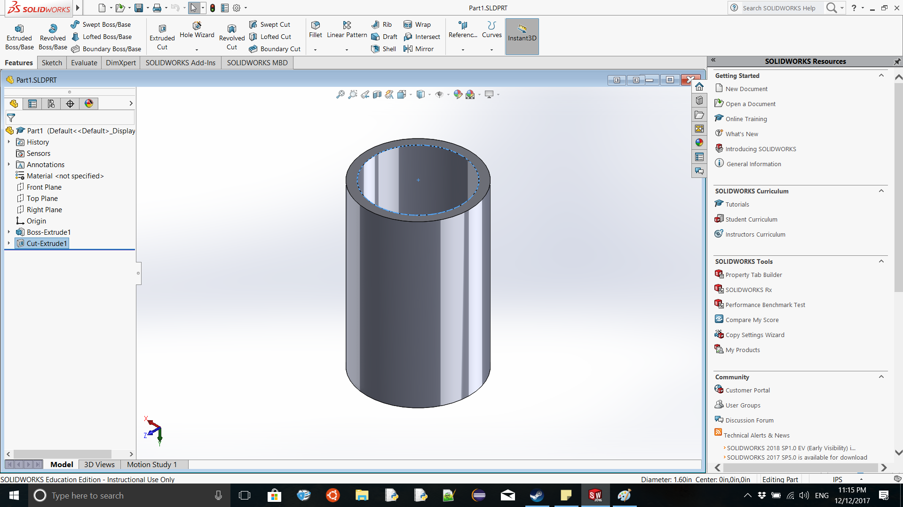

*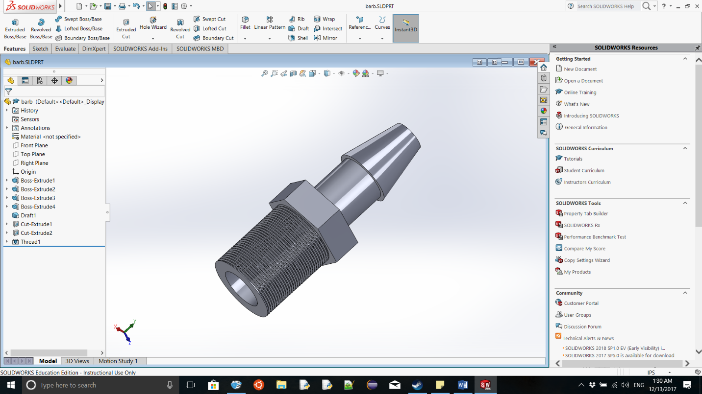Note: Be sure to save your SolidWorks files. You will need to use them for the final SolidWorks assembly due with Homework 7.*

1. **(Due Class 9)** Over the next few homework assignments you will be asked to draw various parts of your fishtank system. The SolidWorks assignments will culminate in HW 8 by combining all the parts listed below into one assembly. Save all SolidWorks drawings/assemblies of the individual components, and turn them in again with the final assembly.

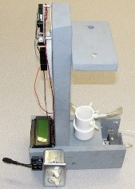*Parts to be created:*

* + the fishtank reservoir with three fittings (inlet, outlet, overflow)
  + the conductivity sensor with fittings (you don’t have to draw the wires, terminals or tubing)
  + the wooden platform assembly
  + the 3-way valve
  + the LCD screen (rough detail of shape is good enough, but use correct measurements)
  + the Arduino (rough detail of shape is good enough, but use correct measurements)
  + 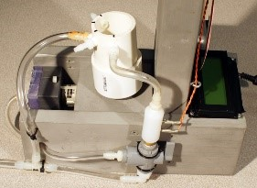the pump (it’s OK to use your pump assembly from ENGR 120)

*Final Assembly:* Turn in the SolidWorks assembly of the fishtank system using all of the components listed above. Please show your fishtank from at least two points of view.