**Production Process**

1. Evaluation of the previous line [of clothes] – did people like our last line of clothes?
2. Change in Consumer Demand – what do people want now?
3. Trend Analysis – Kind of the same thing as the last one

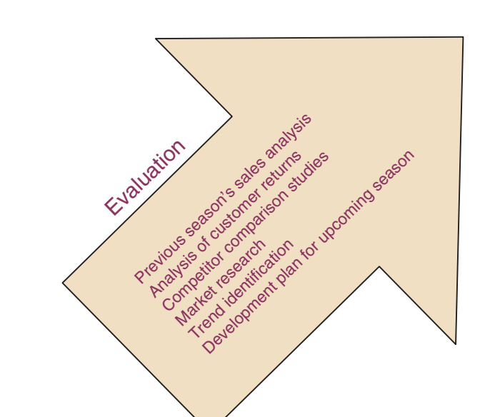

1. Design Concept – Just coming up with a design

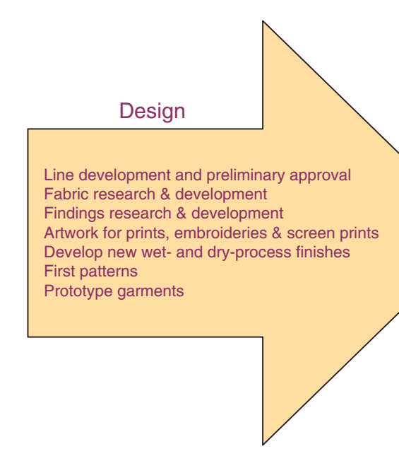

1. Technical Design – Taking the design and figuring out what is needed to make it

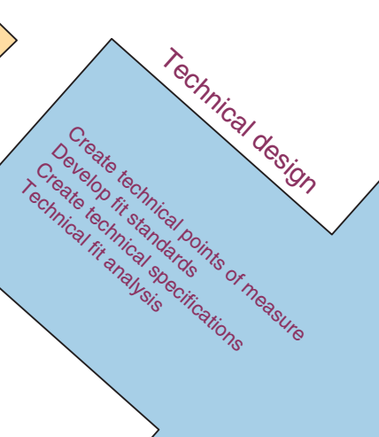

1. Sourcing, including costing – Figuring where the clothes should be made and what materials to use, etc.

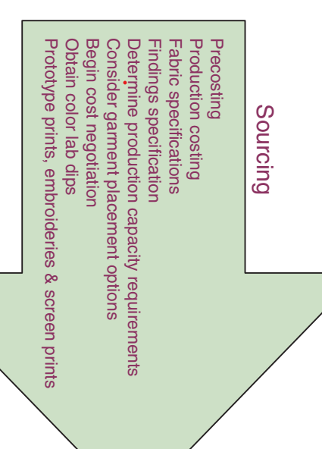

1. Preproduction

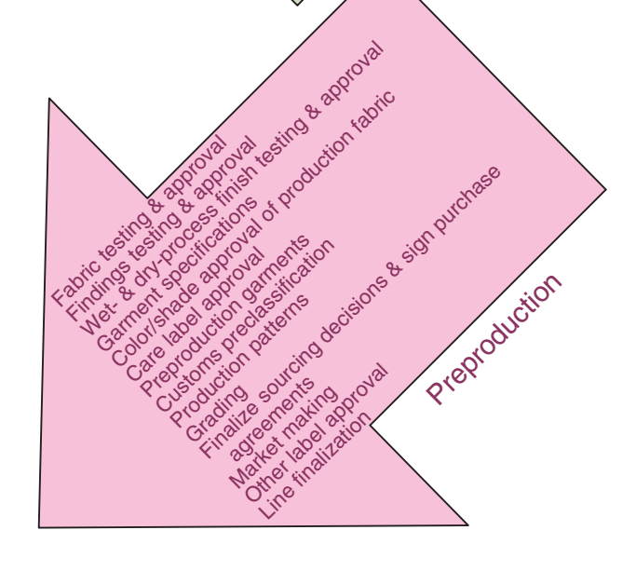

1. Production – Making the clothes

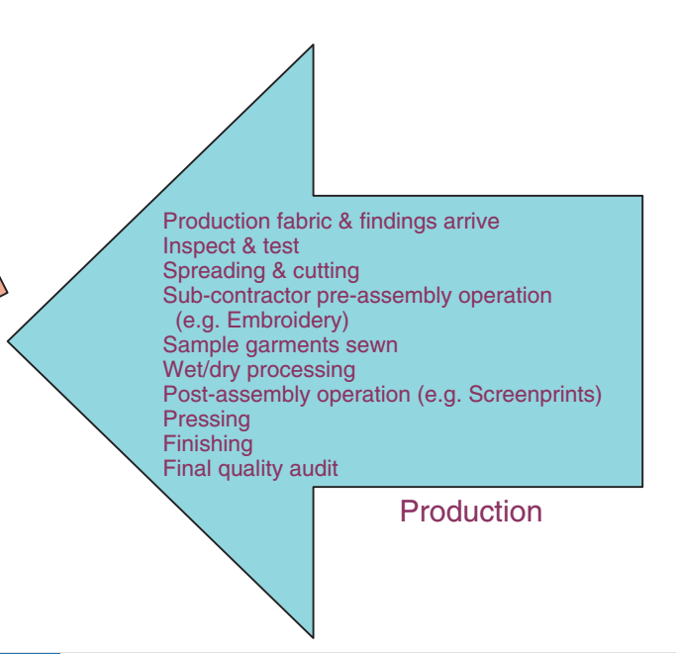

1. Distribution – Moving the clothes to retail stores to be sold

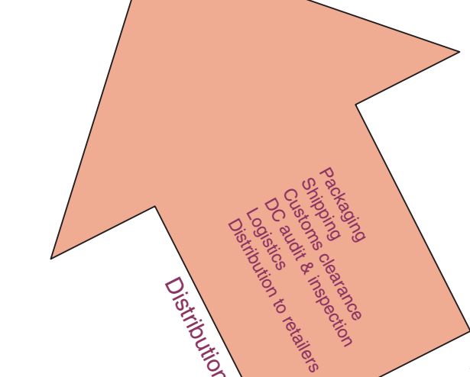

1. Promotion and Sales – Advertising and selling clothes

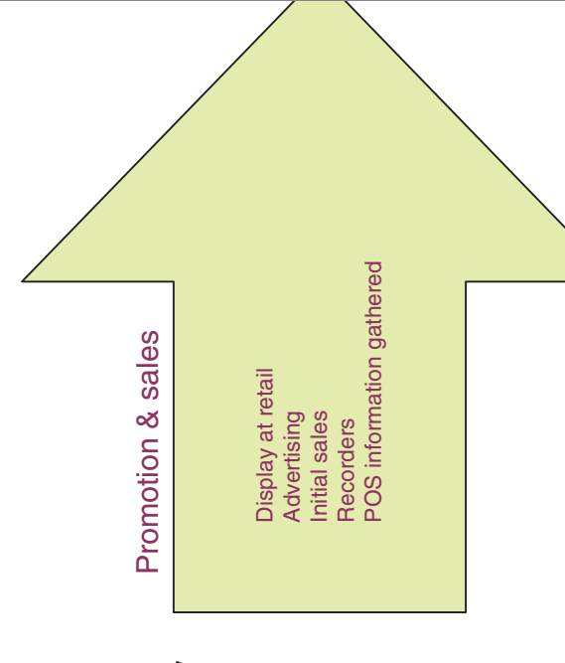

**Types of Garment Costing**

* Pre-Costing – early quick estimate of final cost
* Production Costing – Calculated cost after establishing sourcing and labor
* Final Costing – Calculated cost when including shipping and tax costs, production delays, or sales mark-downs

**Types of Fitting Devices**

* **Darts**

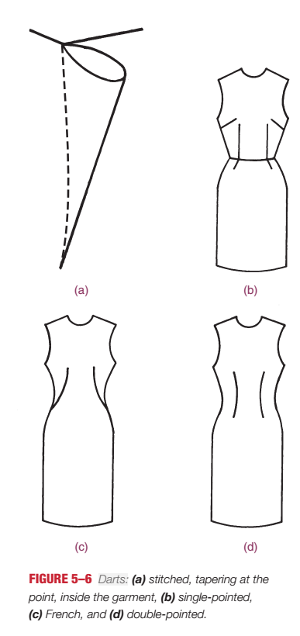

* **Pleats:** Pleats are pieces of the fabric folded to give structure and give decoration, but nt all pleats have to give structure

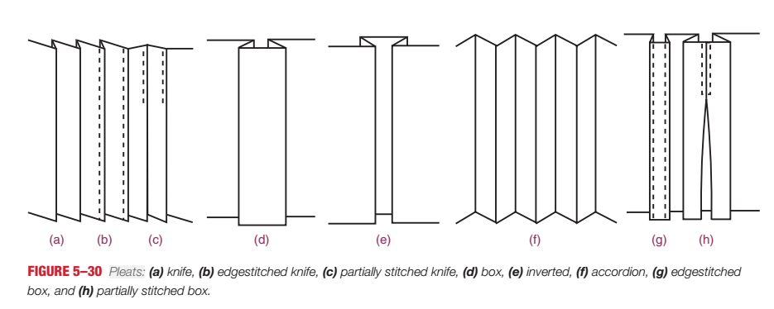

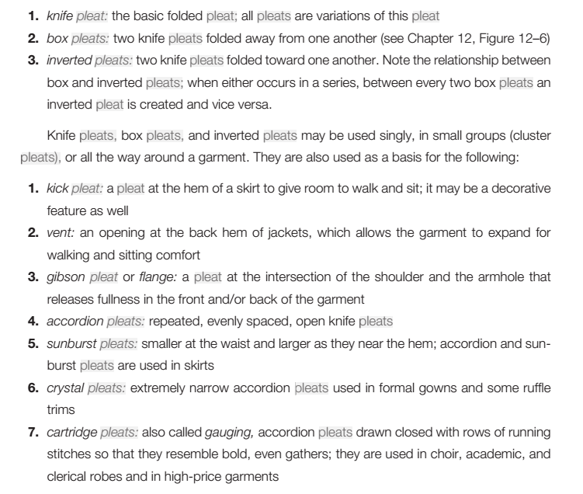

* **Tucks:** Extra fabric stitched on, mostly for look

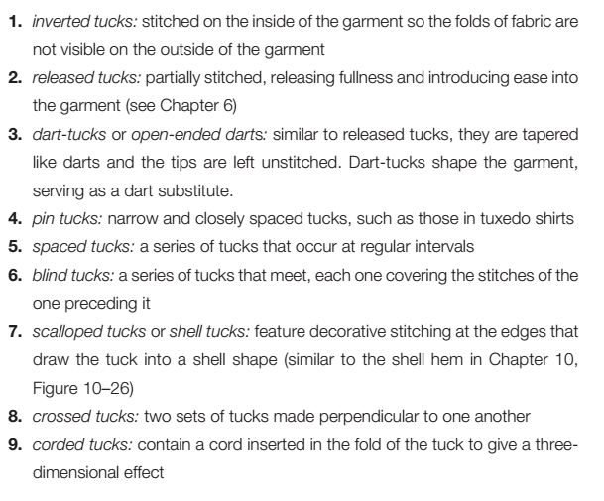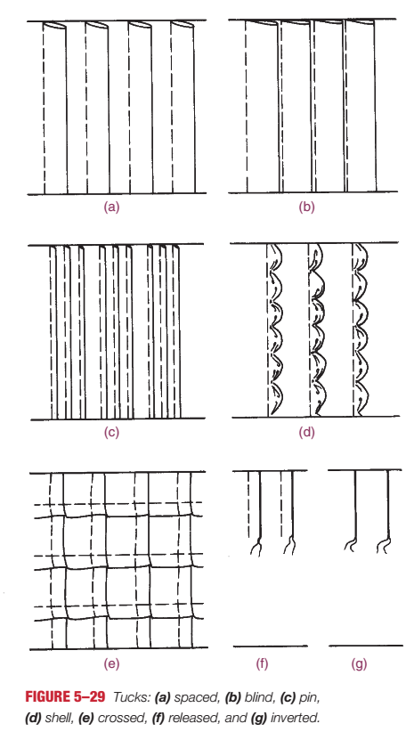

* **Gathers**

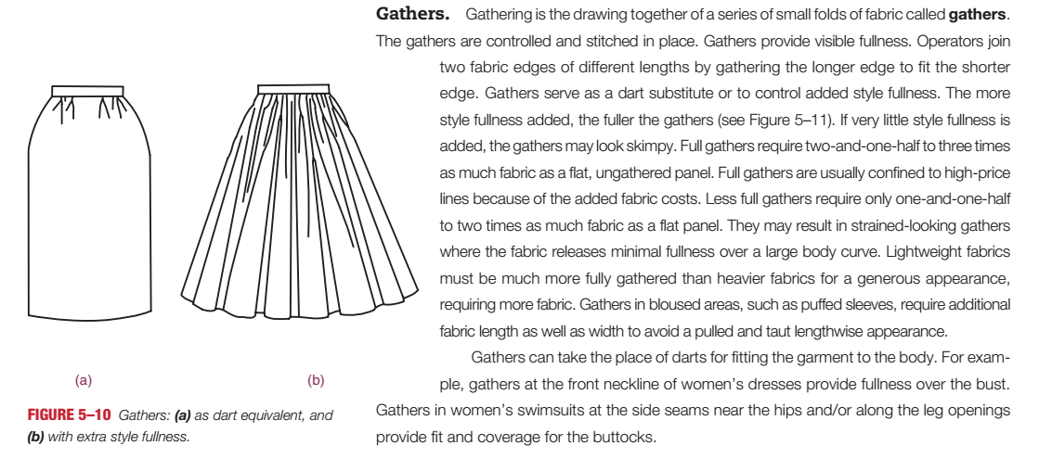

* **Seams:** Two panels of fabric stitched together, creating a visible line
* **Released Fullness:** This is just a visual effect of the other techniques. Released fullness means the garment fits to the curves of the body.

**Major Components of a Garment**

* Collars
  + Flat
  + Standing
  + Rolled
  + Partial Rolled
* Sleeves
  + Closed-band cuff
  + Open-band cuff
  + Hemmed Sleeve
  + 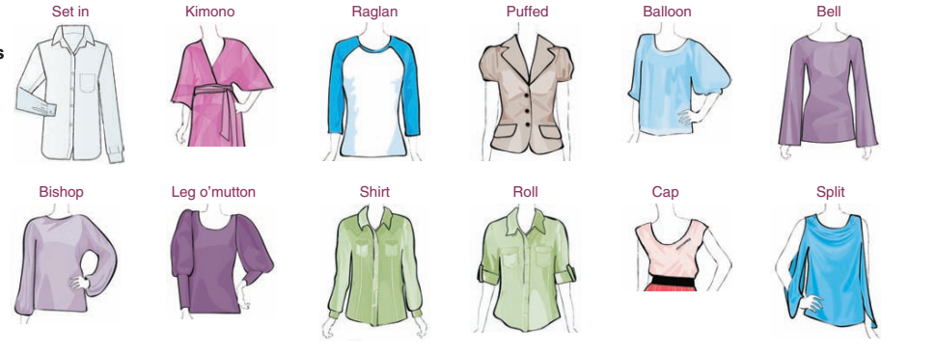
  + 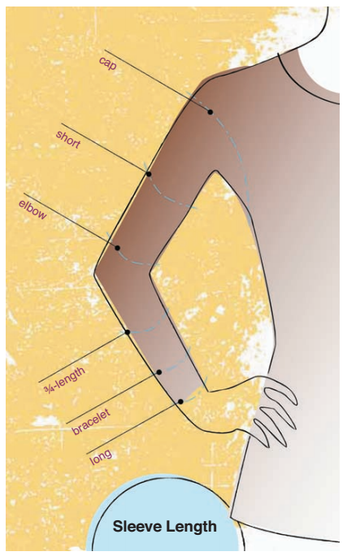
* Waistlines
  + Faced
  + Elastic
  + Normal
  + 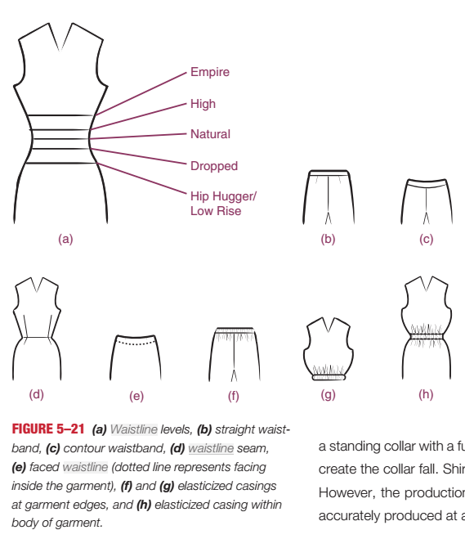
* Linings
  + Fabric sown around the inside to give the full shape of the garment.
  + 
  + 
* Pockets

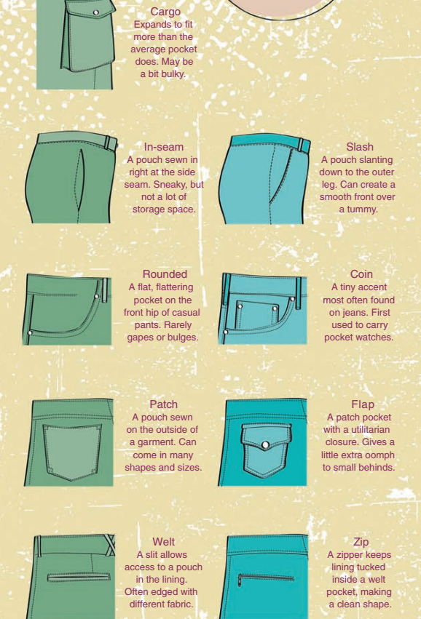

* Fasteners

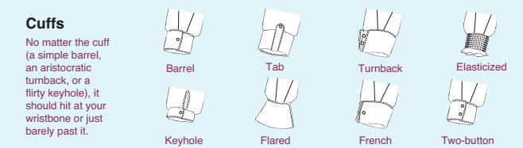

**Different Garment Styles**

Study the handout

**Buttons and Zippers**

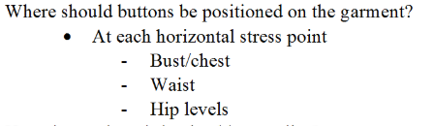

Ya nunu, one of your homeworks had something about zippers in it I think. Find that one, I couldn’t find it.

**Inside Shop vs Outside Shop**

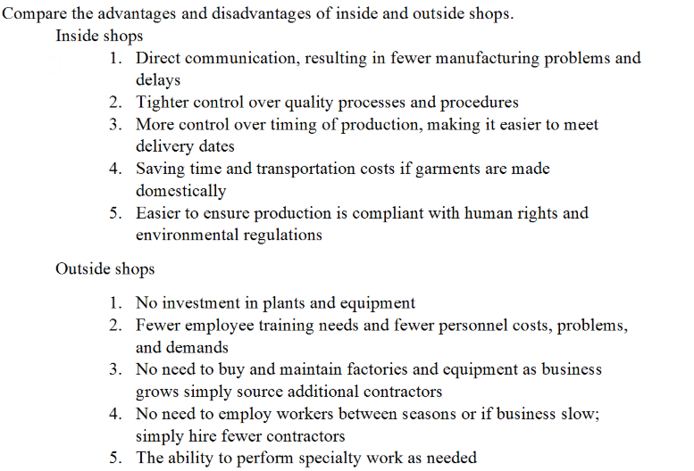

**How are production cost for sewing a garment determined**

* Cost of sourcing materials
* Cost of labor
* Cost of overhead (heating, lighting)
* Maybe more?

**Remember Human rights issues**

I think you have a good idea what human rights issues are involved. You have a strong justice.

**Affects of CIM/CAD/CAM/DP on the manufacturing industry**

They have made manufacturing easier due to being able to identify issues and errors in the design phase using a computer.