Concrete/Corrosion Lab

1. Using the data file provided for each 6-inch diameter cylinder, plot a stress versus strain curve with Excel.
2. Calculate the ***actual*** secant modulus of elasticity, E, for each curve using the secant definition discussed above at 40% of σucs.

As calculated in class, E = 4972457

1. Calculate the ***estimate*** of the secant modulus, Eest, using the formula above.

Given:

Density = 150 lb/ft3

Max Load = 131322.22 lb

Diameter = 6”

Then:

Cross Sectional Area = π * (6” /2)2 = 28.27 in2

σucs = 131322.22 lb / 28.27 in2 = 4644.57 lb/in2

Eest = 33 * (150 lb/ft3)(3/2) * (4644.57 lb/in2)(1/2) = 4131652

1. For each concrete sample, compare your result from the actual secant modulus calculation in step 2 with your calculation of the estimate of secant modulus in step 3. Does your actual value agree with the estimated value? What reasons can you give that may explain the differences?

The two values vary only by a factor of 20.35 %.

These two values agree a little bit, and yet it is common for this kind of discrepancy to appear. The machinery does not give perfect readings, so when we try to evaluate the same value two different ways using two different parts of the same data, chances are they will differ, because the conditions under which the testing machine were reading were different. The machine may have an optimal range somewhere along the curve or something similar.

1. There are several possible shapes for the failure, as shown in the figures below from **ASTM C 39**. Which type of failure did you observe on this sample?

**Types of concrete fracture shapes (from ASTM C 39)**

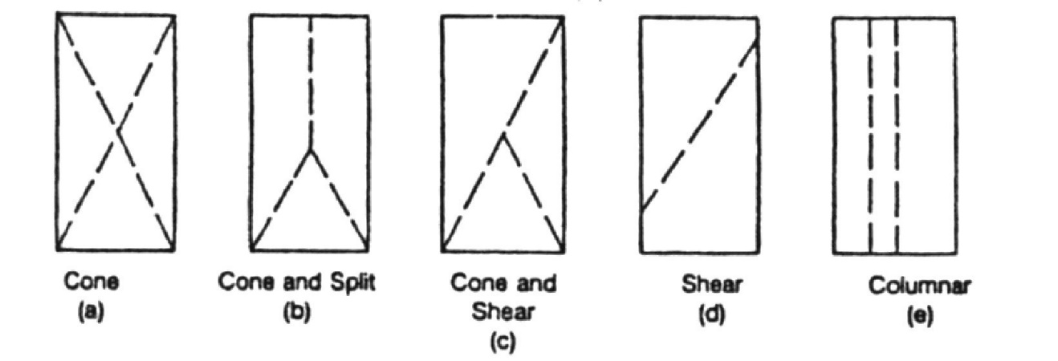

The sample experienced shear fracture.