Information Retrieval Beyond the Text Document

Yong Rui, Michael Ortega, Thomas S. Huang  
Beckman Institute for Advanced Science and Technology  
University of Illinois at Urbana-Champaign  
Urbana, IL 61801, USA  
E-mail:{yrui, ortega-b, huang}@ifp.uiuc.edu,

Sharad Mehrotra  
Department of Information and Computer Science  
University of California, Irvine  
Irvine, CA, 92697-3425  
E-mail: sharad@ics.uci.edu

**Abstract**

With the expansion of the Internet, searching for information goes beyond the boundary of physical libraries. Millions of documents of various media types, such as text, image, video, audio, graphics, and animation, are available around the world and linked by the Internet.

Unfortunately, the state of the art of search engines for media types other than text lags far behind their text counterparts. To address this situation, we have developed the Multimedia Analysis and Retrieval System (MARS). This paper reports some of the progress made over the years towards exploring Information Retrieval beyond the text domain. In particular, the following aspects of MARS are addressed in the paper: visual feature extraction, retrieval models, query reformulation techniques, efficient execution speed performance and user interface considerations. Extensive experimental results are reported to validate the proposed approaches.

# Introduction

Huge amounts of digital data are being generated every day. Scanners convert the analog/physical data into digital form; digital cameras and camcorders directly generate digital data at the production phase. Owing to all these multimedia devices, nowadays information is in all media types, including graphics, images, audio, and video, in addition to the conventional text media type. Not only is multimedia information being generated at an ever increasing rate, it is transmitted all over the world due to the expansion of the Internet. Experts say that the Internet is the largest library that ever existed, it is however also the most disorganized library ever.

Textual document retrieval has achieved considerable progress over the past two decades. Unfortunately, the state of the art of search engines for media types other than text lags far behind their text counterparts. Textual indexing of non-textual media, although common practice, has some limitations. The most notable limitations include the human effort required and the difficulty of describing accurately certain properties humans take for granted while having access to the media. Consider how human indexers would describe the ripples on an ocean; these could be very different under situations such as calm weather or a hurricane. To address this situation, we undertook the Multimedia Analysis and Retrieval System (MARS) project to provide retrieval capabilities to rich multimedia data. Research in MARS addresses several levels including the multimedia features extracted, the retrieval models used, query reformulation techniques, efficient execution speed performance and user interface considerations.

This paper reports some of the progress made over the years towards exploring Information Retrieval (IR) beyond the text domain. In particular, this paper will concentrate on Visual Information Retrieval (VIR) concepts as opposed to implementation issues. MARS explores many different visual feature representations. A review of these features appears in Section 2. These visual features are analogous to keyword features in textual media. Section 3 describes two broad retrieval models we have explored: the Boolean and vector models and the incorporated enhancements to support visual media retrieval such as relevance feedback. Experimental results are given in Section 4. Concluding remarks are discussed in Section 5.

# Visual Feature Extraction

The retrieval performance of any IR system is fundamentally limited by the quality of the “features” and the retrieval model it supports. This section sketches the features obtained from visual media. In text-based retrieval systems, features can be keywords, phrases or structural elements. There are many techniques for reliably extracting, for example, keywords from text documents. The *visual counterparts* to textual features in visual based systems are visual features such as color, texture, and shape.

For each feature there are several different techniques for representation. The reason for this is twofold: a) the field is still under development; and b) more importantly, features are perceived differently by different people and thus different representations cater to different preferences. Image features are generally considered as orthogonal to each other. The idea is that a feature will capture some dimension of the content of the image, and different features will effectively capture different aspects of the image content. In this way two images closely related in one feature could be very different in another feature. A simple example of this are two images, one of a deep blue sky and the other of a blue ocean. These two images could be very similar in terms of just color, however the ripples caused by waves in the ocean add a distinctive pattern that distinguishes the two images in terms of their texture. (Rui et al., 1999) gives a detailed description of the visual features and the following paragraphs emphasize the important ones.

The *Color* feature is one of the most widely used visual features in VIR. The Color feature captures the color content of images. It is relatively robust to background complication and independent of image size and orientation. Some representative studies of color perception and color spaces can be found in (McCamy et al., 1976; Miyahara, 1988). In VIR, Color Histogram (Swain and Ballard, 1991), Color Moments (Stricker and Orengo, 1995) and Color Sets (Smith and Chang, 1995) are the most used representations.

*Texture* refers to the visual patterns that have properties of homogeneity that do not result from the presence of only a single color or intensity. It is an innate property of virtually all surfaces, including clouds, trees, bricks, hair, fabric, etc. It contains important information about the structural arrangement of surfaces and their relationship to the surrounding environment (Haralick et al., 1973). Co-occurrence matrix (Haralick et al., 1973), Tamura texture (Tamura et al., 1978), and Wavelet texture (Kundu and Chen, 1992) are the most puopular texture representations.

In general, the *shape* representations can be divided into two categories, boundary-based and region-based. The former uses only the outer boundary of the shape while the latter uses the entire shape region (Rui et al., 1996). The most successful representatives for these two categories are Fourier Descriptor and Moment Invariants. Some recent work in shape representation and matching includes the Finite Element Method (FEM) (Pentland et al., 1996), Turning Function (Arkin et al., 1991), and Wavelet Descriptor (Chuang and Kuo, 1996).

# Retrieval Models used in MARS

With the large number of retrieval models proposed in the IR literature, MARS attempts to exploit this research for content-based retrieval over images. The retrieval model comprises the document or object model (here a collection of feature representations), a set of feature similarity measures, and a query model.

## The Object Model

We first need to formalize how an object is modeled (Rui et al., 1998b). We will use images as an example, even though this model can be used for other media types as well. An image object *O* is represented as:

*O = O(D, F, R) (1)*

• *D* is the raw image data, e.g. a JPEG image.

• *F =* {*fi*} is a set of low-level visual features associated with the image object, such as color, texture, and shape.

• *R =* {*rij*} is a set of representations for a given feature *fi*, e.g. both color histogram and color moments are representations for the color feature (Swain and Ballard, 1991). Note that, each representation *rij* itself may be a vector consisting of multiple components, i.e.

*rij* = [*rij1, ... rijk, ... rijK*] (2)

where *K* is the length of the vector.

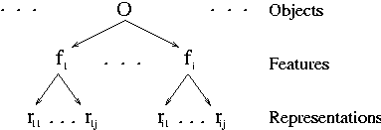

Figure 1: The Object Model

Figure 1 shows a graphic representation of the Object (Image) model. The proposed object model supports multiple representations to accommodate the rich content in the images. An image is thus represented as a collection of low-level image feature representations (Section 2) extracted automatically using computer vision methods, as well as a manual text description of the image.

Each feature representation is associated with some similarity measure (see section 2). All these similarity measures are normalized to lie within [0,1] to denote the degree to which two images are similar in regard to the same feature representation. A value of 1 means they are very similar and a value of 0 means they are very dissimilar. Revisiting our blue sky and ocean example from section 2, the sky and ocean images may have a similarity of 0.9 in the Color Histogram representation of Color and 0.2 in the Wavelet representation of Texture. Thus the two images are fairly similar in their color content, but very different in their texture content. This mapping *M=*{*<feature representationi, similarity measurei>, ...*} together with the Object model *O*, forms *(D, F, R, M)*, a foundation on which query models can be built.

## Query Models

Based on the *object model* and the *similarity measures* defined above, Query models that work with these raw features are built. These Query models together with the Object model form complete retrieval models used for VIR.

We explore two major models for querying. The first model is an adaptation of the Boolean retrieval model to visual retrieval in which selected features are used to build predicates used in a Boolean expression. The second model is a vector (weighted summation) model where all the features of the query object play a role in retrieval. Section 3.3 describes the Boolean model and Section 3.4 describes the vector model.

## Boolean Retrieval

A user may not only be interested in a single feature from a single image. It is very likely that the user may choose multiple features from multiple images. For example, using a point-and-click interface a user can specify a query to retrieve images similar to an image *A* in color and similar to an image *B* in texture. To cope with composite queries, Boolean retrieval model is used to interpret the query and retrieve a set of images ranked based on their similarity to the selected feature.

The basic Boolean retrieval model needs a pre-defined threshold, which has several potential problems [Ortega et al. 1998b]. To overcome these problems, we have adopted the following two extensions to the basic Boolean model to produce a ranked list of answers.

**Fuzzy Boolean Retrieval.** The similarity between the image and the query feature is interpreted as the degree of membership of the image to the fuzzy set of images that match the query feature. Fuzzy set theory is used to interpret the Boolean query and the images are ranked based on their degree of membership in the set.

**Probabilistic Boolean Retrieval.** The similarity between the image and the query feature is considered to be the probability that the image matches the user's information need. Feature independence is exploited to compute the probability of an image satisfying the query which is used to rank the images.

In the discussion below, we will use the following notation. Images in the collection are denoted by *I1*, *I2*, ... *Im*. Features over the images are denoted by *F1*, *F2*, ... *Fr*, where *Fi* denotes both the name of the feature as well as the domain of values that the feature can take. The *jth* instance of feature *Fi* corresponds to image *Ij* and is denoted by *fij*. For example, say *F1* is the color feature which is represented in the database using a histogram. In that case, *F1* is also used to denote the set of all the color histograms, and *f1,5* is the color histogram for image 5. Query variables are denoted by *v1*, *v2*, ... *vn* | *vk*  *Fi* so each *vk* refers to an instance of a feature *Fi* (an *fij*). Note that *Fi*(*Ij*)=*fij*. During query evaluation, each *vk* is used to rank images in the collection based on the feature domain of *fi* (*Fi*), that is *vk*'s domain. Thus, *vk* can be thought of being a list of images from the collection ranked based on the similarity of *vk* to all instances of *Fi*. For example, say *F2* is the set of all wavelet texture vectors in the collection, if *vk*=*f2,5*, then *vk* can be interpreted as being both, the wavelet texture vector corresponding to image 5 and the ranked list of all  with  being the similarity function that applies to two texture values.

A query *Q*(*v1, v2, ... vn*) is viewed as a query tree whose leaves correspond to single feature variable queries. Internal nodes of the tree correspond to the Boolean operators. Specifically, non-leaf nodes are of one of three forms: (*v1, v2, ... vn*), a conjunction of positive literals; (*v1*, *v2*, ... *vp*, ➢ *vp+1* ,... ➢ *vn*), a conjunction consisting of both positive and negative literals; and (*v1*, *v2*, ... *vn*), which is a disjunction of positive literals. The following is an example of a Boolean query: *Q*(*v1*, *v2*) = (*v1*=*f1,5*)  (*v2*=*f2,6*) is a query where *v1* has a value equal to the color histogram associated with image *I5* and *v2* has a value of the texture feature associated with *I6*. Thus, the query *Q* represents the desire to retrieve images whose color matches that of image *I5* *and* whose texture matches that of image *I6*. Figure 2 shows an example query *Q*(*v1*, *v2*, *v3*, *v4*)=((*v1*=*f1,4*)  (*v2*=*f2,8*))((*v3*=*f3,8*)  ➢ (*v4*=*f1,9*)) in its tree representation.

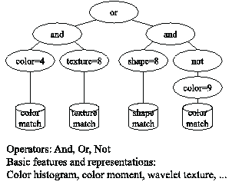

Figure 2 : Sample Query Tree

### Weighting in the query tree

In a query, one feature can receive more importance than another according to the user's perception. The user can assign the desired importance to any feature by a process known as *feature weighting*. Traditionally, retrieval systems (Flickner et al., 1995; Bach et al. 1996) use a linear scaling factor as feature weights. Under our Boolean model, this is not desirable. Fagin and Wimmers (1997) noted that such linear weights do not scale to arbitrary functions used to compute the combined similarity of an image. The reason is that the similarity computation for a node in a query tree may be based on operators other than a weighted summation of the similarity of the children. Fagin and Wimmers (1997) present a way to extend linear weighting to the different components for arbitrary scoring functions as long as they satisfy certain properties. We are unable to use their approach since their mapping does not preserve orthogonality properties on which our algorithms rely (Ortega et al. 1998b). Instead, we use a mapping function from [0,1]  [0,1] of the form

 (3)

which preserves the range boundaries [0,1] and boosts or degrades the similarity in a smooth way. Sample mappings are shown in Figure 3. This method preserves most of the properties explained in (Fagin and Wimmers, 1997), except it is undefined for a weight of 0. In (Fagin and Wimmers, 1997), a weight of 0 means the node can be dismissed. Here, lim*weight*0 *similarity'* = 0 for similarity  [0,1). A perfect similarity of 1 will remain at 1. This mapping is performed at each link connecting a child to a parent in the query tree.

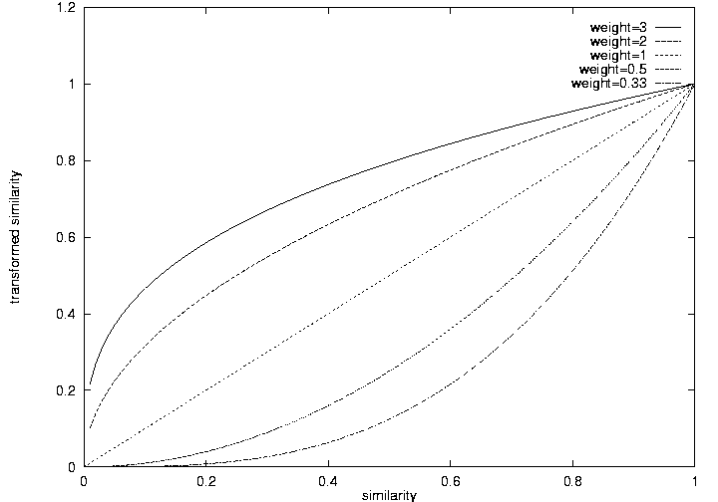

Figure 3 : Various samples for similarity mappings

Figure 4a) shows how the fuzzy model would work with our running example of blue sky and blue ocean images. Figure 4b) shows how the probabilistic model would work with our running example of blue sky and blue ocean images.

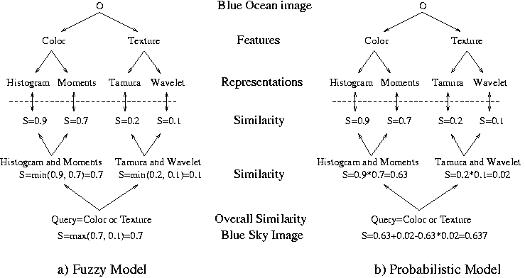

Figure 4 : Various samples for similarity mappings

### Computing Boolean Queries

Fagin (1996) proposed an algorithm to return the top *k* answers for queries with monotonic scoring functions that has been adopted by the Garlic multimedia information system under development at the IBM Almaden Research Center (Fagin and Wimmers, 1997). A function *F* is monotonic if *F*(*x1*, ... *xm*)  *F*(*x'1*, ... *x'm*) for *xi* *x'i* for every *i*. Note that the scoring functions for both conjunctive and disjunctive queries for both the fuzzy and probabilistic Boolean models satisfy the monotonicity property. This algorithm relies on reading a number of objects from each branch in the query tree until it has *k* objects in the intersection. Then it falls back on probing to enable a definite decision. In contrast, our algorithms (Ortega et al., 1998b) are tailored to specific functions that combine object scoring (here called fuzzy and probabilistic models).

Another approach to optimizing query processing over multimedia repositories has been proposed in (Chaudhari and Gravano, 1996). It presents a strategy to optimize queries when users specify thresholds on the grade of match of acceptable objects as filter conditions. It uses the results in (Fagin, 1996) to convert top-*k* queries to threshold queries and then process them as filter conditions. It shows that under certain conditions (uniquely graded repository), this approach is expected to access no more objects than the strategy in (Fagin, 1996). Furthermore, while the above approaches have mainly concentrated on the fuzzy Boolean model, we consider both the fuzzy and probabilistic models in MARS. This is significant since the experimental results illustrate that the probabilistic model outperforms the fuzzy model in terms of retrieval performance (discussed in section 4).

## Vector Model

An IR model consists of a document model, a query model, and a model for computing similarity between the documents and the queries. One of the most popular IR models is the vector model (Buckley and Salton, 1995; Salton and McGill, 1983; Shaw, 1995). Various effective retrieval techniques have been developed for this model. Among them, *term weighting* and *relevance feedback* are of fundamental importance.

Term weighting is a technique for assigning different weights for different keywords (terms) according to their relative importance to the document (Shaw, 1995; Salton and McGill, 1983). If we define *wik* to be the weight for term *tk*, *k*=1, ...,*N*, in document *i* (*Di*), where N is the number of terms. Document *i* can be represented as a weight vector in the term space:

*Di* = [*wi1*, ... *wik*, ... *wiN*] (10)

Experiments have shown that the product of *tf* (term frequency) and *idf* (inverse document frequency) is a good estimation of the weights (Buckley and Salton, 1995; Salton and McGill, 1983; Shaw, 1995).

The query *Q* has the same model as that of a document *D*, i.e. it is a weight vector in the term space:

*Q* = [*wq1*, ... *wqk*, ... *wqN*]. (12)

The similarity between *D* and *Q* is defined as the Cosine distance.

 (13)

where || || denotes norm-2.

As we can see from the previous subsection, in the vector model, the specification of *wqk*'s in *Q* is very critical, since the similarity values (*similarity(D, Q)*'s) are computed based on them. However, it is usually difficult for a user to map his information need into a set of terms precisely. To overcome this difficulty, the technique of *relevance feedback* has been proposed (Buckley and Salton, 1995; Salton and McGill, 1983; Shaw, 1995). Relevance feedback is the process of automatically adjusting an existing query using information fed-back by the user about the relevance of previously retrieved documents. Term weighting and relevance feedback are powerful techniques in IR. We next generalize these concepts to VIR.

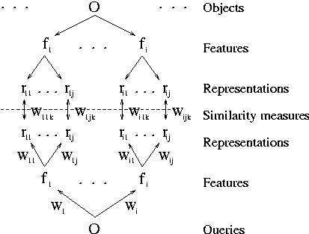

Figure 5 : The retrieval process

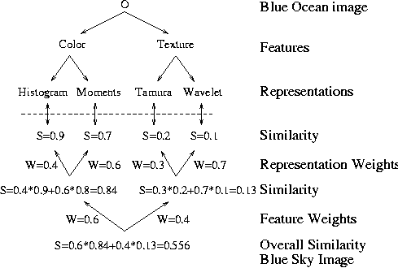

Figure 6 : Example Query calculation pf Blue Sky image against Blue Ocean image

### Vector Query Model and Integration of Relevance Feedback to VIR

As discussed in section 3.1, an object model *O*(*D,F,R*), together with a set of similarity measures *M*={*mij*}, provides the foundation for retrieval (*D,F,R,M*). The similarity measures are used to determine how similar or dissimilar two objects are. Different similarity measures may be used for different feature representations. For example, Euclidean distance is used for comparing vector-based representations while Histogram Intersection is used for comparing color histogram representations (see Section 2).

The Query model is shown in Figure 5. The query has the same form as an object, except it has weights at every branch at all levels. *Wi*, *Wij*, and *Wijk*, are associated with features *fi*, representations *rij*, and components *rijk* respectively. The purpose of the weights is to reflect as closely as possible the combination of feature representations that best represents the users information need. The process of relevance feedback described below aims at updating these weights to form the combination of features that best captures the user's information need.

Intuitively, the similarity between query and object feature representations is computed, and then the feature similarity computed as the weighted sum of the similarity of the individual feature representations. This process is repeated one level higher when the overall similarity of the object is the weighted sum over all the feature similarities. The weights at the lowest level, the component level, are used by the different similarity measures internally. Figure 6 traces this process for our familiar example of a blue sky image as a query and a blue ocean image in the collection.

Based on the image object model and the set of similarity measures, the retrieval process can be described as follows. At the initial query stage, equal weights are associated with the features, representations, and components. Best matches are then displayed back to the user. Depending on his true information need, the user will mark how good the returned matches are (degree of relevance). Based on user’s feedback, the retrieval system will automatically update weights to match the user’s true information need. This process is also illustrated in Figure 5. In Figure 5, the information need embedded in *Q* flows up while the content of *O*'s flows down. They meet at the dashed line, where the similarity measures *mij* are applied to calculate the similarity values *S*(*rij*)'s between *Q* and *O*'s.

Based on the intuition that important representations or components should receive more weights, we have proposed effective algorithms for updating these two levels’ weights. Due to page limitation, we refer the readers to (Rui et al. 1998b).

# Experimental Results

In the experiments reported here, we test our approaches over the image collection from the Fowler Museum of Cultural History at the University of California-Los Angeles. It contains 286 ancient African and Peruvian artifacts and is part of the Museum Educational Site Licensing Project (MESL), sponsored by the Getty Information Institute. The size of the MESL test set is relatively small but it allows us to explore all the color, texture, and shape features simultaneously in a meaningful way. More extensive experiments with larger collections have been performed and reported in (Ortega et al., 1998b; Rui et al., 1998b).

In the following experiments, the visual features used are color, texture and shape of the objects in the image. The representations used are color histogram and color moments (Swain and Ballard, 1991) for the color feature; Tamura (Tamura et al., 1978; Equitz and Niblack, 1994) and co-occurrence matrix (Haralick et al., 1973; Ohanian and Dubes, 1992) texture representations for the texture feature, and Fourier descriptor and chamfer shape descriptor (Rui et al., 1997b) for the shape feature.

## Boolean Retrieval Model Results

To conduct the experiments we chose several queries and manually determined the relevant set of images with help of experts in librarianship as part of a seminar in multimedia retrieval. With the set of queries and relevant answers for each of them, we constructed precision-recall curves (Salton and McGill, 1983). These are based on the well known precision and recall metrics. Precision measures the percentage of relevant answers and recall measures the percent of relevant objects returned to the user. The precision recall graphs are constructed by measuring the precision for various levels of recall.

We conducted experiments to verify the role of feature weighting in retrieval. Figure 7(a) shows results of a *shape or color* query i.e. to retrieve all images having either the same shape or the same color as the query image. We obtained four different precision recall curves by varying the feature weights. The retrieval performance improves when the shape feature receives more emphasis.

We also conducted experiments to observe the impact of the retrieval model used to evaluate the queries. We observed that the fuzzy and probabilistic interpretation of the same query yields different results. Figure 7(b) shows the performance of the same query (a *texture or color* query) in the two models. The result shows that neither model is consistently better that the other in terms of retrieval.

Figure 7(c) shows a complex query (shape(*Ii*) *and* color(*Ii*) *or* shape(*Ij*) *and* layout(*Ij*)) with different weightings. The three weightings fared quite similar, which suggests that complex weightings may not have a significant effect on retrieval performance. We used the same complex query to compare the performance of the retrieval models. The result is shown in Figure 7(d). In general, the probabilistic model outperforms the fuzzy model.

|  |  |
| --- | --- |
| graph\result1.bmp | \\yar\yrui\paper\library98\graph\result2.bmp |
| a) Effects of varying the weighting on a query | b) Fuzzy vs. Probabilistic performance for query |
| \\yar\yrui\paper\library98\graph\result4.bmp | \\yar\yrui\paper\library98\graph\result5.bmp |
| c) Complex query with different weights | d) Fuzzy vs. probabilistic for same complex query |

Figure 7 : Experimental result graphs

## Vector Retrieval Model with Relevance Feedback Results

There are two sets of experiments reported here. The first set of experiments is on the efficiency of the retrieval algorithm, i.e. how fast the retrieval results converge to the true results. The second set of experiments is on the effectiveness of the retrieval algorithm, i.e. how good the retrieval results are subjectively.

### Efficiency of the Algorithm

As we have discussed in Section 3.1, the image object is modeled by the combinations of representations with their corresponding weights. If we fix the representations, then a query can be completely characterized by the set of weights embedded in the query object *Q*. Obviously, the retrieval performance is affected by the offset of the true weights from the initial weights. We thus classify the testinto two categories, i.e. moderate offset, and significant offset, by considering how far away the true weights are from the initial weights. The convergence ratio (recall) for these cases is summarized in Figure 8.

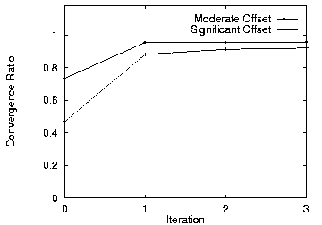

Figure 8 : Convergence Ratio curves

Based on the curves, some observations can be made:

• In all the cases, the convergence ratio (CR) increases the most in the first iteration. Later iterations only result in minor increases in CR. This is a very desirable property, which ensures that the user gets reasonable results after only one-iteration of feedback.

• CR is affected by the degree of offset. The less the offset, the higher the final absolute CR. However, the more the offset, the higher the relative increase of CR.

### Effectiveness of the Algorithm

Extensive experiments have been carried out. Users from various disciplines, such as Computer Vision, Art, Library Science, etc., as well as users from industry, have been invited to judge the retrieval performance of the proposed *interactive* approach. A typical retrieval process on the MESL test set is given in Figures 9 and 10.

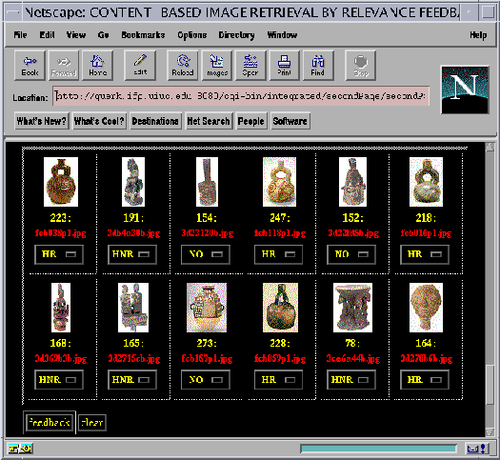

Figure 9 : The retrieval results before the relevance feedback

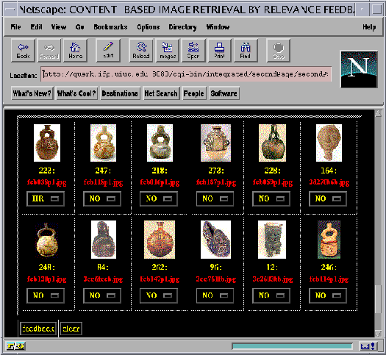

Figure 10 : The retrieval results after the relevance feedback

The user can browse through the image database. Once he or she finds an image of interest, that image is submitted as a query. In Figure 9, the query image is displayed at the upper-left corner and the best 11 retrieved images. The top 11 best matches are displayed in the order from top to bottom and from left to right. The retrieved results are obtained based on their overall similarities to the query image, which are computed from all the features and all the representations. Some retrieved images are similar to the query image in terms of the shape feature while others are similar to the query image in terms of color or texture feature.

Assume the user's true information need is to “retrieve similar images based on their shapes”. In the proposed retrieval approach, the user is no longer required to explicitly map his information need to low-level features, but rather he or she can express his intended information need by marking the relevance scores of the returned images. In this example, images 247, 218, 228 and 164 are marked *highly relevant*. Images 191, 168, 165, and 78 are marked *highly non-relevant*. Images 154, 152, and 273 are marked *no-opinion*.

Based on the information fed-back by the user, the system *dynamically* adjusts the weights, putting more emphasis on the *shape feature*, possibly even more emphasis to one of the two shape representations which better matches the user's subjective perception of shape. The improved retrieval results are displayed in Figure 10. Note that our shape representations are invariant to translation, rotation, and scaling. Therefore, images 164 and 96 are relevant to the query image.

# Conclusion

This paper discussed techniques to extend information retrieval beyond the textual domain. Specifically, it discussed how to extract visual features from images and video; how to adapt a Boolean retrieval model (enhanced with Fuzzy and Probabilistic concepts) for VIR systems; and how to generalize the relevance feedback technique to VIR.

In the past decade, two general approaches to VIR emerged. One is based on text (titles, keywords, and annotation) to search for visual information indirectly. This paradigm requires much human labor and suffers from vocabulary inconsistency problems across human indexers. The other paradigm seeks to build fully automated systems by completely discarding the text information and performing the search on visual information only. Neither paradigm has been very successful. In our view, these two paradigms have both their advantages and disadvantages; and sometimes are complimentary to each other. For example, in the MESL database, it will be much more meaningful if we first do a text-based search to confine the category and then use visual feature based search to refine the result. Another promising research direction is the integration of the human user into the retrieval system loop. A fundamental difference between an old Pattern Recognition system and today's VIR system is that the end user of the latter is human. By integrating human knowledge into the retrieval process, we can bypass the unsolved problem of image understanding. Relevance feedback is one technique designed to deal with this problem.

# Acknowledgements

This work was supported by NSF CAREER award IIS-9734300; in part by NSF CISE Research Infrastructure Grant CDA-9624396; in part by the Army Research Laboratory under Cooperative Agreement No. DAAL01-96-0003. Michael Ortega is supported in part by CONACYT Grant 89061. Some example images used in this article are used with permission from the Fowler Museum of Cultural History at the University of California-Los Angeles.

# References

[Arkin et al., 1991] Arkin, E. M., Chew, L., Huttenlocher, D., Kedem, K., and Mitchell, J. (1991). An efficiently computable metric for comparing polygonal shapes. IEEE Trans. Patt. Recog. and Mach. Intell., 13(3).

[Bach et al., 1996] Bach, J. R., Fuller, C., Gupta, A., Hampapur, A., Horowitz, B., Humphrey, R., Jain, R., and fe Shu, C. The Virage image search engine: An open framework for image management. In Proc. SPIE Storage and Retrieval for Image and Video Databases. February, 1996.

[Beyer et al., 1998] Beyer, K., Goldstein, J., Ramakrishnan, R., and Shaft, U. (1998). When Is “Nearest Neighbor” Meaningful? Submitted for publication.

[Buckley and Salton, 1995] Buckley, C. and Salton, G. (1995). Optimization of relevance feedback weights. In Proc. of SIGIR'95.

[Chaudhari and Gravano, 1996] Chaudhari, S. and Gravano, L. (1996). Optimizing Queries over Multimedia Repositories. Proc. of SIGMOD.

[Chuang and Kuo, 1996] Chuang, G. C.­H. and Kuo, C.­C. J. (1996). Wavelet descriptor of planar curves: Theory and applications. IEEE Trans. Image Proc., 5(1):56--70.

[Equitz and Niblack, 1994] Equitz, W. and Niblack, W. (1994). Retrieving images from a database using texture - algorithms from the QBIC system. Technical Report RJ 9805, Computer Science, IBM Research Report.

[Fagin, 1996] Fagin, R. (1996). Combining Fuzzy Information from Multiple Systems. Proc. of the 15th ACM Symp. on PODS.

[Fagin and Wimmers, 1997] Fagin, R. and Wimmers, E. L. (1997). Incorporating user preferences in multimedia queries. In Proc of Int. Conf. on Database Theory.

[Flickner et al., 1995] Flickner, M., Sawhney, H., Niblack, W., Ashley, J., Huang, Q., Dom, B., Gorkani, M., Hafine, J., Lee, D., Petkovic, D., Steele, D., and Yanker, P. (1995). Query by image and video content: The QBIC system. IEEE Computer.

[Haralick et al., 1973] Haralick, R. M., Shanmugam, K., and Dinstein, I. (1973). Texture features for image classification. IEEE Trans. on Sys, Man, and Cyb, SMC­3(6).

[Hu, 1962] Hu, M. K. (1962). Visual pattern recognition by moment invariants, computer methods in image analysis. IRE Transactions on Information Theory, 8.

[Kundu and Chen, 1992] Kundu, A. and Chen, J.­L. (1992). Texture classification using qmf bank­based subband decomposition. CVGIP: Graphical Models and Image Processing, 54(5):369--384.

[McCamy et al., 1976] McCamy, C. S., Marcus, H., and Davidson, J. G. (1976). A color­rendition chart. Journal of Applied Photographic Engineering, 2(3).

[Miyahara, 1988] Miyahara, M. (1988). Mathematical transform of (r,g,b) color data to munsell (h,s,v) color data. In SPIE Visual Communications and Image Processing, volume 1001.

[Ortega et al., 1998a] Ortega, M., Chakrabarti, K., Porkaew, K., and Mehrotra, S. (1998a). Cross media validation in a multimedia retrieval system. ACM Digital Libraries 98 Workshop on Metrics in Digital Libraries.

[Ortega et al., 1997] Ortega, M., Rui, Y., Chakrabarti, K., Mehrotra, S., and Huang, T. S. (1997). Supporting similarity queries in MARS. In Proc. of ACM Conf. on Multimedia.

[Ortega et al., 1998b] Ortega, M., Rui, Y., Chakrabarti, K., Porkaew, K., Mehrotra, S., and Huang, T. S. (1998b). Supporting ranked Boolean similarity queries in mars. IEEE Trans. on Knowledge and Data Engineering, 10(6).

[Pentland et al., 1996] Pentland, A., Picard, R. W., and Sclaroff, S. (1996). Photobook: Content­based manipulation of image databases. International Journal of Computer Vision.

[Rui et al., 1996] Rui, Y., She, A. C., and Huang, T. S. (1996). Modified Fourier descriptors for shape representation - a practical approach. In Proc of First International Workshop on Image Databases and Multi Media Search.

[Rui et al., 1997a] Rui, Y., Huang, T. S., and Mehrotra, S. (1997a). Content­based image retrieval with relevance feedback in MARS. In Proc. IEEE Int. Conf. on Image Proc.

[Rui et al., 1998a] Rui, Y., Huang, T. S., and Mehrotra, S. (1998a). Exploring video structures beyond the shots. In Proc. of IEEE conf. Multimedia Computing and Systems.

Rui et al., 1998b] Rui, Y., Huang, T. S., Ortega, M., and Mehrotra, S. (1998b). Relevance feedback: A power tool in interactive content­based image retrieval. IEEE Transactions on Circuits and Systems for Video Technology, 8(5).

[Rui et al., 1999] Rui, Y., Huang, T. S., Chang, S.-F. (1999). Image Retrieval: Past, Present, and Future, Accepted to International Journal on Visual Communiation and Image Representation, 1999.

[Salton and McGill, 1983] Salton, G. and McGill, M. J. (1983). Introduction to Modern Information Retrieval. McGraw­Hill Book Company.

[Shaw, 1995] Shaw, W. M. Term­relevance computations and perfect retrieval performance. Information Processing and Management. Vol 31, no 4. Pp491-498.

[Smith and Chang, 1995] Smith, J. R. and Chang, S.­F. (1995b). Tools and techniques for color image retrieval. In IS & T/SPIE proceedings Vol.2670, Storage & Retrieval for Image and Video Databases IV.

[Stricker and Orengo, 1995] Stricker, M. and Orengo, M. (1995). Similarity of color images. In Proc. SPIE Storage and Retrieval for Image and Video Databases.

[Swain and Ballard, 1991] Swain, M. and Ballard, D. (1991). Color indexing. International Journal of Computer Vision, 7(1).

[Tamura et al., 1978] Tamura, H., Mori, S., and Yamawaki, T. (1978). Texture features corresponding to visual perception. IEEE Trans. on Sys, Man, and Cyb, SMC­8(6).

# Author Biographies

**Yong Rui** received the B.S. degree from Southeast University, P. R. China in 1991 and the M.S. degree from Tsinghua University, P. R. China in 1994, both in Electrical Engineering. He received his Ph.D. degree in Electrical and Computer Engineering at the University of Illinois at Urbana-Champaign in 1999. Since March, 1999, he is a researcher at Microsoft Research, Redmond, WA. His research interests include multimedia information retrieval, multimedia signal processing, computer vision and artificial intelligence. He has published over 30 technical papers in the above areas. He is a Huitong University Fellowship recipient 1989-1990, a Guanghua University Fellowship recipient 1992-1993, and a CSE Engineering College Fellowship recipient 1996-1998.

**Michael Ortega** Received his B.E. degree with honors from the Mexican Autonomous Institute of Technology in Aug. 1994 with a SEP fellowship for the duration of the studies. Currently he is pursuing his graduate studies at the University of Illinois at Urbana Champaign. Michael Ortega received a Fulbright/CONACYT/García Robles scholarship to pursue graduate studies as well as the Mavis Award at the University of Illinois and is a member of the Phi Kappa Phi honor society, the IEEE computer society and member of the ACM. His research interests include multimedia databases, database optimization for uncertainty support and content based multimedia information retrieval.

**Thomas S. Huang** received his B.S. Degree in Electrical Engineering from National Taiwan University, Taipei, Taiwan, China; and his M.S. and Sc.D. Degrees in Electrical Engineering from the Massachusetts Institute of Technology, Cambridge, Massachusetts. He was on the Faculty of the Department of Electrical Engineering at MIT from 1963 to 1973; and on the Faculty of the School of Electrical Engineering and Director of its Laboratory for Information and Signal Processing at Purdue University from 1973 to 1980. In 1980, he joined the University of Illinois at Urbana-Champaign, where he is now William L. Everitt Distinguished Professor of Electrical and Computer Engineering, and Research Professor at the Coordinated Science Laboratory, and Head of the Image Formation and Processing Group at the Beckman Institute for Advanced Science and Technology.

Dr. Huang's professional interests lie in the broad area of information technology, especially the transmission and processing of multidimensional signals. He has published 12 books, and over 300 papers in Network Theory, Digital Filtering, Image Processing, and Computer Vision. He is a Fellow of the International Association of Pattern Recognition, IEEE, and the Optical Society of American; and has received a Guggenheim Fellowship, an A.V. Humboldt Foundation Senior U.S. Scientist Award, and a Fellowship from the Japan Association for the Promotion of Science. He received the IEEE Acoustics, Speech, and Signal Processing Society's Technical Achievement Award in 1987, and the Society Award in 1991. He is a Founding Editor of the International Journal Computer Vision, Graphics, and Image Processing; and Editor of the Springer Series in Information Sciences, published by Springer Verlag.

**Sharad Mehrotra** received his M.S. and PhD at the University of Texas at Austin in 1990 and 1993 respectively, both in Computer Science. Subsequently he worked at MITL, Princeton as a scientist from 1993-1994. He is an assistant professor in the Computer Science department at the University of Illinois at Urbana-Champaign since 1994. He specializes in the areas of database management, distributed systems, and information retrieval. His current research projects are on multimedia analysis, content-based retrieval of multimedia objects, multidimensional indexing, uncertainty management in databases, and concurrency and transaction management. Dr. Mehrotra is an author of over 50 research publications in these areas. Dr. Mehrotra is the recipient of the NSF Career Award and the Bill Gear Outstanding junior faculty award in 1997.