**Introduction**

PLE is a privately held company based out of St. Louis, Missouri that designs and manufactures classic push mowers for residential usage. The vast majority of products are supplied by PLE to dealerships, who then sell them to consumers. A total of 1,660 people are employed by PLE around the world. Half of the company's employees work at the St. Louis headquarters and the other half at the other factories. The company has recently launched two flagship products a mower and a tractor into the marketplace. The primary goal of this report is to update department supervisor Elizabeth Burke on trends in defects and retention-related issues. In addition, suggestions will be made to cut down on defects and boost worker retention.

**Product defects over the years**

An Analysis of Variance (ANOVA) was carried out. Based on the result of the analysis, it was noted that there is a significant difference in the number of defects over the years (F (4,59) = 178.22, p < 0.001). This shows that the number of defects changed noticeably within the 5 years period of sales for the two products mower and tractor in PLE. As shown in Figure 1 below, the number of defects was noted to have reduced by more than 40% in 2018, when compared to the year 2014. This means the company’s measures taken so far have resulted in significant improvement of the product’s operational capabilities. Even despite the fact that the number has dropped the number is still considered high, indicating that there is still a lot that needs to be done to further reduce the numbers to a negligible range.

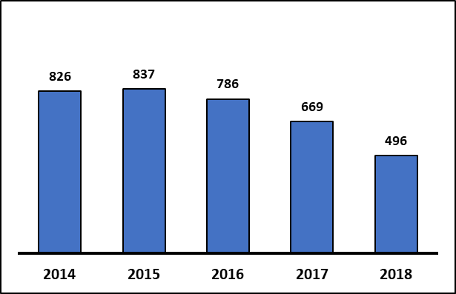

Figure : Average number of defects per million items received from suppliers

**Factors that affect employee retention**

There were four (4) variables that were thought to have a significant impact on the years the employee has stayed in the organization (employee retention). The variables were Education years, GPA, Age, and gender. The numerical variables were investigated using regression analysis and the categorical were investigated using an independent sample t-test. The results from the analysis showed that the number of years an employee spent in education and GPA did not have any effect on employee retention. What this means for the organization is that providing education and GPA should be prioritized for recruitment, given that do not play any important role in predicting if an employee will stay longer in the organization.

The average retention for males was 5.54 and 5.53 for females in PLE. Based on the test results both scores are not different from each other. This shows that gender does not affect employee retention. Thus, PLE can employ any gender regardless and the retention rate will not be compromised.

Age was the only variable that has a significant relationship with employee retention, based on the trend shown in Figure 2 below, as the age of employees increased so did employee retention. Therefore, in the organization PLE, older employees stayed longer in the organization than the younger employees. Indicating that the organization needs to consider the critical age of a potential employee before recruitment.

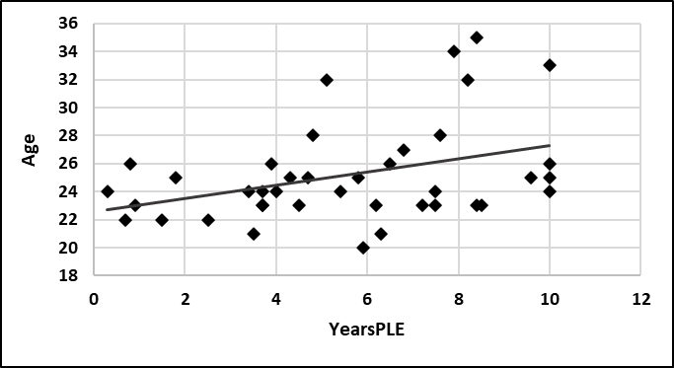

Figure : scatter plot with regression line showing the relationship between years in PLE and AGE

**Conclusion**

The two products produced by PLE have a notable number of yearly defects. Although this number has reduced significantly over the past 5 years, the recent records for 2018 are still on the high side and this means that there are still major works that need to be done to reduce defects with the new products. Employees are the backbone of the PLE organization and there is a need to understand how the organization can retain talents for a longer period. The most important factor in this context was age and it was noted aged individuals are more likely to stay longer than younger individuals.

**Recommendations**

***Measures to reduce defects after delivery***

In order to reduce the number of defects after delivery, the organization needs to have a department that is mandated with the responsibility of ensuring the functionality of all devices before packaging. The department can segregate the tests based on delivery time. Thus, orders that need to be delivered earlier should be prioritized for testing. This approach will ensure that all of the defects are identified and fixed before delivery to the customers.

The second measure that can be taken by the organization is to ensure that the packaging and the distribution channels that are used for delivery do not result in equipment damage. Thus, it is imperative that the organization have a handling procedure or guideline that needs to be followed by the distributors to minimize the chances of damage to the machinery.

***Improving employee retention***

Based on the analysis so far, only age had a significant relationship with years in PLE. Thus, there is a need for the organization to look carefully at the age distribution of the employees in the organization. Based on the results, as the age increase so does the years in PLE. Therefore, the organization will need to prioritize employment for 26+ aged individuals, to increase the chances of retaining the employee for more than 6 years in the organization. Also, the organization needs to prioritize improving the skill and training exposure for the aged individuals in the organization.