Apparent Contradictions in the Aluminum–Water Hydrolysis Literature are Predominantly Methodological: a Provenance-Tracked, Leakage-Controlled Analysis
Dogukan Unal
Abstract
The aluminum–water hydrolysis literature for hydrogen production reports parameter effects that contradict one another across studies—most visibly a direction-changing particle-size effect and activation energies spanning $3.5$–$102.6$ kJ mol$​^{−1}$—which blocks data-driven design and leaves open whether the contradictions reflect genuine physico-chemical regimes or artifacts of isolated, non-standardized experimental conditions. We unify the scattered literature into a provenance-tracked open dataset (315 condition-level yield rows from 31 studies, plus a separate 76-row kinetic table) and analyze it with leakage-controlled evaluation, a study-level variance decomposition, and a within-study consistency test, with pre-registered claims and transparent nulls. Under study-grouped cross-validation the strong apparent predictability of random splits collapses (optimism gap $0.62$–$0.85$ in $R^{2}$), and a between-study variance decomposition shows that methodological covariates are associated with $≈55\%$ of the between-study yield variance versus $≈2\%$ for the physico-chemical regime label (system_class), with the temperature-control method alone the single largest source ($≈33\%$). The flagship particle-size “contradiction” is internally consistent within every study that varies size ($5/5$ negative), identifying it as a cross-study integration artifact rather than a physical sign reversal. We therefore conclude—associationally and at $n​≈​31$ studies—that the literature’s apparent contradictions are predominantly methodological; we release the curated dataset, the reproducible analysis, and a minimum-information reporting standard for aluminum-hydrolysis studies.
aluminum–water hydrolysis ,hydrogen production ,reproducibility , data leakage ,meta-analysis ,methodological heterogeneity ,open dataset

Highlights
- 31 aluminum–water hydrolysis studies unified into one provenance-tracked dataset.
- Study-grouped cross-validation exposes a large optimism gap ($R^{2}$ $0.62$–$0.85$).
- Methodology explains $≈$55% of between-study yield variance vs $≈$2% for regime.
- Temperature-control method alone is the single largest source ($≈$33%).
- Particle-size effect is negative within all 5/5 studies; the “flip” is an artifact.

Introduction
The reaction of aluminum with water, $2 Al+3 H_{2}O→Al_{2}O_{3}+3 H_{2}$ (or via hydroxides), is an attractive route to hydrogen on demand: it is triggered by water alone, stores energy at high density, and needs no high-pressure H$​_{2}$ infrastructure. Two decades of experiments have mapped how temperature, alkalinity, particle size, alloying/activation, and water chemistry control the yield and rate. Yet the resulting literature is internally contradictory. Reported activation energies span $3.5$–$102.6$ kJ mol$​^{−1}$; the effect of particle size is reported as both beneficial and detrimental; the rate–yield trade-off is inconsistent; and studies disagree on which parameter dominates. These contradictions are usually attributed, in passing, to “different conditions,” but the attribution has never been tested.
This is the unresolved question we address: are the apparent inter-study contradictions genuine physico-chemical regime differences, or artifacts of isolated, non-standardized experimental conditions? The distinction matters because it determines whether the literature can be pooled to build predictive design models at all. Prior machine-learning work on aluminum–water hydrolysis is, to our knowledge, limited to a single-study, in-sample neural network reporting near-perfect prediction (Das et al. 2023). Such a near-perfect in-sample fit is exactly the generalization illusion that a cross-study analysis must guard against: a model that interpolates one laboratory’s data says nothing about whether the literature agrees.
We take the opposite stance. We unify the scattered literature into a single provenance-tracked dataset and ask, with leakage-controlled evaluation, how far one study transfers to another, and what accounts for the differences when it does not. We pre-registered the analyses and their success criteria before computing them, and we report nulls transparently as “no detectable effect at this sample size” rather than as evidence of absence.

Contributions.
- A curated, provenance-tracked, quality-tiered open dataset of 315 condition-level hydrogen-yield rows from 31 studies, with a separate 76-row kinetic table (activation energies and rates), released under CC-BY.
- A leakage-controlled evaluation showing that random-split predictability ($R^{2}​≈​0.55$) collapses under study-grouped cross-validation ($R^{2}<0$; optimism gap $0.62$–$0.85$)—the literature does not pool naively.
- The central finding: a study-level variance decomposition in which methodological covariates explain $≈​55\%$ of the between-study yield variance versus $≈​2\%$ for the physico-chemical regime, with the temperature-control method alone the largest single source ($≈​33\%$); the effect survives controlling for regime.
- Resolution of the flagship particle-size contradiction as a cross-study integration artifact (within-study effect negative in $5/5$ studies).
- A proposed minimum-information reporting standard for aluminum-hydrolysis studies, to make future data poolable.

Related work

Aluminum–water hydrolysis.
Activating aluminum so it reacts with neutral or alkaline water is a mature experimental field. Strategies include dissolved alkali (NaOH/KOH), bulk alloying with low-melting metals (Bi, Sn, In, Ga), high-energy ball milling with such additives, gallium-based liquid-metal/eutectic activation, and the use of waste or scrap aluminum (Wen et al. 2018; Porciúncula et al. 2012; Urbonavičius et al. 2024). Reviews of the field (Musicco et al. 2025; Preez and Bessarabov 2021) are qualitative narrative comparisons that catalog these contradictions but do not quantify their origin, unify the data, or test pooling.

The generalization illusion in single-study models.
Data-driven modeling of this reaction is nascent. The closest prior work is a single-study artificial neural network reporting a near-perfect in-sample fit within one laboratory’s data (Das et al. 2023). In-sample performance on one study’s grid is uninformative about cross-study transfer; our leakage analysis makes this gap explicit.

Leakage-controlled evaluation.
Grouped/blocked cross-validation, where all records from a group (here, a study) are held out together, is the established defense against optimistic in-sample estimates in materials, chemistry, and the natural sciences (Bernett et al. 2024; John et al. 2025) (and, in chemometrics, (Pomerantsev and Rodionova 2021)). Recent perspectives on data science in catalysis and materials likewise stress provenance, reproducibility, and honest generalization assessment (Suvarna and Pérez-Ramírez 2024; Bozal-Ginesta et al. 2025; Coelho et al. 2022; Xue et al. 2024; Noble et al. 2022). We apply this discipline to aluminum hydrolysis for the first time and, beyond demonstrating leakage, use the variance structure to attribute the between-study disagreement.

Methodology as a confound, and reporting standards.
Individual studies already report that protocol choices shift measured values substantially—vessel insulation and temperature control (Urbonavičius et al. 2023), water type, and catalyst pre-treatment (Wen et al. 2018). Minimum-information reporting standards have improved poolability in related areas (Wulf et al. 2021; Hoque and Guzman 2018); we adapt that template to aluminum hydrolysis.

Data and methods

Provenance-tracked dataset
We screened the aluminum–water hydrolysis literature and extracted, from 31 full-text studies in hand, every distinct experimental condition reporting a hydrogen outcome. Each row records the target (H$​_{2}$ yield, % of the $1244$ mL g$​^{−1}$ pure-Al theoretical), physical parameters (temperature, alkali concentration, particle size, activator ratio, elemental composition), categorical descriptors, full provenance (study DOI, table/figure source, extractor, extraction method), and quality/methodology metadata. The grouping key is the study DOI. Absent quantities are encoded as $0$ and unreported quantities as missing, never conflated. Each study is assigned a physico-chemical regime label system_class $∈$ {pure_al_alkali, al_alloy, mechanically_activated, liquid_metal_activated, waste_al}, verified against the source materials/methods. The final yield dataset has 315 rows from 31 studies (Fig. 1); a separate 76-row kinetic table holds activation energies and rates (reported or fit from rate-vs-temperature data), with their own provenance and fit-quality fields, and is never merged into the yield table.
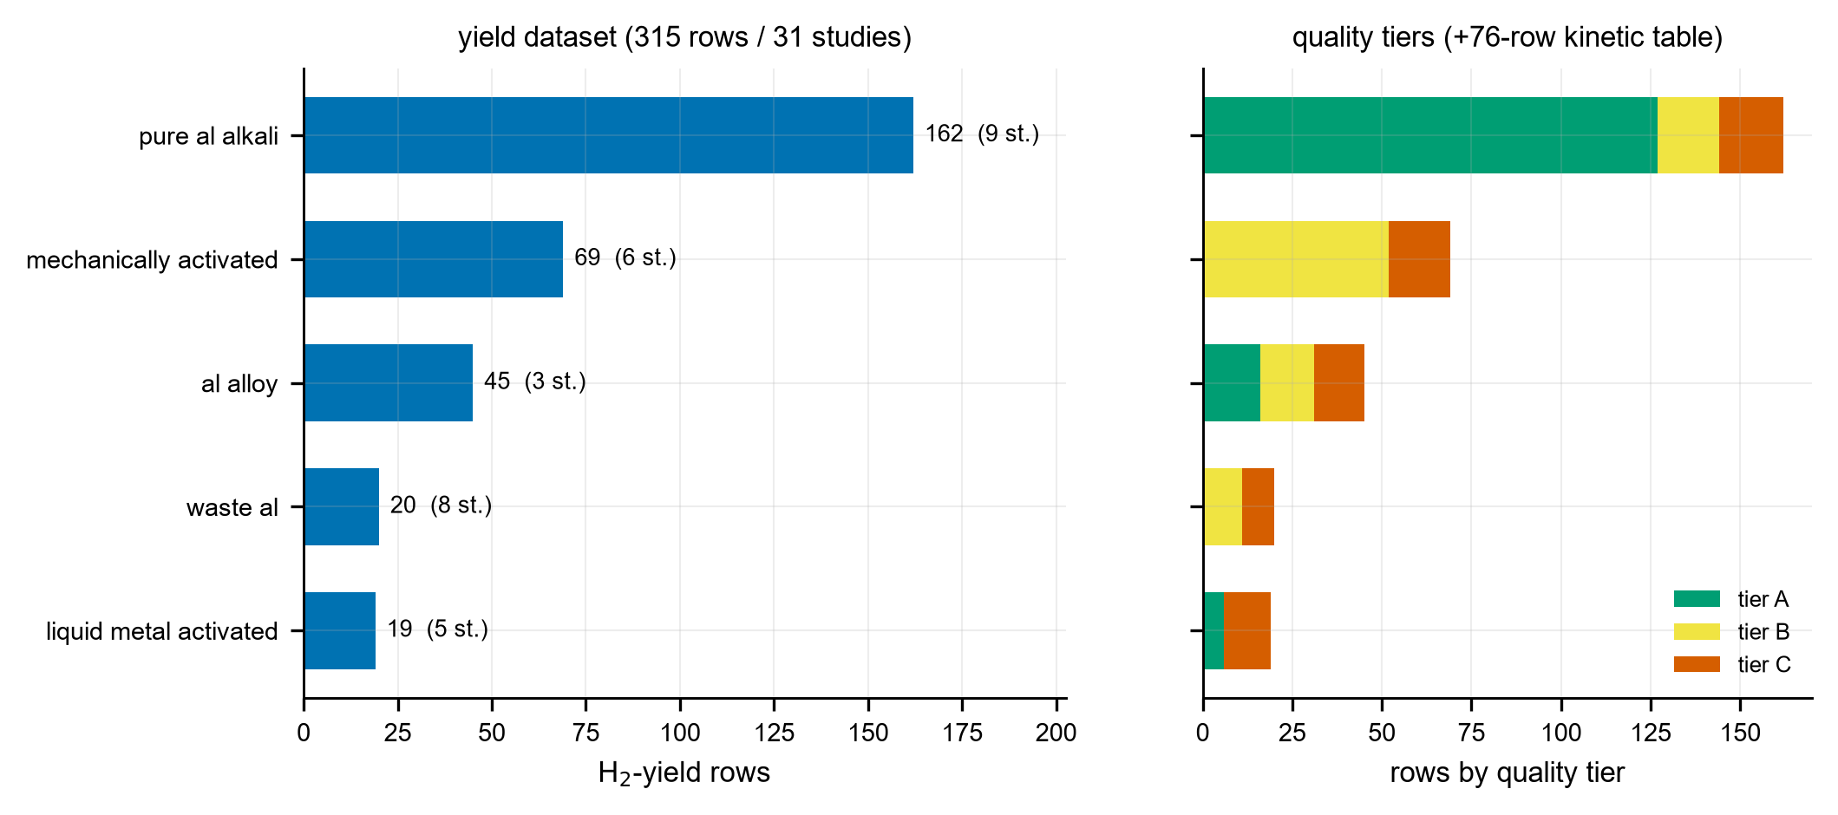
The curated open dataset. Per-system_class yield-row counts with study counts (left) and the A/B/C quality-tier composition (right); a separate 76-row kinetic table is noted. $315$ yield rows from $31$ studies, released under CC-BY.
Two independent re-extraction passes provide quality control: a double extraction of $≈​16\%$ of yield rows showed $52/52$ exact value agreement, and a classification audit re-derived system_class for all 31 studies from source; digitized kinetic points were re-read independently ($≈​1.5\%$ point error). Studies whose Arrhenius fits failed a quality gate ($R^{2}​≥​0.90$, $≥​3$ temperatures) were dropped rather than forced.

Leakage-controlled evaluation
For each of six comparative regressors (ElasticNet, $k$NN, random forest, XGBoost, LightGBM, Gaussian process) we estimate the held-out coefficient of determination under two protocols: ordinary $k$-fold (records split at random) and study-grouped $k$-fold (all records of a study held out together). The optimism gap, $R_{\text{random}}^{2}−R_{\text{grouped}}^{2}$, measures how much random splitting overstates cross-study generalization. Tree models retain missing values; linear/kernel models use median imputation and one-hot encoding.

Between-study variance decomposition (primary analysis)
To ask what accounts for the disagreement, we aggregate to the study level (one row per study: mean yield and the study’s modal covariate values) and decompose the between-study variance of mean yield. For a categorical predictor $C$ we report the variance share $R_{C}^{2}=1−SS_{within}(C)/SS_{total}$, comparing the physical-regime label against methodological covariates (temperature_control, measurement_method, water_type, quality_tier, vessel_type). We test whether the methodological signal is genuine—rather than a re-encoding of study identity or a confound with regime—by (i) auditing the study-level coverage of each covariate level, (ii) cross-tabulating against system_class, and (iii) reporting the incremental variance explained by the temperature-control method after controlling for regime. All headline numbers carry cluster-bootstrap confidence intervals (resampling studies); contrasts use Holm correction. We treat the kinetic $E_{a}$ analysis and the within-study tests analogously.

Discipline
Hypotheses and success thresholds were frozen before computation. Language on observational findings is associational, not causal. We report nulls as “no detectable effect at $n​≈​31$ studies / $3$–$9$ per regime.” Machine-learning attributions (SHAP/importances) are used descriptively only. All numbers in this paper trace to a committed analysis artifact, and the full pipeline is released.

Results

The literature does not pool: a large optimism gap
Under random $k$-fold splits the tree models reach $R^{2}​≈​0.55$ (random forest $0.56$, LightGBM $0.57$, XGBoost $0.55$). Under study-grouped cross-validation the same models fall to $R^{2}<0$, i.e. worse than predicting the global mean on a held-out study, for an optimism gap of $0.62$–$0.85$ (Fig. 2). The gap persists after removing the single largest study ($0.48$–$0.73$), so it is not an artifact of one dominant source. A model trained on some studies therefore does not predict an unseen study—the precondition for asking whether the contradictions are real or artifactual.

Methodology, not physical regime, explains the between-study variance
At the study level, $≈​50\%$ of the total yield variance lies between studies. The physico-chemical regime label explains almost none of it: $R_{\text{system_class}}^{2}=0.018$ (cluster-bootstrap 95% CI $[0.015,0.373]$). Methodological covariates jointly explain $R^{2}=0.553$ (CI $[0.361,0.999]$), $≈​27×$ more (Fig. 3). The single largest source is the temperature-control method: $R_{\text{temperature_control}}^{2}=0.332$ (CI $[0.030,0.676]$); studies using a self-heating protocol report higher mean yields ($86\%$) than isothermal-bath studies ($75\%$), and uncontrolled studies far lower ($32\%$).
This signal is not a relabeling of study identity or of physical regime. Each temperature-control level is shared by many studies ($22/7/2$ studies for isothermal-bath/self-heating/uncontrolled) and spans $4$–$5$ of the five regimes, so it is not collinear with system_class. Its contribution survives controlling for regime: the incremental variance explained by temperature control given system_class is $+0.467$ (cluster-bootstrap CI $[+0.037,+0.772]$, excluding $0$), whereas regime given method adds only $+0.153$. Residual between-study spread remains within the dominant isothermal-bath level (yield range $26$–$100$, s.d. $18.7$), so temperature control is the largest single source of between-study variance, though not the only one; hence we claim predominantly, not purely, methodological.

The flagship particle-size contradiction is a cross-study artifact
The literature’s headline contradiction is a direction-changing particle-size effect. Within every study that varies particle size ($5/5$), the within-study effect has the same sign: smaller particles give higher yield (Spearman $ρ$ between $−0.29$ and $−0.87$; Fig. 4). The apparent “flip” across the literature arises from comparing different size ranges and material regimes between studies, not from any within-study sign reversal. The flagship contradiction is thus an integration artifact.

Activation energy does not organize by regime
Reported and independently re-fit activation energies (76-row kinetic table) do not cluster by system_class: the within-regime spread is comparable to the between-regime spread, and liquid_metal_activated alone ranges from $8.5$ to $58$ kJ mol$​^{−1}$ (Fig. 5). A variance decomposition of per-study $E_{a}$ by regime is not significant ($η^{2}=0.36$, permutation $p=0.13$ on the $≥​3$-study classes). The coarse regime label does not capture the kinetics.

Within-study predictability is heterogeneous (a transparent null)
Whether each study is internally predictable is mixed: within-study leave-one-condition-out skill is clearly positive for well-designed parameter sweeps, where the response is a smooth, monotone surface (Fig. 6; within-study skill $0.84$–$0.86$), but the median across 14 testable studies is $−0.145$ (CI $[−0.45,+0.23]$). We report this as no detectable uniform within-study predictability at these per-study sample sizes ($5$–$120$ rows), not as evidence that within-study physics is inconsistent; the between-study variance and the consistent particle-size direction both point the other way.
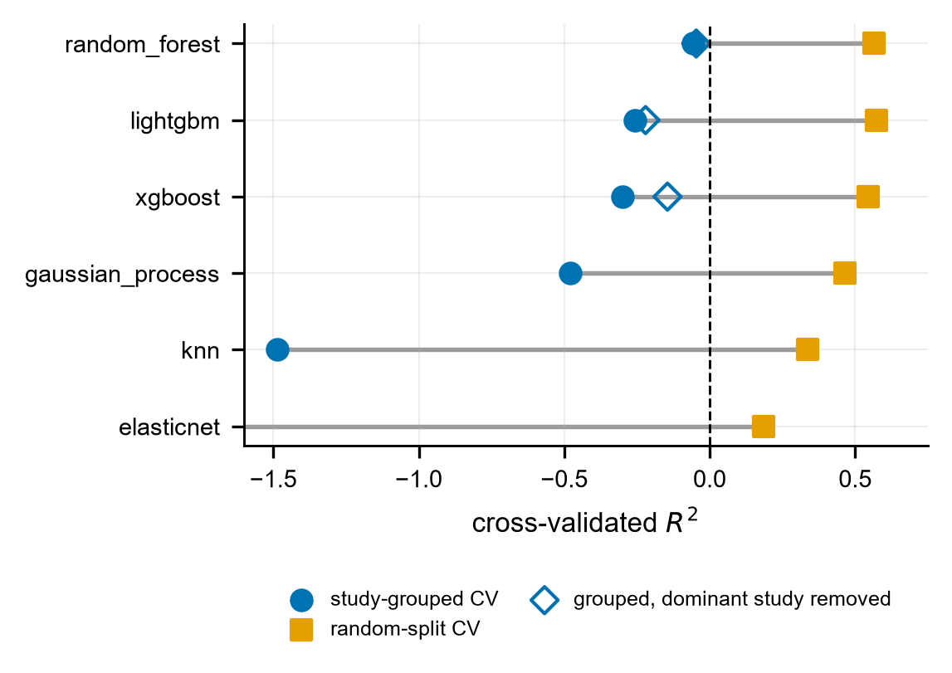
Leakage control. Each model is a dumbbell from its study-grouped cross-validated $R^{2}$ ( $•$ ) to its random-split $R^{2}$ ( $◼$ ); the open diamond is the study-grouped $R^{2}$ after removing the single largest study (tree models only). Tree models reach $R^{2}​≈​0.55$ under random splits but fall below zero under study-grouped cross-validation (optimism gap $0.62$–$0.85$): a model trained on some studies does not predict an unseen study.
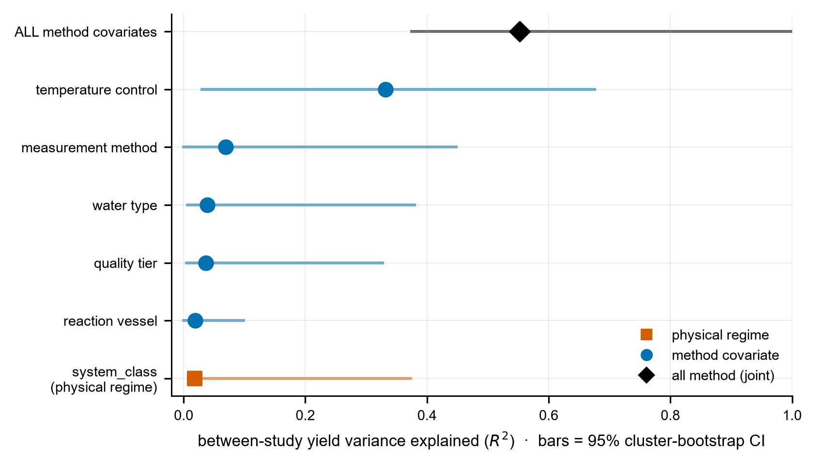
Methodology, not physical regime, explains the between-study yield variance (headline). Between-study variance of study-mean yield explained ($R^{2}$, dot) with a 95% cluster-bootstrap confidence interval (bar), one row per predictor. The physico-chemical regime label (system_class) explains $0.02$; all methodological covariates jointly explain $0.55$ ($≈​27×$), and the temperature-control method alone explains $0.33$. Associational; the temperature-control effect survives controlling for regime (incremental $R^{2}=+0.47$, bootstrap CI excludes $0$).
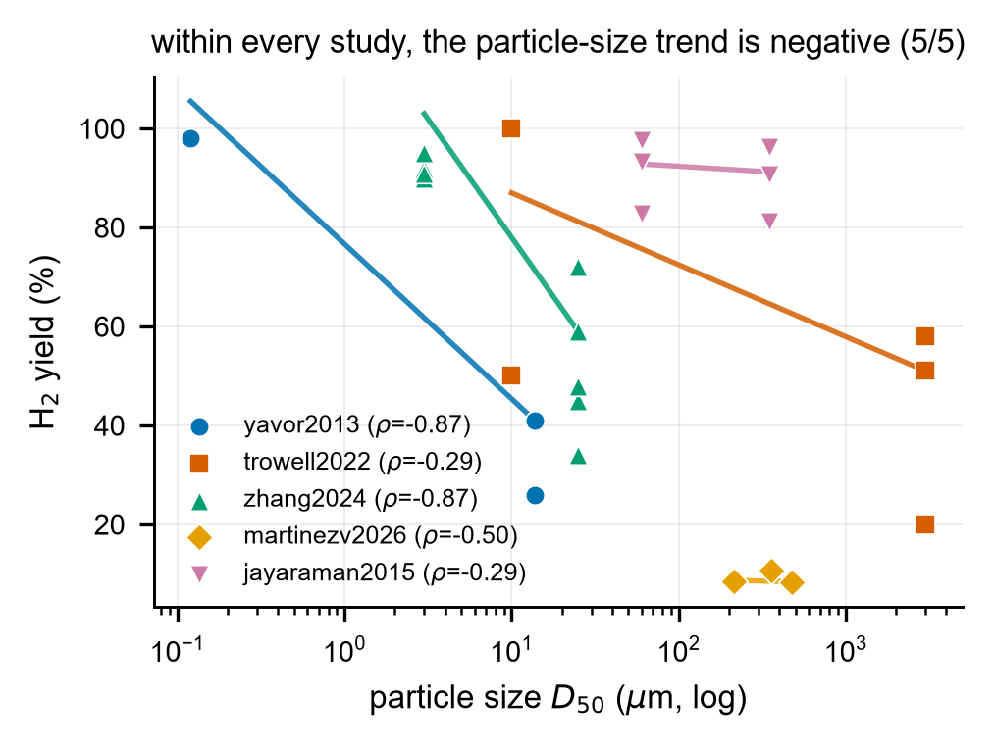
The flagship particle-size contradiction is internally consistent. Raw $(D_{50},\text{yield})$ points per study (log $x$) with a robust Theil–Sen trend line; the per-study Spearman $ρ$ is in the legend. All $5/5$ studies trend negative (smaller particle $⇒$ higher yield), so the literature-wide “flip” is a cross-study integration artifact, not a within-study sign reversal.
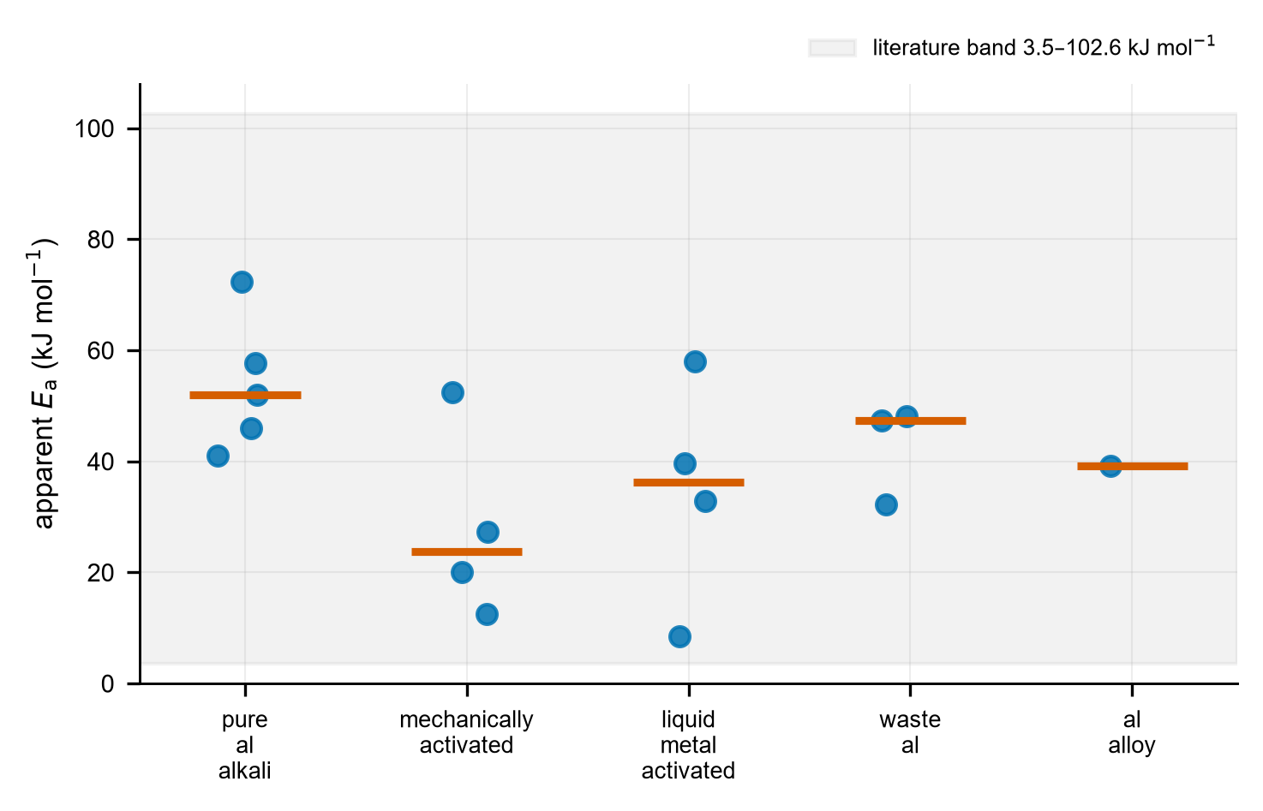
Apparent activation energy does not organize by physical regime. Per-study apparent $E_{a}$ (points) with a class-median bar per system_class; the shaded band is the literature range $3.5$–$102.6$ kJ mol$​^{−1}$. The within-regime spread is comparable to the between-regime spread (liquid_metal_activated alone spans $8.5$–$58$ kJ mol$​^{−1}$).
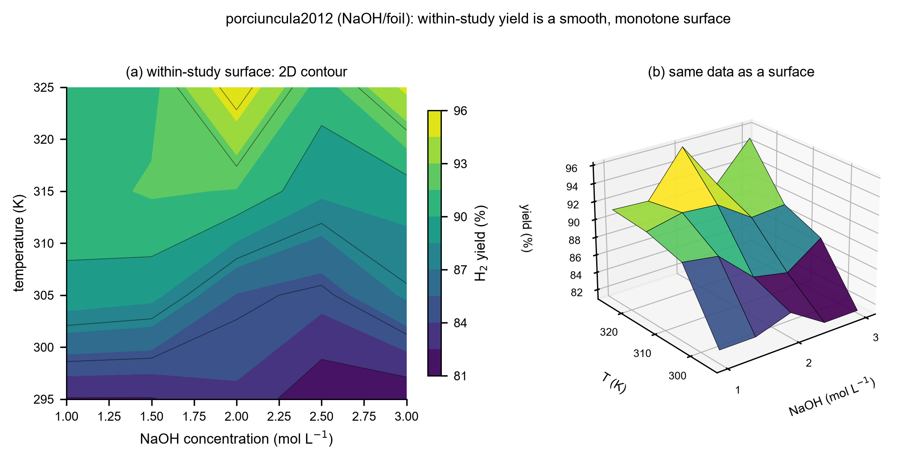
Within a single well-designed study the response is smooth. porciuncula2012 (NaOH, foil) temperature $×$ concentration factorial: (a) a 2D contour and (b) the same data as a 3D surface. Within this study the yield rises smoothly and monotonically with both temperature and alkali concentration—within-study data are clean, locating the contradictions in the cross-study integration. (3D shown only here, where the data are an intrinsic response surface, and always with the 2D companion.)

Discussion

What the contradictions are—and are not
Taken together, the results support a single claim: the apparent inter-study contradictions in aluminum–water hydrolysis are predominantly methodological. Naive pooling overstates predictability (the optimism gap); the physico-chemical regime label explains almost none of the between-study variance ($≈​2\%$) while methodological covariates explain the majority ($≈​55\%$), led by how temperature is controlled; and the flagship particle-size contradiction dissolves into a within-study-consistent effect. The practical implication is direct: a hydrogen yield reported without its measurement protocol is only weakly comparable across laboratories, and meta-analyses that pool raw yields will inherit methodological variance as if it were chemistry.

Physics is not absent
“Predominantly methodological” is not “purely methodological.” The regime label is coarse; finer, particle-size-dependent kinetics—tunable between nano- and micro-aluminium powders—genuinely shape the reaction (Saceleanu et al. 2019), and such physics operates within studies, below the resolution of a five-level label and partly absorbed into the methodological covariates with which it co-varies. Our attribution is also observational: because methodology is largely a study-level attribute, the temperature-control association could be partly confounded with other unmeasured study-level choices. We therefore state the finding associationally and quantify, rather than assert, its robustness.

A minimum-information reporting standard
The remedy is standardization. Table 1 is a minimum-information checklist for aluminum-hydrolysis studies, ordered by how much between-study variance each field carried in our analysis and templated on minimum-information standards in catalysis and materials (Wulf et al. 2021; Hoque and Guzman 2018). Reporting these items would let future yields be compared across laboratories and would shrink the methodological variance this paper quantifies, turning the released dataset into a growing, comparable benchmark.
Proposed minimum-information reporting standard for aluminum–water hydrolysis hydrogen-yield studies. Items are ordered by the between-study yield variance each carried here (Sec. 3.2); temperature control is the largest single source.
Field | Report | Between-study $R^{2}$ here
Temperature control | method (isothermal bath / self-heating / uncontrolled) + setpoint or boundary | 0.33
Measurement method | water displacement / pressure / GC / mass-flow | 0.07
Water type & purity | DI / tap / alkaline / saline, with conductivity or grade | 0.04
Quality / control | isothermal vs. uncontrolled; replication; value reported vs. derived | 0.04
Reaction vessel | open or closed; insulated? | 0.02
Alkali | type (NaOH/KOH/none) + concentration (mol L$​^{−1}$) | —
Particle size | $D_{50}$ ($μ$m) + sizing method | —
Activation route | pure / melt-alloyed / ball-milled / liquid-metal / waste | —
Yield basis | theoretical reference (mL g$​^{−1}$); % vs. volumetric | —
Rate definition | initial / maximum / average; $t_{50}$/$t_{80}$ if a rate is claimed | —
Provenance | study DOI, number of conditions, replicate count | —

Limitations
The analysis rests on 31 studies ($3$–$9$ per regime); negative results (no regime moderation of yield; no regime structure in $E_{a}$; heterogeneous within-study predictability) are reported as “no detectable effect at this sample size,” not as proof of absence. The within-study predictability test is power-limited at small per-study $n$. Two regimes (waste_al, liquid_metal_activated) are exploratory ($<​40$ rows). Open-access retrieval may bias the sample; we mitigate this with a quality tier and report it as a limitation. The headline attribution is associational, and because methodology is largely a study-level attribute it may co-vary with unmeasured study choices. Physics is not excluded: the coarse regime label does not capture finer, within-study particle-size-dependent kinetics (Saceleanu et al. 2019), so the claim is predominantly, not purely, methodological. Positioning citations are complete from DOI-verified metadata; the exact in-sample $R^{2}$ of the single-study prior model is to be confirmed against its full text, and one 2021 review citation was omitted as unverifiable rather than mis-attributed.

Data and code availability
The curated yield dataset (315 rows), the kinetic table (76 rows), and the full, deterministic analysis pipeline are released under CC-BY (code: MIT). Raw third-party PDFs are not redistributed; the dataset records DOIs and provenance so that any value can be traced to its source.

Conclusion
We unified the scattered aluminum–water hydrolysis literature into a provenance-tracked, quality-tiered open dataset and used leakage-controlled, pre-registered analysis to test whether its long-documented contradictions are physical or methodological. The data answer clearly, if associationally: under study-grouped evaluation naive pooling fails, the physico-chemical regime explains $≈​2\%$ of the between-study yield variance while methodological covariates explain $≈​55\%$ (temperature control alone $≈​33\%$), and the flagship particle-size contradiction is consistent within studies. The contradictions are predominantly an artifact of non-standardized measurement, not genuine regime disagreement. Beyond the finding, the contribution is durable infrastructure—an open dataset, a reproducible leakage-controlled benchmark, and a minimum-information reporting standard—that can turn a contradictory literature into a comparable, growing resource.

Data and code availability
The curated dataset (315 condition-level yield rows and the separate 76-row kinetic table), the analysis pipeline, and the figure-generation scripts are released openly: data under CC-BY-4.0 and code under MIT. A versioned archive with a citable DOI is deposited at Zenodo ([TODO: Zenodo DOI]); the development repository is at https://github.com/zegran/AIH2. A dataset card documenting the schema, provenance, quality tiers, and scope accompanies the deposit.

Declaration of competing interest
The author declares no competing financial or personal interests.

CRediT authorship contribution statement
Dogukan Unal: Conceptualization, Methodology, Software, Formal analysis, Data curation, Writing – original draft, Writing – review & editing, Visualization.

Declaration of generative AI and AI-assisted technologies
During the preparation of this work the author used generative AI agents (Anthropic’s Claude, via the Claude Code environment) for literature triage, assistance with data extraction from source papers, statistical analysis and analysis code, figure generation, and drafting of the manuscript. All AI-assisted steps were carried out under the author’s direction. The author reviewed and verified all extracted data, analyses, results, and claims, edited the AI output as needed, and takes full responsibility for the content of this publication. The AI tools are not listed as authors and made no independent scientific judgements.
Bernett, Judith, David B. Blumenthal, Dominik G. Grimm, et al. 2024. “Guiding Questions to Avoid Data Leakage in Biological Machine Learning Applications.” Nature Methods 21: 1444–53. https://doi.org/10.1038/s41592-024-02362-y.
Bozal-Ginesta, Carlota, Sergio Pablo-García, Changhyeok Choi, Albert Tarancón, and Alán Aspuru-Guzik. 2025. “Developing Machine Learning for Heterogeneous Catalysis with Experimental and Computational Data.” Nature Reviews Chemistry, ahead of print. https://doi.org/10.1038/s41570-025-00740-4.
Coelho, Leonardo B., Dawei Zhang, Yves Van Ingelgem, Denis Steckelmacher, Ann Nowé, and Herman Terryn. 2022. “Reviewing Machine Learning of Corrosion Prediction in a Data-Oriented Perspective.” Npj Materials Degradation 6: 1–16. https://doi.org/10.1038/s41529-022-00218-4.
Das, Biswajyoti, P. S. Robi, and Pinakeswar Mahanta. 2023. “Experimental Investigation and Modelling by Machine Learning Techniques for Hydrogen Generation by Reacting Aluminium with Aqueous NaOH Solution.” Fuel, ahead of print. https://doi.org/10.1016/j.fuel.2023.128924.
Hoque, Md Ariful, and Marcelo I. Guzman. 2018. “Photocatalytic Activity: Experimental Features to Report in Heterogeneous Photocatalysis.” Materials 11 (10): 1990. https://doi.org/10.3390/ma11101990.
John, Kingsley, Daniel D. Saurette, and Brandon Heung. 2025. “The Problematic Case of Data Leakage: A Case for Leave-Profile-Out Cross-Validation in 3-Dimensional Digital Soil Mapping.” Geoderma, ahead of print. https://doi.org/10.1016/j.geoderma.2025.117223.
Musicco, Nicola, Marcello Gelfi, Paolo Iora, et al. 2025. “A Review of Hydrogen Generation Methods via Aluminum-Water Reactions.” International Journal of Thermofluids, ahead of print. https://doi.org/10.1016/j.ijft.2025.101152.
Noble, Daniel W. A., Patrice Pottier, Malgorzata Lagisz, et al. 2022. “Meta-Analytic Approaches and Effect Sizes to Account for ‘Nuisance Heterogeneity’ in Comparative Physiology.” Journal of Experimental Biology 225 (Suppl_1). https://doi.org/10.1242/jeb.243225.
Pomerantsev, Alexey L., and Oxana Ye. Rodionova. 2021. “Procrustes Cross-Validation of Short Datasets in PCA Context.” Talanta 226: 122104. https://doi.org/10.1016/j.talanta.2021.122104.
Porciúncula, C. B., N. R. Marcilio, I. C. Tessaro, and M. Gerchmann. 2012. “Production of Hydrogen in the Reaction Between Aluminum and Water in the Presence of NaOH and KOH.” Brazilian Journal of Chemical Engineering 29: 337–48. https://doi.org/10.1590/s0104-66322012000200014.
Preez, S. P. du, and D. G. Bessarabov. 2021. “On-Demand Hydrogen Generation by the Hydrolysis of Ball-Milled Aluminum Composites: A Process Overview.” International Journal of Hydrogen Energy 46: 35790–813. https://doi.org/10.1016/j.ijhydene.2021.03.240.
Saceleanu, Flaviu, Thu V. Vuong, Emma R. Master, and John Z. Wen. 2019. “Tunable Kinetics of Nanoaluminum and Microaluminum Powders Reacting with Water to Produce Hydrogen.” International Journal of Energy Research 43: 7384–96. https://doi.org/10.1002/er.4769.
Suvarna, Manu, and Javier Pérez-Ramírez. 2024. “Embracing Data Science in Catalysis Research.” Nature Catalysis 7: 624–35. https://doi.org/10.1038/s41929-024-01150-3.
Urbonavičius, Marius, Šarūnas Varnagiris, Ainars Knoks, et al. 2024. “Enhanced Hydrogen Generation Through Low-Temperature Plasma Treatment of Waste Aluminum for Hydrolysis Reaction.” Materials 17: 2637. https://doi.org/10.3390/ma17112637.
Urbonavičius, Marius, Šarūnas Varnagiris, Ainars Mezulis, et al. 2023. “Hydrogen from Industrial Aluminium Scraps: Hydrolysis Under Various Conditions, Modelling of pH Behaviour and Analysis of Reaction by-Product.” International Journal of Hydrogen Energy, ahead of print. https://doi.org/10.1016/j.ijhydene.2023.09.065.
Wen, Yu-Chieh, Wei-Min Huang, and Hong-Wen Wang. 2018. “Kinetics Study on the Generation of Hydrogen from an Aluminum/Water System Using Synthesized Aluminum Hydroxides.” International Journal of Energy Research, ahead of print. https://doi.org/10.1002/er.3955.
Wulf, Christoph, Matthias Beller, Tim Boenisch, et al. 2021. “A Unified Research Data Infrastructure for Catalysis Research – Challenges and Concepts.” ChemCatChem 13. https://doi.org/10.1002/cctc.202001974.
Xue, Pengcheng, Ruihu Qiu, Cheng Peng, et al. 2024. “Solutions for Lithium Battery Materials Data Issues in Machine Learning: Overview and Future Outlook.” Advanced Science 11. https://doi.org/10.1002/advs.202410065.

