Zhishen Yang B00601430

1. Experimental study with Wireshark

TCP Segment:

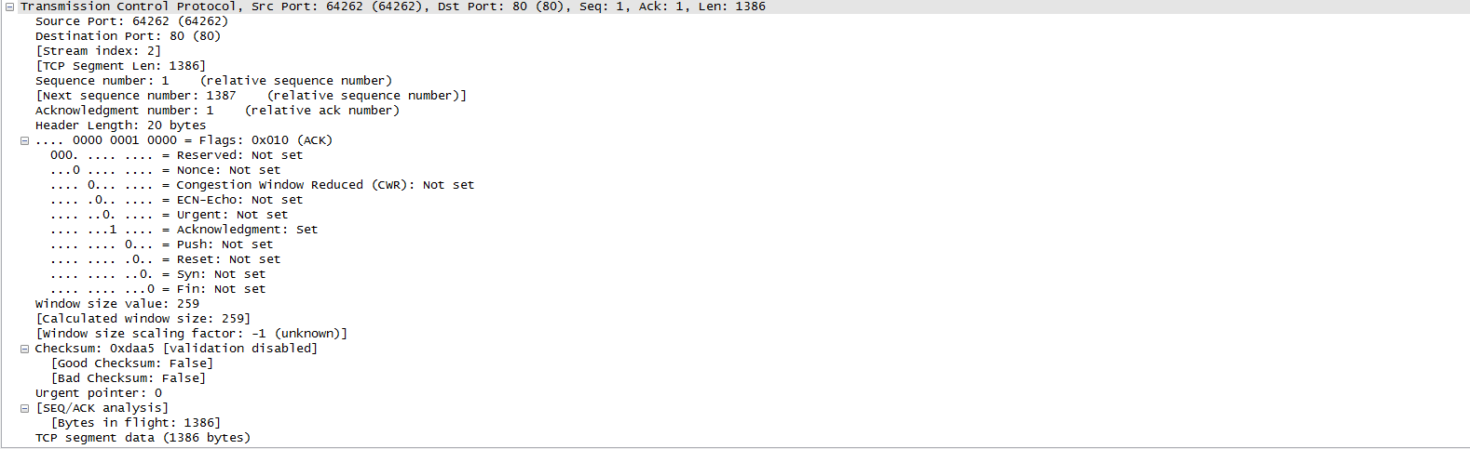

0 15 16 31

|  |  |  |  |  |  |  |  |  |
| --- | --- | --- | --- | --- | --- | --- | --- | --- |
| Source port number:64262 | | | | | | | | Destination port number:80 |
| Sequence number:1 | | | | | | | | |
| Acknowledgement Number:1 | | | | | | | | |
| Header length :20 | Reserved: Not set | Urg:Not set | Ack:set | Psh:Not set | Rst:  Not  set | Syn:  Not  Set | Fin:  Not  Set | Window size: 259 |
| TCP checksum = 0xdaa5 | | | | | | | | Urgent pointer: 0 |
| TCP Segment data = 1386 bytes | | | | | | | | |

Urg=urgent, Ack=acknowledgment, Psh=push, rst=Reset

IP header:

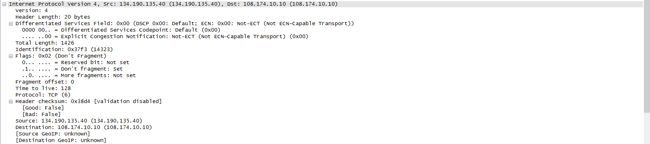

0 16 31

|  |  |  |  |  |  |  |
| --- | --- | --- | --- | --- | --- | --- |
| IP version:4 | Header  Length: 20 bytes | Type of service: 0x00 | Total length: 1426 | | | |
| Identification: 0x37f3 | | | R:0 | DF:1 | MF:0 | Fragment Offset: 0 |
| Time-to-live:128 | | Protocol: TCP(6) | Header Checksum: 0x38d4 | | | |
| Source IP Address: 134.190.135.40 | | | | | | |
| Destination IP Address: 108.174.10.10 | | | | | | |

R: Reserved bit, DF: Don’t fragment, MF: more fragment

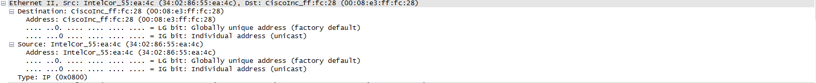

Ethernet Header:

|  |  |  |  |
| --- | --- | --- | --- |
| Destination Address:  00:08:e3:ff:fc:28 | Source Address:  34:02:86:55:ea:4c | Type: IP (0x0800) | DATA |

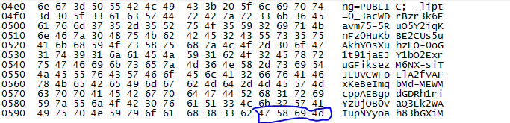

Ethernet trailer: 47 58 69 4d

Cpp programs and files are in question2 folder

1. How to use:

Compile program first: g++ -o q21 q21.cpp

Run program command: ./q21 input_filepath

Example: ./q21 text.txt

BinaryStream.txt contains bit stream

ReconvertedText.txt contains reconverted text.

1. (a)

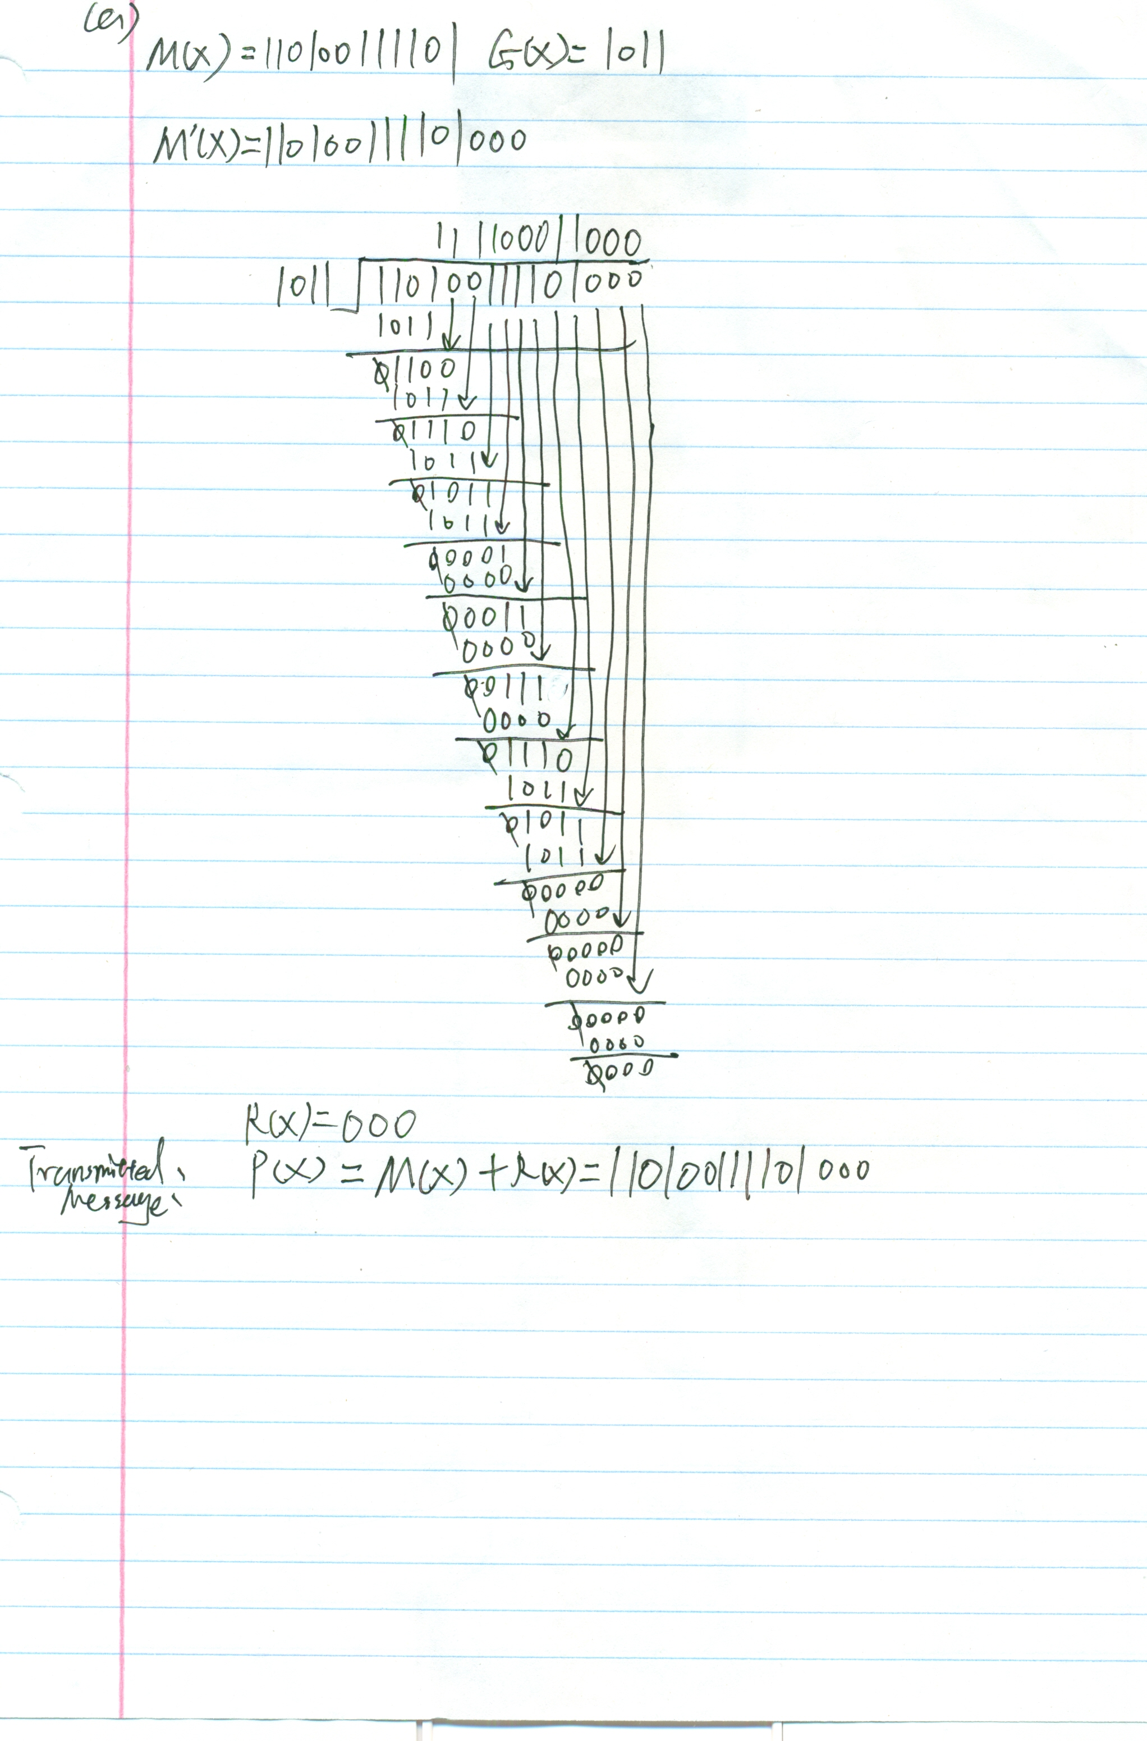

3(b)

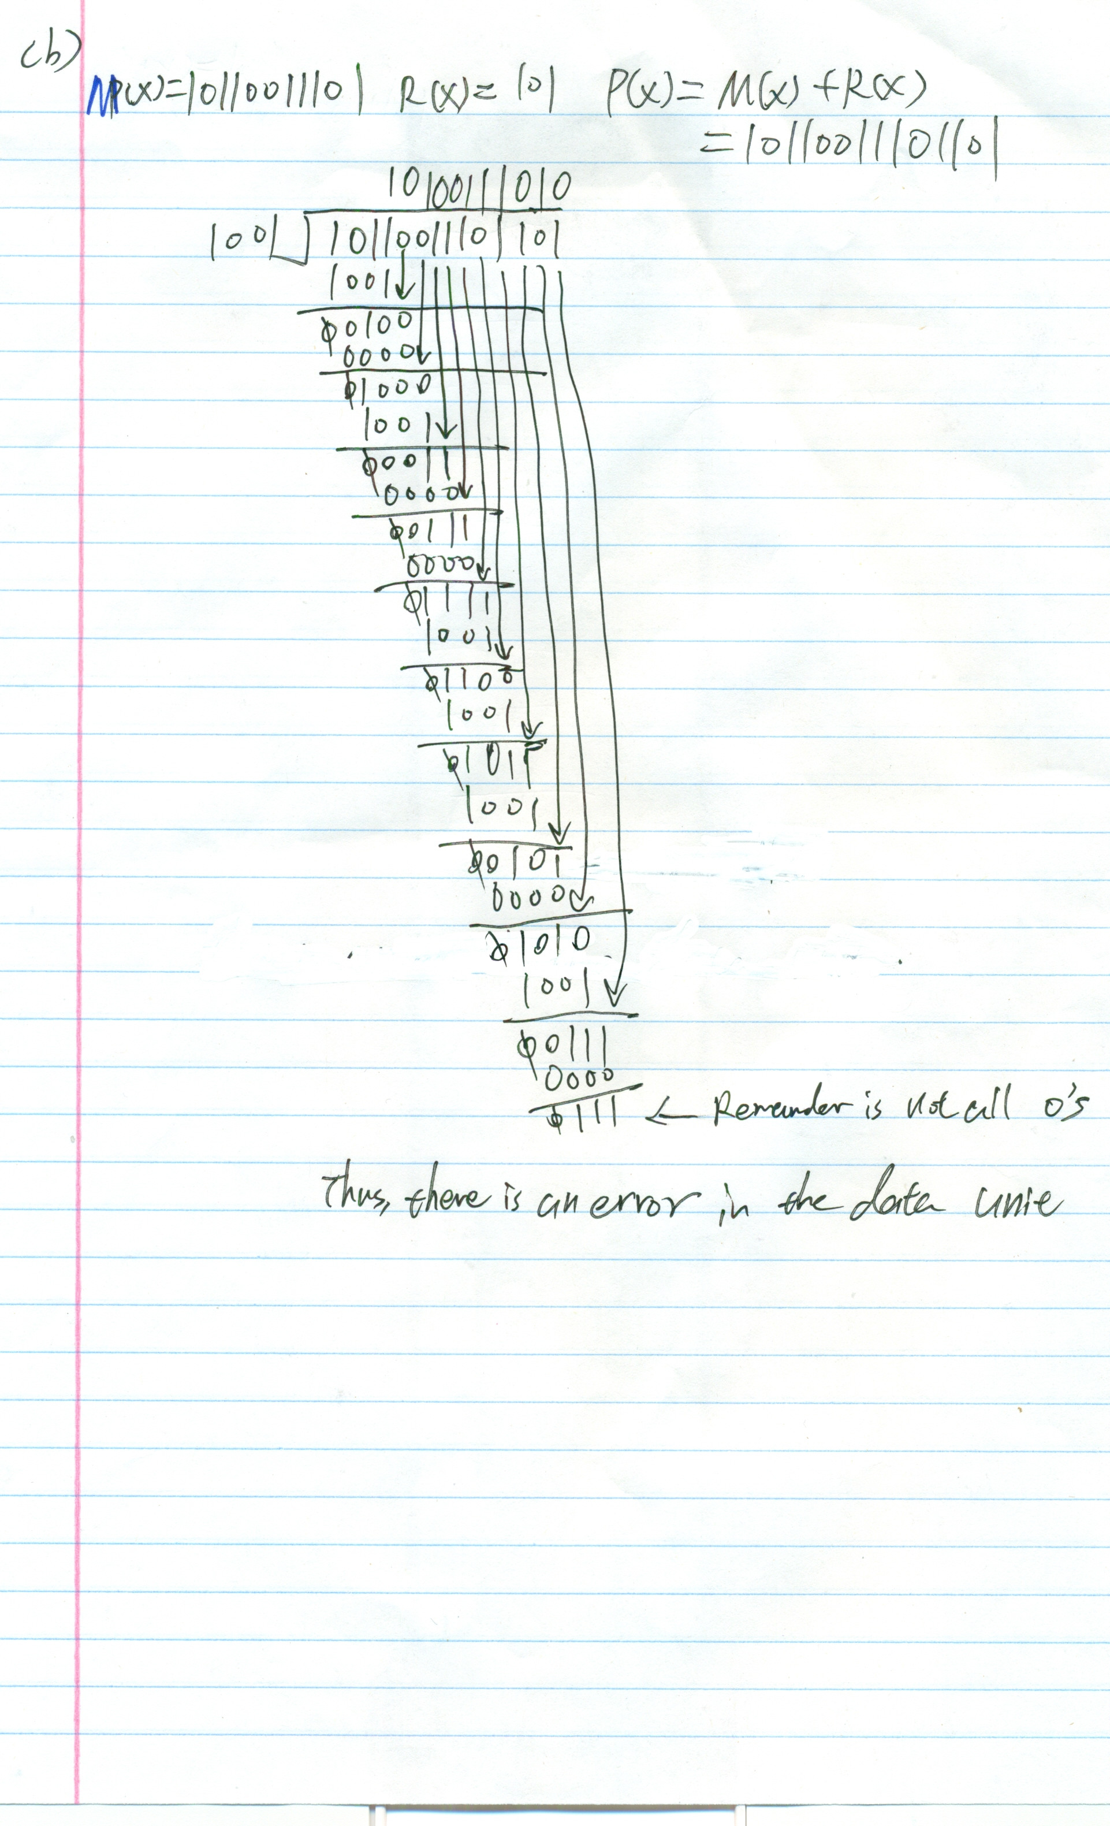

3(c)

q3.cpp is in the question3 folder

Test 1:

G(x)=1101

M(x)=1101011

Test received message: 1101011010

Test G(x)=1101

**Input and output:**

zyang@bluenose:~/csci4171/assignment2$ ./q3

Please input Message to be sent:

1101011

Please input reference polynomial in binary:

1101

Please input received message:

1101011010

Please input reference polynomial for received message:

1101

Test Result

CRC remainder:

010

Actual message to be transmitted:

1101011010

Error Check

There is no error for received message: 1101011010

**Test example2:**

G(x)=11001

M(x)= 10110011

Test received message: 1000000010000

Test G(x)=11001

**Input and output example:**

zyang@bluenose:~/csci4171/assignment2$ ./q3

Please input Message to be sent:

10110011

Please input reference polynomial in binary:

11001

Please input received message:

1000000010000

Please input reference polynomial for received message:

11011

Test Result

CRC remainder:

0100

Actual message to be transmitted:

101100110100

Error Check

There is an error for received message: 1000000010000

(d)

Cpp program q34.cpp is in the folder question3.

I set bit error to 30 bits ,32 bits, 40 bits

Output from the q34.cpp:

zyang@bluenose:~/csci4171/assignment2$ ./q34

30

Error/Time of tests: 1000/1000

==========================

32

Error/Time of tests: 1000/1000

==========================

40

Error/Time of tests: 1000/1000

==========================

|  |  |  |
| --- | --- | --- |
| Burst error length | Number of frames | Number of frames in which error was detected |
| 30 bits | 1000 | 1000 |
| 32 bits | 1000 | 1000 |
| 40 bits | 1000 | 1000 |