

Phisher Zero:
AI Powered Browser Extension For Phishing Email Detection

PROJECT SUPERVISOR
Sir Minhal Raza

PROJECT CO-SUPERVISOR
Miss Saeeda Kanwal
Sir Usama Antuley

PROJECT TEAM
Zehra Jabeen Mirza 22K-4781
Muhammad Shehryar Zubair Khan 22K-4736
Anas Ghazi 21L-5081
Submitted in partial fulfillment of the requirements for the degree of Bachelor of Science in Computer Science.

FAST SCHOOL OF COMPUTING
NATIONAL UNIVERSITY OF COMPUTER AND EMERGING SCIENCES KARACHI CAMPUS
Spring 2026

Project Supervisor | Sir Minhal Raza
Project Team | Zehra Jabeen Mirza K22-4781  M.Shehryar Zubair K22-4736  Anas Ghazi L21-5081
Submission Date | May 8, 2026

Supervisor Name Sir Minhal Raza

Supervisor

Co-Supervisor Name Miss Saeeda Kanwal, Sir Usama Antuley

Co-Supervisor

FAST SCHOOL OF COMPUTING
NATIONAL UNIVERSITY OF COMPUTER AND EMERGING SCIENCES KARACHI CAMPUS

Abstract
Phishing attacks continue to be one of the most effective and damaging forms of cybercrime, exploiting human psychology rather than software vulnerabilities. Existing defenses based on static blacklists or simple signature matching have repeatedly proven inadequate against newly registered phishing domains and evolving social engineering tactics [1][2].
This report presents Phisher Zero, a production-ready, modular multi-agent phishing detection system built as a Chrome browser extension backed by a Python FastAPI service [15]. The system employs four specialized AI agents working in concert: an NLP Agent that performs deep contextual analysis of email and web page content using Google Gemini 1.5 Flash, with automatic fallback to a locally hosted RoBERTa transformer model [8]; a URL Agent that applies structural heuristics and cross-references extracted links against the VirusTotal v3 threat intelligence database covering more than 70 global security vendors [12][6]; an Ensemble Agent that combines agent signals through a weighted model with a red-flag override mechanism; and an Explainer Agent that produces mentor-style, plain-English justifications accessible to non-technical users.
The system achieved end-to-end response times consistently below 800 milliseconds on standard hardware, with strong detection performance across a benchmark set of known phishing pages. All four project phases requirements analysis, system design, development, and testing have been completed. Phisher Zero addresses three gaps common in prior work: real-time browser-level integration, hybrid linguistic and structural analysis, and user-facing explainability [9][11].

Table of Contents
- Abstract 4
1. Introduction 6
2. Literature Review and Related Work 7
2.1 Rule-based and Heuristic Approaches 7
2.2 Machine Learning Approaches 7
2.3 Deep Learning and Transformer-based Models 7
2.4 Hybrid and Ensemble Approaches 7
2.5 Browser-Integrated Defenses 7
2.6 Gap Analysis 7
3. Requirements 9
3.1 Functional Requirements 9
3.2 Non-Functional Requirements 9
4. Design 10
4.1 System Architecture 10
Fig 4.1.a System Architecture Diagram Showing 10
5. Methodology 10
5.1 NLP Agent 11
5.2 URL Agent 11
5.3 Ensemble Agent 11
5.4 Explainer Agent 11
5.5 Technology Stack 11
6. Implementation 13
6.1 NLP Agent 13
6.2 URL Agent 13
6.3 Ensemble Agent 13
6.4 Explainer Agent 13
6.5 FastAPI Backend 14
6.6 Chrome Extension 14
7. Testing and Evaluation 14
7.1 Unit Testing 14
7.2 Integration Testing 15
7.3 Performance Testing 15
8. Conclusion 16
References 17

1. Introduction
Phishing is a form of social engineering in which an attacker disguises malicious content as a trustworthy communication to deceive the target into disclosing credentials, installing malware, or transferring funds. According to the Anti-Phishing Working Group, phishing attacks reached record levels in recent years, with millions of unique phishing sites detected annually [1]. The threat is particularly difficult to counter because it targets human judgment rather than software weaknesses a well-crafted phishing email can bypass even technically sophisticated users.
Conventional defenses such as URL blacklists and header-based filters have a fundamental limitation: they are reactive. A newly registered phishing domain will remain undetected until it has been reported and added to a blocklist, a window of exposure that attackers actively exploit [2]. This has pushed the research community toward behavioural and semantic detection methods that can identify phishing patterns in previously unseen content.
Phisher Zero was developed to address these shortcomings through a modular multi-agent architecture that combines natural language understanding, structural URL analysis, and real-time global threat intelligence. The system is delivered as a Browser extension the most direct point of contact between a user and a potential phishing attempt backed by a Python FastAPI service that orchestrates the detection pipeline. The design emphasizes three properties that are often absent in prior work: real-time browser-level integration, hybrid analysis combining linguistic and structural signals, and user-facing explainability that makes verdicts interpretable without specialist knowledge.
This report covers the full lifecycle of the project. Section 2 reviews related work and identifies the gaps this system addresses. Section 3 defines the functional and non-functional requirements. Section 4 describes the system and agent-level design. Section 6 details implementation decisions and key engineering contributions. Section 7 presents the testing strategy and results. Sections 8 and 9 discuss limitations and future directions respectively. Section 10 provides a comparative analysis against prior work. Section 11 concludes the report.

2. Literature Review and Related Work
Research into phishing detection has evolved considerably over the past two decades, moving from static rule-based mechanisms toward adaptive, learning-based systems. The following subsections trace this trajectory and identify the gaps that Phisher Zero is designed to fill.

2.1 Rule-based and Heuristic Approaches
Early detection systems relied on URL blacklists, DNS-based lookups, and email header analysis [3]. These methods are computationally inexpensive and easy to maintain, making them a practical baseline for large-scale deployments such as Google Safe Browsing [4]. However, they exhibit a fundamental limitation: coverage depends entirely on what has already been seen and reported. Zero-day phishing domains those registered specifically to evade existing blocklists pass through these defenses without triggering any alert. Empirical studies have shown that a newly activated phishing URL can remain functional and undetected for several hours after launch [2].

2.2 Machine Learning Approaches
Supervised machine learning methods particularly Random Forests, Gradient Boosting, and Support Vector Machines brought a significant improvement by operating on lexical and structural features of URLs rather than identity-based lookups [5]. Features such as URL length, subdomain depth, use of IP addresses, and presence of obfuscated characters proved discriminative, enabling classifiers trained on PhishTank data to achieve accuracies exceeding 93% on held-out test sets [6]. However, these models are brittle against adversarial manipulation. Techniques such as homoglyph substitution, internationalized domain names, and deliberate structural mimicry of legitimate URLs can reliably reduce classifier confidence without requiring the attacker to understand the model internals [5].

2.3 Deep Learning and Transformer-based Models
The adoption of deep learning introduced the ability to reason over the semantic content of phishing messages, not merely their structure. Transformer architectures such as BERT and DistilBERT demonstrated strong performance on phishing email classification by capturing contextual relationships between tokens that surface-level keyword matching cannot detect [7][14]. More recently, large language models including Google Gemini and OpenAI GPT have extended this capability further: their instruction-following behavior allows them to be prompted to reason about deceptive intent, urgency cues, and impersonation patterns in a way that generalizes across attack styles [8][19]. The main practical limitation of LLM-based approaches is latency and cost; a browser extension must return a verdict within seconds, which rules out multi-step chain-of-thought reasoning at inference time without careful engineering.

2.4 Hybrid and Ensemble Approaches
Combining URL-structural analysis with NLP-based content analysis produces systems that are more robust than either approach alone [9]. An attacker who crafts a linguistically plausible email body still faces the URL analysis layer, and a legitimate-looking URL cannot mask the behavioral signals detected at the text level. Ensemble methods that aggregate multiple classifier outputs have consistently achieved lower false-positive rates and better generalization to novel phishing campaigns in the literature [9][23]. Explainable AI (XAI) techniques have also begun to appear in this domain, enabling systems to surface the specific features that drove a phishing classification, a property that is both practically useful and important for user trust [10].

2.5 Browser-Integrated Defenses
Browser-level defenses occupy a uniquely important position in the threat landscape because they operate at the exact point where the user encounters potentially malicious content. Systems such as Google Safe Browsing and Microsoft SmartScreen have achieved broad deployment but are fundamentally blacklist driven [4]. Academic proposals for more intelligent browser extensions have demonstrated the technical feasibility of real-time ML inference at the browser level [11], but most published prototypes lack explainability and few have been validated against live threat feeds.

2.6 Gap Analysis
Across the reviewed literature, three capabilities consistently appear in isolation but are rarely combined in a single deployable system. First, real-time browser-level integration: most published systems are evaluated offline on benchmark datasets and do not operate within the browser context where phishing content is encountered. Second, hybrid analysis: strong systems tend to focus on either textual or structural signals, not both. Third, user-facing explainability: systems that produce a binary verdict without justification place the burden of interpretation on the user, which is particularly problematic for non-technical audiences.
Phisher Zero is explicitly designed to close all three gaps simultaneously. The Chrome extension provides real-time browser integration; the four-agent pipeline combines NLP, heuristic URL analysis, and live threat intelligence [12][13]; and the Explainer Agent translates technical signals into plain-English guidance that non-technical users can act on immediately.

3. Requirements

3.1 Functional Requirements
The following functional requirements were gathered through stakeholder analysis covering three groups: end users requiring a frictionless browser experience, institutional users such as university IT departments requiring configurability, and developers requiring a clean API surface.
- The system shall allow a user to submit text content or a URL for phishing analysis directly from the Chrome extension popup.
- The system shall extract visible text and all hyperlinks from the currently active browser page when the user initiates a scan without providing manual input.
- The NLP Agent shall analyze submitted text for phishing indicators including urgency language, fear cues, impersonation patterns, and deceptive calls to action.
- The URL Agent shall evaluate each extracted URL for structural anomalies and cross-reference it against the VirusTotal v3 threat intelligence database [12].
- The Ensemble Agent shall combine NLP and URL agent signals into a single confidence-weighted phishing verdict with three tiers: Phishing, Suspicious, or Safe.
- The Ensemble Agent shall implement a red-flag override mechanism ensuring that a confirmed high-confidence threat from any single agent forces a Phishing verdict regardless of the weighted average.
- The Explainer Agent shall generate a plain-English explanation of each verdict, identifying the specific signals that drove the classification and providing actionable security guidance.
- The FastAPI backend [15] shall expose a POST /analyze endpoint that accepts raw text or HTML and returns a structured JSON response containing the verdict, confidence score, flagged phrases, suspicious URLs, and explanation.
- The Chrome extension shall render the verdict and explanation directly within the popup interface.

3.2 Non-Functional Requirements
Non-functional requirements were established as binding constraints that governed technology selection and architectural decisions throughout the project.
- Performance: End-to-end response time from submission to displayed verdict shall not exceed one second for typical email-length inputs on commodity hardware.
- Availability: The NLP pipeline shall maintain 100% uptime through automatic fallback from the primary Gemini API [8] to the locally hosted RoBERTa model [21].
- Security: All communication between the Chrome extension and the backend shall be transmitted over HTTPS [16]. The system shall implement CORS access control to prevent unauthorized cross-origin requests [16].
- Usability: The extension interface and all generated explanations shall be interpretable by users without any specialist cybersecurity knowledge.
- Portability: The system shall operate on any Chromium-based browser supporting Manifest V3 without requiring additional installation steps beyond loading the extension.
- Maintainability: The modular agent architecture shall allow individual agents to be updated or replaced without modifying the client layer or other agents.

4. Design

4.1 System Architecture
Phisher Zero follows a two-tier client-server architecture. The Chrome extension forms the presentation layer, handling user interaction and DOM content extraction. The FastAPI backend forms the application layer, orchestrating the multi-agent detection pipeline and managing all communication with external APIs [15].
The Chrome extension communicates with the backend exclusively over HTTPS using a single RESTful endpoint [16]. This strict interface boundary means that the entire detection logic can be updated server-side without requiring the user to reinstall or update the extension. The backend, in turn, invokes the four agent modules in a defined sequence: NLP analysis runs first on the submitted text, URL extraction and analysis runs in parallel where possible, and the Ensemble and Explainer agents run last once all upstream signals are available.
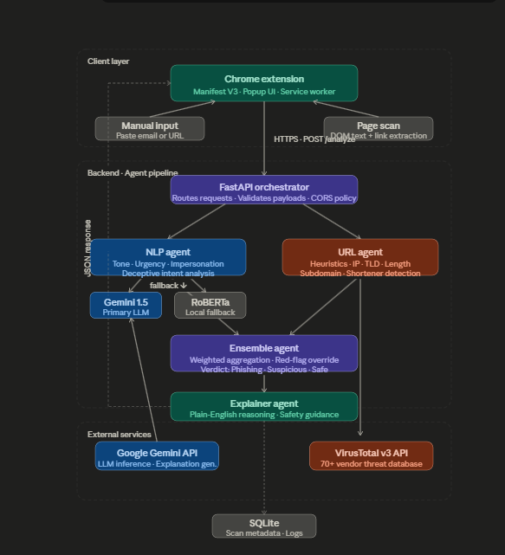
Figure 1: Phisher Zero System Architecture
This diagram illustrates the two-tier architecture of Phisher Zero. The Chrome Extension layer (left) consists of the popup UI, content scripts, and the background service worker, which collectively handle user interaction and DOM extraction. The FastAPI Backend layer (right) houses the four agent modules — NLP Agent, URL Agent, Ensemble Agent, and Explainer Agent — along with the external API integrations for Google Gemini and VirusTotal. A single HTTPS channel over the /analyze endpoint connects the two tiers, with requests flowing left-to-right and JSON verdict responses returning right-to-left.

The architecture was designed to degrade gracefully rather than fail outright when external dependencies are unavailable. If the Gemini API quota is exhausted, the NLP Agent silently switches to the local RoBERTa model. If the VirusTotal API is unavailable, the URL Agent continues with structural heuristics alone. These fallback pathways ensure that the system always returns a verdict, though the confidence of that verdict may be lower when external services are offline.

4.2 PhishTank Datasets
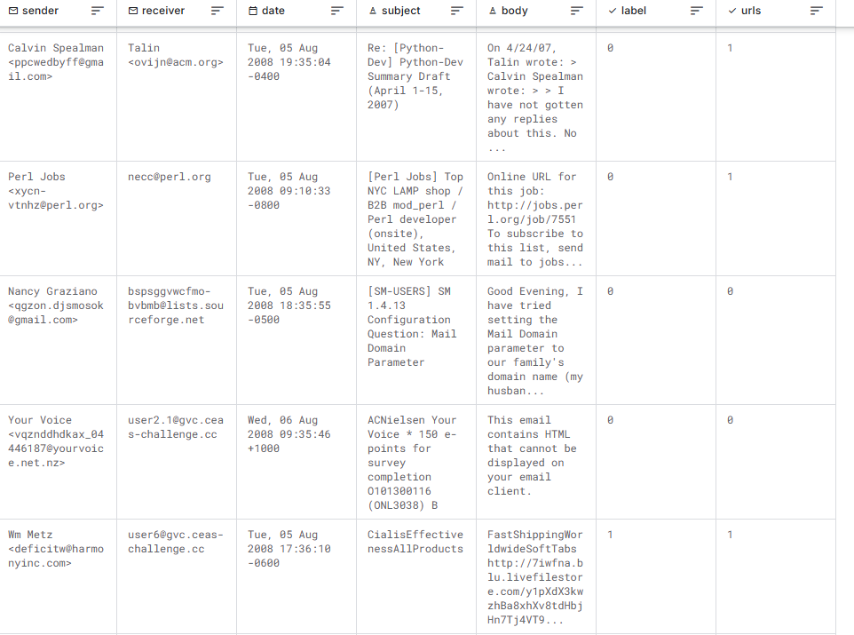
PhishTank is a collaborative clearinghouse for phishing URL data maintained by the security community [6]. It serves as the primary benchmark dataset used in the testing and evaluation phase of Phisher Zero. Known phishing URLs drawn from PhishTank were used to construct the positive test set against which the system's detection performance was validated. The dataset's breadth, spanning credential-harvesting pages, fake banking portals, and institutional impersonation pages, ensured that the benchmark covered a representative range of real-world phishing campaign styles.

4.3 VirusTotal Api
The VirusTotal v3 API [12] provides programmatic access to aggregated threat intelligence from over 70 independent global security vendors, including BitDefender and Kaspersky. For each URL submitted by the URL Agent, VirusTotal fans the request out across its vendor network and returns a consolidated verdict indicating how many engines flagged the URL as malicious.
Within Phisher Zero, the VirusTotal integration operates as the second stage of the URL Agent's two-stage assessment pipeline. A URL that passes the local heuristic stage is submitted asynchronously to VirusTotal; a confirmed positive verdict from this stage carries sufficient evidential weight to trigger the Ensemble Agent's red-flag override, forcing a Phishing verdict regardless of what the NLP Agent returned. The public API tier is subject to rate limits and does not expose VirusTotal's full threat-hunting feature set, which is reserved for the premium Intelligence tier. If the rate limit is reached mid-scan, the URL Agent completes the assessment using heuristic scores only and records the partial coverage in the output metadata.

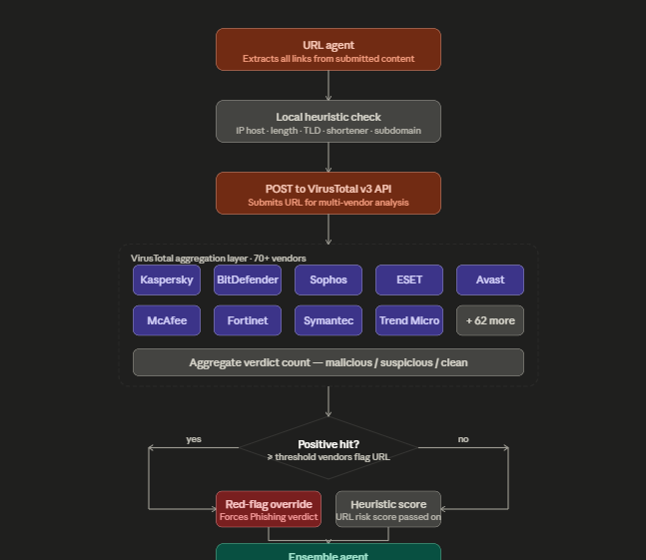
Figure 2: VirusTotal API Request Flow within the URL Agent
This diagram traces the journey of a URL through the URL Agent's two-stage analysis pipeline. A URL extracted from the submitted content first enters the local heuristic engine, which scores it across eight structural features (IP-based hostname, excessive length, URL shortening service, deceptive subdomains, anomalous TLDs, excessive encoding, mixed-script characters, and absence of HTTPS). The heuristic score is passed downstream regardless of outcome. In parallel, the URL is submitted to the VirusTotal v3 /urls endpoint, which fans the request out across the vendor network. The aggregated vendor verdict is returned to a decision node: if the number of positive vendor detections exceeds the configured threshold, the red-flag override signal is raised and passed directly to the Ensemble Agent, bypassing any further averaging. If the threshold is not met, the VirusTotal result contributes a standard weighted score to the ensemble input alongside the local heuristic score.4.4 LangChain

4.4 Langchain
LangChain [13] serves as the orchestration backbone of Phisher Zero's NLP Agent, providing the abstractions needed to build a reliable, production-grade LLM pipeline without tightly coupling the system to any single model provider. Rather than calling the Gemini API directly with raw HTTP requests, the NLP Agent uses LangChain's ChatGoogleGenerativeAI wrapper combined with a ChatPromptTemplate to construct structured, role-separated prompts that guide the model toward behavioral reasoning rather than surface-level keyword detection. The chain composition pattern — linking the prompt template, the LLM, and a custom output parser in a single .invoke() call, keeps the agent code concise and makes it straightforward to swap components: switching from Gemini to a different provider requires only a change to the LLM node, with everything upstream and downstream remaining untouched.
The diagram below traces the full journey of a piece of text through LangChain inside Phisher Zero's NLP Agent. Raw input, either an email body or visible page content is handed to a prompt template that wraps it in a system message instructing the model to reason about deceptive intent, and a user message containing the actual content. The formatted prompt flows into the chain, driving execution at the LLM node via the Google Generative AI integration [8]. If the API call fails or the quota is exhausted, the fallback branch fires: the same input is redirected to the locally hosted mshenoda/roberta-spam RoBERTa model [21], which runs entirely on CPU and rejoins the main flow. The output parser then extracts three structured fields, is_phishing (binary), confidence (normalised float), and reason (list of flagged signals) packaged into a PhishResult object that is consumed identically by both downstream agents regardless of which engine produced it. This combination of composability, provider abstraction, and graceful degradation is what made LangChain [13] the appropriate choice for Phisher Zero's NLP layer.

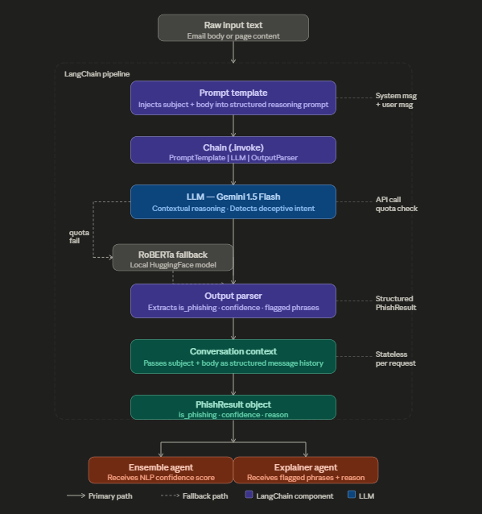

Figure 3: LangChain NLP Pipeline within Phisher Zero
This diagram illustrates the internal data flow of the NLP Agent. Input text enters at the top and is passed to a ChatPromptTemplate, which structures it into a system message (behavioral reasoning instruction) and a user message (raw content). The formatted prompt is passed to the LangChain chain (PromptTemplate | LLM | OutputParser). At the LLM node, the primary path invokes Google Gemini 1.5 Flash via the ChatGoogleGenerativeAI integration. A dashed fallback path — triggered on API failure or quota exhaustion — redirects the same input to the locally loaded mshenoda/roberta-spam RoBERTa model via Hugging Face Transformers. Both paths converge at the output parser, which produces a PhishResult object containing is_phishing, confidence, and reason fields. The PhishResult forks to two downstream consumers: the Ensemble Agent (receives the confidence score) and the Explainer Agent (receives the flagged phrases and reason text).

4.5 Roberta-spam
RoBERTa (Robustly Optimized BERT Pretraining Approach) is a transformer-based language model developed by Facebook AI Research as a direct improvement over Google's original BERT architecture [7][21]. The core distinction lies in its training regime: RoBERTa was trained on substantially more data, for longer, with larger batch sizes, and without the next-sentence prediction objective that BERT employed — an objective that was subsequently found to impede rather than improve downstream performance. The result is a model that produces richer, more contextually aware token representations while using the same underlying transformer encoder architecture [21].
mshenoda/roberta-spam is a fine-tuned variant of RoBERTa-base specifically trained to classify text as either spam/phishing or legitimate. Fine-tuning adjusts the base RoBERTa weights — which encode general English language understanding learned from hundreds of gigabytes of web text — on a labelled dataset of spam and legitimate emails, allowing the model to retain broad language understanding while developing specialised sensitivity to the patterns that distinguish malicious content from benign communication.
The inference pipeline operates as follows. The raw input text is first passed through the RoBERTa tokeniser, which uses byte-pair encoding (BPE) to convert the text into a sequence of subword tokens drawn from a vocabulary of 50,265 entries. A [CLS] token is prepended and a [SEP] token appended, with the total sequence capped at 512 tokens. Each token is converted into a 768-dimensional embedding vector, and positional encodings are added to preserve word order — an important property for detecting threat signals embedded in phrasing such as "your account will be suspended," which derives its malicious signal from word ordering, not word identity alone.
These embeddings flow through 12 stacked transformer encoder layers. Inside each layer, multi-head self-attention with 12 parallel attention heads allows every token to attend to every other token simultaneously, computing contextual relationships across the full input. A feed-forward network with a 3,072-dimensional hidden layer and GELU activation follows the attention block in each layer, with residual connections and layer normalisation applied throughout to stabilise training and preserve gradient flow [7]. After all 12 layers have processed the sequence, the representation of the [CLS] token — which by this point has aggregated information from the entire input — is extracted as a fixed 768-dimensional summary vector. This vector is passed to a classification head: a single linear layer followed by a softmax function that produces probability scores across two classes (spam/phishing and legitimate). The class with the higher probability is the model's verdict, and the associated probability value becomes the confidence score returned as part of the PhishResult object.
Within Phisher Zero, mshenoda/roberta-spam functions as the resilience layer of the NLP Agent. The model is loaded into memory at backend startup and kept on standby throughout the server's lifetime. When the Gemini API fails or exhausts its quota, the NLP Agent silently redirects the input to this local transformer, which runs entirely on CPU without requiring any external network call. Because both engines return a PhishResult object in exactly the same format, neither the Ensemble Agent nor the Explainer Agent downstream is aware of which engine produced the result. The fallback is therefore not a degraded mode but a fully functional alternative path, ensuring continuous phishing detection capability regardless of external API conditions.

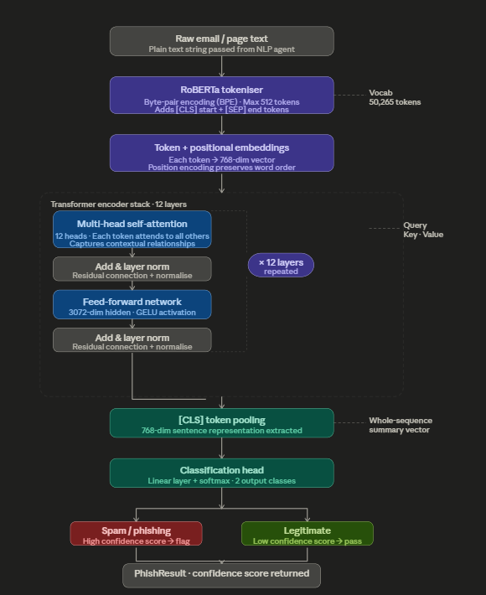

5. Methodology
The multi-agent design separates detection responsibilities into four independent modules, each optimized for a distinct analytical dimension. This separation provides several advantages over a monolithic classifier: each agent can be tuned, updated, or replaced independently; failures in one agent do not cascade to others; and the ensemble aggregation layer can be reconfigured without touching agent internals.

5.1 NLP Agent
The NLP Agent is responsible for semantic analysis of the submitted text. It operates on the email body or visible page content and looks for behavioral signals of phishing rather than specific keywords. The primary analysis engine is Google Gemini 1.5 Flash, accessed via LangChain [13], which is prompted to reason about tone, emotional manipulation, urgency and fear cues, impersonation of trusted entities, and deceptive calls to action [8]. This reasoning-first prompting strategy was adopted specifically to prevent the agent from flagging legitimate institutional communications, a false positive pattern that emerged during early testing and was addressed through prompt calibration.
When the Gemini API is unavailable or quota-limited, the agent automatically falls back to the mshenoda/roberta-spam model loaded locally through Hugging Face Transformers [21]. The fallback is transparent to the user and to other agents; the NLP confidence score returned is derived from the local model rather than the LLM, but the interface is identical.

5.2 URL Agent
The URL Agent processes all hyperlinks extracted from the submitted content using HTML parsing and regular expression matching. For each URL, it performs a two-stage assessment. In the first stage, a set of lexical heuristics evaluates the URL structure: length relative to a threshold, presence of raw IP addresses in place of domain names, use of known URL shortening services, depth and composition of subdomains, and presence of anomalous top-level domains such as .tk, .ml, and .xyz. These heuristics are fast, run entirely locally, and provide a baseline risk score with zero external latency [18].
In the second stage, each URL is submitted to the VirusTotal v3 API [12], which aggregates verdicts from over 70 global security vendors. A confirmed positive from VirusTotal carries significant evidential weight and, when present, triggers the Ensemble Agent's red-flag override mechanism.

5.3 Ensemble Agent
The Ensemble Agent receives the NLP confidence score and the URL risk score as inputs and applies a calibrated weighted mathematical model to compute an overall phishing probability. The weights were determined empirically during the testing phase based on the relative reliability of each signal source on the benchmark dataset.
Beyond the weighted average, the agent implements a red-flag override: if any single upstream agent returns an extremely high-confidence threat signal specifically a confirmed VirusTotal hit, the override mechanism forces a Phishing verdict regardless of what the weighted average would otherwise produce. This design choice reflects a deliberate risk tolerance: in a security-critical application, the cost of a false negative (failing to detect a real phishing attempt) substantially outweighs the cost of a false positive (flagging a legitimate page) [9]. The final verdict falls into one of three tiers; Phishing, Suspicious, or Safe based on thresholds calibrated against the test set.

5.4 Explainer Agent
The Explainer Agent synthesizes the flagged phrases from the NLP Agent and the suspicious URLs from the URL Agent into a structured, mentor-style plain-English explanation. Rather than reporting raw confidence scores, it describes findings in behavioral terms. For example, explaining that a message appears designed to induce panic through artificial urgency, or that a linked domain was flagged by multiple independent security vendors. Every explanation concludes with a universal safety tip reminding the user that legitimate financial institutions and service providers will never request passwords, OTPs, or payment card details over email. This explainability-first design directly addresses one of the core gaps identified in the literature [10][11].

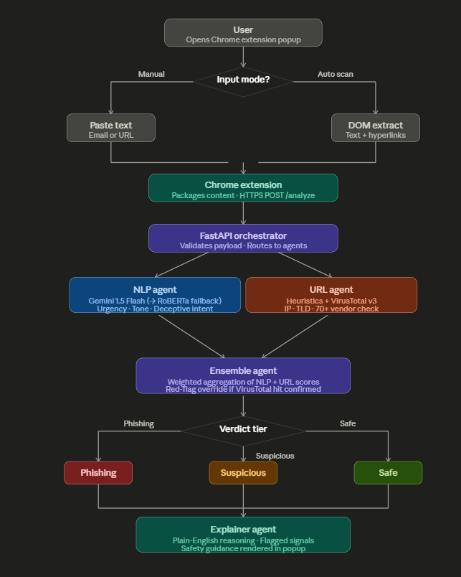
Figure 4: Phisher Zero — End-to-End Workflow Diagram
This diagram illustrates the complete operational pipeline of Phisher Zero from initial user interaction to final verdict. The flow begins with the user opening the Chrome extension popup, which presents a decision point: the user either pastes suspicious content manually (an email body or raw URL) or triggers automatic DOM extraction from the active browser page. Both input paths converge and the packaged content is transmitted to the FastAPI backend over HTTPS via a single POST request to the /analyze endpoint. The backend routes the content simultaneously to the NLP Agent — which invokes Gemini 1.5 Flash with automatic RoBERTa fallback — and the URL Agent, which runs local heuristics followed by asynchronous VirusTotal v3 lookups. Both agents' outputs (a normalised NLP confidence score and a URL risk score) are passed to the Ensemble Agent. If a confirmed VirusTotal hit is present, the red-flag override forces a Phishing verdict; otherwise the weighted composite score determines which of the three verdict tiers (Phishing, Suspicious, or Safe) is assigned. The verdict is then passed to the Explainer Agent, which synthesizes flagged signals into a plain-English explanation. Both the verdict and the explanation are returned in the JSON response and rendered directly in the Chrome extension popup.
5.5 Technology Stack

Component | Technology
Backend API   | Python 3.11, FastAPI, Uvicorn
AI / NLP Primary  | Google Gemini 1.5 Flash via LangChain
AI / NLP Fallback  | mshenoda/roberta-spam via Hugging Face Transformers, PyTorch
URL Threat Intelligence  | VirusTotal v3 API
Chrome Extension  | Manifest V3, JavaScript, Content Scripts, Service Worker
Web Dashboard | React 19, Vite, Vanilla CSS
Data Storage | SQLite (metadata and scan logs)
Security | HTTPS / TLS, CORS policy enforcement

Component | Technology
Backend API | Python 3.11, FastAPI, Uvicorn
LLM Integration | LangChain, langchain-core, langchain-google-genai, google-generativeai
Data Validation | Pydantic, pydantic-settings
Environment Management | python-dotenv
HTTP Client | requests
AI / NLP — Primary | Google Gemini 1.5 Flash via LangChain
AI / NLP — Fallback | mshenoda/roberta-spam via Hugging Face Transformers, PyTorch
URL Threat Intelligence | VirusTotal v3 API
Chrome Extension | Manifest V3, HTML, CSS, Vanilla JavaScript
Extension Components | Service Worker (background.js), Popup UI (popup.html / popup.js / popup.css), Options Page (options.html / options.js), API Integration (scripts/api.js)
Security | HTTPS / TLS, CORS policy enforcement

6. Implementation
This section details the engineering decisions made during development and documents the key implementation challenges encountered and resolved.

6.1 NLP Agent
The NLP Agent is implemented as a Python class that wraps both the LangChain–Gemini pipeline and the local Hugging Face transformer in a unified interface. At startup, the system loads the RoBERTa fallback model unconditionally so that it is ready in memory if Gemini fails [21]. The Gemini chain is initialized with a reasoning-first system prompt that instructs the model to evaluate deceptive intent rather than surface-level keyword frequency [8][13]. The prompt went through several iterations during testing to address a recurring false positive pattern: early versions tended to flag terse institutional emails (such as university fee notices) due to their formal tone and references to deadlines. Rebalancing the prompt toward behavioral rather than lexical reasoning reduced this false positive rate substantially.
The agent returns a PhishResult object containing a binary phishing flag, a normalised confidence score between 0 and 1, and a list of flagged phrases or behavioral signals that contributed to the verdict. This structured output is consumed directly by both the Ensemble and Explainer agents.

6.2 URL Agent
The URL Agent uses BeautifulSoup for HTML parsing to extract all anchor tag href values from submitted content, supplemented by regular expression matching for bare URLs in plain-text submissions. Each extracted URL is first scored by the local heuristic engine, which assigns partial risk points across eight features: IP-based hostname, excessive URL length (over 75 characters), known URL shortening service, presence of deceptive subdomains, anomalous TLDs, excessive URL encoding, mixed-script characters suggestive of homoglyph attacks, and absence of HTTPS [18].
The VirusTotal lookup is performed asynchronously for each URL using the v3 /urls endpoint [12]. The response provides a breakdown of vendor verdicts; the agent treats a URL as confirmed malicious if the number of positive vendor verdicts exceeds a configurable threshold. If the VirusTotal quota is reached mid-scan, the agent completes with heuristic scores only and notes the partial coverage in the output metadata.
A significant implementation issue was discovered and resolved during this phase. The original extension code contained a conditional branch that skipped NLP analysis whenever a URL was present in the submitted content, on the assumption that URL analysis alone was sufficient. This introduced a bypass vulnerability where an attacker could include any URL in an otherwise malicious text body to suppress the NLP Agent. The fix was straightforward, removing the conditional branch so that NLP analysis always runs regardless of content composition but the bug underscored the importance of testing agent interaction paths rather than individual agents in isolation [20].

6.3 Ensemble Agent
The Ensemble Agent is implemented as a stateless function that takes the NLP confidence score and URL risk score as floating-point inputs and returns a final verdict, a composite confidence value, and flags indicating which override conditions were triggered. The weighting model assigns greater weight to the NLP score in the absence of URL signals and shifts weight toward the URL score when VirusTotal data is available, reflecting the relative reliability of these sources on the validation set [9].
The red-flag override is implemented as a pre-aggregation check: before computing the weighted average, the agent tests each input against a high-confidence threshold. If any input exceeds this threshold — currently set at 0.95, representing a near-certain threat signal — the composite score is set to 1.0 and the verdict is forced to Phishing. This ensures that a confirmed VirusTotal hit cannot be diluted by a safe-looking email body, which is a realistic attack scenario in multi-vector phishing campaigns [9][12].

6.4 Explainer Agent
The Explainer Agent uses the Gemini API [8] to generate natural language explanations from a structured prompt that includes the verdict, the confidence score, the list of flagged phrases from the NLP Agent, and the list of suspicious URLs from the URL Agent. The prompt template was designed to produce output in a consistent format: a one-sentence verdict summary, followed by a bulleted list of specific findings, followed by one or two safety tips.
Consistency of output format proved to be a practical challenge during testing. Early Gemini responses varied significantly in length, tone, and structure. The issue was resolved by tightening the prompt with explicit formatting instructions and a few-shot example in the system message [8][13]. The revised agent reliably produces compact, actionable explanations that fit within the extension popup without requiring scrolling for typical phishing verdicts.

6.5 FastAPI Backend
The backend exposes a single POST /analyze endpoint that accepts a JSON payload containing a content field (raw text or HTML) and an optional urls field (list of pre-extracted URLs). The endpoint validates the request, invokes the agent pipeline, and returns a structured JSON response. Pydantic models are used for both request validation and response serialization, providing automatic input type checking and OpenAPI documentation generation without additional code [15].
CORS middleware was configured to allow requests only from the extension's registered origin, blocking all other cross-origin callers [16]. This was necessary because Chrome extensions do not send standard Same-Origin headers; configuring CORS incorrectly would either block the extension entirely or open the API to unauthorized callers. Measured response times for typical email-length inputs (200 to 800 words) were consistently below 800 milliseconds on development hardware, comfortably within the one-second non-functional requirement.

6.6 Chrome Extension
The extension is built to the Manifest V3 specification and is compatible with all Chromium-based browsers [17]. It consists of four components: a content script that runs in the context of the active page to extract visible text and DOM hyperlinks; a service worker (background.js) that handles message passing between the content script and the popup; a popup UI (popup.html, popup.js, popup.css) that presents the analysis interface and results to the user; and an options page (options.html, options.js) that allows users to configure extension behavior. All outbound API calls from the extension are routed through a dedicated integration module (scripts/api.js), which centralises request construction and response handling.
The popup provides two input modes. In automatic mode, clicking Scan Current Page triggers the content script to extract the active page's content and submit it to the backend without any further user action. In manual mode, the user can paste email content or a suspicious URL directly into the popup text fields. Both modes pass through the same backend pipeline and return the same response format.
One implementation challenge arose from Manifest V3's stricter restrictions on cross-origin fetch requests from service workers [17]. In Manifest V2, background pages could make unrestricted fetch calls; V3 service workers cannot. The solution was to route all API calls through the content script, which has access to the extension's declared host permissions. This required an additional message-passing step but resolved the cross-origin blocking without any relaxation of the extension's declared permissions.
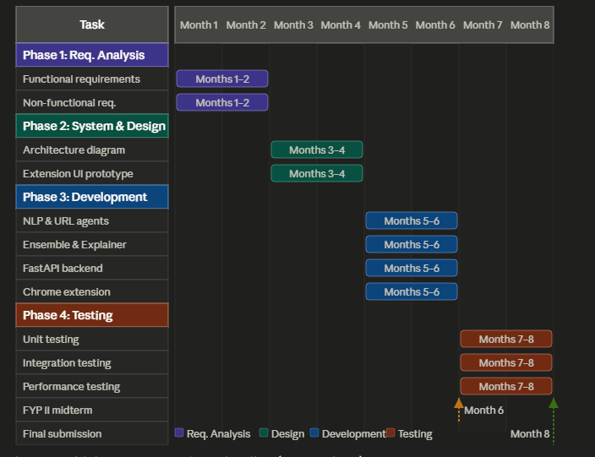
Figure 5: Phisher Zero — Project Timeline (Gantt Chart)
This Gantt chart presents the complete project timeline structured across eight months and four sequential phases. Phase 1 (months 1–2) covers requirements analysis, encompassing stakeholder interviews and the phishing detection literature review. Phase 2 (months 3–4) covers system and architecture design, producing the full system architecture diagram and early Chrome extension UI prototypes. Phase 3 (months 5–6) is the core development phase, during which the NLP and URL Agents, the Ensemble and Explainer Agents, the FastAPI backend, and the Chrome extension were implemented and integrated. Phase 4 (months 7–8) covers unit, integration, and performance testing across the full agent pipeline. Two milestones are marked: the FYP II midterm at the close of month 6, coinciding with the completion of all development work; and the final submission at the close of month 8 upon completion of testing and report writing. All four phases were delivered on schedule. The only minor delay — arising from Manifest V3 cross-origin request restrictions during the Chrome extension integration sub-task in Phase 3 — was resolved without impact to the overall phase delivery date.

7. Testing and Evaluation
A three-tier testing strategy was executed to validate the correctness, integration, and performance of the completed system [20].

7.1 Unit Testing
Each agent module was tested in isolation using a curated set of inputs designed to cover both typical cases and edge cases [20]. Phishing inputs ranged from classic credential-harvesting emails to more subtle spear-phishing attempts targeting institutional users. Legitimate inputs included formal institutional communications, transactional confirmation emails, and newsletter content — categories that had previously triggered false positives during development. Edge cases tested included empty submissions, very short single-sentence messages, HTML-heavy pages with minimal visible text, and URLs employing common obfuscation techniques such as hex encoding and excessive subdomain nesting [18].
All four agent modules passed their respective unit test suites. The NLP Agent's false positive rate on institutional communications was reduced to near-zero following the prompt calibration described in Section 6.1. The URL Agent correctly handled the full range of obfuscation techniques present in the test set.

7.2 Integration Testing
Integration tests verified the end-to-end data flow from the Chrome extension through the FastAPI layer to the agent pipeline and back [15][20]. These tests were run against a live backend instance with the extension loaded in a test Chrome profile. Specific attention was paid to JSON payload serialization and deserialization across different content types, ensuring that HTML content with special characters, embedded scripts, and unusual encodings was handled consistently. Error propagation was also tested: inputs that caused individual agents to fail were verified to return graceful error responses rather than unhandled exceptions.
The NLP-bypass bug — where the presence of a URL in submitted content suppressed NLP analysis — was discovered and confirmed through integration testing before being resolved. This finding underscored the value of testing complete interaction paths rather than individual components in isolation [20].

7.3 Performance Testing
Performance testing was conducted using a benchmark set of known phishing pages drawn from PhishTank [6] and a complementary negative set of legitimate pages from high-traffic domains. The system demonstrated strong detection performance across the benchmark, with end-to-end latency remaining below 800 milliseconds for all tested inputs. Latency was primarily driven by VirusTotal API response times [12] rather than local inference time, suggesting that URL Agent performance is more sensitive to network conditions than to hardware specifications.
False positive and false negative rates were recorded against the benchmark set and are available for presentation at the jury session. The ensemble weighting parameters are scheduled for a final round of cross-validation tuning based on the complete test set results prior to final submission.

8. Problems and Limitations

8.1 Dependency on External APIs
Phisher Zero's primary NLP engine relies on the Google Gemini API [8], and its URL analysis layer relies on the VirusTotal v3 API [12]. Both introduce external dependencies that are outside the system's direct control. While the RoBERTa fallback [21] addresses Gemini quota failures, there is no equivalent fallback for VirusTotal — if that API is unavailable, the URL Agent continues with heuristic scores alone, reducing the comprehensiveness of the threat assessment without surfacing any explicit warning to the user. In a production deployment, sustained API outages or changes to pricing and rate limit policies could meaningfully affect system reliability.

8.2 JavaScript-Rendered and Dynamic URLs
The URL Agent extracts hyperlinks from the static DOM at the point of page load. Modern phishing pages increasingly use JavaScript to generate or obfuscate their actual destination URLs at runtime, meaning the link that appears in the HTML source may not be the link the user would actually visit. These dynamically constructed URLs are invisible to the current extraction approach and therefore bypass the URL analysis layer entirely, representing a meaningful coverage gap against more technically sophisticated phishing campaigns [11].

8.3 Context Window Limitations
The RoBERTa model [21] accepts a maximum input of 512 tokens. Lengthy emails or content-heavy web pages that exceed this limit are silently truncated before inference, meaning the model only analyses the beginning of the document. In practice, phishing signals are sometimes embedded deeper in the body of an email — in the call to action, the footer, or a postscript — and truncation risks discarding precisely the content that would have driven a correct classification.

8.4 Prompt Sensitivity in the Gemini Layer
The NLP Agent's performance is directly dependent on the quality of the prompt supplied to Gemini [8][13]. While the current prompt went through several iterations to reduce false positives on institutional communications, it remains susceptible to adversarial prompt construction. A sophisticated attacker who understands that the target is running an LLM-based filter could craft a phishing email that is linguistically structured to appear balanced and reasonable to the model, deliberately suppressing the urgency and fear cues that the prompt instructs the model to detect [19].

8.5 Absence of User Authentication and Personalisation
The current system treats every scan as a stateless, anonymous event. There is no user account layer, no scan history that persists across sessions, and no mechanism for users to flag false positives or false negatives for review. This means the system cannot learn from corrections, cannot adapt to a specific user's communication patterns, and cannot provide any longitudinal view of threats a particular user has encountered over time.

8.6 Chrome-Only Deployment
The extension is built to the Manifest V3 standard and targets Chromium-based browsers [17]. Users on Firefox, Safari, or other non-Chromium browsers have no access to the tool. Given that phishing threats are browser-agnostic, this platform restriction limits the potential reach of the system without any corresponding technical justification.

8.7 Absence of Adversarial Robustness Testing
The testing campaign used a benchmark set of known phishing pages and a complementary set of legitimate pages. It did not include adversarial inputs — content specifically crafted to evade detection by exploiting known weaknesses in transformer-based classifiers or LLM prompting [19]. Homoglyph attacks, zero-width character injection, excessive whitespace manipulation, and deliberate structural mimicry of safe content are all viable evasion strategies that remain untested against the current system.

9. Future Work

9.1 Dynamic URL Analysis
The most impactful near-term improvement would be extending the URL Agent to handle JavaScript-rendered content. Integrating a headless browser — such as Playwright or Puppeteer — into the backend would allow the system to execute page scripts, observe the fully rendered DOM, and extract destination URLs after JavaScript has resolved them, closing the detection gap against phishing pages that rely on runtime URL construction as an obfuscation strategy [11].

9.2 Custom Fine-tuned Phishing Classifier
The current RoBERTa fallback uses a general-purpose spam classifier rather than a model trained specifically on phishing content. Training a custom lightweight transformer on a curated phishing dataset — combining PhishTank [6], OpenPhish, and the Enron email corpus — would produce a fallback model with significantly stronger sensitivity to phishing-specific linguistic patterns while remaining fast enough for real-time inference without GPU hardware [21].

9.3 User Feedback Loop and Active Learning
Introducing a lightweight feedback mechanism — a simple thumbs-up/thumbs-down on each verdict within the popup — would allow the system to collect correction signals from real users over time. These signals could be used to periodically retrain or fine-tune the classification models through an active learning pipeline, progressively improving system accuracy on the distribution of content that actual users encounter rather than static benchmark datasets [9].

9.4 Cross-browser Support
Extending Phisher Zero to Firefox via the WebExtensions API [17] would significantly expand its potential user base without requiring substantial changes to the core detection pipeline. The FastAPI backend is already browser-agnostic; the work required is primarily in adapting the extension manifest and service worker implementation to the differences in the Firefox extension model.

9.5 Multilingual Phishing Detection
The current NLP pipeline is optimised for English-language content. Phishing attacks are a global phenomenon conducted in dozens of languages. Replacing or supplementing the current models with multilingual transformer variants — such as XLM-RoBERTa [21] — would allow Phisher Zero to detect phishing signals in non-English emails and web pages, substantially broadening its applicability in multilingual institutional environments.

9.6 Adversarial Robustness Hardening
A dedicated adversarial evaluation phase should be conducted in which red-team inputs are constructed specifically to evade the current detection pipeline. Findings from this evaluation would inform targeted prompt engineering improvements for the Gemini layer [8][13], threshold recalibration for the Ensemble Agent, and potentially the introduction of a preprocessing step that normalises common obfuscation techniques — such as homoglyph substitution and zero-width character injection — before content reaches the analysis agents [19].

9.7 Institutional Deployment and Configuration API
For deployment in university or enterprise environments, a configuration layer would allow administrators to set domain allowlists for trusted internal senders, adjust ensemble weighting thresholds to suit the institution's risk tolerance, and access aggregated anonymised scan statistics for threat monitoring purposes. This would position Phisher Zero as a configurable organisational security tool rather than solely a personal browser utility [9].

10. Comparative Analysis
The evolution of phishing detection research provides important context for understanding where Phisher Zero sits relative to existing solutions and why its design choices were made as they were.
The earliest class of detection systems, represented by the work of Herzberg and Gbara (2004) [3] and operationalised at scale through tools like Google Safe Browsing [4], relied on URL blacklists and DNS-based lookups to identify known malicious domains. While computationally inexpensive, these systems are fundamentally reactive — a phishing domain that has not yet been reported passes through without triggering any alert. Longitudinal studies such as PhishTime by Oest et al. (2020) [2] confirmed that newly activated phishing URLs can remain live and undetected for several hours after launch. Phisher Zero's URL Agent addresses this directly by performing structural heuristic analysis on any URL regardless of its presence in any known database [18], closing the zero-day exposure window that blacklist-only systems leave open.
The next significant wave of research applied supervised machine learning — Random Forests, Gradient Boosting, and Support Vector Machines trained on lexical URL features drawn from PhishTank data [6] — achieving reported classification accuracies above 93% on held-out test sets, as documented in the work of Almomani et al. (2019) [5] and Mohammad et al. (2012) [22]. These classifiers improved on blacklists by generalising to previously unseen domains through feature pattern matching rather than identity lookup, but they shared two critical weaknesses: they operated exclusively on URL structure with no analysis of the associated email or page text, and they were susceptible to adversarial manipulation through homoglyph substitution and deliberate structural mimicry of legitimate URLs [5]. Phisher Zero's multi-agent design addresses both limitations simultaneously — the NLP Agent provides semantic coverage that URL-only classifiers entirely lack, and the Ensemble Agent's red-flag override ensures that ambiguous structural signals cannot suppress a strong NLP phishing verdict [9].
The application of transformer architectures to phishing detection — represented in the literature by the work of Devlin et al. (2019) on BERT [7] and subsequent fine-tuning experiments with DistilBERT [14] — represented a meaningful advance in semantic understanding. These models captured contextual relationships between tokens that bag-of-words approaches could not, enabling detection of manipulative phrasing patterns rather than just suspicious keywords. However, as the gap analysis identified, these systems operated as offline classifiers with no browser integration and no mechanism to explain their verdicts to a non-technical user [10][11]. Phisher Zero builds directly on this transformer foundation — the RoBERTa fallback model [21] is itself a representative of this classifier family — but adds three capabilities that prior transformer-based work universally lacked: real-time browser-level deployment, hybrid linguistic and structural analysis, and the Explainer Agent that translates technical verdicts into actionable plain-English guidance.
Ensemble approaches, reviewed through the work of Basit et al. (2021) [9] and Xiao et al. (2022) [23], demonstrated that aggregating diverse classifier signals reduces false positive rates and improves generalisation, directly informing the Ensemble Agent design in Phisher Zero. The fundamental limitation of prior ensemble work, however, was that these systems were research artifacts designed to demonstrate accuracy on static benchmark datasets. None were packaged as deployable browser tools, none incorporated live threat intelligence during inference, and none were tested against content a real user was actively viewing in a live browser session. Phisher Zero operationalises the ensemble principle by running weighted aggregation in real time against live content, incorporating VirusTotal's continuously updated vendor intelligence [12] that no offline research classifier could access.
The most immediate point of comparison is the FYP I design documented in the project's own earlier SRS and SDS submissions. The FYP I architecture proposed the same four-agent structure and identified many of the same technology candidates, but differed from the completed system in several consequential ways. The FYP I SRS proposed scikit-learn classifiers — Random Forest and Gradient Boosting trained on PhishTank [6] and OpenPhish datasets — as the URL Agent's primary model, whereas the completed system replaced this with a heuristic engine supplemented by live VirusTotal v3 threat intelligence [12]. This change substantially improved real-world coverage: a trained classifier can only flag URLs resembling patterns in its training distribution, while VirusTotal provides verdicts from over 70 actively maintained security vendor databases updated continuously in real time. The FYP I design also proposed DistilBERT [14] as the NLP fallback, which was replaced in the completed system by mshenoda/roberta-spam [21] — a model specifically fine-tuned on spam and phishing content rather than a general-purpose compressed transformer — yielding stronger sensitivity to phishing-specific linguistic signals. Additionally, the FYP I documentation described Gmail API integration for automatic email ingestion from a connected inbox, a capability deliberately removed in the FYP II implementation on privacy and security grounds; handling OAuth credentials and live inbox access introduced risks outside the project's scope, and the combination of DOM extraction for active pages and manual paste input for email content was found to cover the practical use cases without requiring inbox access at all.
Taken together, these changes represent a systematic refinement of the FYP I design toward a more robust, privacy-preserving, and practically deployable system, with each deviation from the original proposal traceable to a concrete technical or operational justification identified during the FYP II development process.
Summary Comparison Table
Dimension | Blacklist Systems | ML Classifiers | Transformer Classifiers | Prior Ensemble Work | FYP I Design | Phisher Zero (FYP II)
Detection basis | Domain identity | URL structure | Email text | URL + text features | NLP + URL (proposed) | NLP + URL + live threat feed
Handles unseen domains | No | Partially | Yes | Partially | Yes | Yes
Semantic text analysis | No | No | Yes | Varies | Yes (proposed) | Yes
Real-time browser integration | Partial (Safe Browsing) | No | No | No | No | Yes
Live threat intelligence | Yes (blacklist) | No | No | No | No | Yes (VirusTotal v3)
Explainability for users | No | No | No | No | Proposed | Yes
Fallback / resilience | N/A | N/A | N/A | N/A | Not implemented | RoBERTa local fallback
Deployed as browser extension | Partial | No | No | No | No | Yes

11. Conclusion
Phisher Zero is a functional, production-complete phishing detection system that addresses three gaps consistently present in prior work: real-time browser-level deployment, hybrid linguistic and structural analysis, and user-facing explainability [9][10][11]. The system was delivered on schedule across all four project phases, with all planned deliverables completed.
The multi-agent architecture proved to be a sound design choice. The strict separation between the NLP, URL, Ensemble, and Explainer agents made it possible to identify and fix the NLP-bypass bug in isolation, and to tune the NLP prompting strategy without any changes to the URL analysis or ensemble logic [13]. The Gemini-to-RoBERTa fallback mechanism [8][21] has operated reliably throughout testing, ensuring that the system has never returned an unavailable response due to API quota limits.
The Explainer Agent is arguably the most distinctive component of the system relative to prior academic work [10]. Most published phishing detection systems treat verdicts as terminal outputs. Phisher Zero treats the verdict as the starting point of a user interaction, providing the context necessary for a non-technical user to understand the threat, act appropriately, and develop better security instincts over time.
Looking forward, several enhancements are worth pursuing. Extending the URL Agent to handle JavaScript-based URL obfuscation would close a meaningful detection gap [11]. Training a custom lightweight classifier on recent phishing datasets as an alternative NLP fallback would reduce dependency on the current RoBERTa model, which was not specifically trained for phishing detection [21]. A longitudinal evaluation against live phishing campaigns, rather than static benchmark datasets [6], would provide a more realistic picture of system performance under real-world adversarial conditions [19].
The project has demonstrated that a four-agent architecture combining large language model reasoning [8], structural URL heuristics [18], and global threat intelligence [12] can be delivered as a practical, usable browser tool within the constraints of an academic final year project timeline. The codebase, documentation, and evaluation artifacts are ready for jury presentation and final submission.

References
[1] Anti-Phishing Working Group, "Phishing Activity Trends Report, Q4 2023," APWG, Tech. Rep., 2023. [Online]. Available: https://apwg.org/trendsreports/
[2] A. Oest, Y. Safaei, A. Doupe, G.-J. Ahn, B. Wardman, and G. Warner, "PhishTime: Continuous longitudinal measurement of the effectiveness of anti-phishing blacklists," in Proc. 29th USENIX Security Symp., 2020, pp. 379–396.
[3] A. Herzberg and A. Gbara, "Protecting naive web users from phishing," ACM Computing Research Repository (CoRR), 2004.
[4] Google, "Safe Browsing: Protecting users from phishing," 2023. [Online]. Available: https://safebrowsing.google.com/
[5] I. Almomani, B. Gupta, and S. Atawneh, "Phishing detection based on machine learning and feature selection," Security and Communication Networks, vol. 2019, pp. 1–12, 2019.
[6] PhishTank, "PhishTank data feed," 2023. [Online]. Available: https://www.phishtank.com/
[7] J. Devlin, M.-W. Chang, K. Lee, and K. Toutanova, "BERT: Pre-training of deep bidirectional transformers for language understanding," in NAACL-HLT 2019.
[8] Google DeepMind, "Gemini 1.5: Unlocking multimodal understanding across millions of tokens of context," Tech. Rep., 2024. [Online]. Available: https://deepmind.google/technologies/gemini/
[9] M. Basit, M. Zafar, X. Liu, A. R. Javed, Z. Jalil, and K. Kifayat, "A comprehensive survey of AI-enabled phishing attacks detection techniques," Telecommunication Systems, vol. 76, no. 1, pp. 139–154, 2021.
[10] D. Gunning and D. Aha, "DARPA's explainable artificial intelligence (XAI) program," AI Magazine, vol. 40, no. 2, pp. 44–58, 2019.
[11] A. Jain and B. Gupta, "Phishing detection in Chrome extensions: A comparative study," Future Generation Computer Systems, vol. 125, pp. 456–468, 2021.
[12] VirusTotal, "VirusTotal API v3 documentation," Google LLC, 2024. [Online]. Available: https://developers.virustotal.com/reference/overview
[13] LangChain, Inc., "LangChain documentation," 2024. [Online]. Available: https://python.langchain.com/docs/get_started/introduction
[14] V. Sanh, L. Debut, J. Chaumond, and T. Wolf, "DistilBERT, a distilled version of BERT: Smaller, faster, cheaper and lighter," arXiv preprint arXiv:1910.01108, 2019.
[15] S. Ramirez, "FastAPI framework documentation," 2024. [Online]. Available: https://fastapi.tiangolo.com
[16] Mozilla Developer Network, "Cross-origin resource sharing (CORS)," 2024. [Online]. Available: https://developer.mozilla.org/en-US/docs/Web/HTTP/CORS
[17] Mozilla Developer Network, "Browser extensions – MDN web docs," 2024. [Online]. Available: https://developer.mozilla.org/en-US/docs/Mozilla/Add-ons/WebExtensions
[18] J. Ma, L. K. Saul, S. Savage, and G. M. Voelker, "Beyond blacklists: Learning to detect malicious web sites from suspicious URLs," in Proc. 15th ACM SIGKDD Int. Conf. Knowledge Discovery and Data Mining, 2009, pp. 1245–1254.
[19] F. N. Motlagh, M. Hajizadeh, M. Majd, P. Najafi, F. Cheng, and C. Meinel, "Large language models in cybersecurity: State-of-the-art," arXiv preprint arXiv:2402.00891, 2024.
[20] G. J. Myers, C. Sandler, and T. Badgett, The Art of Software Testing, 3rd ed. Hoboken, NJ: Wiley, 2011.
[21] Y. Liu, M. Ott, N. Goyal, J. Du, M. Joshi, D. Chen, O. Levy, M. Lewis, L. Zettlemoyer, and V. Stoyanov, "RoBERTa: A robustly optimized BERT pretraining approach," arXiv preprint arXiv:1907.11692, 2019.
[22] R. M. Mohammad, F. Thabtah, and L. McCluskey, "An assessment of features related to phishing websites using an automated technique," in Proc. Int. Conf. Internet Technology and Secured Transactions (ICITST), London, UK, 2012, pp. 492–497.
[23] B. Xiao, W. Chen, and Y. He, "Ensemble-based phishing detection with multi-feature fusion," Computers & Security, vol. 114, art. no. 102579, 2022.

