**CN LAB PROJECT**

**TEAM MEMBERS**

**22K-4736**

**22K-4781**

**22K-4720**

**VIRTUAL OFFICE NETWORK USING VPN**

**About the Project:**

**We have implemented an office based network which uses VPN to communicate through a secured/hidden route through the public routers. On top of that, we have implemented all office necessities such as DNS, giving the company a website (SAZ Tech), SMTP and FTP. Furthermore, the IPs were distributed via sub-netting to save IP numbers and the IPs are given to each device via DHCP through routers. Routing has been done through RIP version 2 to ensure smooth packet transfer. Some departments have been given additional services such as SSH and Telnet was given to the IT department for any IT related work. The Project has been implemented on Cisco Packet Tracer and the configurations are provided below.**

**DHCP CONFIGURATION:**

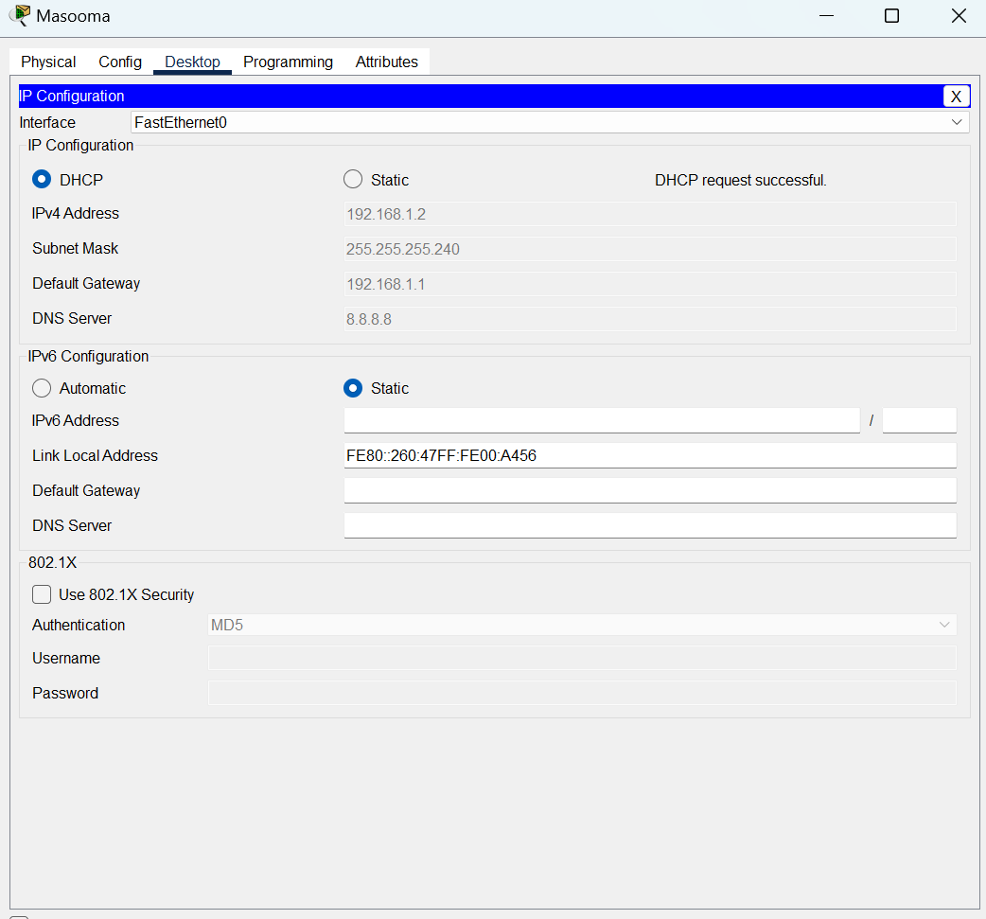

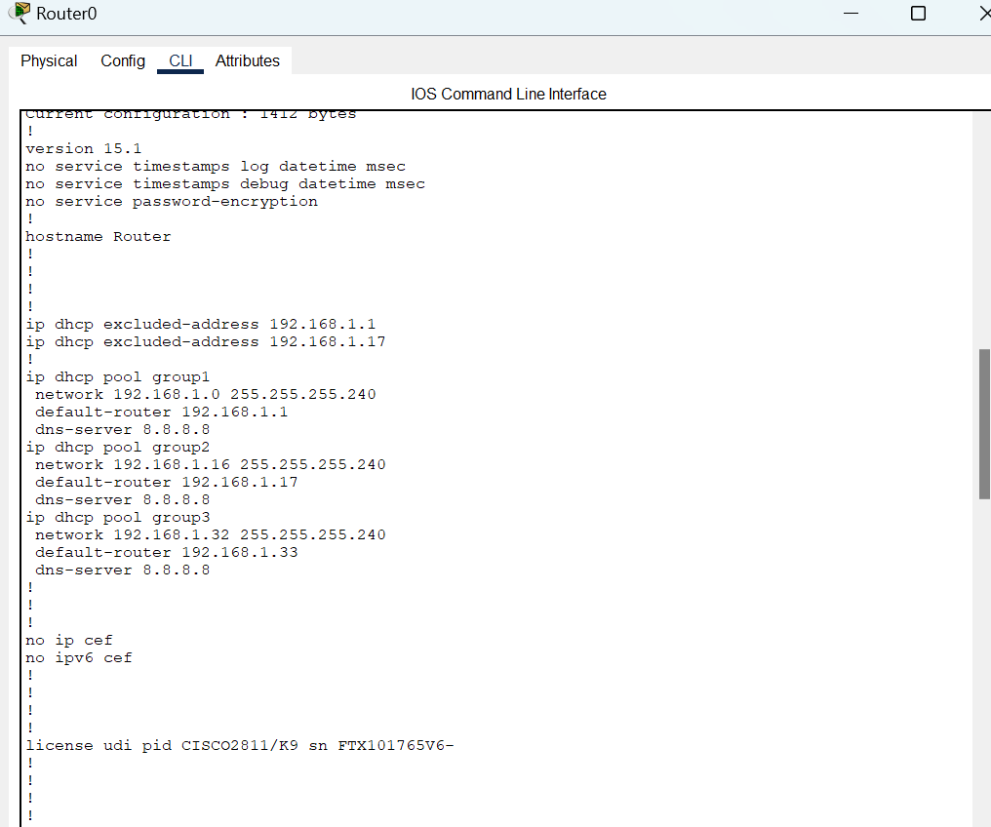

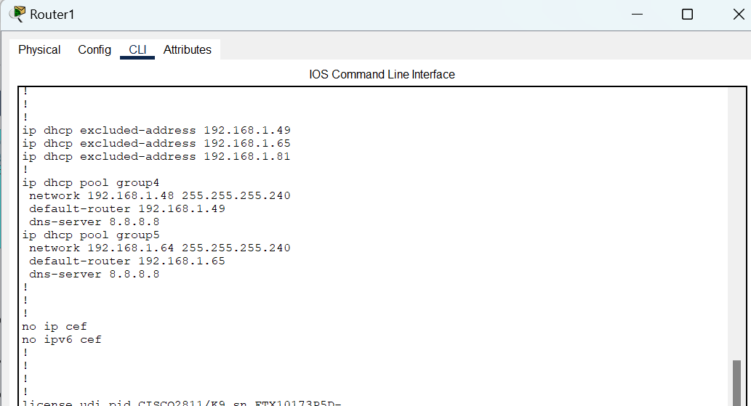

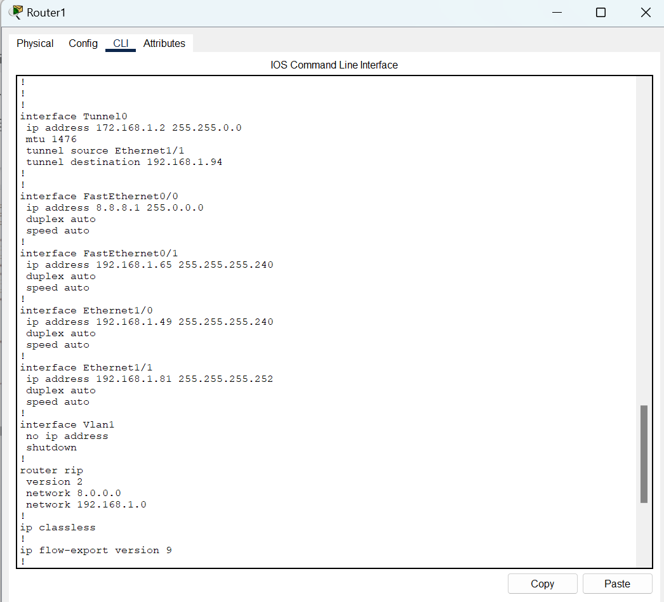

**RIP 2:**

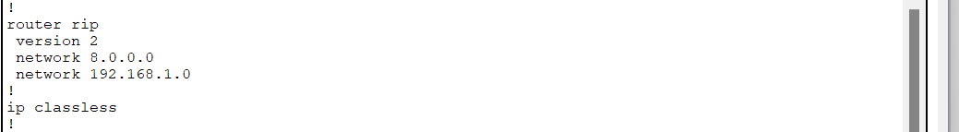

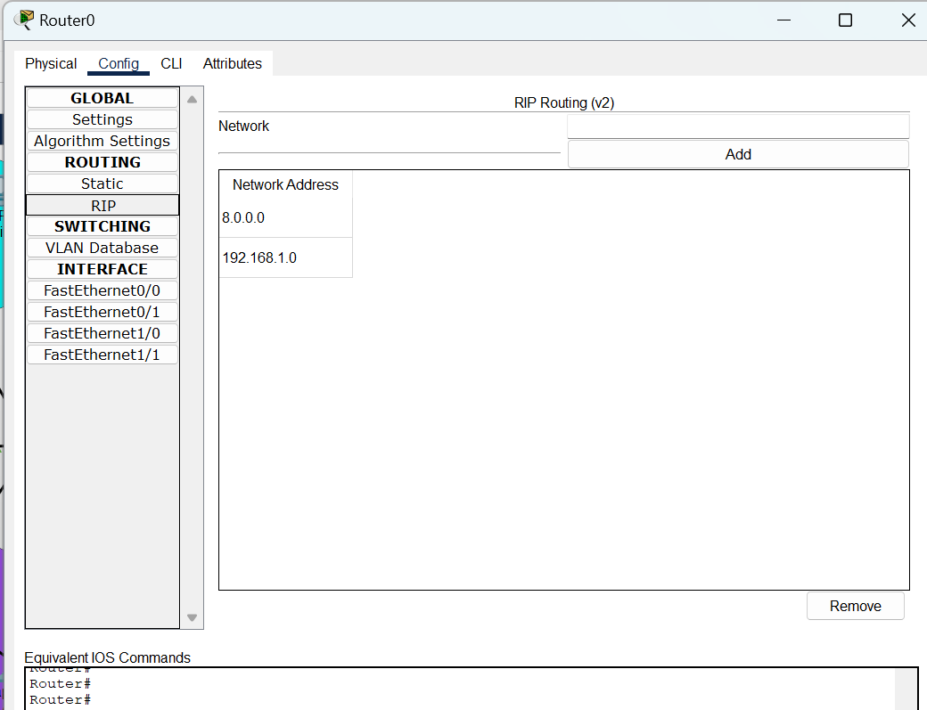

**VPN CONFIGURATION:**

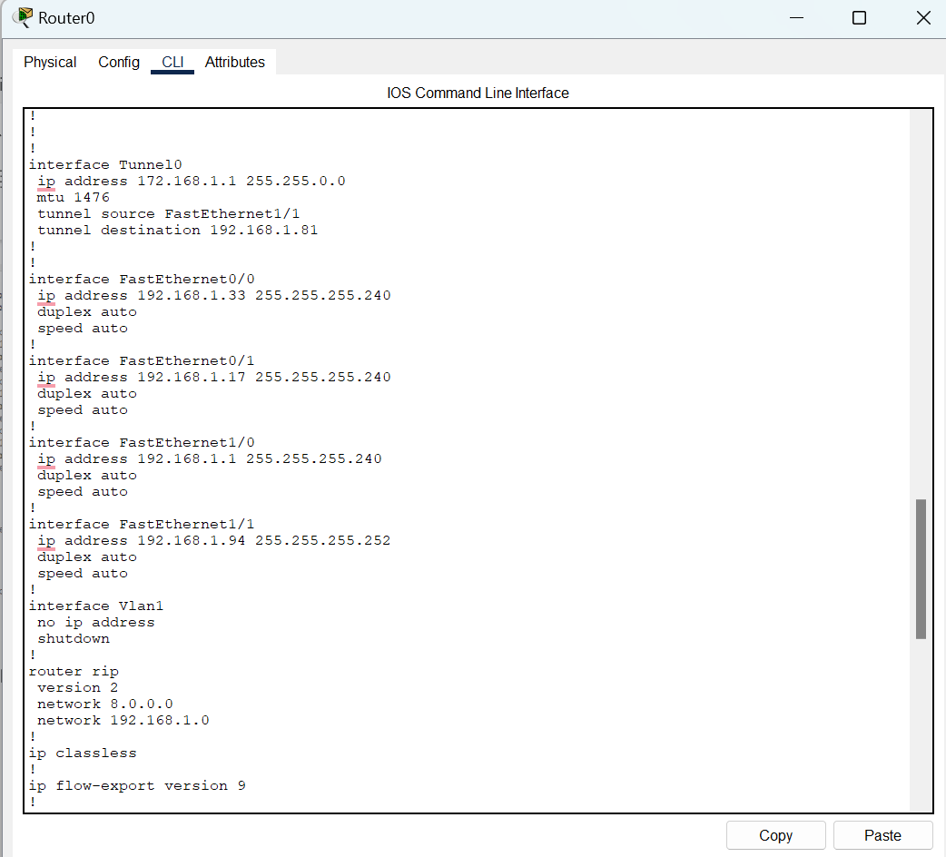

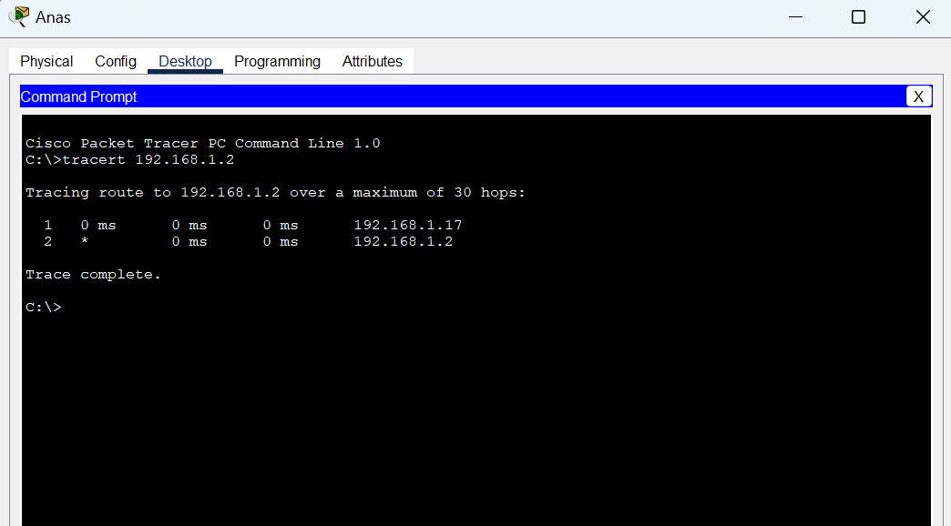

**SMTP:**

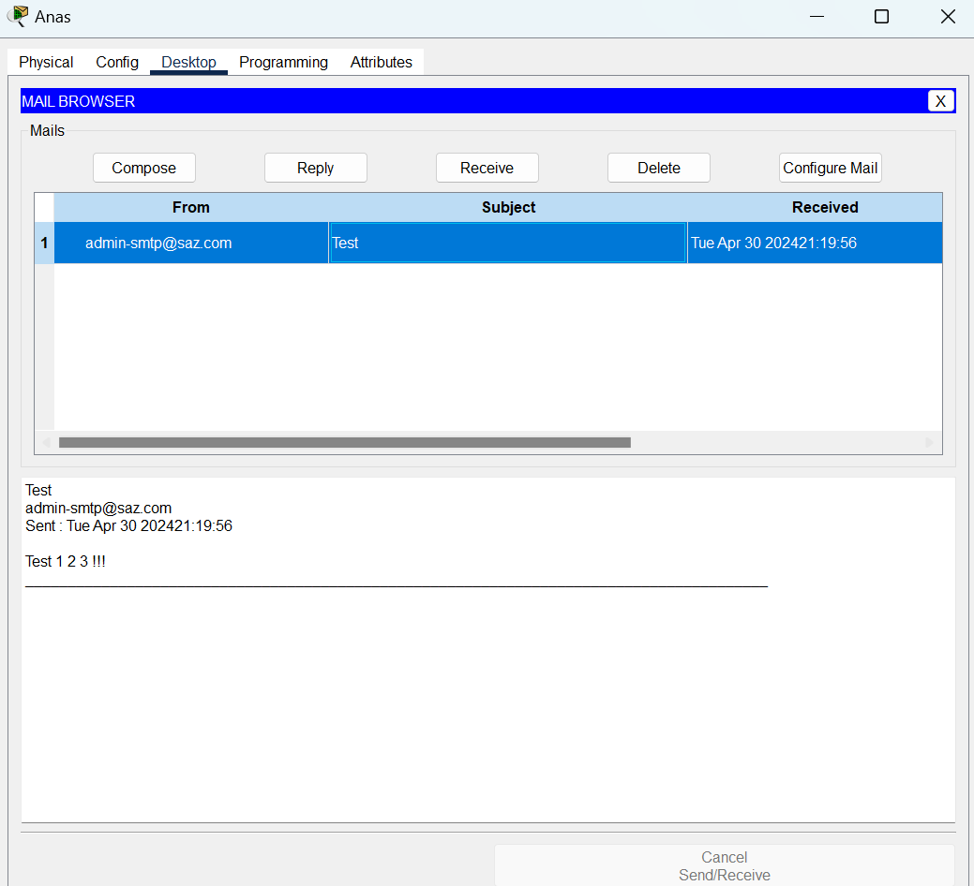

**FTP:**

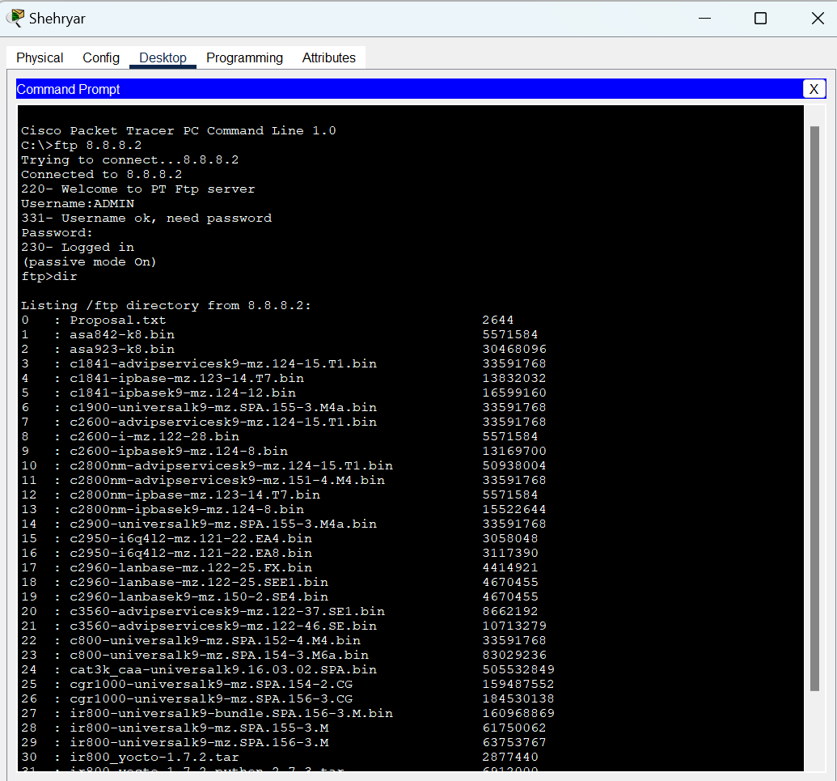

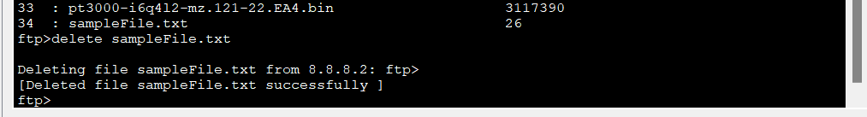

**DNS:**

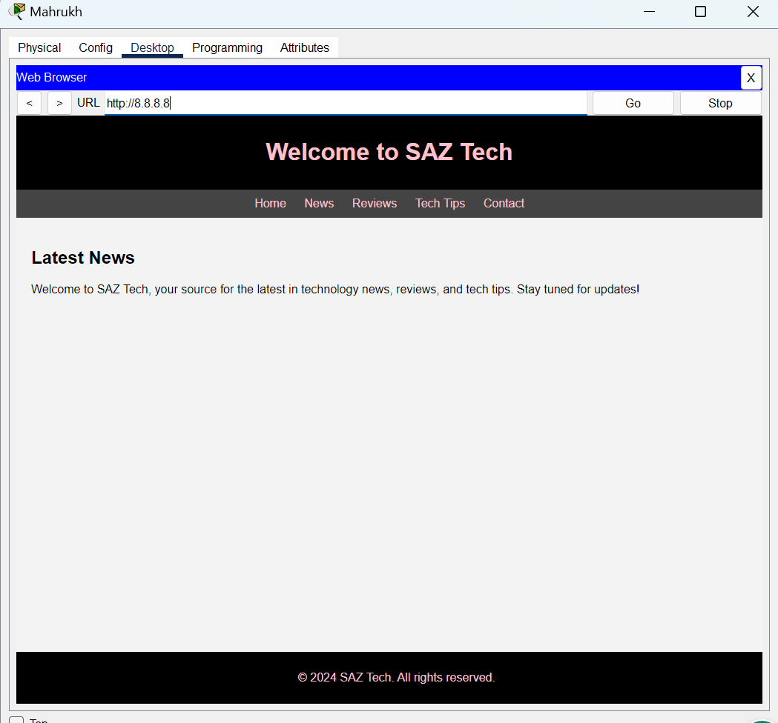



**TELNET AND SSH:**

