**Full EC2 Project Overview: “End-to-End Scalable Web Infrastructure using EC2”**

**WEEK 2 - EC2Quiz Web App**

## **Overview:**

In this Week 2 project, we will enhance the EC2-hosted quiz web app by focusing on data backup, image creation, and secure access practices. By the end of this module, your EC2 instance will be safely backed up and access to it will be more secure.

## **Step 1: View and Understand Your EC2’s EBS Volume**

Using AWS Console

1. Go toEC2 Console
2. Click on **Instances**
3. Select your EC2 instance
4. Scroll to the **Storage** tab
5. Note the **Volume ID** (starts with vol-)

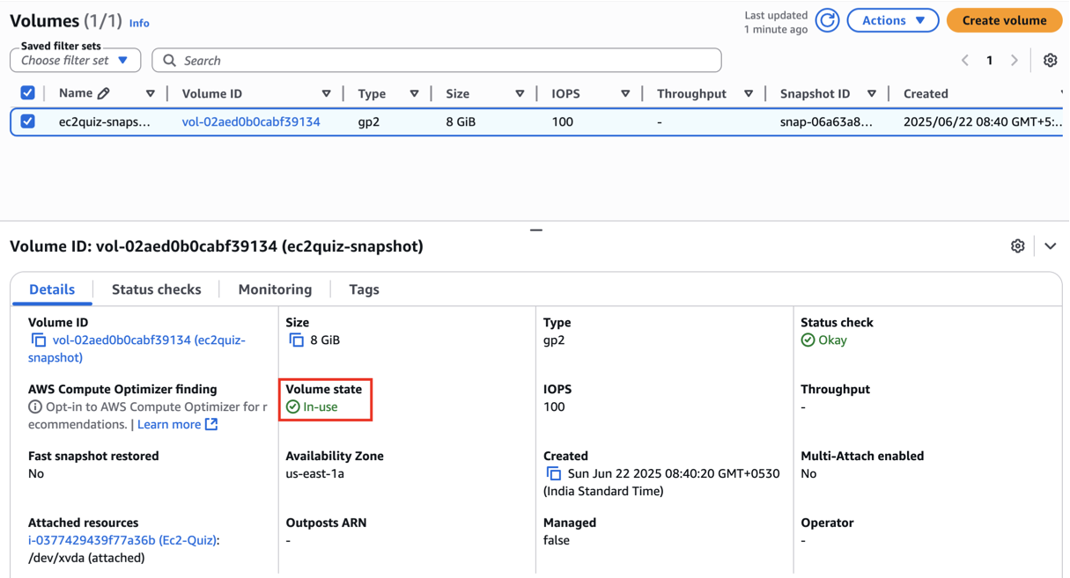

This is your EBS root volume. This volume stores your OS, Apache server, and quiz website files.

## **Step 2: Take a Snapshot of Your EC2’s EBS Volume**

Snapshots allow you to recover your EC2 instance if it crashes or becomes corrupted. It's a best practice before any major change or update.

1. Find your volume ID (from Step 1)
2. Right-click or click **Actions → Create Snapshot**
3. Fill the form:  
   * **Name**: QuizApp-Backup
   * **Description**: Snapshot of EC2 instance hosting quiz web app
4. Click **Create Snapshot**

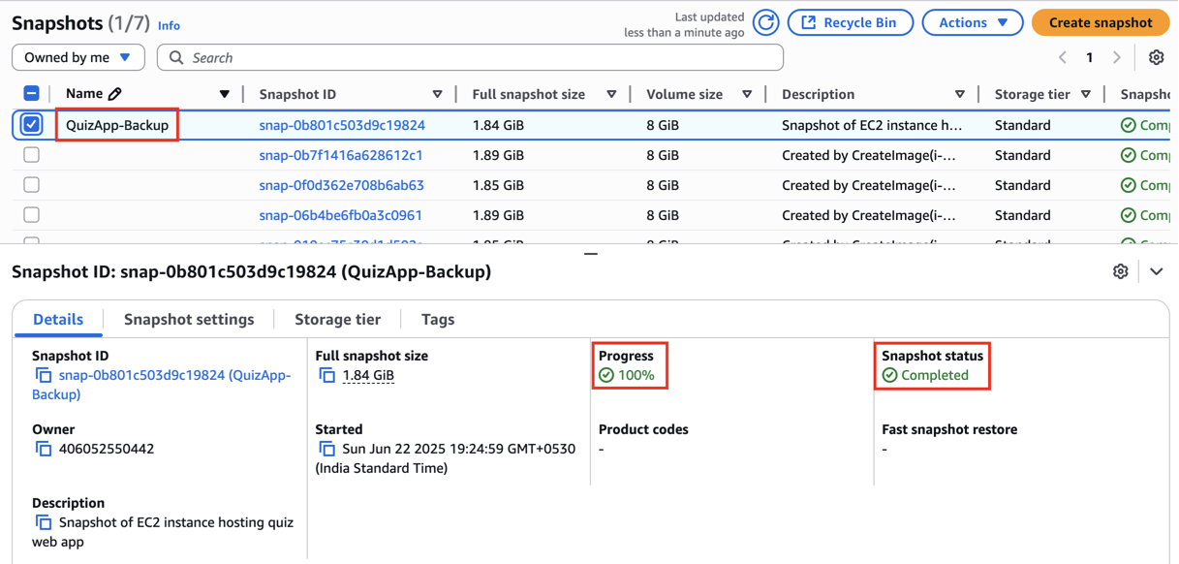

You’ll see it under **Snapshots** section with the status pending (refresh after a minute or two, it’ll turn to completed)

After Snapshot is Created,

* It is **stored in your AWS account**
* You can use it later to create a **new EBS volume** or launch an EC2 instance from it

This is a critical backup step! if your instance is ever deleted or corrupted, you can restore it using this snapshot.

## **Step 3: Create an Amazon Machine Image (AMI) of Your EC2 Instance**

While a snapshot only backs up the disk, an AMI allows you to recreate the entire EC2 instance - same settings, same software, same files ~ all in one go.  
You can use this to launch new EC2s with zero setup.

1. Go to the **EC2 Console**
2. Click **Instances**
3. Select your **quiz app EC2 instance**
4. Click **Actions → Image and templates → Create Image  
   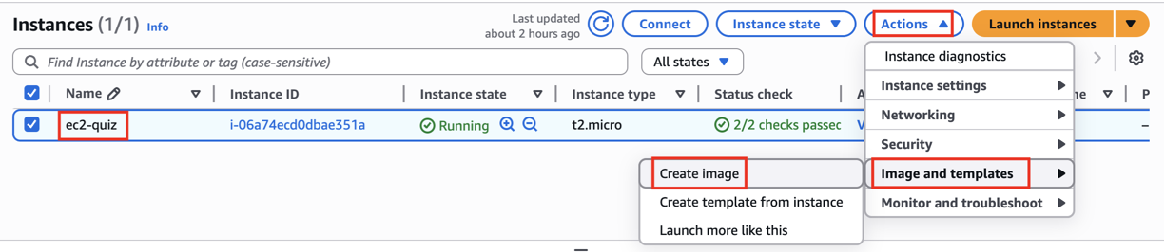**
5. Fill the form:
   * **Image name**: QuizApp-Week2-AMI
   * **Image description**: AMI of EC2 instance hosting quiz app after backup & Apache setup
   * **No Reboot**: leave **unchecked** (recommended to reboot during image creation)

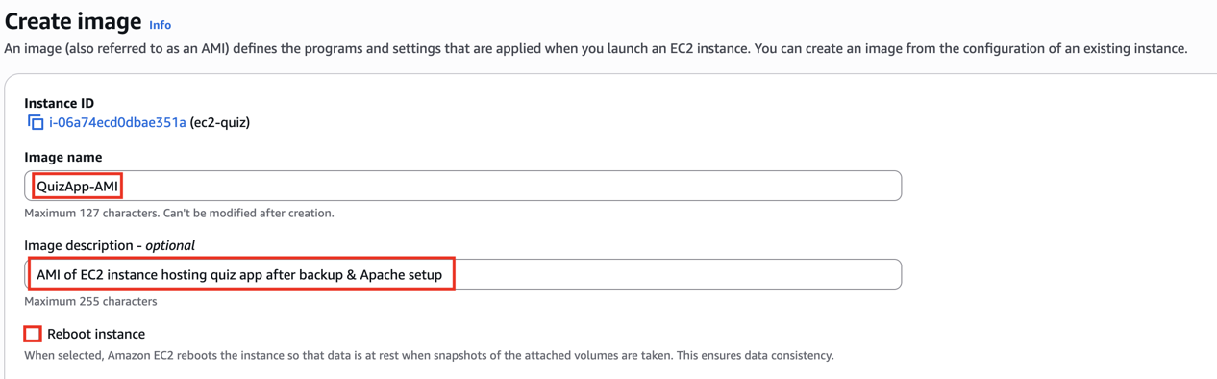

1. Click **Create Image**

You can now find the AMI under the **AMIs** section in the left menu.

**What does it do?**

* AWS creates a temporary snapshot of your root volume
* You can now use this AMI to **launch identical EC2s** — same Apache, HTML, everything

## **Step 4: Secure EC2 Access**

**Key Pair:**

When you launched your EC2 instance, you selected or created a **Key Pair** (PEM file) for SSH access.

* **NEVER share** your .pem file
* Store it securely on your local machine (or cloud vault)
* Remove SSH access from the Security Group if key is no longer in use
* Do **not hardcode** your key or expose it in scripts

**Security Group** – Only Allow What’s **Needed**

Let’s ensure no other ports are open.

**Steps:**

* Go to EC2 Console > Security Groups
* Select the one attached to your EC2
* Click Inbound Rules > Edit

By default, your EC2 instance needs:

* Port 22 (SSH) — for you to connect
* Port 80 (HTTP) — for the quiz web app

