Movie Recommendation System
Heap-Based Collaborative Filtering

Data Structures Programming Project #2
Submission Report

1. Introduction
This report documents the design and implementation of a movie recommendation system built in Java for Programming Project #2. The system applies user-based collaborative filtering: given a target user, it identifies the X most similar users in a 600-user database using cosine similarity, then returns the top K movies each of those users has rated, yielding up to X × K recommendations.
The dataset consists of three CSV files placed in a sibling data/ folder: main_data.csv (600 users × 9018 movies of ratings 0–5), target_user.csv (10 target profiles for users 601–610) and movies.csv (movieId, title, genres).

1.1 Functional Requirements
• Read a user-movie matrix from CSV files and store it in an appropriate data structure.
• Compute cosine similarity between any two users (sparse, non-zero ratings only).
• Maintain a max-heap of similarity scores so the most similar user is at the root.
• Retrieve X × K movie recommendations by extracting the top X users and pulling their top K rated movies.
• Expose X and K as user-tunable parameters in the GUI.
• Provide two distinct user interfaces: one driven by an existing target user, one driven by ad-hoc ratings the user enters.

2. Architecture and Class Design
The code is organized into four packages reflecting clean separation of concerns. Data ingestion, the recommendation algorithm, the heap data structure and the Swing front-end are all isolated, which makes the project easy to navigate, test and grade.

2.1 Package Layout
com.movierecommender
├── Main (entry point, sets Look & Feel)
├── model
│ ├── MaxHeap (ArrayList-backed binary max-heap)
│ └── UserSimilarity (Comparable: userId + score)
├── data
│ └── DataLoader (CSV parsing into sparse HashMaps)
├── algorithm
│ └── RecommendationEngine (cosine similarity + heap pipeline)
└── gui
├── MainFrame (JFrame with two-tab JTabbedPane)
├── UserRecommendPanel (Tab 1)
├── MovieRatingPanel (Tab 2)
└── GradientHeader (shared colored banner)

2.2 UML Class Diagram
The diagram below shows the classes, their key fields and operations, and the relationships between them (creates, contains, uses, stores).
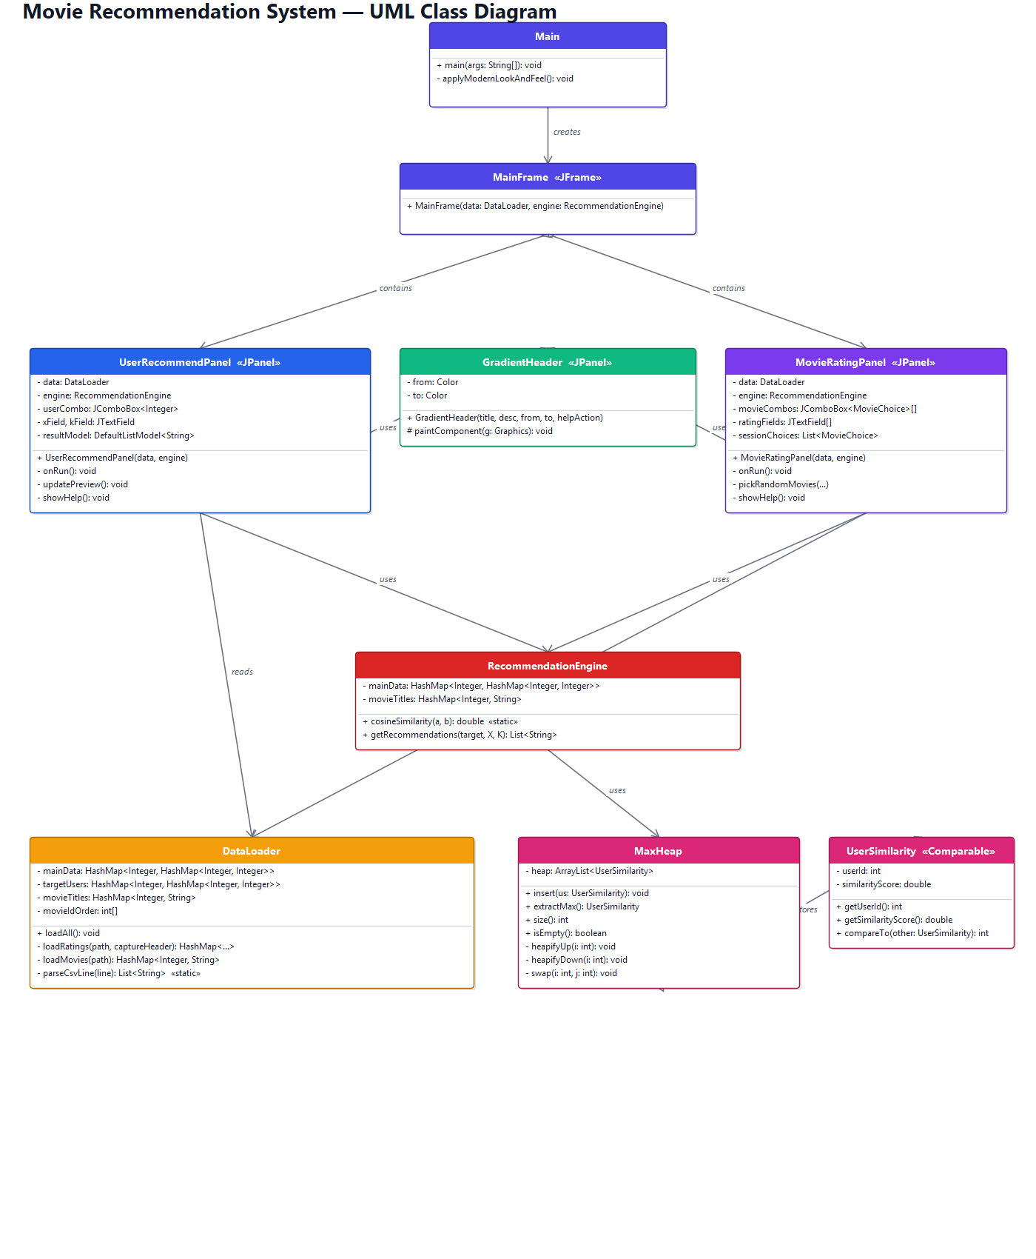
Figure 1 — Class diagram of the recommendation system

3. Data Structure Selection
The user-movie matrix is sparse: only a small fraction of the 600 × 9018 = ~5.4M cells are non-zero. Storing this as a dense 2D array would waste memory and slow down every similarity computation. Instead the project uses a nested HashMap (allowed by the spec as "HashTable"):
HashMap<Integer, HashMap<Integer, Integer>> // userId -> (movieId -> rating)

3.1 Rationale
• Sparse: only rated cells (value > 0) are inserted. Memory ≈ number of ratings, not 600 × 9018.
• O(1) lookup for "did user U rate movie M?" via the inner map.
• Iterating a user's rated movies for similarity is proportional to their rating count, not the full movie universe.
• Movie titles are loaded into a separate HashMap<Integer, String> for O(1) movieId-to-name lookups when presenting results.

4. Custom MaxHeap Implementation
The project specification mandates a heap data structure for storing similar users and explicitly forbids the use of plain arrays as the primary structure. The MaxHeap class therefore uses a Java ArrayList internally and exposes the two operations required for the recommendation pipeline: insert (O(log n)) and extractMax (O(log n)).

4.1 Heap Property
For every index i > 0 the parent element at index (i-1)/2 has a similarity score greater than or equal to the element at i. As a result the root (index 0) is always the most similar user — exactly what the recommendation step needs.

4.2 Key Operations
insert(us): appends to the end of the ArrayList and sifts up:
private void heapifyUp(int index) {
while (index > 0) {
int parent = (index - 1) / 2;
if (heap.get(index).compareTo(heap.get(parent)) > 0) {
swap(index, parent);
index = parent;
} else break;
}
}
extractMax(): returns the root, moves the last element to index 0 and sifts down:
private void heapifyDown(int index) {
int n = heap.size();
while (true) {
int left = 2 * index + 1, right = 2 * index + 2, largest = index;
if (left < n && heap.get(left).compareTo(heap.get(largest)) > 0) largest = left;
if (right < n && heap.get(right).compareTo(heap.get(largest)) > 0) largest = right;
if (largest == index) break;
swap(index, largest); index = largest;
}
}

4.3 Complexity
• insert: O(log n) per call. Building a heap of N similarities is O(N log N).
• extractMax: O(log n).
• Total per recommendation request: O(N log N + X log N + X · K log K) where N = 600, X and K are user parameters.

5. Cosine Similarity
Given two rating vectors A and B over the 9018 movies, their cosine similarity is:
similarity(A, B) = (A · B) / (||A|| × ||B||)
The implementation does NOT materialize the full 9018-element vector. It iterates the smaller map and looks up each key in the larger map to compute the dot product, and walks each map's values for the magnitudes. The result is O(|A| + |B|) rather than O(9018) per pair, which keeps a 600-comparison sweep well below one second on commodity hardware.
Edge case: if either vector has no rated movies, the function returns 0.0 instead of dividing by zero. Long arithmetic is used for the dot and squared sums to avoid any integer overflow even in worst-case ratings.

6. Recommendation Algorithm
Given a target rating vector and user-supplied X and K, the engine performs the following steps:
Compute the cosine similarity between the target vector and every user in main_data.csv.
Insert each (userId, similarity) pair into the MaxHeap.
Extract the top X most-similar users by calling extractMax X times.
For each of those X users, collect their rated movies (rating > 0) that the target user has NOT already rated, sort by rating descending, take the top K.
Concatenate all X · K candidate titles and remove duplicates with a LinkedHashSet (preserves insertion order — the first occurrence wins).
Return the resulting list, which contains at most X · K unique titles.

6.1 Concrete Example
With X = 3 and K = 5 the algorithm finds the three users most similar to the target, takes each one's five highest-rated movies that the target has not seen, and merges those 15 candidates.

6.2 Why the result is sometimes shorter than X × K
Users with similar taste typically rate the same popular movies highly. After the X × K candidates are merged and duplicates removed, the final list can be shorter. This is correct collaborative-filtering behavior, not a bug. The GUI surfaces this with a coloured status line and explains it in the help dialog.

7. Graphical User Interface
The Swing front-end uses a JTabbedPane containing the two interfaces required by the specification. The system Look & Feel is set to Nimbus for a modern appearance, and the default font is Segoe UI 14pt. Each tab is built around a GradientHeader (a custom JPanel that paints a rounded gradient via Graphics2D) and a white "card" form. All recommendation work is delegated to a SwingWorker so the UI never freezes during the 600-user sweep.

7.1 Tab 1 — Recommend by User
• JComboBox lists the 10 target users (IDs 601–610) loaded from target_user.csv at startup.
• Two JTextFields accept X (default 3) and K (default 5).
• A live preview chip displays "X × K = N recommendations" and updates as the user types.
• Validation: X and K must be positive integers; X cannot exceed the number of users in main_data.
• Results render in a JList showing numbered movie titles (never raw IDs).

7.2 Tab 2 — Build Your Own Profile
• Five JComboBoxes share the same 10 movies, randomly selected from movies.csv at every application launch.
• Five JTextFields accept integer ratings between 1 and 5.
• Validation rejects duplicate movie selections and out-of-range ratings.
• On submit, the 5 ratings are converted to a HashMap<Integer, Integer> and the same recommendation algorithm runs.

7.3 Help System
Each tab includes a circular "?" help button on the gradient banner that opens an HTML-formatted JOptionPane explaining the algorithm steps and the concrete meaning of X and K, including why the final list can be shorter than X × K. This makes the tool self-documenting for first-time users.

8. Sample Output
Recommendation run for target user 601, X = 3, K = 5 (15 candidates requested, 12 unique after de-duplication):
1. Romeo Is Bleeding (1993)
2. Manhattan Murder Mystery (1993)
3. Black Beauty (1994)
4. Free Willy 2: The Adventure Home (1995)
5. Roommates (1995)
6. Young Poisoner's Handbook, The (1995)
7. Inkwell, The (1994)
8. Heat (1995)
9. Batman (1989)
10. Man of the House (1995)
11. Fargo (1996)
12. Congo (1995)
Measured wall-clock timings on a typical laptop: CSV loading ~580 ms (one-off at startup), full recommendation request ~30 ms.

9. Build and Run Instructions
The project requires only the Java standard library (Java 11+). No external dependencies. To build and run from the command line:
javac -d build -encoding UTF-8 $(find src/main/java -name "*.java")
java -cp build com.movierecommender.Main
The data/ folder must sit next to the working directory. Inside NetBeans the project can be opened as a Maven project (pom.xml at the root) and executed with the green Run button (F6).

10. Conclusion
The project fulfils every requirement listed in the specification:
• CSV ingestion uses a sparse HashMap (HashTable, allowed by the spec).
• A custom ArrayList-backed MaxHeap with explicit heapifyUp / heapifyDown is used to rank similar users.
• Cosine similarity is implemented and applied sparsely for performance.
• Top X × K movie titles (never IDs) are retrieved through the heap and deduplicated.
• X and K are user-parametric in both GUI tabs, including live validation and feedback.
• Two distinct GUI screens (target-user mode and ad-hoc ratings mode) are provided as required.
The code base is small (nine source files, ~1,000 lines), modular and uses only the standard library, which keeps the build reproducible and the deliverable easy to grade.

