Ride_Cancellation_Prediction_Product_Document
Table of Contents
- Executive Summary
- Product Description and Vision
- Core Features and Capabilities
- Technical Architecture and Infrastructure
- Technology Stack
- Data & Model Security Architecture
- Role and Access Model
- Data Sensitivity & Privacy Levels
- User Experience and Interface
- Installation and Deployment (Hugging Face Spaces)
- Integration and Scalability
- Competitive Analysis and Differentiation
- Usage Scenarios and Business Value
- Technical Requirements
- Contact and Support

1. Executive Summary
Ride Cancellation Prediction is a demo, machine learning–based analytics and prediction application deployed on Hugging Face Spaces.
The application presents a proof-of-concept model that estimates the probability of ride cancellations using historical booking data and exposes the model through an interactive web interface.
Through this interface, stakeholders can explore potential risk factors, simulate different scenarios, and conceptually assess preventive actions before cancellations occur, within the scope of a demo application.
The primary goal of the project is to demonstrate how a machine learning model can be developed end-to-end, evaluated, and deployed as a live demo application.

This demo project highlights:
- An example of an end-to-end machine learning pipeline
- Deployment of an ML model as an interactive demo on Hugging Face Spaces
- An analytical approach to addressing a real-world business problem

2. Product Description and Vision
2.1 Problem Domain
Ride cancellations have negative impacts on:
- Revenue
- Customer trust
- Driver efficiency
- Platform reliability
Most existing systems detect cancellations after they occur, which leads to reactive rather than preventive decision-making.

2.2 Solution: Ride Cancellation Prediction
This project provides a demo (proof-of-concept) machine learning application designed to illustrate how ride cancellations can be predicted in advance.
The application offers a live prediction interface where users can:
- Input ride-related features
- Instantly receive a cancellation probability
- Conceptually explore which factors increase cancellation risk
The system goes beyond a notebook-based analysis by demonstrating how a machine learning model can be presented as an interactive, live demo application.

2.3 Target Audience
This demo project is intended for:
- Ride-hailing platforms
- Operations and product teams
- Data science recruiters
- Business analysts
- Machine learning engineers evaluating real-world ML projects

3. Core Features and Capabilities
3.1 Exploratory Data Analysis (EDA)
Analysis was performed to understand the dataset and cancellation patterns:
- Cancellation distribution analysis
- Time-based patterns (hour, day, peak times)
- Insights on correlations between features

3.2 Feature Engineering
To improve model performance and data representation, the following preprocessing steps were applied:
- Decomposition of date and time components
- Encoding of categorical variables
- Normalization of numerical features

3.3 Machine Learning Prediction
The project addresses a binary classification task for predicting ride cancellations:
- Canceled / Not Canceled
- Probability-based model outputs
- Threshold-based risk interpretation

3.4 Live Web Interface
An interactive demo interface was developed to showcase model predictions:
- User input forms for ride-related features
- Real-time prediction outputs
- Conceptual model explanation visuals (feature importance)

4. Technical Architecture and Infrastructure
4.1 Overall Architecture
The project is designed as a demo application with four main layers:
Frontend Layer
- Interactive user interface on Hugging Face Spaces (Gradio / Streamlit)
Application Layer
- Prediction logic
- User input validation
- Feature preprocessing
Model Layer
- Trained machine learning model
- Serialized model artifacts
Data Layer
- Processed datasets
- Feature metadata

4.2 Project Structure
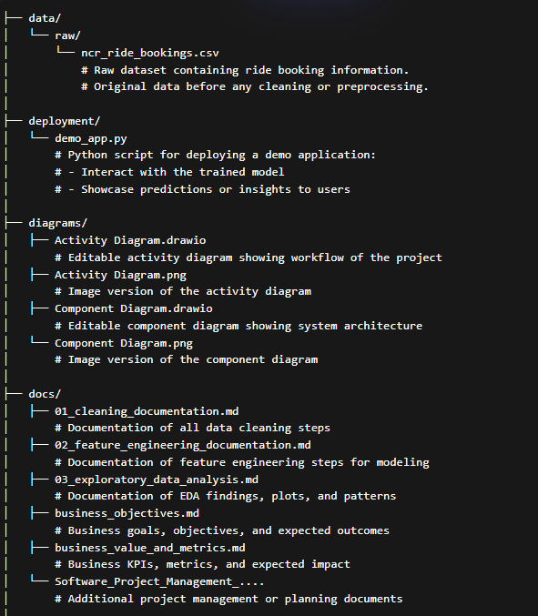

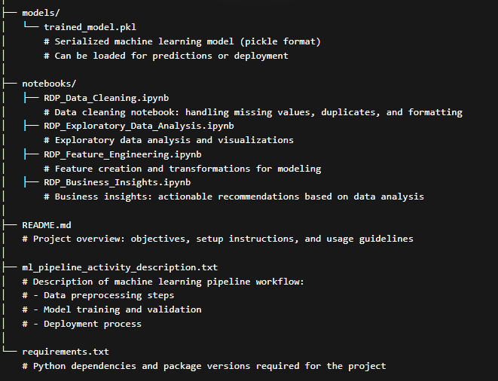

4.3 Data Flow (Demo Model)
- User Input: User enters ride details (e.g., pickup time, distance, customer type) via the web UI.
- Input Validation & Preprocessing: Inputs are checked for missing or incorrect values and transformed into model-compatible features.
- Model Prediction: Preprocessed features are passed to the trained ride cancellation prediction model.
- Probability Output: The model generates a cancellation probability score (0–100%).
- UI Display: The result is displayed instantly on the demo interface, allowing users to see the likelihood of cancellation in real-time.

5. Technology Stack (Demo Model)
Machine Learning & Data Processing:
- Python 3.x
- pandas, NumPy
- scikit-learn
Deployment & Demo UI:
- Hugging Face Spaces
- Gradio (used for interactive demo)
Visualization (Optional in Demo):
- Matplotlib
- Seaborn
Version Control:
- Git & GitHub
6. Data & Model Security Architecture (Demo Model)
- No sensitive credentials stored in the demo environment.
- No personally identifiable information (PII) is used.
- Trained model artifacts are stored separately from code and datasets.
- The Hugging Face Spaces deployment runs in an isolated environment to ensure security.
7. Role and Access Model (Demo Model)
Public User
- Can input ride features (e.g., pickup time, distance)
- Can view prediction results
Project Owner / Demo Maintainer
- Can update the model
- Can adjust input features
- Can control deployment settings

- Data Sensitivity & Privacy Levels (Demo Model)
- Public: Aggregated insights and prediction outputs shown in the demo UI
- Internal: Processed datasets used for model training
- Restricted: Raw ride-level data (may be shared on GitHub, but never exposed in the demo application)
The deployed demo application never exposes raw ride-level data through the UI or model predictions.

9. User Experience and Interface (Demo Model)
9.1 Interactive UI
- Simple and clean input fields for ride details
- Real-time prediction results displayed instantly
- Probability-based outputs (e.g., 75% chance of cancellation) instead of just yes/no labels
9.2 Interpretability
- Feature importance visualization (which ride features affected the prediction most)
- Clear textual explanations for results
- Business-friendly wording, making it easy for non-technical users to understand

10. Installation and Deployment (Hugging Face Spaces – Demo Model)
Deployment Type:
- Hugging Face Spaces (Gradio used for interactive demo)
Steps:
- Create a new Hugging Face Space
- Select Python SDK
- Upload:
  - app.py (demo interface script)
  - requirements.txt (Python dependencies)
  - Trained model files (.pkl or .joblib)
- Build & deploy automatically via Git push
Environment:
- CPU-based deployment (GPU not required)
- Isolated environment ensures demo security

11. Integration and Scalability (Demo Model)
- The demo is deployed on Hugging Face Spaces using Gradio and provides an interactive web interface for users.
- It does not include a REST API; external applications cannot call the model directly.
- Can be integrated into dashboards or other applications via the web interface (e.g., embedding the demo link).
- Scalable with retraining pipelines for updated data.
- Cloud-native design allows flexible deployment.

12. Competitive Analysis and Differentiation (Demo Model)
Feature | This Demo Project | Static Reports
Live Predictions | ✅ | ❌
Deployment (Interactive UI) | ✅ | ❌
Business Interpretability | ✅ | ⚠️
End-to-End Pipeline | ✅ | ❌
Recruiter Visibility / Portfolio Showcase | ✅ | ❌
Notes:
- Live predictions are available through the Hugging Face Spaces demo.
- The interactive deployment allows users and recruiters to see results in real-time.
- Feature importance and textual explanations provide business-friendly interpretability.
- The end-to-end pipeline—from raw data preprocessing to model predictions—is fully demonstrated.

13. Usage Scenarios and Business Value (Demo Model)
Business Value:
- Early cancellation risk detection
- Improved operational decisions
- Reduced customer churn
- Better resource allocation
Example Scenario:
- A ride-hailing platform predicts high-risk rides before confirmation and applies dynamic interventions to prevent cancellations.

14. Technical Requirements (Demo Model)
Runtime:
- Python 3.8+
Libraries:
- pandas
- scikit-learn
- gradio (for demo interface) / streamlit
Deployment:
- Hugging Face account

15. Contact and Support
Project Owner: Zehra Buse Tüfekçi
Focus Area: Data Analytics & Machine Learning
Deployment Platform: Hugging Face Spaces

