**WEB MINING FINAL PROJECT REPORT**

Zehra Rıdvanoğulları – 180709029

Alperen Ayyıldız – 180709019

**Project Description**

We tried to prove “Echo Chamber” in social media. For that aim we took data from a specific Twitter user by using Twitter API and tweepy library of python. And we filtered the data focusing on one topic which is “evolution” in our case by using python regex. And we have took more data from this account’s followers. And we applied sentiment analysis to see the echo chamber in twitter. For sentiment analysis we used TextBlob library of python.

* Importing the libraries and Twitter API authentication

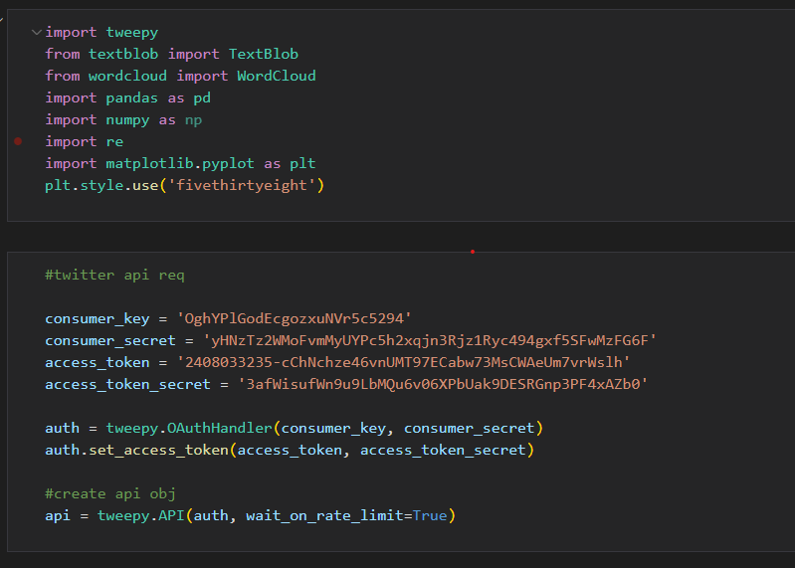

* We have chosen Richard Dawkins who is famous person in this topic. And took his user timeline data.

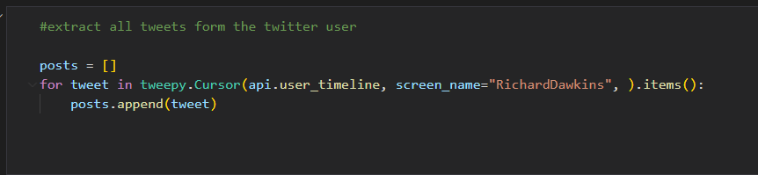

* And we cleaned the data from punctuations, hyperlinks etc.

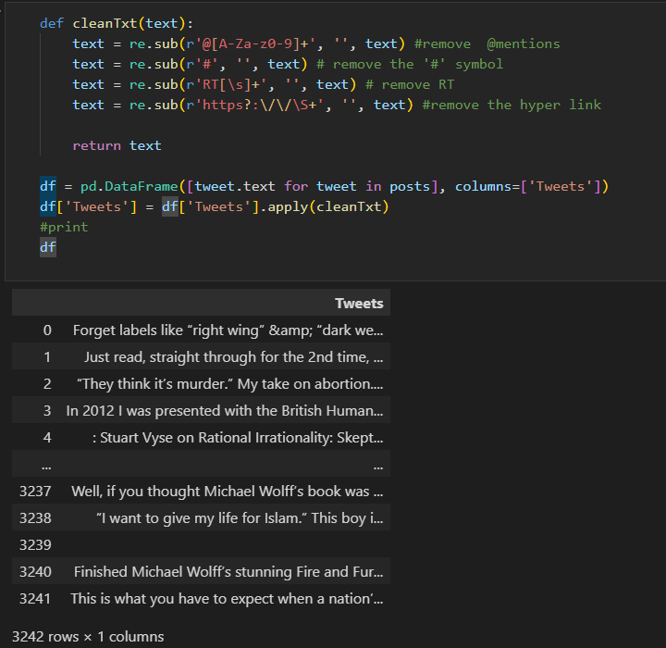

* And we have decided on a word list which helps us to filter the tweets about Evolution.

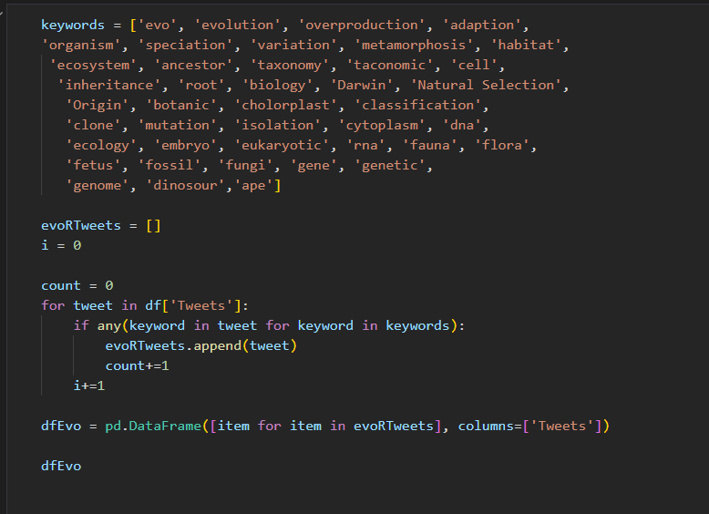

* Here we measured subjectivity and polarization.
* Subjectivity measures whether the sentence is objective or subjective. It can take a value between 0 and one. If it is near 1 it is more subjective the other way is the opposite situation.
* And the Polarization value helps to decide whether the text is polarized or not.

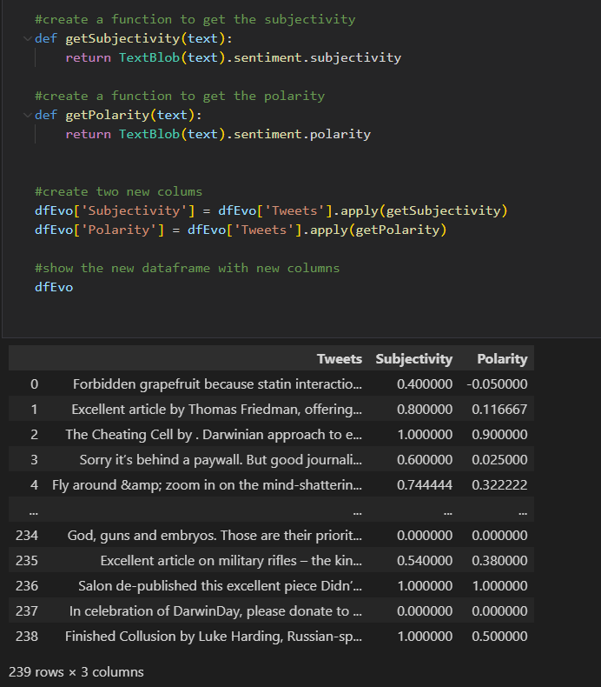

* Here we have added a new column called “Analysis” which includes if tweet is positive, negative or neutral.

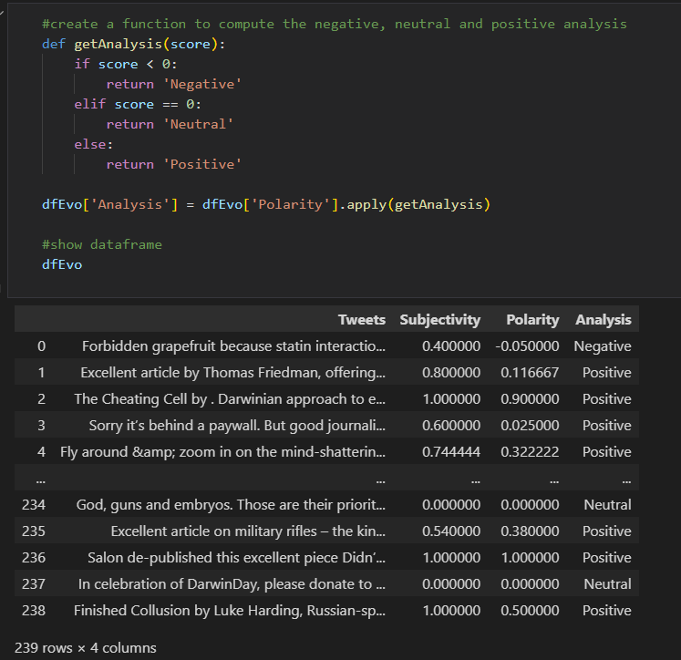

* And here there is the positivity percentage of the user on Evolution topic.

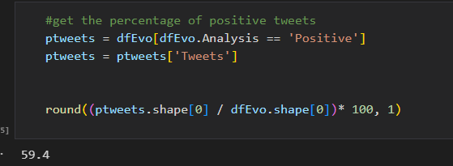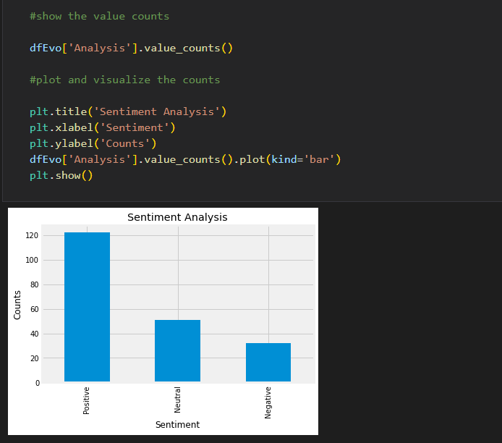

* And here we can see a plot that shows number of positive, negative and neutral tweets of that user.

* And than we took tweet data from Steve Stewart Williams, Razib Khan, Steven Pinker, Colin Wright. And filtered the data focusing on Evolution again. In the end we did the same calculations and sentiment analysis on each user data. Here our outputs. Which is the proof of Echo Chamber in our case.
* Results of Steve Stewart Wiliams who is follower of Richard Dawkins, Razib Khan and Steven Pinker

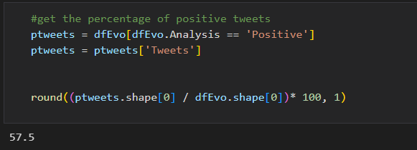 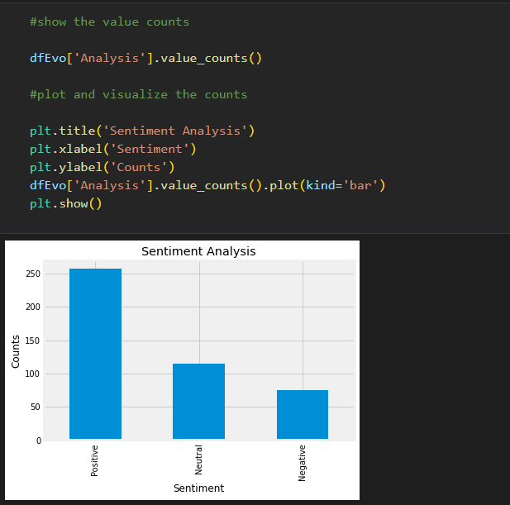

* Results of Razib Khan who is follower of Steve Stewart Williams, Steven Pinker Colin Wright

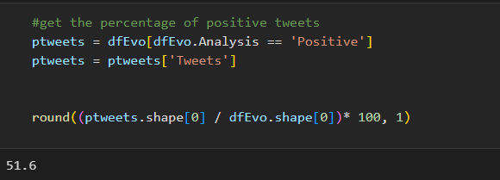

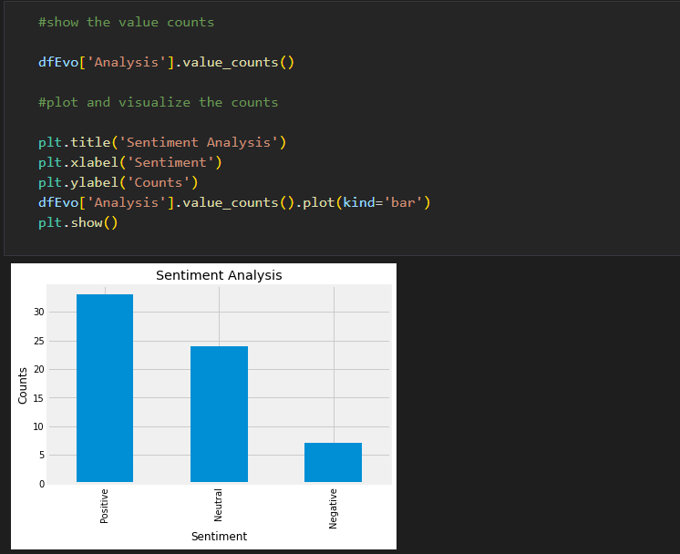

* Results of Steven Pinker who is follower of Richard Dawkins, Razib Khan

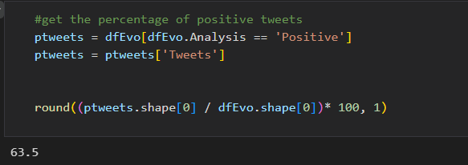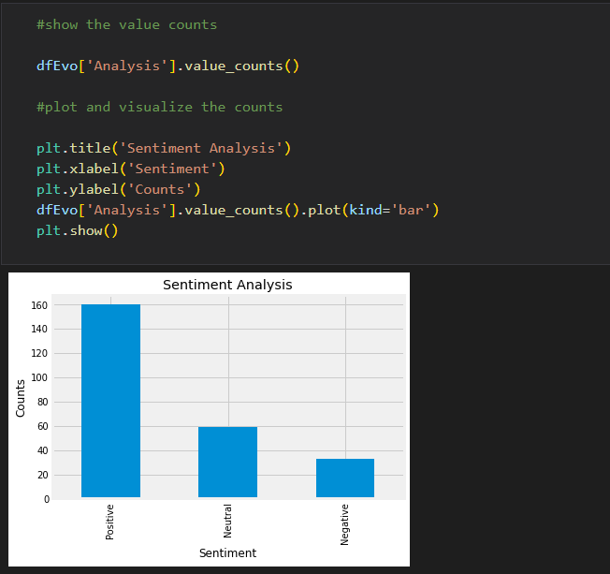

* Results of Colin Wright who is follower of Richard Dawkins, Razib Khan, Steven Pinker, Steve Stewart Williams

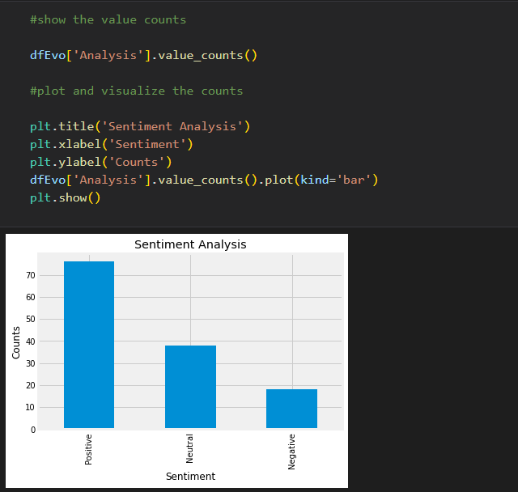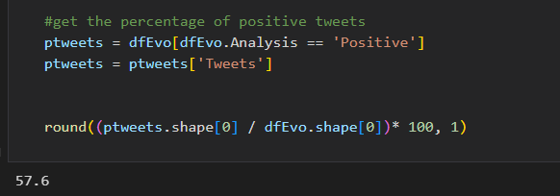

* All of them have high percentage of positivity about evolution and they also follow each other. So we can say that echo chamber exists in our case.