- 文件，先运行new_spider_day.py把微博存到数据库，再从数据库复制微博id到blog_ids，再运行wb_pl.py

Mysql数据库新建一个weibo数据库
new_spider_day.py、wb_pl.py这两个文件的数据库配置改成你自己电脑上的账号密码
db = pymysql.connect("localhost", "root", "123456", "weibo")

安装的包：pymysql、requests、fake_useragent、pandas、lxml、retrying

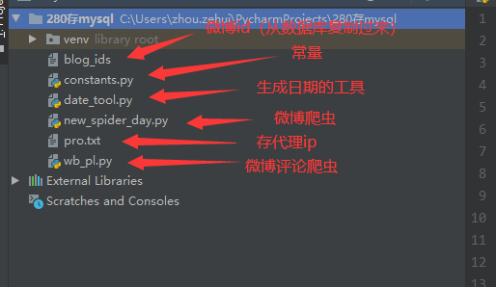

- constants.py，这个文件要改代理ip地址和web_cookie
# 代理ip地址，熊猫代理 http://www.xiongmaodaili.com/
# 买3块，按量提取，一次一个，json格式，生成api复制过来
proxy_url = 'http://route.xiongmaodaili.com/xiongmao-web/api/glip?secret=8f2094d52c612e35f270b1778582575d&orderNo=GL20200317161309UvbKpyG4&count=1&isTxt=0&proxyType=1'

# cookie过期了就修改下，登录新浪微博后，按F12把cookie复制过来
web_cookie = 'SINAGLOBAL=9039371595693.941.1576205125652; _ga=GA1.2.1684815725.1577155440; SCF=AqURd7rrLbKR6K42oMeW_I-_GcEWkVQLrLN_HSe9iIZfLvEHysRovUNPcxHjgUWwbtG3AoLgdfCCrxUQhPvoDew.; wvr=6; UOR=,,www.baidu.com; login_sid_t=5b546dae2ebc2a3792be9d99b34c813c; cross_origin_proto=SSL; _s_tentry=passport.weibo.com; Apache=2662580903264.209.1585616855192; ULV=1585616855198:27:13:2:2662580903264.209.1585616855192:1585529345440; SUB=_2A25zhuenDeRhGeVI7lER9CvFyD6IHXVQ8l5vrDV8PUNbmtAfLWz1kW9NTAX_rHqK4qame2CKWbIXLDGfZI5ry3Jd; SUBP=0033WrSXqPxfM725Ws9jqgMF55529P9D9WWES-MGSxVJk.S7AzfIp_iT5JpX5KzhUgL.FoecSKe7Sh-4e0z2dJLoIEXLxKBLBonL1h5LxKqL1-BLB-qLxKqLBo5L1KBLxKnLBoBLBKnLxKqLBo5LBoBt; SUHB=0rrLt_fapdU0KJ; ALF=1617152886; SSOLoginState=1585616887; webim_unReadCount=%7B%22time%22%3A1585616892191%2C%22dm_pub_total%22%3A0%2C%22chat_group_client%22%3A0%2C%22allcountNum%22%3A0%2C%22msgbox%22%3A0%7D'

