Toy Dataset for an unsupervised learning method: Clustering on make_blobs dataset

make_blobs generates isotropic Gaussian blobs
K-means is the right tool for cloud data while VQPCA is perfect for piecewise-linear data
K-Means clustering on country profile → standardize within cluster → PCA for dimensionality reduction → OLS regression (global vs. per-cluster vs. cluster-as-feature). Forecasting is the deliverable, clustering is preprocessing.

Parameter | Value | Justification
n_samples | 200 | 194 countries in Climate Watch.
n_features | 5 | The 5 IPCC sectors: Energy, Industrial Processes, Agriculture, Waste, LULUCF. Each toy "country" has a standardized sector profile.
centers | 4 | Hypothesized archetypes: energy-dominant industrialized, industry-process dominant, agriculture/LULUCF dominant, balanced low-emitter.
cluster_std | run two scenarios: 1.0 and 2.5 | Sensitivity test mirroring the lecture's well-separated vs. overlapping benchmarks. Real GHG profiles overlap.
center_box | (-5, 5) | Default-like.
random_state | 42 | Reproducibility.

Regression target synthesis
Each cluster has its own linear law y = α_k + β_k · x + noise where (α_k, β_k) differs per cluster. y represents future total emissions at horizon +10 years given current profile. Per-cluster regression should beat global regression because the global model averages across the cluster-specific laws.

Metrics
From lecture (slides 130-132):
- Inertia (elbow method)
- Davies-Bouldin index (minimize)
Standard internal indices:
- Silhouette score (maximize)
- Calinski-Harabasz (maximize)
External, ground-truth-required (toy only):
- ARI (Adjusted Rand Index)
- AMI (Adjusted Mutual Information)
Regression metrics (mirroring RUL Table 5.1):
- RMSE
- R²
VQPCA, GSRE, I_LPCA are skipped: this clustering target is cloud-shaped, not piecewise-linear, so VQPCA has no advantage over K-Means here. (slide 140-141)

Validation steps
- Generate toy (easy + hard scenarios).
- Scan k from 2 to 8, plot all metrics vs. k, confirm metrics recover the planted k=4 on the easy case.
- Compare three regression strategies on test split: global, per-cluster, cluster-as-feature.
- Report RMSE / R² in a comparison table.

Scenario A (Easy):
Silhouette Score (Internal): 0.526
Adjusted Rand Index (External): 0.987

Scenario B (Hard):
Silhouette Score (Internal): 0.214
Adjusted Rand Index (External): 0.524
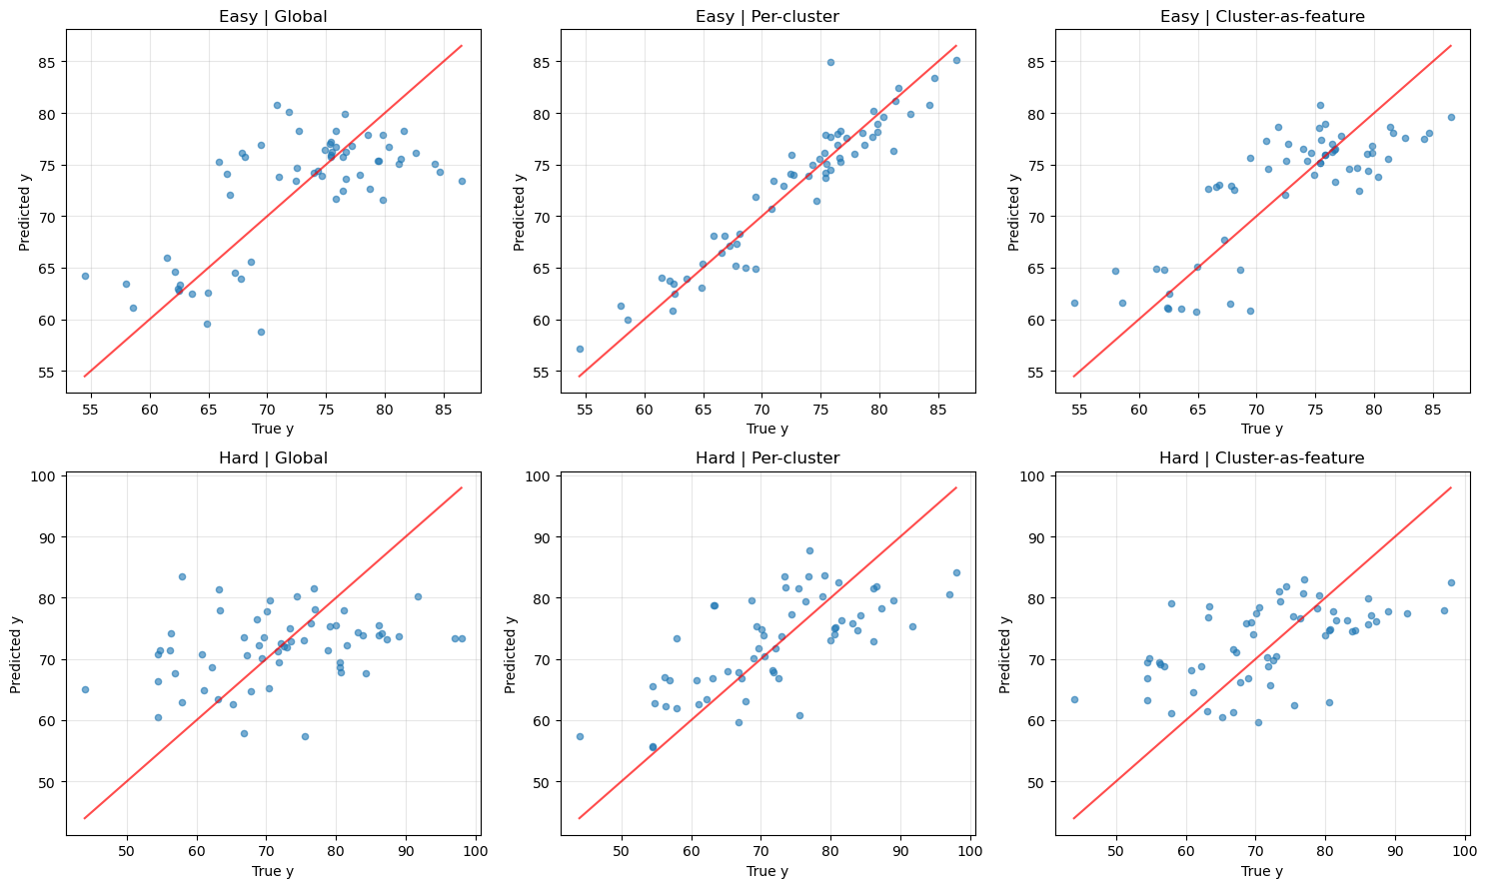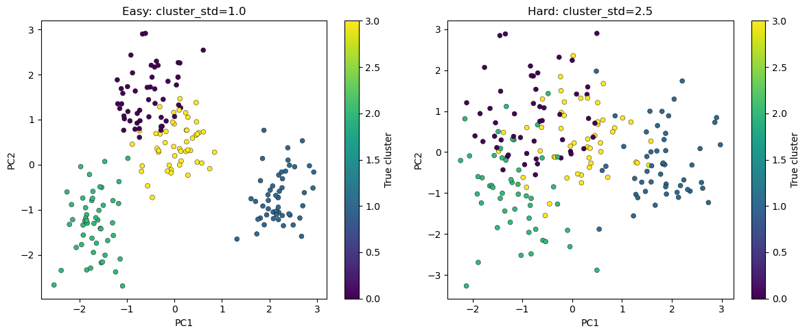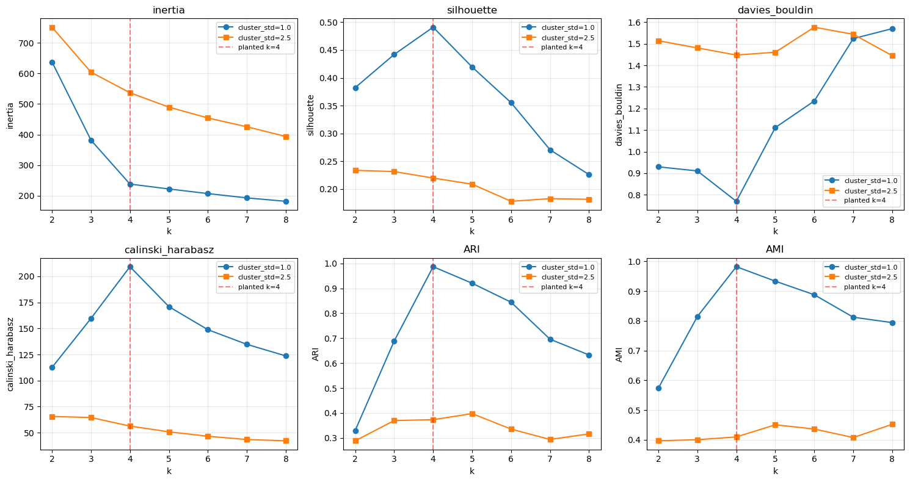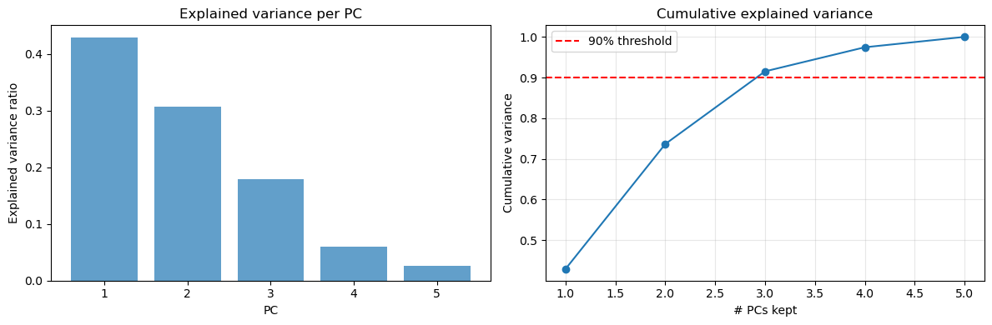
Metric scan, easy toy (cluster_std=1.0)
k | Inertia | Silhouette | Davies-Bouldin | Calinski-Harabasz | ARI | AMI
2 | 637.40 | 0.382 | 0.930 | 112.64 | 0.330 | 0.574
3 | 381.56 | 0.442 | 0.911 | 159.65 | 0.689 | 0.814
4 | 237.94 | 0.491 | 0.770 | 209.25 | 0.987 | 0.982
5 | 221.95 | 0.419 | 1.112 | 170.89 | 0.920 | 0.933
6 | 206.81 | 0.355 | 1.235 | 148.81 | 0.844 | 0.888
7 | 192.72 | 0.271 | 1.524 | 134.74 | 0.696 | 0.812
8 | 181.54 | 0.226 | 1.570 | 123.66 | 0.633 | 0.794

Metric scan, hard toy (cluster_std=2.5)
k | Inertia | Silhouette | Davies-Bouldin | Calinski-Harabasz | ARI | AMI
2 | 751.14 | 0.234 | 1.514 | 65.60 | 0.289 | 0.397
3 | 604.09 | 0.231 | 1.481 | 64.55 | 0.370 | 0.400
4 | 536.76 | 0.220 | 1.448 | 56.38 | 0.373 | 0.410
5 | 489.58 | 0.209 | 1.461 | 50.83 | 0.398 | 0.451
6 | 454.29 | 0.178 | 1.577 | 46.61 | 0.336 | 0.436
7 | 425.44 | 0.183 | 1.544 | 43.44 | 0.294 | 0.408
8 | 393.65 | 0.182 | 1.445 | 42.25 | 0.316 | 0.452

Regression comparison, easy toy
Strategy | RMSE | R²
Global OLS | 5.23 | 0.468
Per-cluster OLS | 2.21 | 0.905
Cluster-as-feature OLS | 4.23 | 0.652

Regression comparison, hard toy
Strategy | RMSE | R²
Global OLS | 10.97 | 0.071
Per-cluster OLS | 8.00 | 0.506
Cluster-as-feature OLS | 9.48 | 0.306

